Brett Anderson

CS3560

HW3

Fall 2015

First, I created a new repo and added some files and folders.

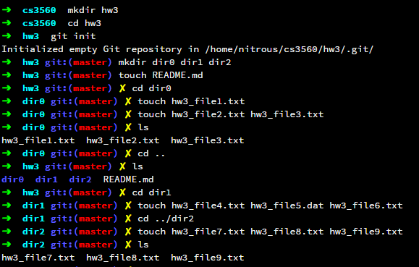

Then I committed all the files and added a tag: v1.

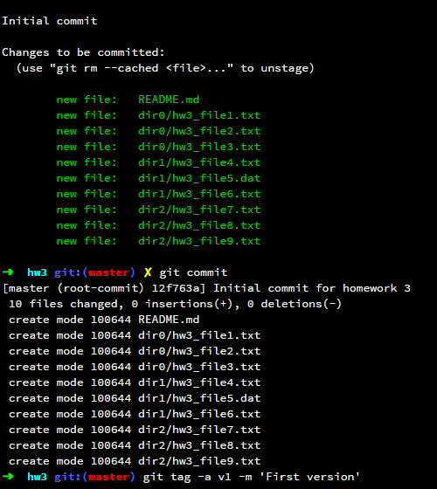

Next I created a new branch called testing.

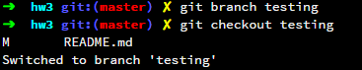

I made some changes in the testing branch, committed them, tagged as v2.

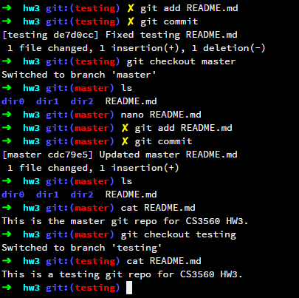

Changed back to master, committed changes to the README, and tagged v1.1. Then changed to testing, modified the README, and tagged v2.1.

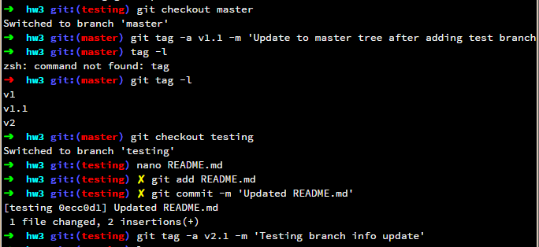

And here are the results.

