Jacob Carlsen

Assignment 3

I began by creating a new directory and initializing a git repo:

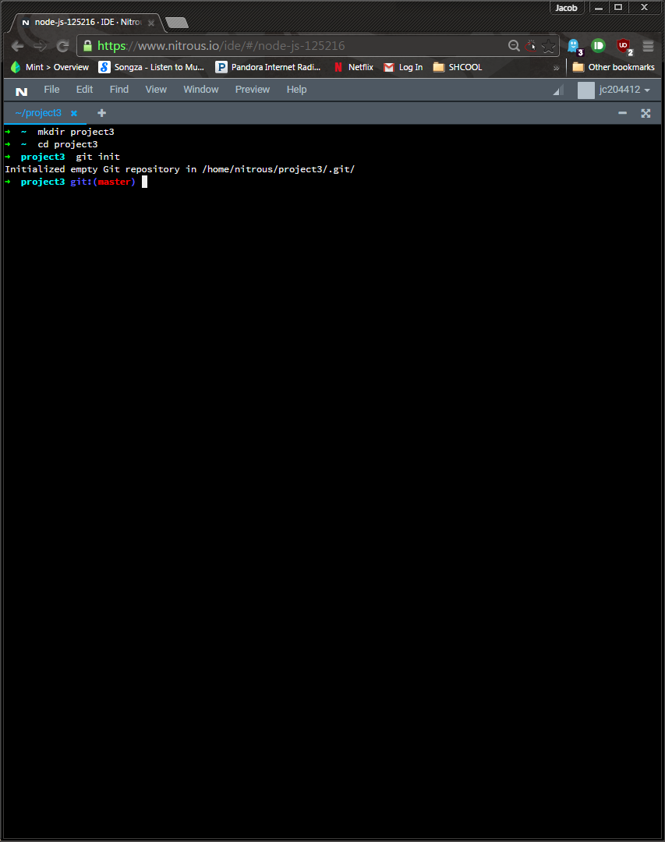

I then created 3 subfolders: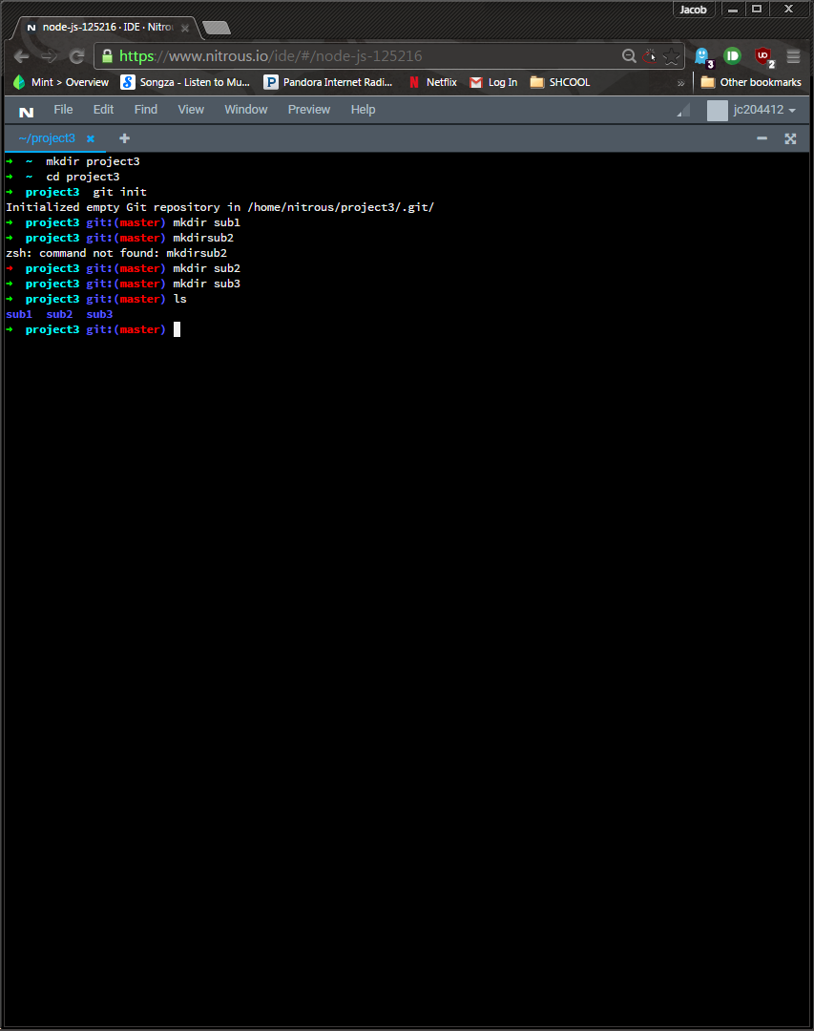

I then created 2 files in each folder and a readme: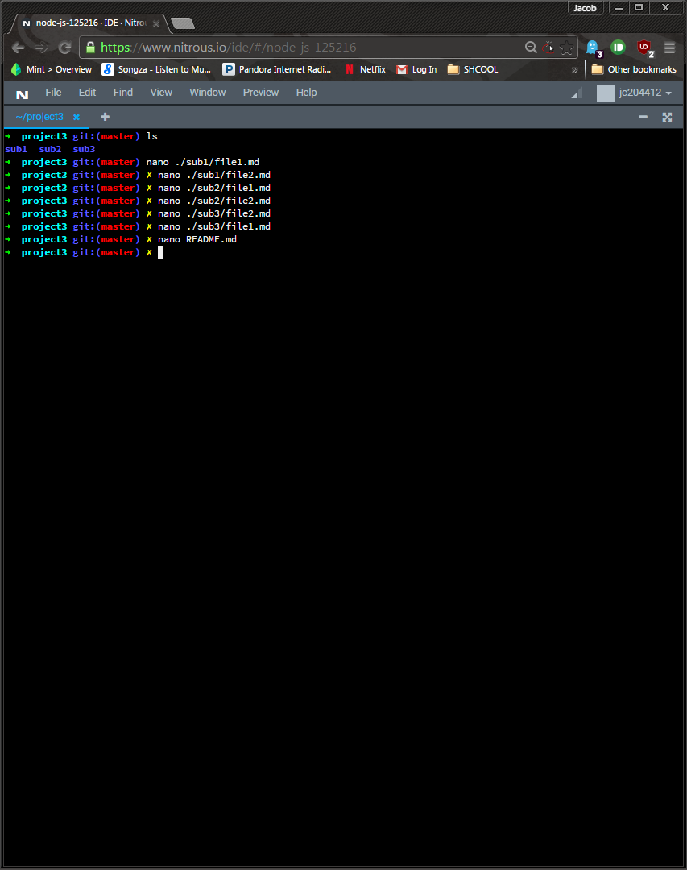

I then committed the changes: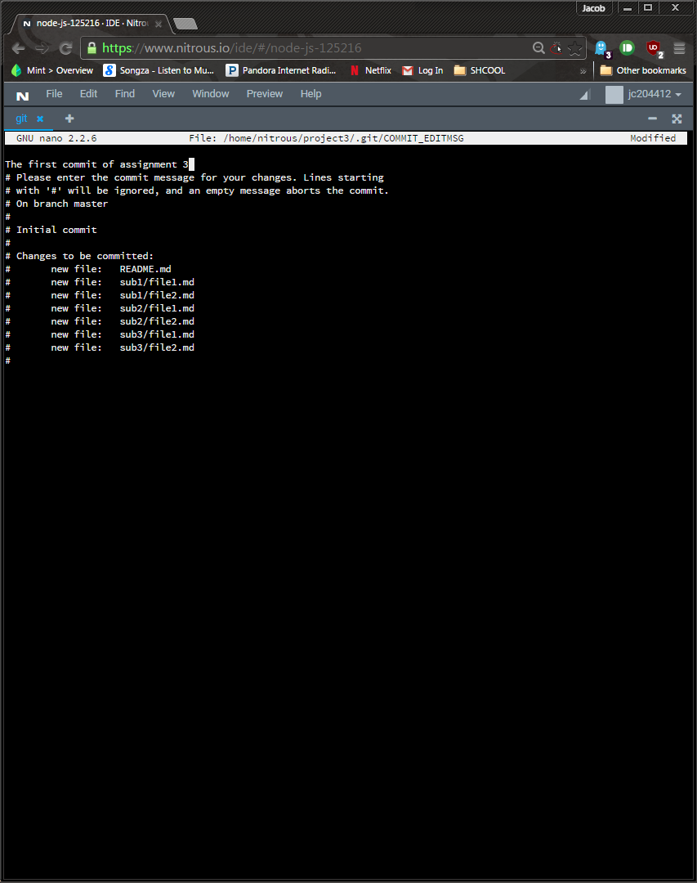

and then I created a tag v1:

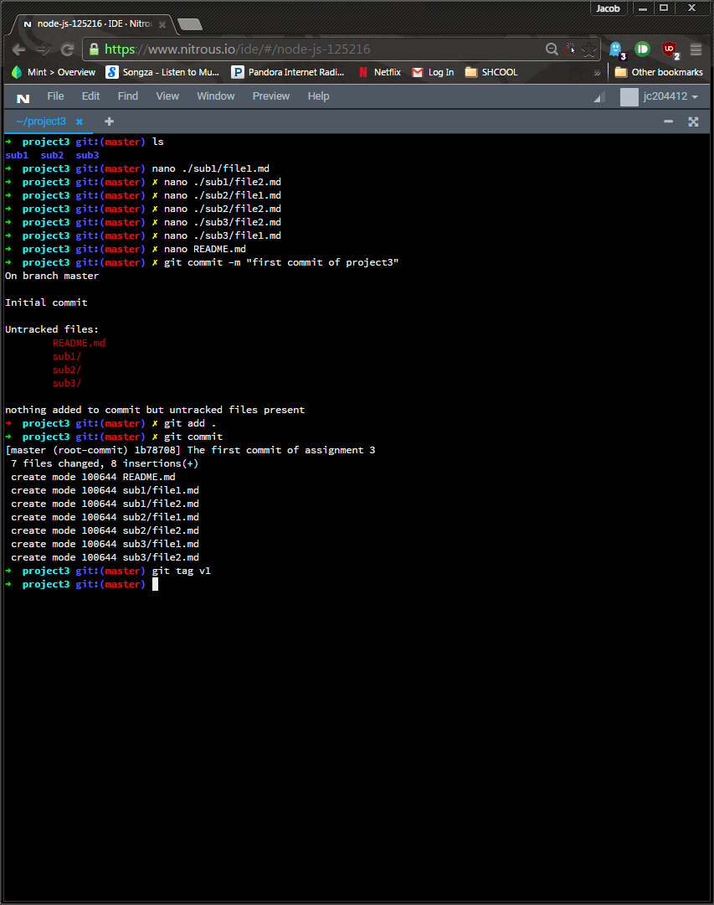

I then created a new folder, put a new file in it, and deleted an old one:  
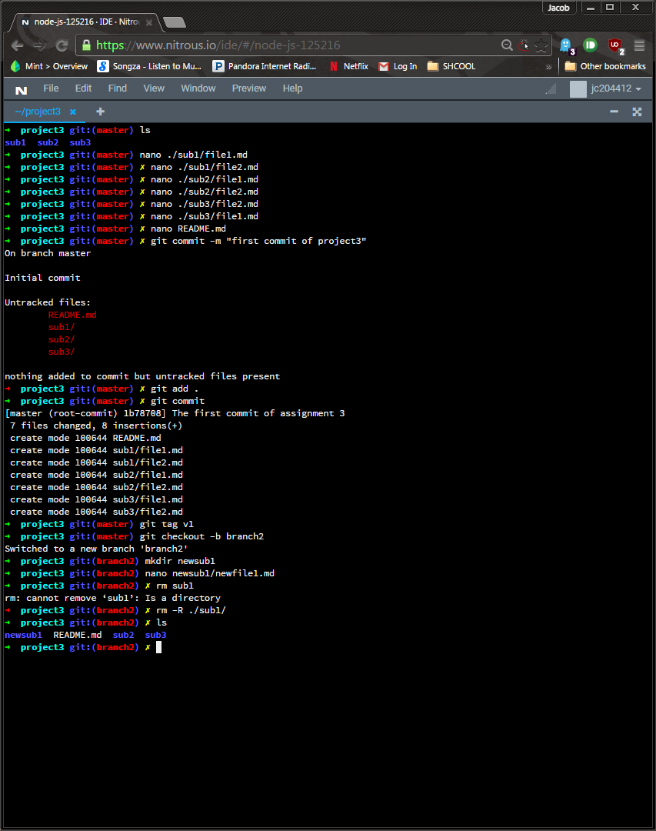

I also edited the readme then commited the changes: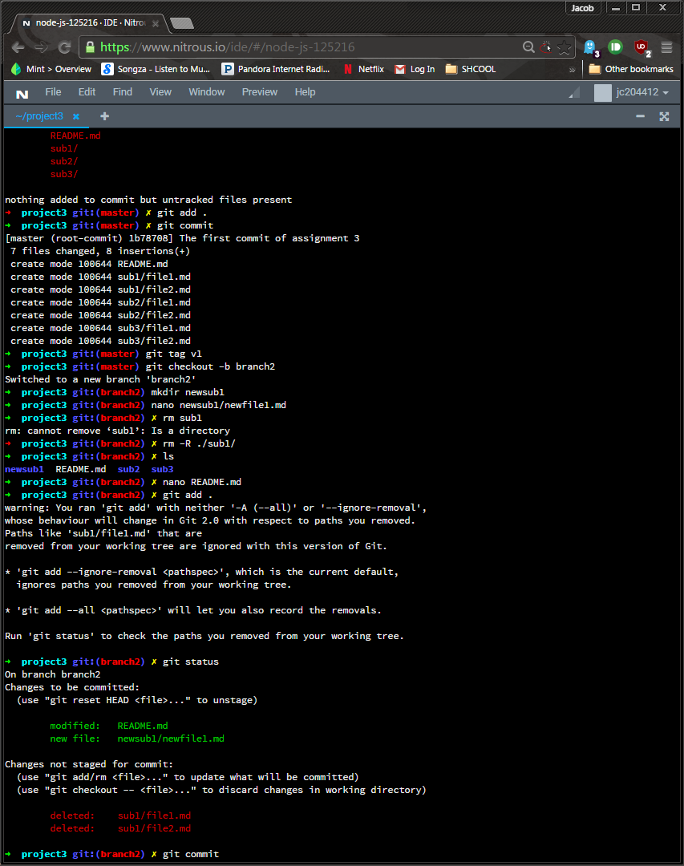

I tagged it with an appropriate message:

I then revised the readme files for both branches and committed them all along with the tags: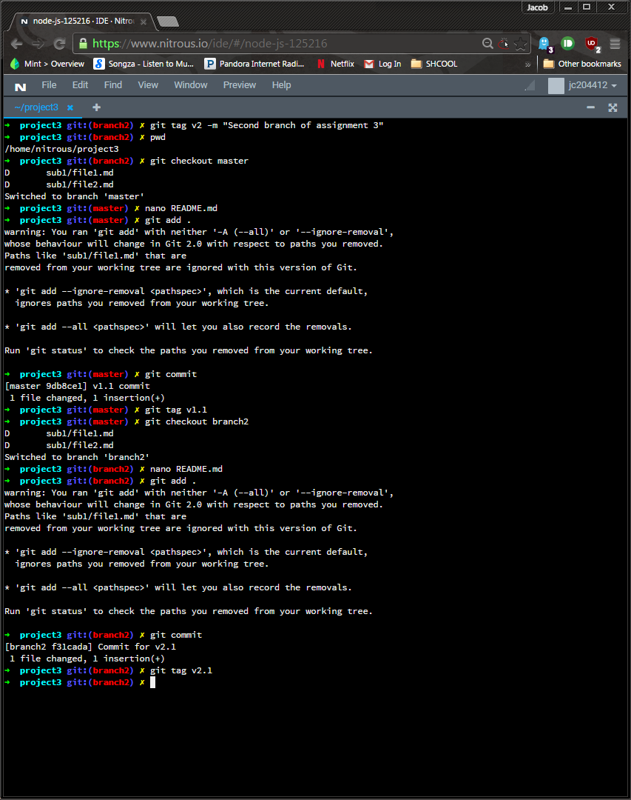

I then printed all the tags in one place:  
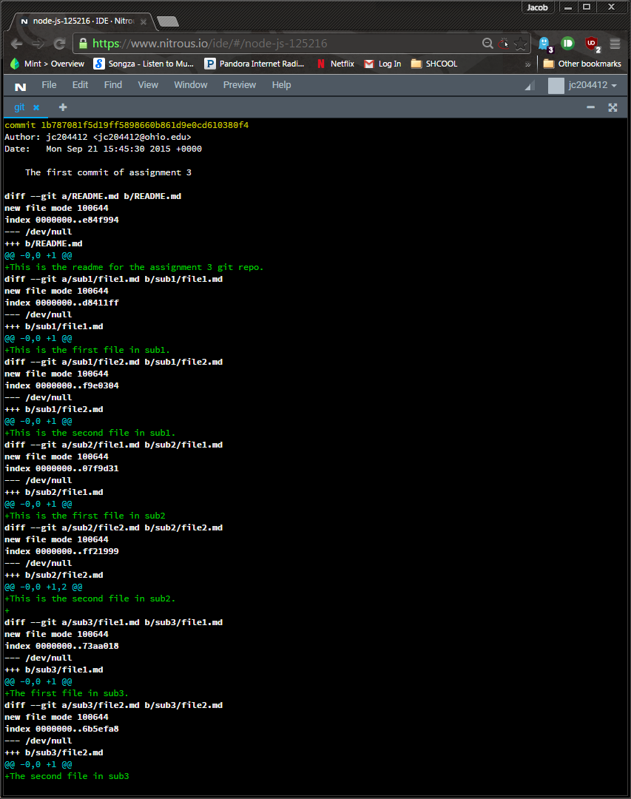

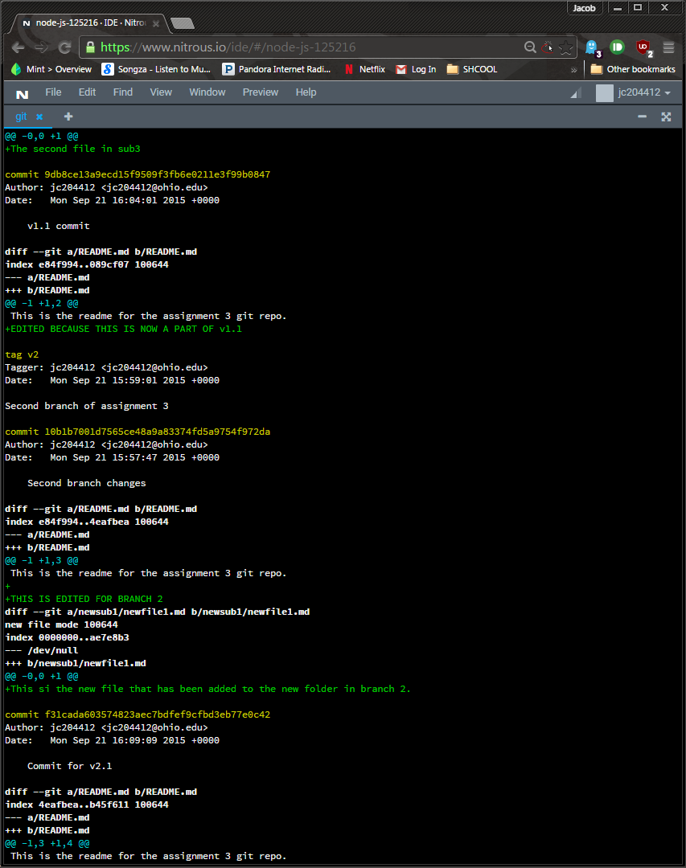

I could not get Sourcetree or Github working with the classroom repository, they both gave the same error:

