1. Create a new git repo from scratch using git init:

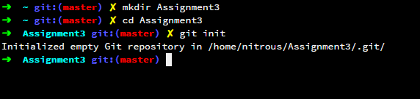

1. Creating three subfolders to the tree. With two files in each

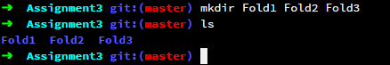

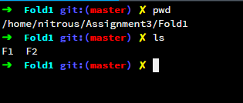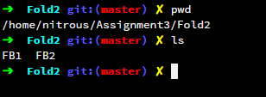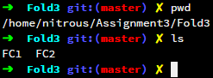

1. Adding readme.md to the root folder

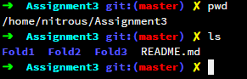

1. Committing all the files with tag named v1



1. Create a new branch and add a new subfolder and one new file within, delete one subfolder, revise the readme to state the name of the new branch, and add a message to the tag

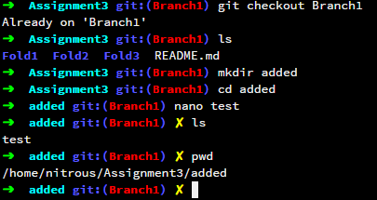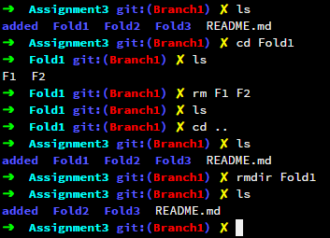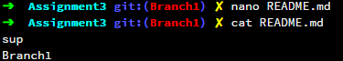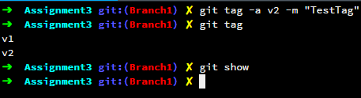

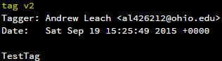

1. Switch back to the old branch, revise the readme to state the name of this branch commit the changes create a tag v1.1

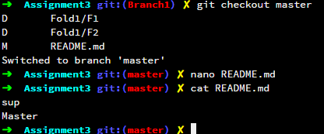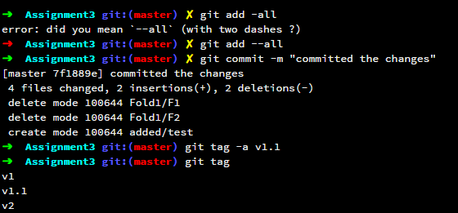

1. Switching back to the other branch, revising the readme again and commiting the changes. Created a tag named v2.1

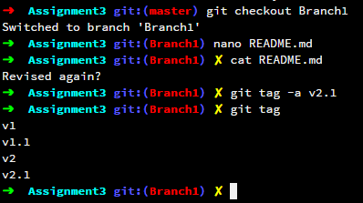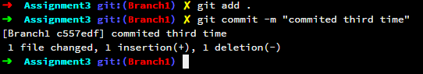

1. Looking at the work…

