Eric Keep

September 21, 2015

CS 3560 Assignment 3

1. Create a new git repo: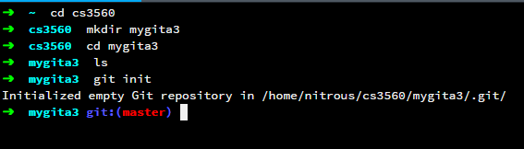
2. Add 3 new subfolders to the repo, each holding two files:

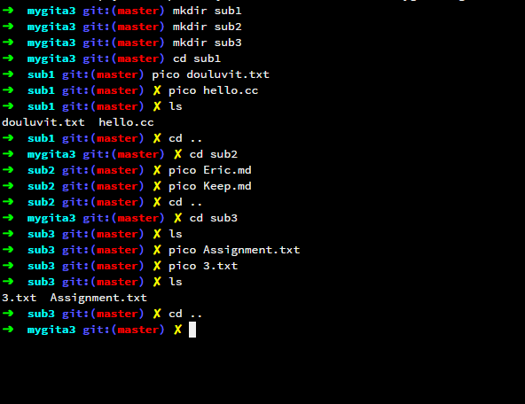

1. Add a README.md to the root of the directory:

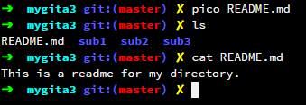

1. Commit these changes with the tag v1:

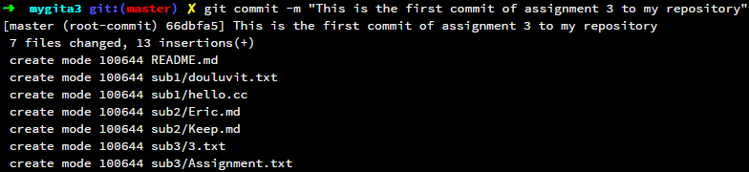

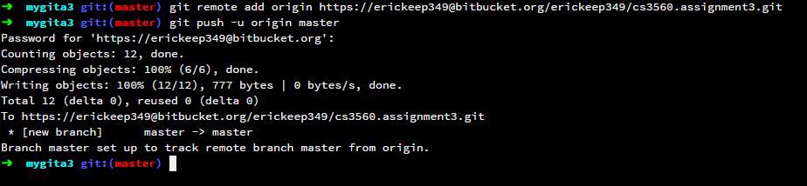

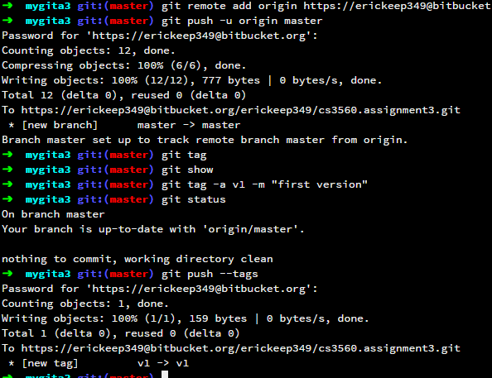

1. Create a new branch. Add a new subfolder and at least one new file in the new subfolder. Delete one subfolder. Revise the README file to state the name of the new branch. Commit the changes. Create a tag named "v2". Use "-m" to add a message to the tag

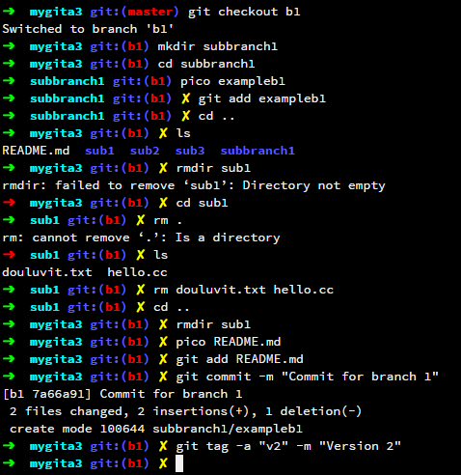

(I messed up commiting the removals before I did the tag)

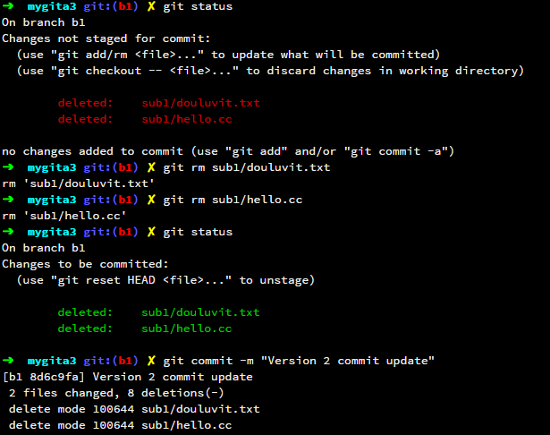

1. Switch to the old branch. Revise the README file to state the name of this branch. Commit the changes. Create a tag name "v1.1"

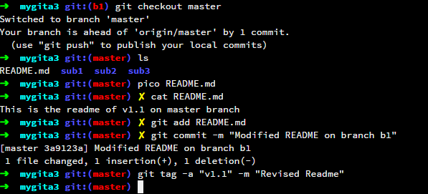

1. Switch back to the other branch. Revise the README file again and commit the changes. Create a tag named "v2.1"

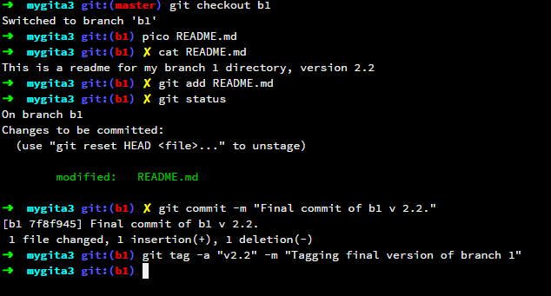

1. Open the git repo in SourceTree to show the branches and tags (I wasn’t sure how to access the nitrous through SourceTree so I downloaded to my PC – the branches and tags seemed to be copied over fine though)

