Harrison Kitts

CS 3560

HW 3 Assignment

1. Create a new git repo:

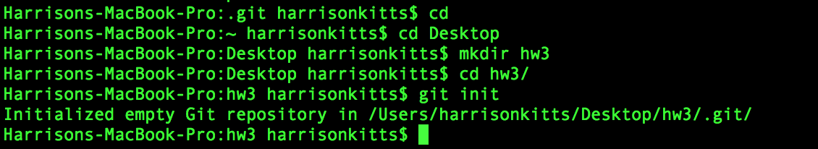

1. Create 3 subfolders each with 2 files:

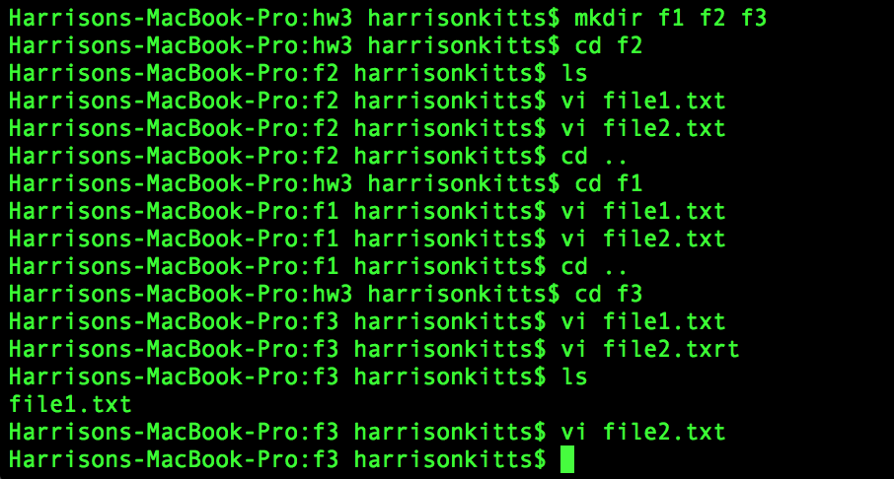

1. Add README.md to root folder

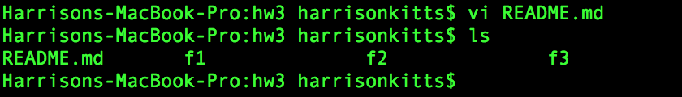

1. Commit files and make a tag “v1”

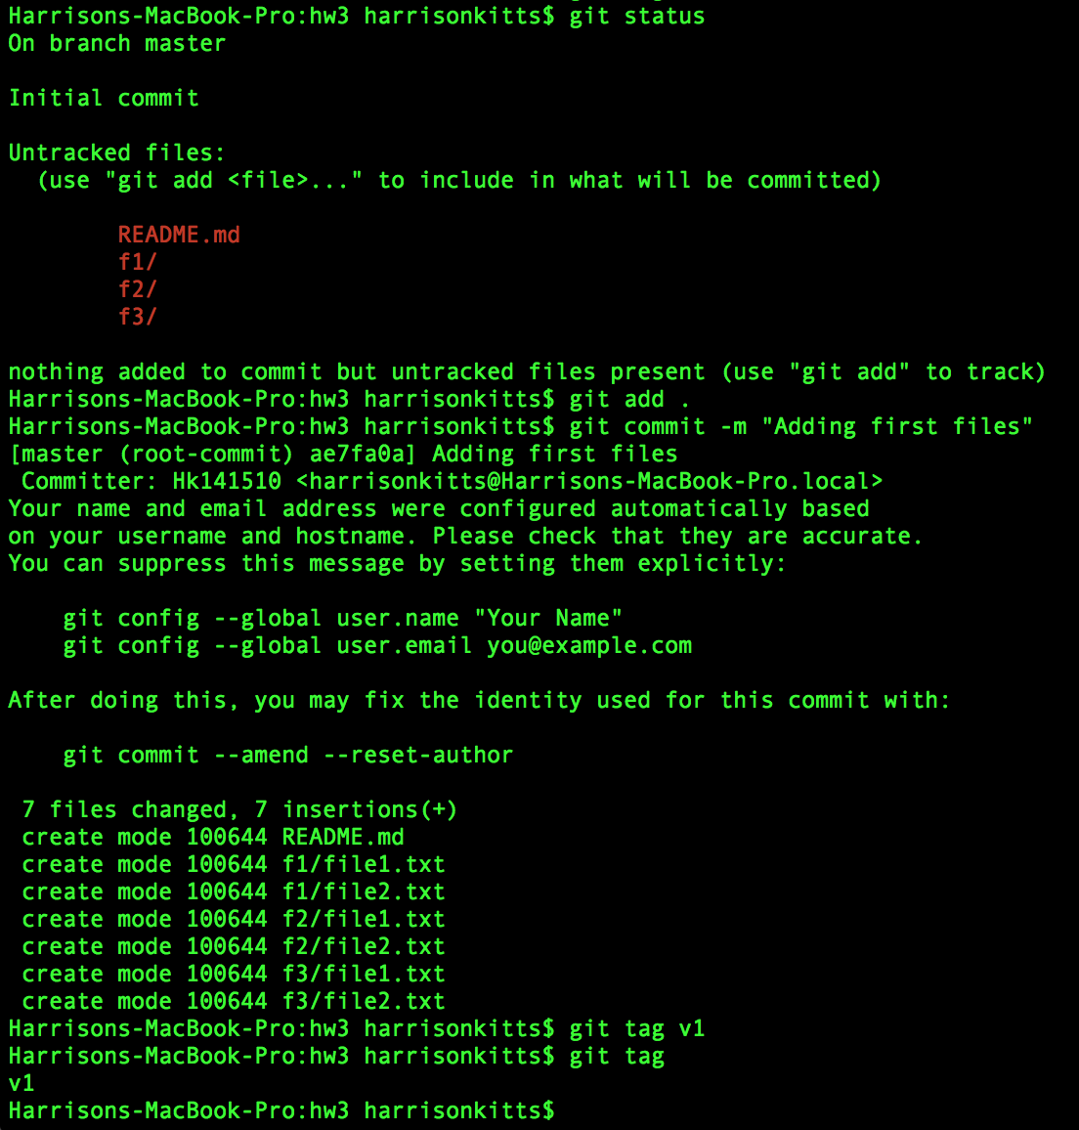

1. Create a new branch. Add a new subfolder and at least one new file in the new subfolder. Delete one subfolder. Revise the README file to state the name of the new branch. Commit the changes. Create a tag named "v2". Use "-m" to add a message to the tag.

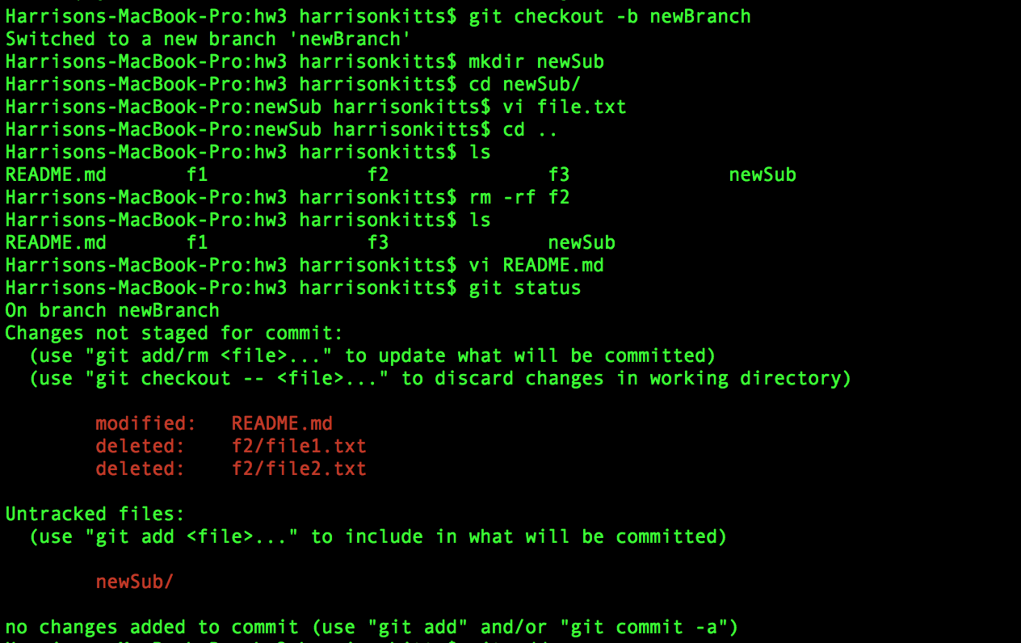

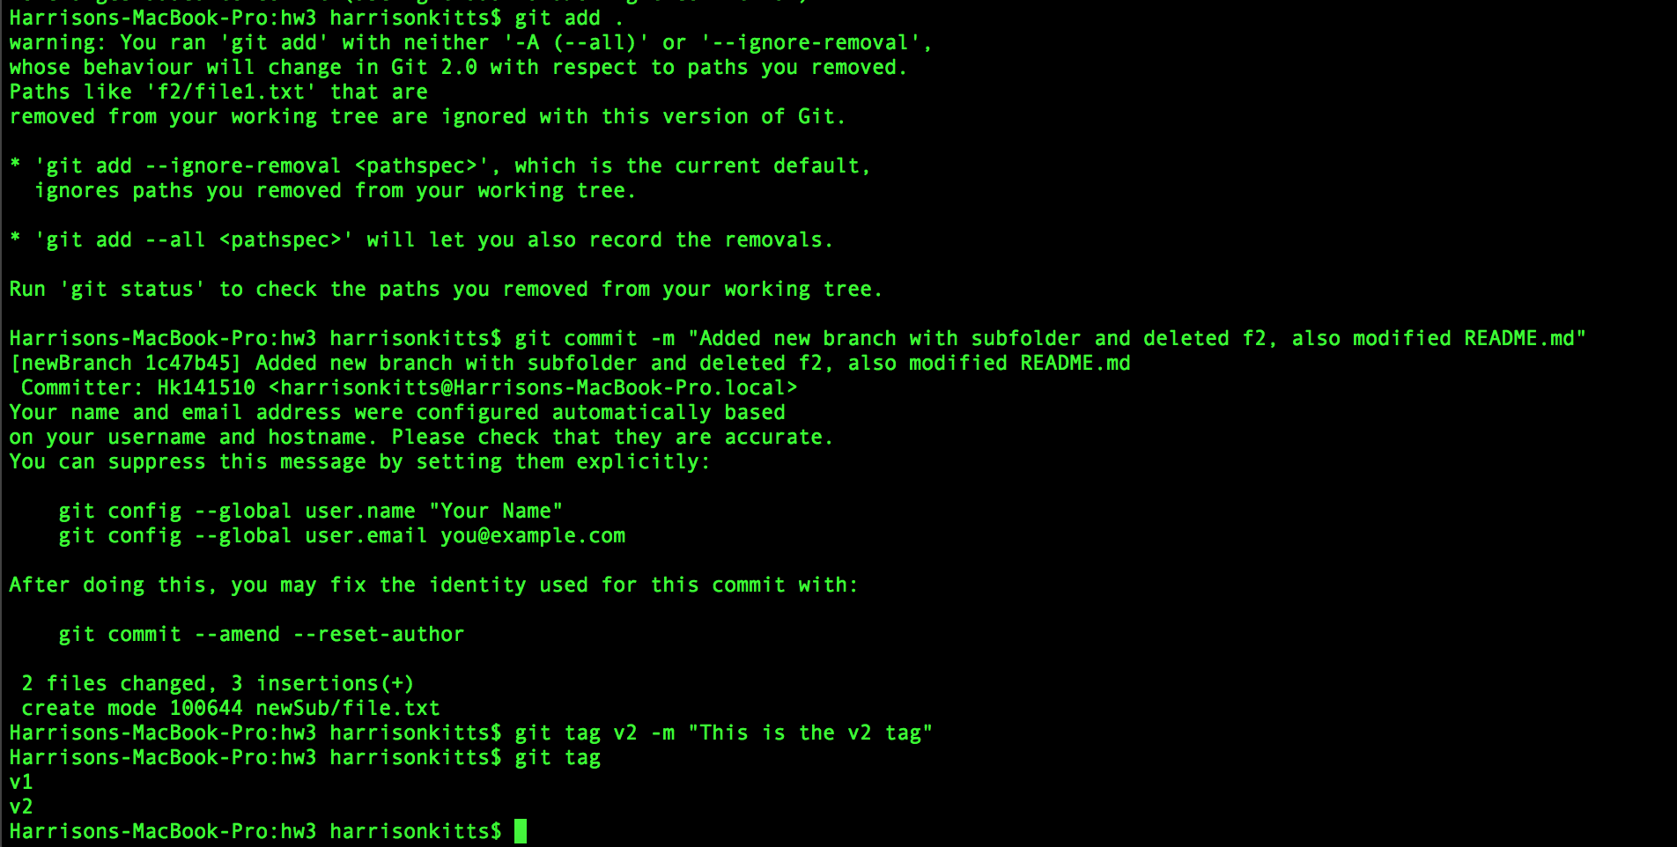

1. Switch to the old branch. Revise the README file to state the name of this branch. Commit the changes. Create a tag name "v1.1"

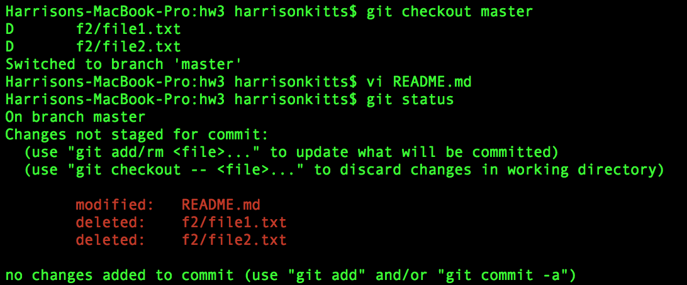

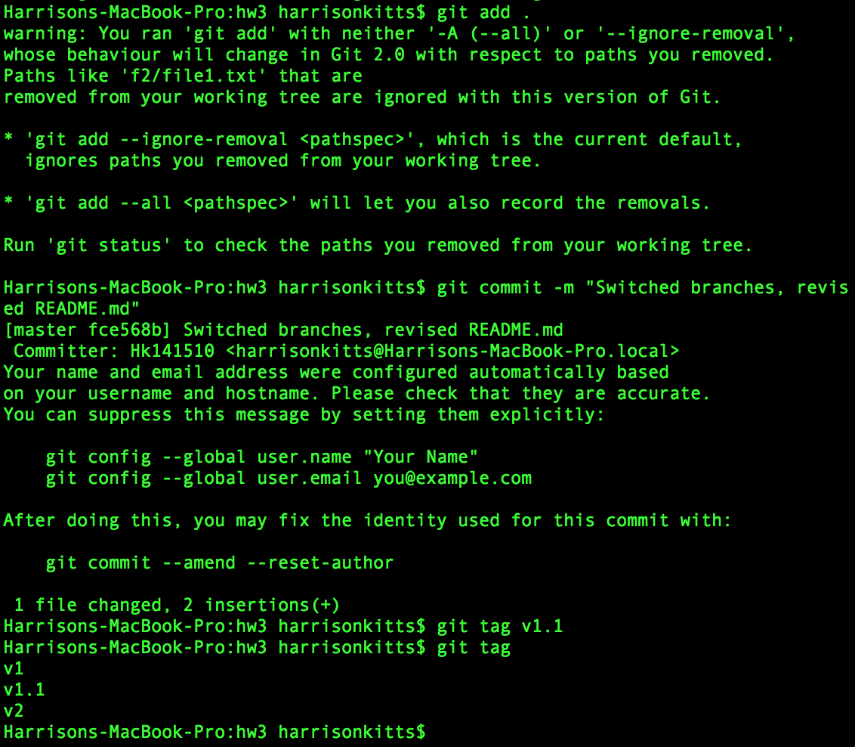

1. Switch back to the other branch. Revise the README file again and commit the changes. Create a tage named "v2.1".

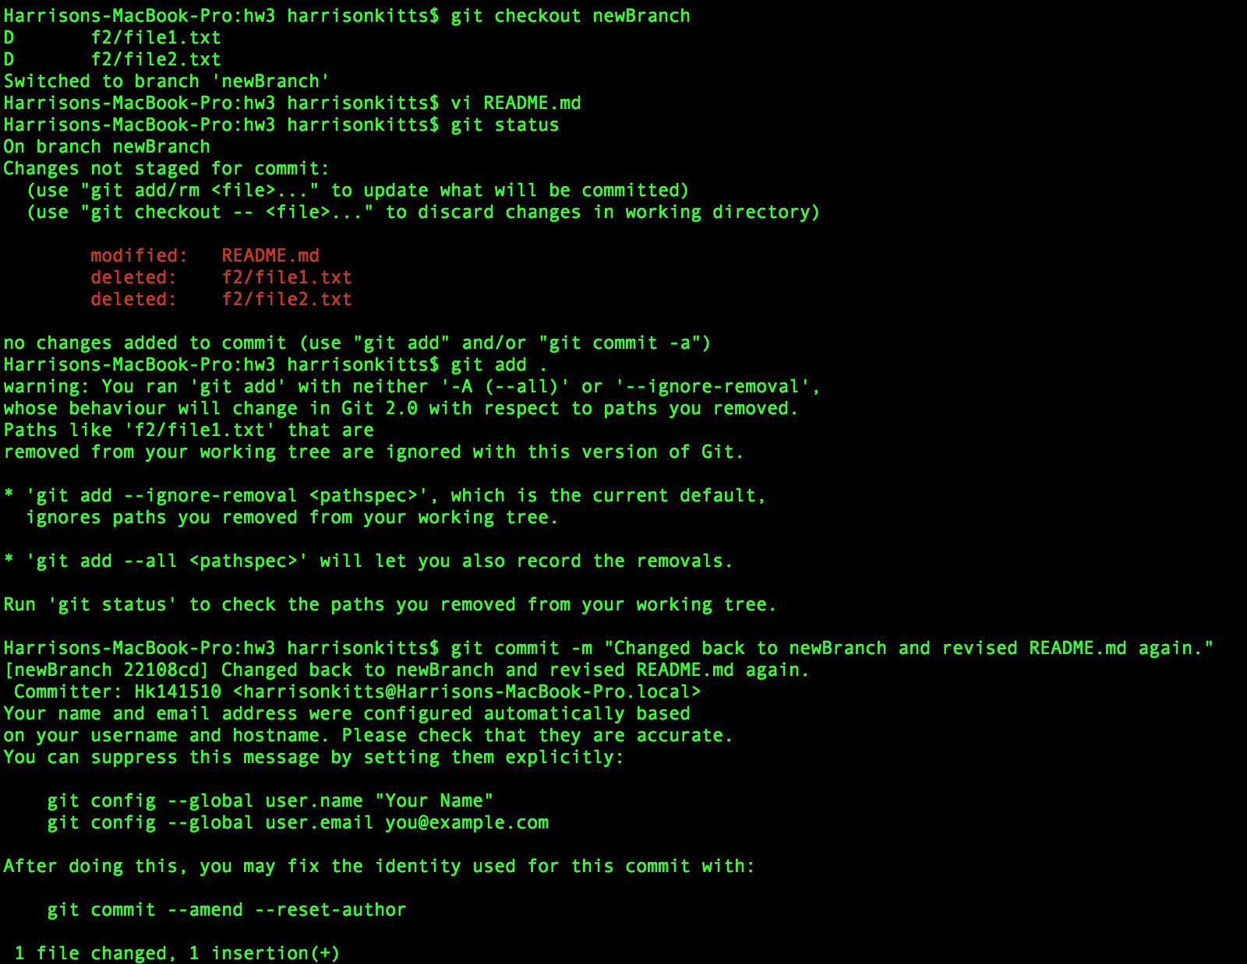

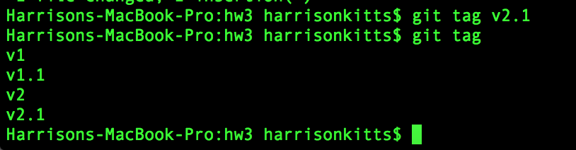

1. I don’t have source tree or github so here are screenshots of the branches and their tags.

