John Robertson

Assignment 3

Create a new git repo from scratch (tip: git init)



Add three subfolders to the working tree. Each subfolder has two files in it.



Add README.md to the root folder

See picture above

* Commit all files. Create a tag named "v1".

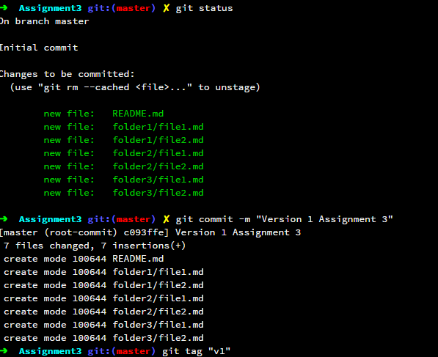

* Create a new branch. Add a new subfolder and at least one new file in the new subfolder. Delete one subfolder. Revise the README file to state the name of the new branch. Commit the changes. Create a tag named "v2". Use "-m" to add a message to the tag.

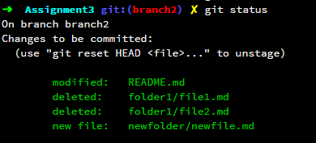

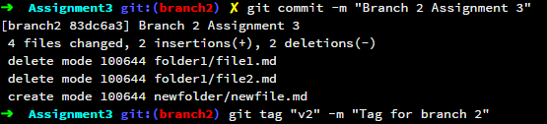

* Switch to the old branch. Revise the README file to state the name of this branch. Commit the changes. Create a tag name "v1.1"

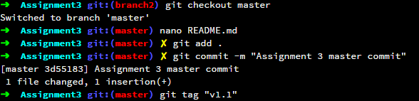

* Switch back to the other branch. Revise the README file again and commit the changes. Create a tage named "v2.1".

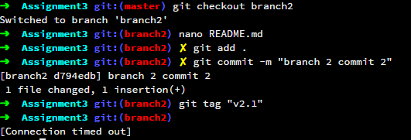

* Open the Git repo in SourceTree or Github GUI Client software. Take screenshots to show the two branches and the tags.

Did not figure out how to do this.