Mia Wilson

9/22/15

CS3560

Assignment 3

Created a git repo, add subfolders and files in those subfolders, and add a README.md

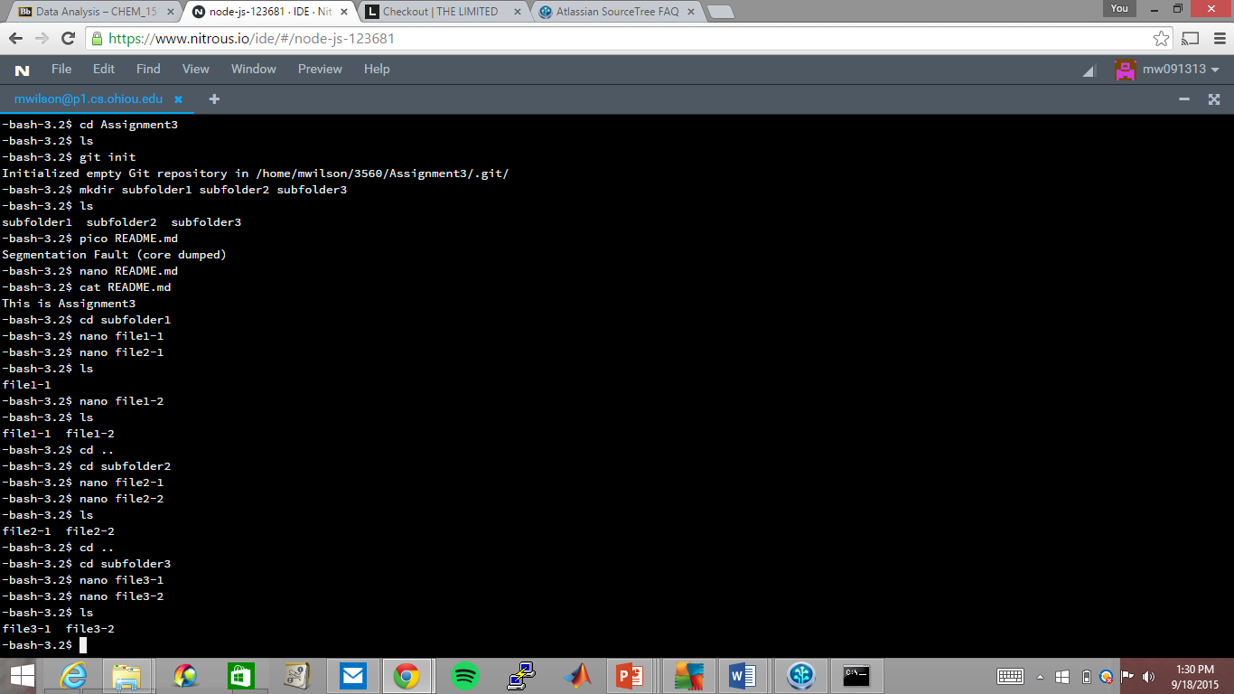

Commit files and tag the commit as v1

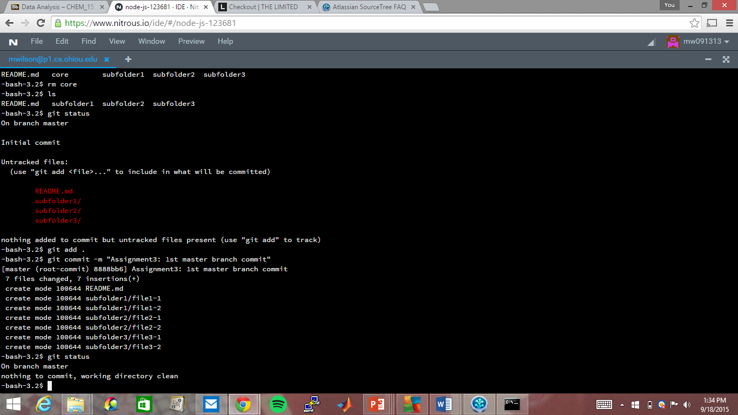

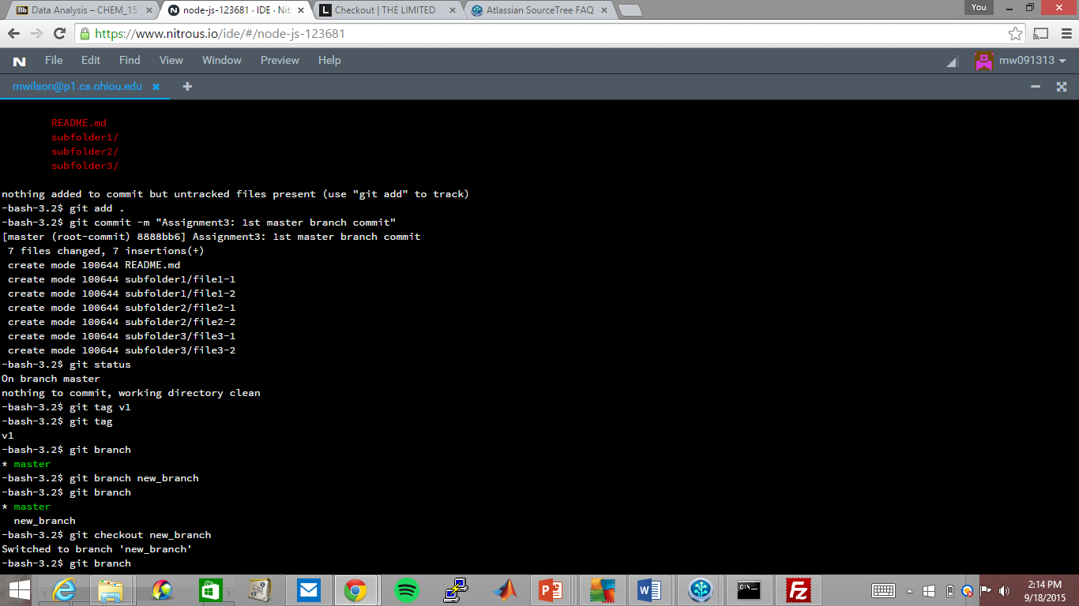

Add a new branch, switch to it, add subfolder and file, delete a subfolder, revise README.md, and commit it all and tag the commit as v2

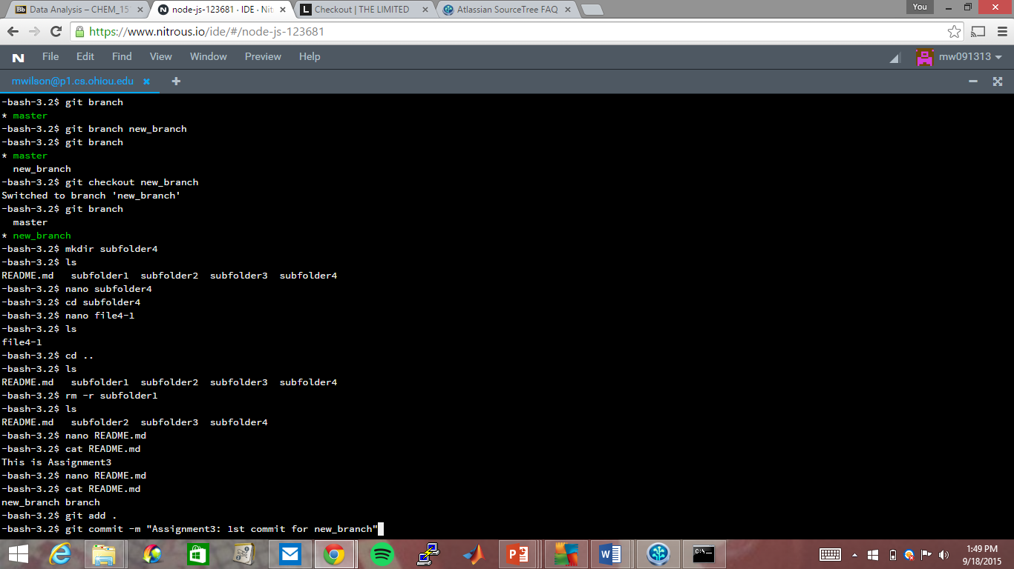

Change back to master branch, revise README.md, commit the change and tag as v1.1 and switch back to the new branch

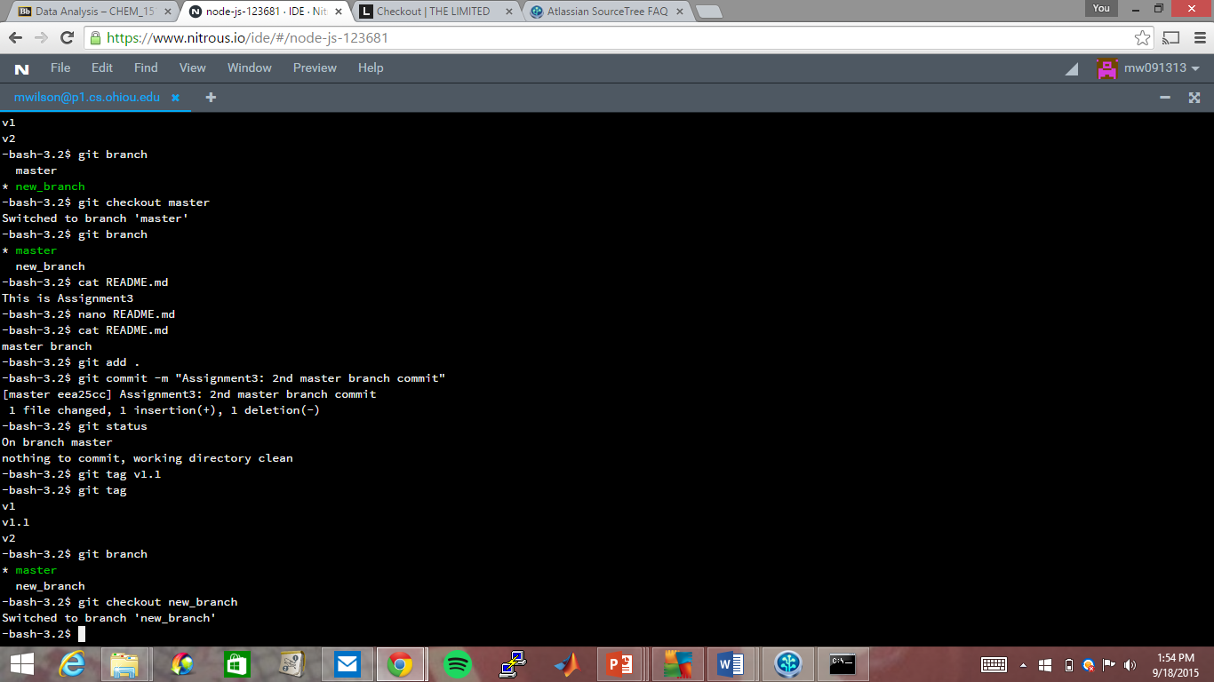

Revise README.md, commit the change, and tag it as v2.1

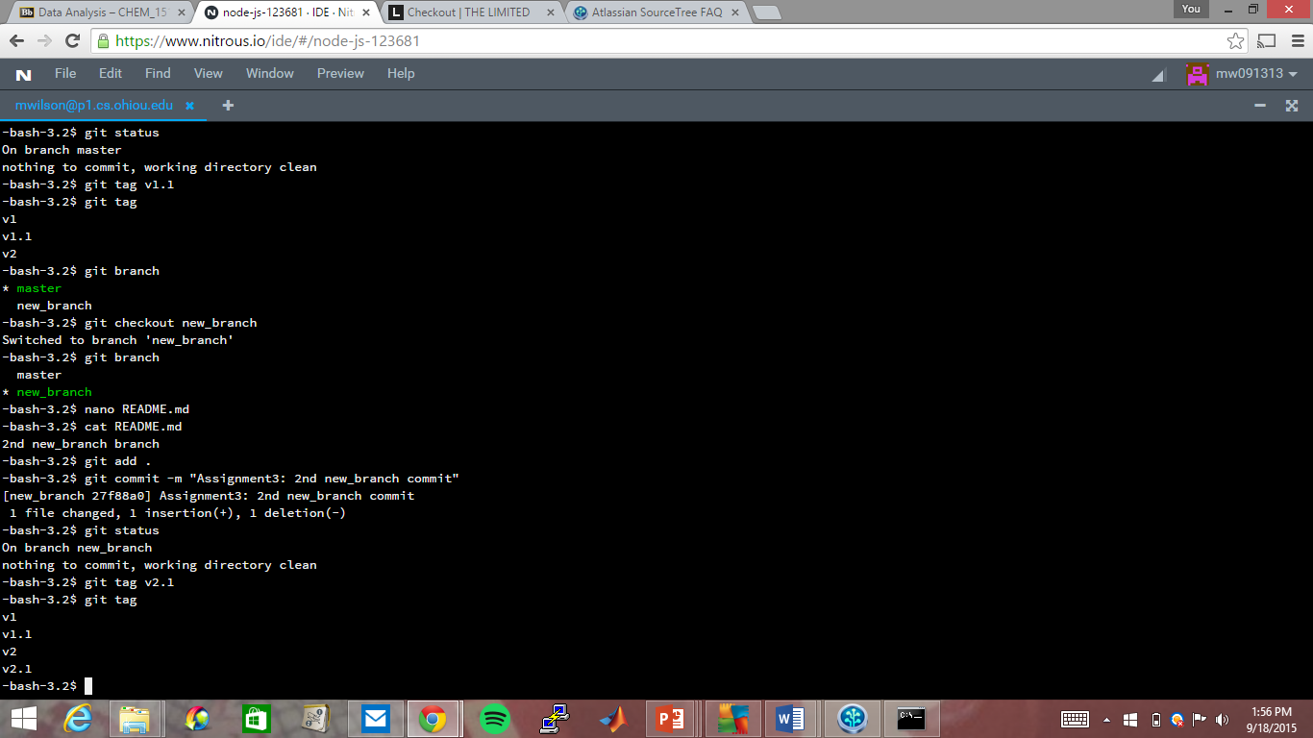

Source tree

