**Step 1:**

**Add Chrome to the Environment Variable**

#### Right Click on the Chrome Icon on your Desktop and Click on “Open File Location”

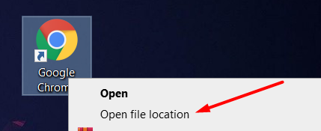

#### Copy this Path



#### Open Windows Search bar and Type “Edit Environment”

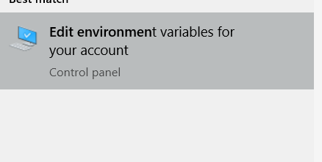

#### Click on that and Under “User Variables” double click on “Path”

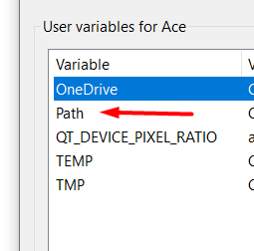

#### Click on one of the Empty Spots and Place the Chrome Address

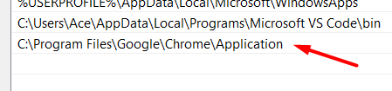

#### Press Ok.

**Step 2:**

**Setting Up the Project**

**####** Open the folder in CMD and Make sure you have Python 3 installed

#### Run command "pip install -r req.txt”

#### Go into the Cookies folder and Copy the Path of that folder

My path looks like this



####Run this command and Replace PATH with the path to the cookies folder **chrome.exe -remote-debugging-port=9014 --user-data-dir="PATH"**

#### My command looks like this



#### This will Open up a chrome browser

#### Log into Seller Central Account. This will save your login so you won’t have to log in again and again

**Step 3:**

**Running the Project**

#### Now run the main.py file using the command

**py ./main.py**