Receipt of payment for 1803/243 Franklin St, Melbourne VIC 3000
Messages: 3

Message 1
Type | ORIG
Sort Date | 2025-02-25 18:39
Header Date | 25/02/2025 18:39 AEDT
Header Subject | Receipt of payment for 1803/243 Franklin St, Melbourne VIC 3000
Source .doc | 250225_-_Receipt_of_payment_for_1803_243_Franklin_St__Melbourne_VIC_3000_.doc

Subject | Receipt of payment for 1803/243 Franklin St, Melbourne VIC 3000
From | "Jessica Xie - Areal Property Hawthorn (MPM)" <MPM@email.propertyme.com>
Date | 25/02/2025 18:39 AEDT
To | Chawakorn Kamnuansil <ck.chawakorn@gmail.com>

Hi Chawakorn,
Thanks for your recent payment of $2,825.00 that we processed on 24/02/2025. We have attached a payment receipt to this email which details any changes to your rent paid to dates.
Please don't hesitate to contact us should you have any queries.
With thanks,
Jessica Xie
Areal Property (MPM) Pty Ltd
03 9818 8991
jessica.xie@areal.com.au
https://www.areal.com.au/

If you have any feedback regarding my service, please feel free to contact my manager.
Jamie Ong (Head of Property Management) jamie.ong@areal.com.au

DISCLAIMER & WARNING. This correspondence and the information contained in this and associated e-mails are confidential and were only intended for the exclusive use of the addressee(s). If you have received this e-mail in error, any use, copying or inference with this information is unauthorized and prohibited and please immediately delete it and any related attachments or emails from your system and its related sub system and notify the sender. You must never copy, disclose, make conclusions and other information in this message that do not relate to the business of the Areal Property and shall be understood as neither given nor approved or agreed by it. Although Areal Property has taken reasonable precautions to ensure no viruses are present in this e-mail, Areal Property cannot accept responsibility for any loss or damage arising from the use of this e-mail or attachments.

Click to unsubscribe from future email communication

- _250225_MPM@email.propertyme.com_Receipt_of_payment_for_1803_243_Franklin_St__Melbourne_VIC_3000-231/Receipt # 85835.pdf

Attachment Thumbnails
1. Receipt # 85835.pdf
Receipt # 85835.pdf — Page 1/1 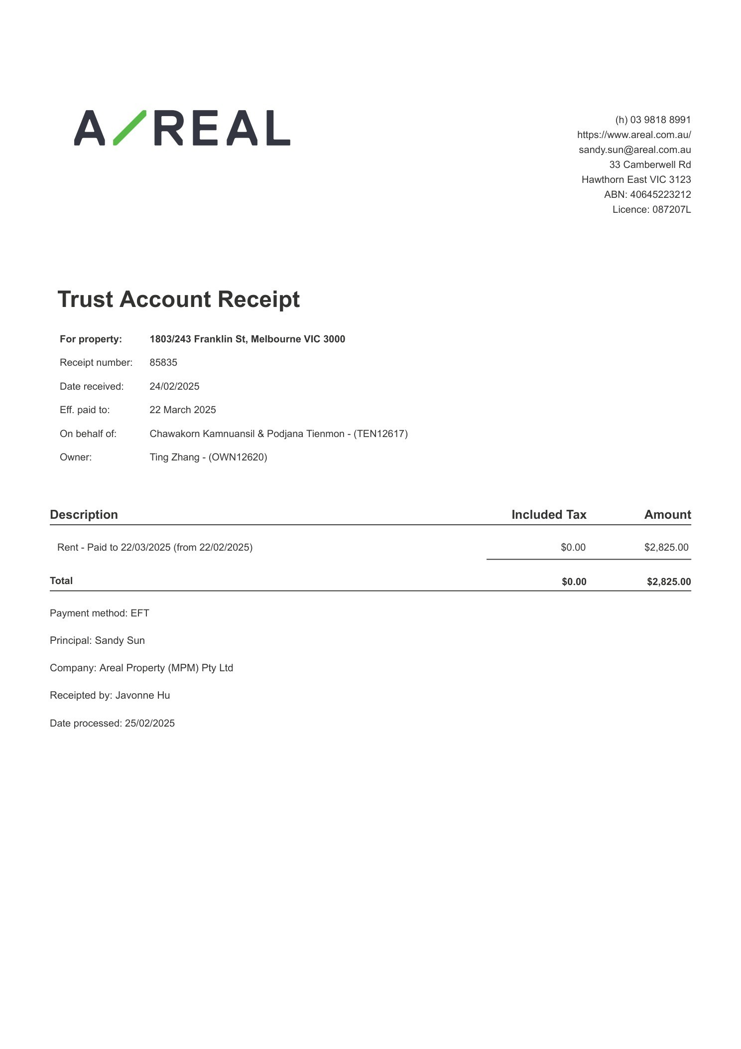

Message 2
Type | ORIG
Sort Date | 2025-03-25 18:44
Header Date | 25/03/2025 18:44 AEDT
Header Subject | Receipt of payment for 1803/243 Franklin St, Melbourne VIC 3000
Source .doc | 250325_-_Receipt_of_payment_for_1803_243_Franklin_St__Melbourne_VIC_3000_.doc

Subject | Receipt of payment for 1803/243 Franklin St, Melbourne VIC 3000
From | "Hilary Ho - Areal Property Hawthorn (MPM)" <MPM@email.propertyme.com>
Date | 25/03/2025 18:44 AEDT
To | Chawakorn Kamnuansil <ck.chawakorn@gmail.com>

Hi Chawakorn,
Thanks for your recent payment of $2,825.00 that we processed on 24/03/2025. We have attached a payment receipt to this email which details any changes to your rent paid to dates.
Please don't hesitate to contact us should you have any queries.
With thanks,
Hilary Ho
Areal Property (MPM) Pty Ltd
03 9818 8991
hilary.ho@areal.com.au
https://www.areal.com.au/

If you have any feedback regarding my service, please feel free to contact my manager.
Jamie Ong (Head of Property Management) jamie.ong@areal.com.au

DISCLAIMER & WARNING. This correspondence and the information contained in this and associated e-mails are confidential and were only intended for the exclusive use of the addressee(s). If you have received this e-mail in error, any use, copying or inference with this information is unauthorized and prohibited and please immediately delete it and any related attachments or emails from your system and its related sub system and notify the sender. You must never copy, disclose, make conclusions and other information in this message that do not relate to the business of the Areal Property and shall be understood as neither given nor approved or agreed by it. Although Areal Property has taken reasonable precautions to ensure no viruses are present in this e-mail, Areal Property cannot accept responsibility for any loss or damage arising from the use of this e-mail or attachments.

Click to unsubscribe from future email communication

- _250325_MPM@email.propertyme.com_Receipt_of_payment_for_1803_243_Franklin_St__Melbourne_VIC_3000-195/Receipt # 87045.pdf

Attachment Thumbnails
1. Receipt # 87045.pdf
Receipt # 87045.pdf — Page 1/1 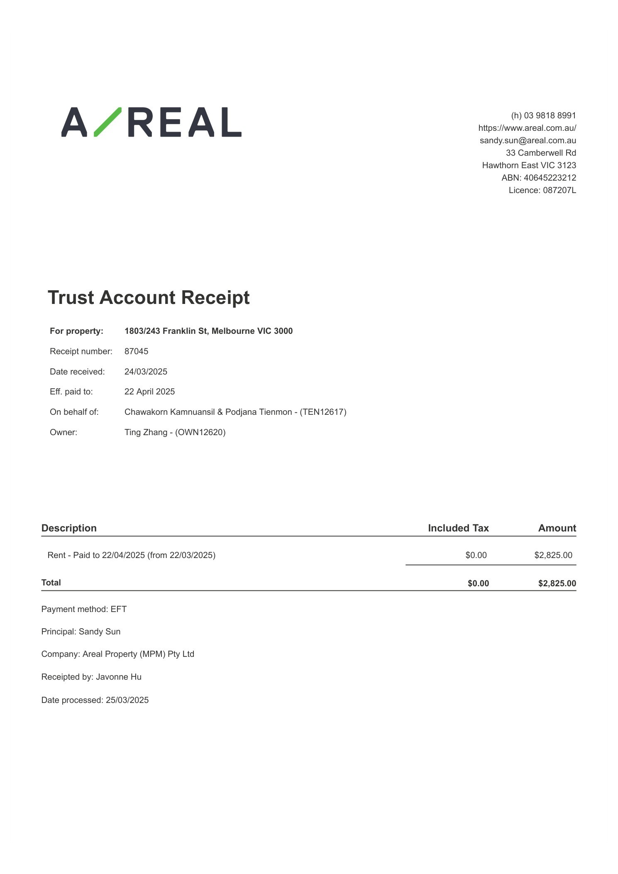

Message 3
Type | ORIG
Sort Date | 2025-04-23 15:10
Header Date | 23/04/2025 15:10 AEST
Header Subject | Receipt of payment for 1803/243 Franklin St, Melbourne VIC 3000
Source .doc | 250423_-_Receipt_of_payment_for_1803_243_Franklin_St__Melbourne_VIC_3000_.doc

Subject | Receipt of payment for 1803/243 Franklin St, Melbourne VIC 3000
From | "Sylvia Hao - Areal Property Hawthorn (MPM)" <MPM@email.propertyme.com>
Date | 23/04/2025 15:10 AEST
To | Chawakorn Kamnuansil <ck.chawakorn@gmail.com>

Hi Chawakorn,
Thanks for your recent payment of $2,825.00 that we processed on 22/04/2025. We have attached a payment receipt to this email which details any changes to your rent paid to dates.
Please don't hesitate to contact us should you have any queries.
With thanks,
Sylvia Hao
Areal Property (MPM) Pty Ltd
03 9818 8991
sylvia.hao@areal.com.au
https://www.areal.com.au/

If you have any feedback regarding my service, please feel free to contact my manager.
Jamie Ong (Head of Property Management) jamie.ong@areal.com.au

DISCLAIMER & WARNING. This correspondence and the information contained in this and associated e-mails are confidential and were only intended for the exclusive use of the addressee(s). If you have received this e-mail in error, any use, copying or inference with this information is unauthorized and prohibited and please immediately delete it and any related attachments or emails from your system and its related sub system and notify the sender. You must never copy, disclose, make conclusions and other information in this message that do not relate to the business of the Areal Property and shall be understood as neither given nor approved or agreed by it. Although Areal Property has taken reasonable precautions to ensure no viruses are present in this e-mail, Areal Property cannot accept responsibility for any loss or damage arising from the use of this e-mail or attachments.

Click to unsubscribe from future email communication

- _250423_MPM@email.propertyme.com_Receipt_of_payment_for_1803_243_Franklin_St__Melbourne_VIC_3000-192/Receipt # 88184.pdf

Attachment Thumbnails
1. Receipt # 88184.pdf
Receipt # 88184.pdf — Page 1/1 