VCAT Application R202518214/00 – Challenge to Notice to Vacate
Messages: 3

Message 1
Type | ORIG
Sort Date | 2025-07-14 22:39
Header Date | 14/07/2025 22:39 AEST
Header Subject | VCAT Application R202518214/00 – Challenge to Notice to Vacate
Source .doc | 250714_-_VCAT_Application_R202518214_00___Challenge_to_Notice_to_Vacate_.doc

Subject | VCAT Application R202518214/00 – Challenge to Notice to Vacate
From | Chawakorn Kamnuansil <ck.chawakorn@gmail.com>
Date | 14/07/2025 22:39 AEST
To | "Sylvia Hao - Areal Property Hawthorn (MPM)" <mpm@email.propertyme.com>

Dear Areal Property Team,
I am writing to provide you with a copy of the VCAT application I lodged on 14 July 2025, relating to the Notice to Vacate issued on 11 July 2025 for the property:
Unit 1803, 243 Franklin Street, Melbourne VIC 3000.
This application challenges the validity of the Notice to Vacate, on the basis that it constitutes retaliatory eviction following legitimate maintenance complaints.
Attached to this email you will find:
- A copy of the VCAT application form (Reference Number: R202518214/00)
- A copy of the Notice to Vacate
This email serves as formal service of the application as required under VCAT rules.
Please confirm receipt of this email.
If you have any questions, feel free to contact me by email or phone.
Kind regards,
Chawakorn Kamnuansil

- _250714_ck.chawakorn@gmail.com_VCAT_Application_R202518214_00___Challenge_to_Notice_to_Vacate-279/VCAT Application R202518214:00 – Notice to Vacate Challenge.pdf
- _250714_ck.chawakorn@gmail.com_VCAT_Application_R202518214_00___Challenge_to_Notice_to_Vacate-279/NOTICE TO VACATE U1803 243 FRANKLIN ST.pdf

Attachment Thumbnails
1. VCAT Application R202518214:00 – Notice to Vacate Challenge.pdf
VCAT Application R202518214:00 – Notice to Vacate Challenge.pdf — Page 1/1 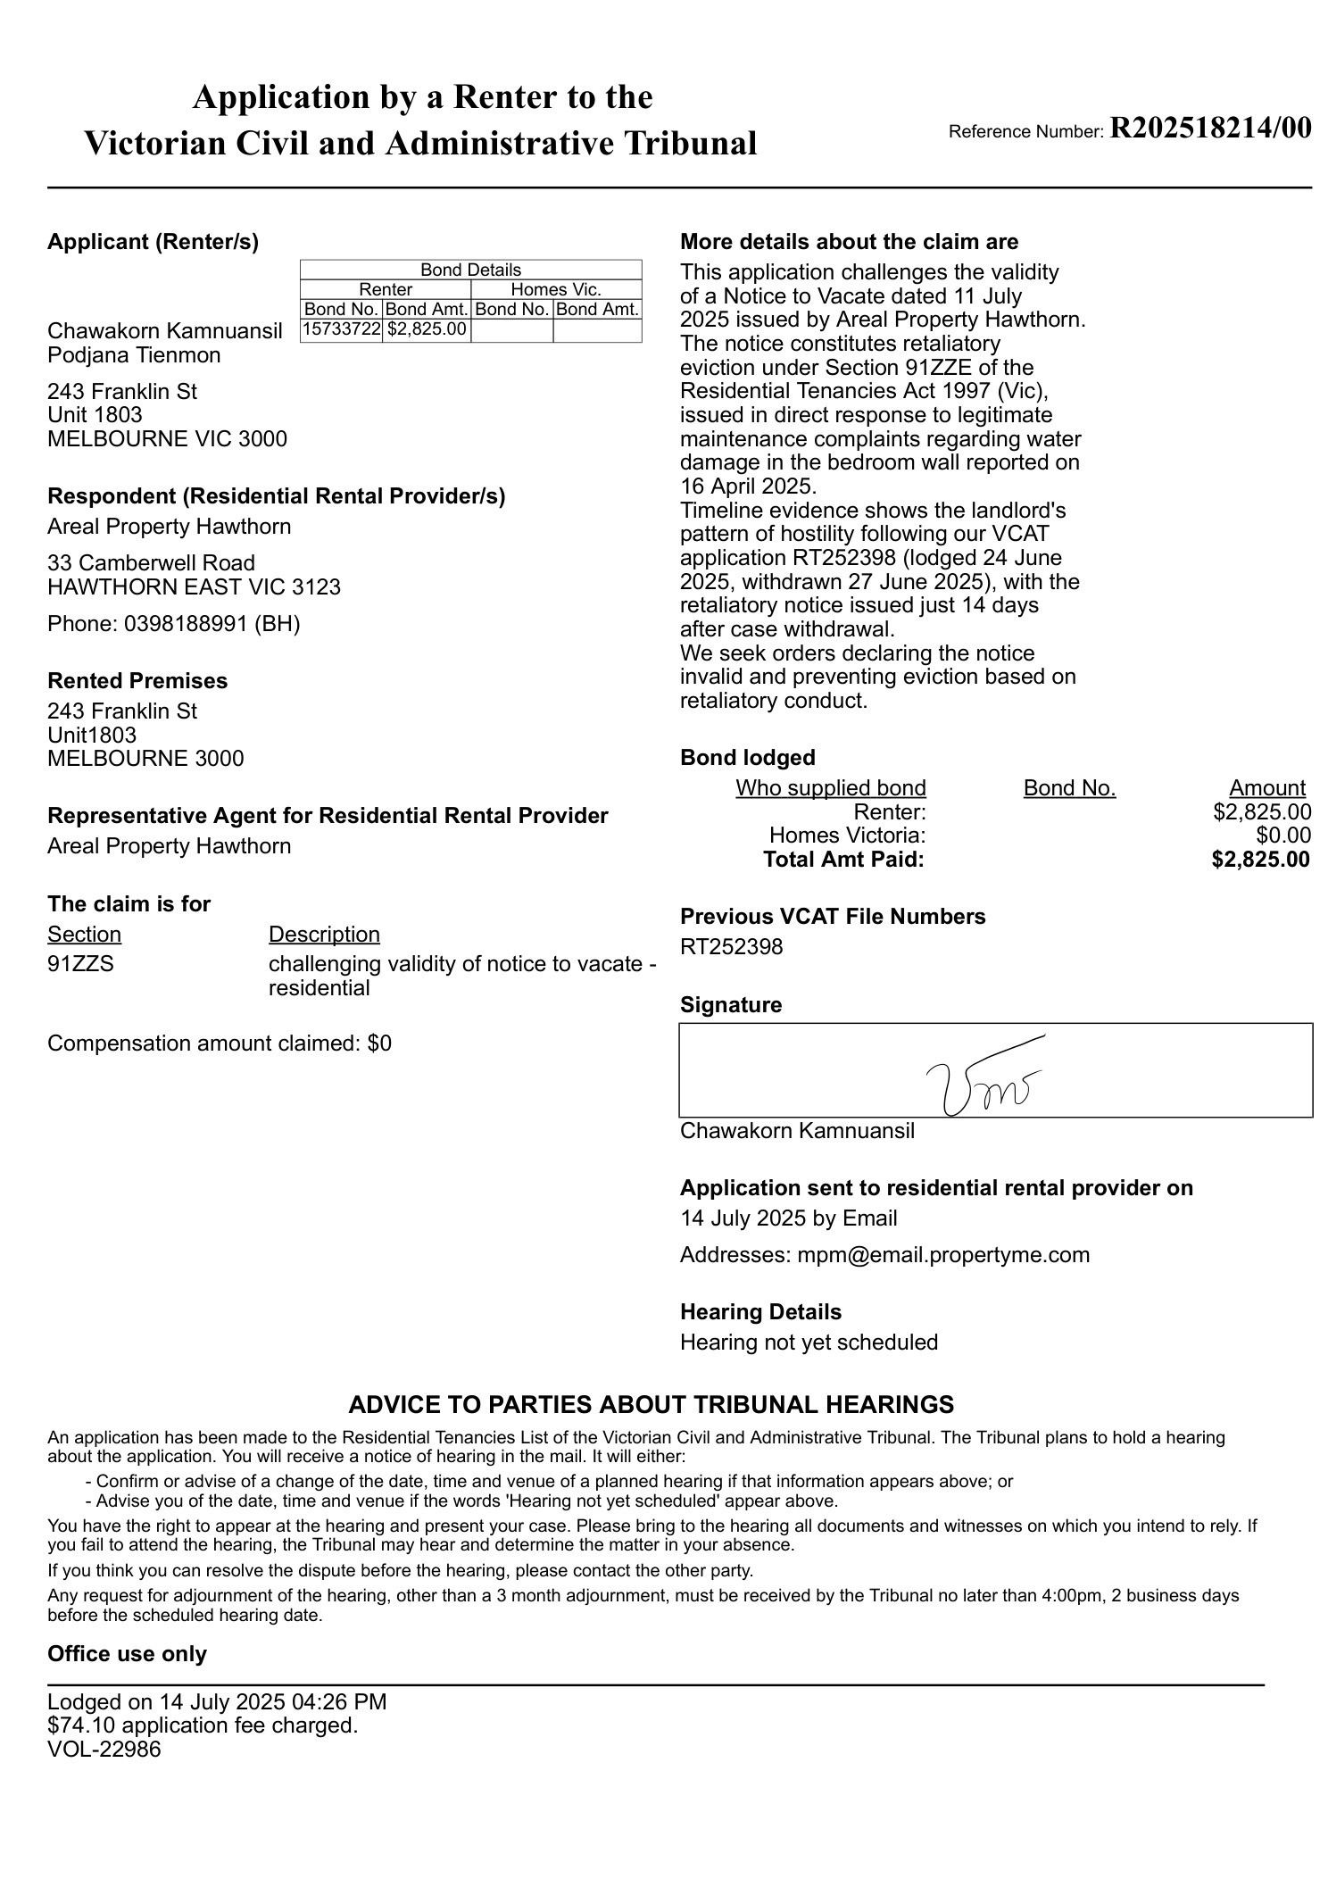
2. NOTICE TO VACATE U1803 243 FRANKLIN ST.pdf
NOTICE TO VACATE U1803 243 FRANKLIN ST.pdf — Page 1/3 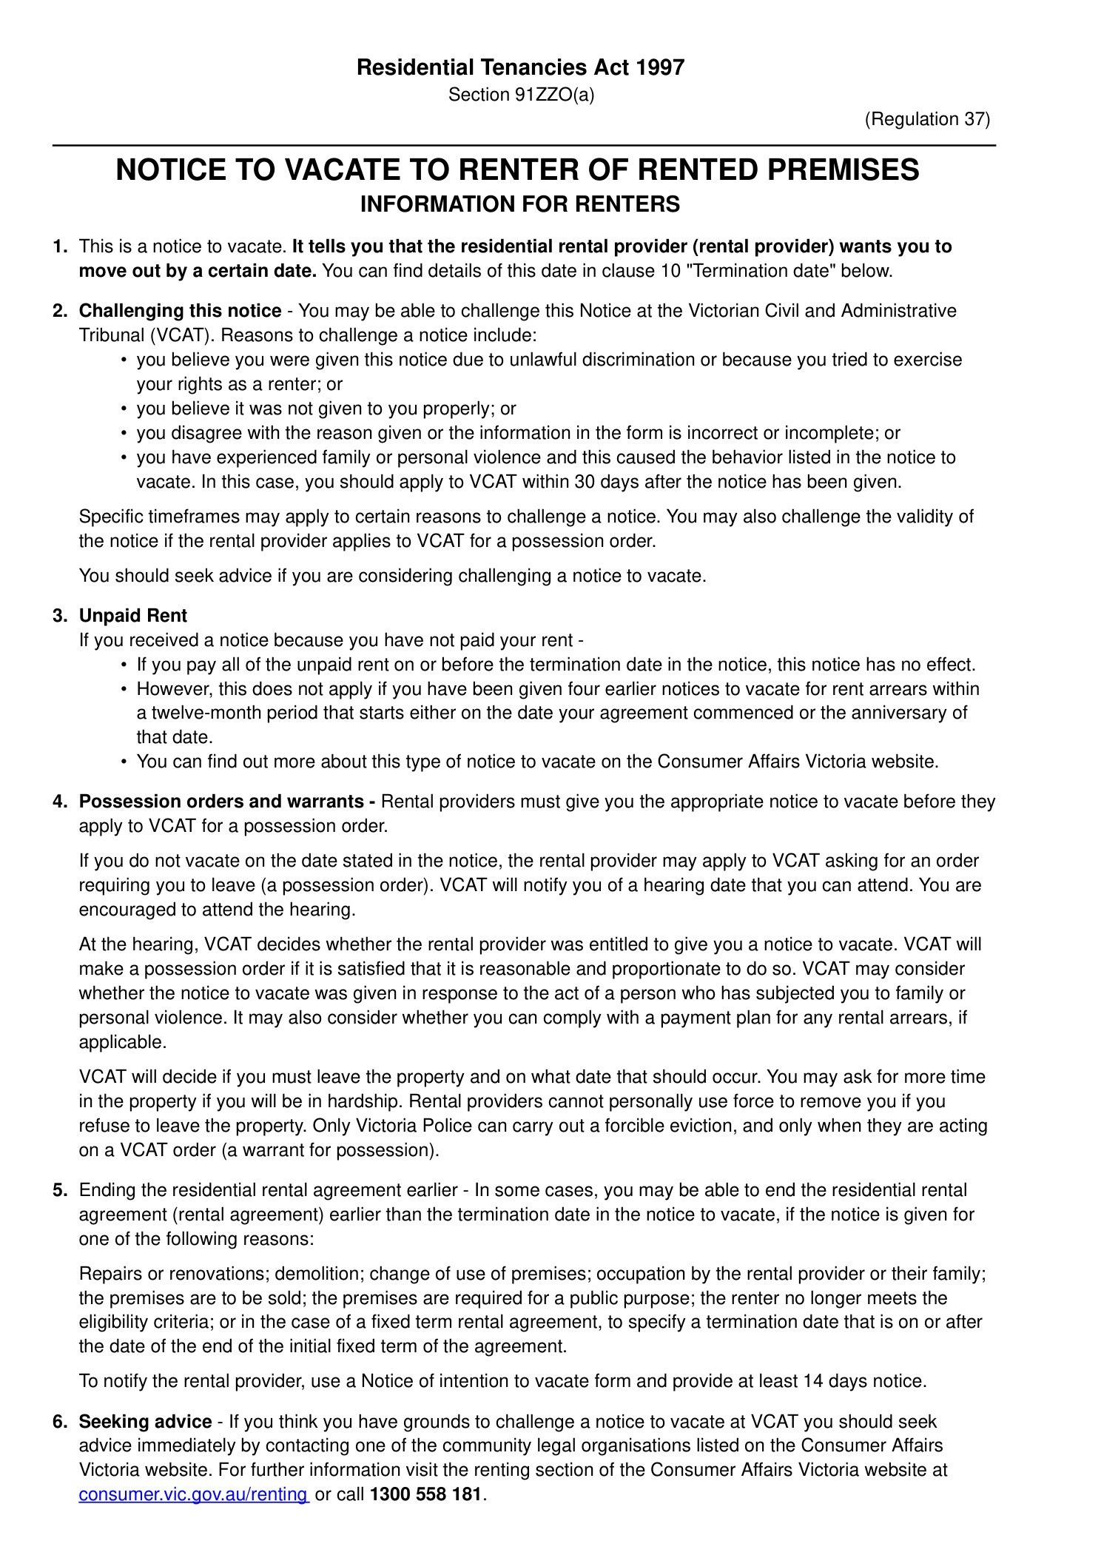 NOTICE TO VACATE U1803 243 FRANKLIN ST.pdf — Page 2/3 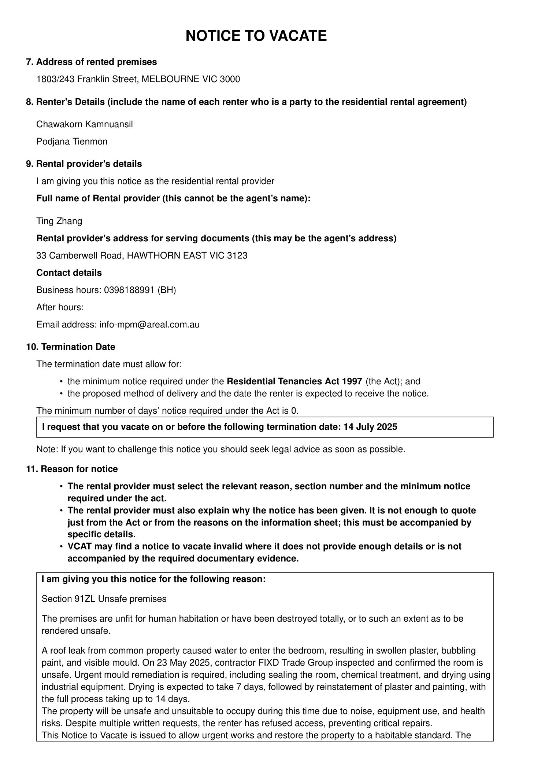 NOTICE TO VACATE U1803 243 FRANKLIN ST.pdf — Page 3/3 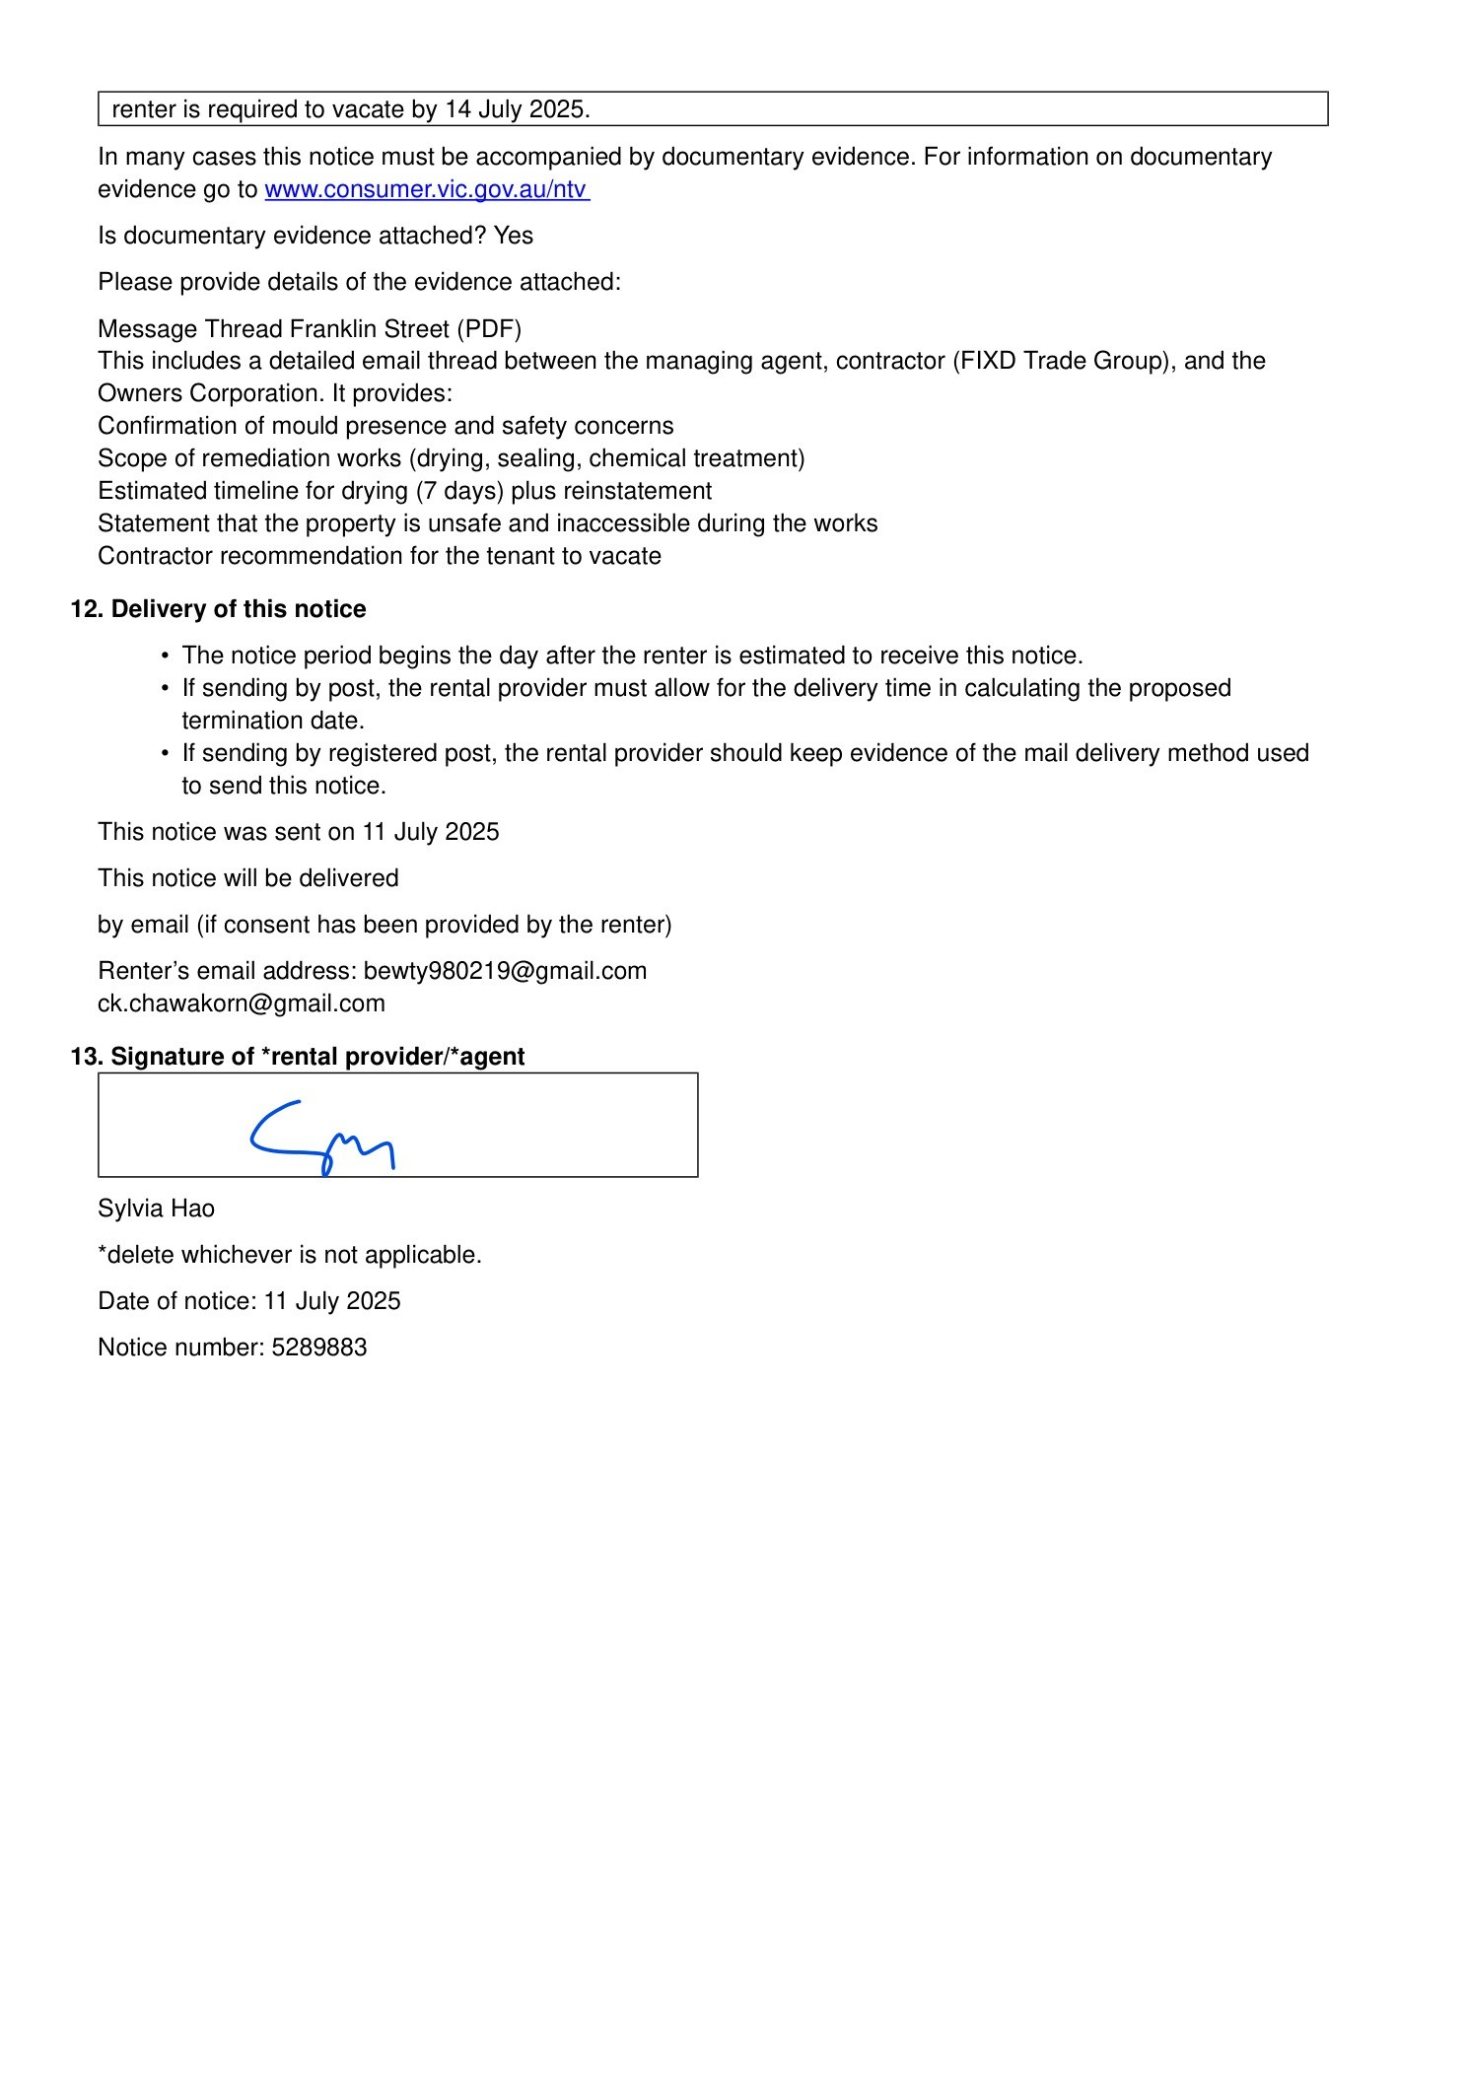

Message 2
Type | FWD
Sort Date | 2025-07-15 18:28
Header Date | 15/07/2025 18:28 AEST
Header Subject | Fwd: VCAT Application R202518214/00 – Challenge to Notice to Vacate
Source .doc | 250715_-_Fwd__VCAT_Application_R202518214_00___Challenge_to_Notice_to_Vacate_.doc

Subject | Fwd: VCAT Application R202518214/00 – Challenge to Notice to Vacate
From | Chawakorn Kamnuansil <ck.chawakorn@gmail.com>
Date | 15/07/2025 18:28 AEST
To | renting@courts.vic.gov.au

- _250715_ck.chawakorn@gmail.com_Fwd__VCAT_Application_R202518214_00___Challenge_to_Notice_to_Vacate-277/VCAT Application R202518214:00 – Notice to Vacate Challenge.pdf
- _250715_ck.chawakorn@gmail.com_Fwd__VCAT_Application_R202518214_00___Challenge_to_Notice_to_Vacate-277/NOTICE TO VACATE U1803 243 FRANKLIN ST.pdf

Attachment Thumbnails
1. VCAT Application R202518214:00 – Notice to Vacate Challenge.pdf
VCAT Application R202518214:00 – Notice to Vacate Challenge.pdf — Page 1/1
2. NOTICE TO VACATE U1803 243 FRANKLIN ST.pdf
NOTICE TO VACATE U1803 243 FRANKLIN ST.pdf — Page 1/3 NOTICE TO VACATE U1803 243 FRANKLIN ST.pdf — Page 2/3 NOTICE TO VACATE U1803 243 FRANKLIN ST.pdf — Page 3/3

Message 3
Type | RE
Sort Date | 2025-07-22 15:56
Header Date | 22/07/2025 15:56 AEST
Header Subject | Re: VCAT Application R202518214/00 – Challenge to Notice to Vacate
Source .doc | 250722_-_Re_VCAT_Application_R202518214_00___Challenge_to_Notice_to_Vacate_.doc

Subject | Re: VCAT Application R202518214/00 – Challenge to Notice to Vacate
From | "Sylvia Hao - Areal Property Hawthorn (MPM)" <MPM@email.propertyme.com>
Date | 22/07/2025 15:56 AEST
To | Chawakorn Kamnuansil <ck.chawakorn@gmail.com>, bewty980219@gmail.com
Cc | mpm@email.propertyme.com

Dear Chawakorn Kamnuansil and Podjana Tienmon,
I hope you are both well.
Please find attached a copy of the VCAT order dated 21 July 2025 (Ref: R2025/18214/00) regarding your recent application.
As noted in the order, the Tribunal has suggested that if both parties can agree, a temporary relocation for approximately 14 days would allow the necessary repairs to be carried out at the property. Following the completion of these works, you would be able to return and resume your tenancy.
In line with this recommendation, we would like to offer you the opportunity to temporarily vacate the property for a 14-day period so repairs can proceed without delay. We are happy to coordinate dates and details with you to minimise disruption.
Please let us know your availability or any questions you may have.
Kind regards,
Sylvia Hao
Relationship Manager

M 0420 675 561
P 03 9818 8991
A 33 Camberwell Road, Hawthorn East VIC 3123



If you have any feedback regarding my service, please feel free to contact my manager.
Jamie Ong (Head of Property Management) jamie.ong@areal.com.au

DISCLAIMER & WARNING. This correspondence and the information contained in this and associated e-mails are confidential and were only intended for the exclusive use of the addressee(s). If you have received this e-mail in error, any use, copying or inference with this information is unauthorized and prohibited and please immediately delete it and any related attachments or emails from your system and its related sub system and notify the sender. You must never copy, disclose, make conclusions and other information in this message that do not relate to the business of the Areal Property and shall be understood as neither given nor approved or agreed by it. Although Areal Property has taken reasonable precautions to ensure no viruses are present in this e-mail, Areal Property cannot accept responsibility for any loss or damage arising from the use of this e-mail or attachments.

Click to unsubscribe from future email communication

- _250722_MPM@email.propertyme.com_Re_VCAT_Application_R202518214_00___Challenge_to_Notice_to_Vacate-287/order_194615752283.pdf

Attachment Thumbnails
1. order_194615752283.pdf
order_194615752283.pdf — Page 1/1 