Notice to vacate - 1803/243 Franklin Street, Melbourne VIC 3000
Messages: 1

Message 1
Type | ORIG
Sort Date | 2025-07-11 17:12
Header Date | 11/07/2025 17:12 AEST
Header Subject | Notice to vacate - 1803/243 Franklin Street, Melbourne VIC 3000
Source .doc | 250711_-_Notice_to_vacate_-_1803_243_Franklin_Street__Melbourne_VIC_3000_.doc

Subject | Notice to vacate - 1803/243 Franklin Street, Melbourne VIC 3000
From | "Sylvia Hao - Areal Property Hawthorn (MPM)" <MPM@email.propertyme.com>
Date | 11/07/2025 17:12 AEST
To | Chawakorn Kamnuansil <ck.chawakorn@gmail.com>
Cc | mpm@email.propertyme.com

Dear Chawakorn
I am writing to inform you that the owner of your rental property has directed us to issue the attached notice. This serves as an official notification to vacate the premises located at 1803/243 Franklin Street, Melbourne VIC 3000
Notice Details:
- Reason for Notice: Unsafe premises
- Required Vacate Date: 14 July 2025
Shortly, you will receive a separate email from us with comprehensive instructions regarding vacating the property, finalising payments, and key return procedures.
Should you have any questions or need any further clarification regarding this notice, please don't hesitate to contact me. Your cooperation and acknowledgment of this notice are greatly appreciated.
We are here to support you through this transition and ensure that the process is as smooth and amicable as possible.
Kind Regards,
Sylvia Hao
Relationship Manager
sylvia.hao@areal.com.au
0420 675 561

If you have any feedback regarding my service, please feel free to contact my manager.
Jamie Ong (Head of Property Management) jamie.ong@areal.com.au

DISCLAIMER & WARNING. This correspondence and the information contained in this and associated e-mails are confidential and were only intended for the exclusive use of the addressee(s). If you have received this e-mail in error, any use, copying or inference with this information is unauthorized and prohibited and please immediately delete it and any related attachments or emails from your system and its related sub system and notify the sender. You must never copy, disclose, make conclusions and other information in this message that do not relate to the business of the Areal Property and shall be understood as neither given nor approved or agreed by it. Although Areal Property has taken reasonable precautions to ensure no viruses are present in this e-mail, Areal Property cannot accept responsibility for any loss or damage arising from the use of this e-mail or attachments.

Click to unsubscribe from future email communication

- _250711_MPM@email.propertyme.com_Notice_to_vacate_-_1803_243_Franklin_Street__Melbourne_VIC_3000-269/NOTICE TO VACATE U1803 243 FRANKLIN ST.pdf
- _250711_MPM@email.propertyme.com_Notice_to_vacate_-_1803_243_Franklin_Street__Melbourne_VIC_3000-269/Message Thread Franklin Stpdf.pdf

Attachment Thumbnails
1. NOTICE TO VACATE U1803 243 FRANKLIN ST.pdf
NOTICE TO VACATE U1803 243 FRANKLIN ST.pdf — Page 1/3 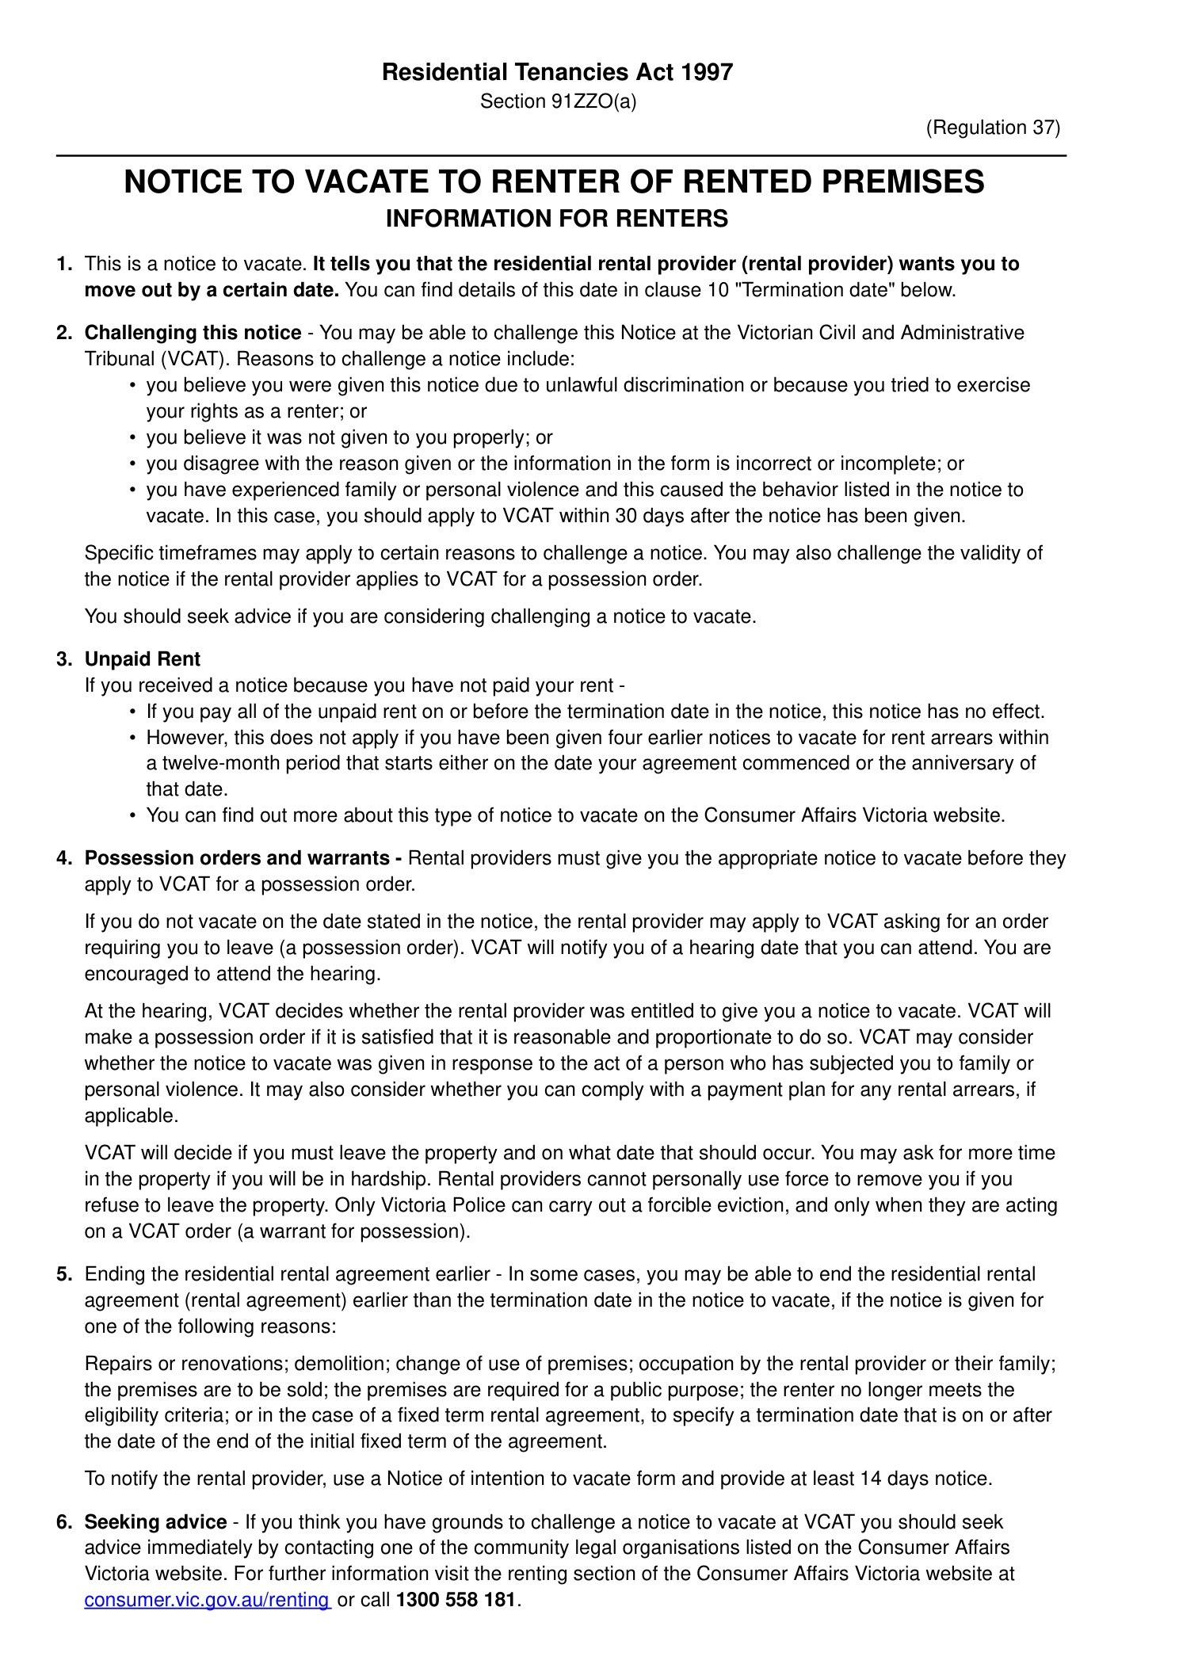 NOTICE TO VACATE U1803 243 FRANKLIN ST.pdf — Page 2/3 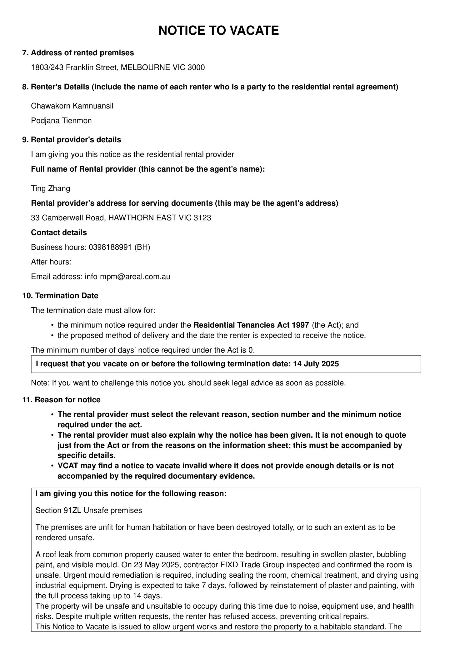 NOTICE TO VACATE U1803 243 FRANKLIN ST.pdf — Page 3/3 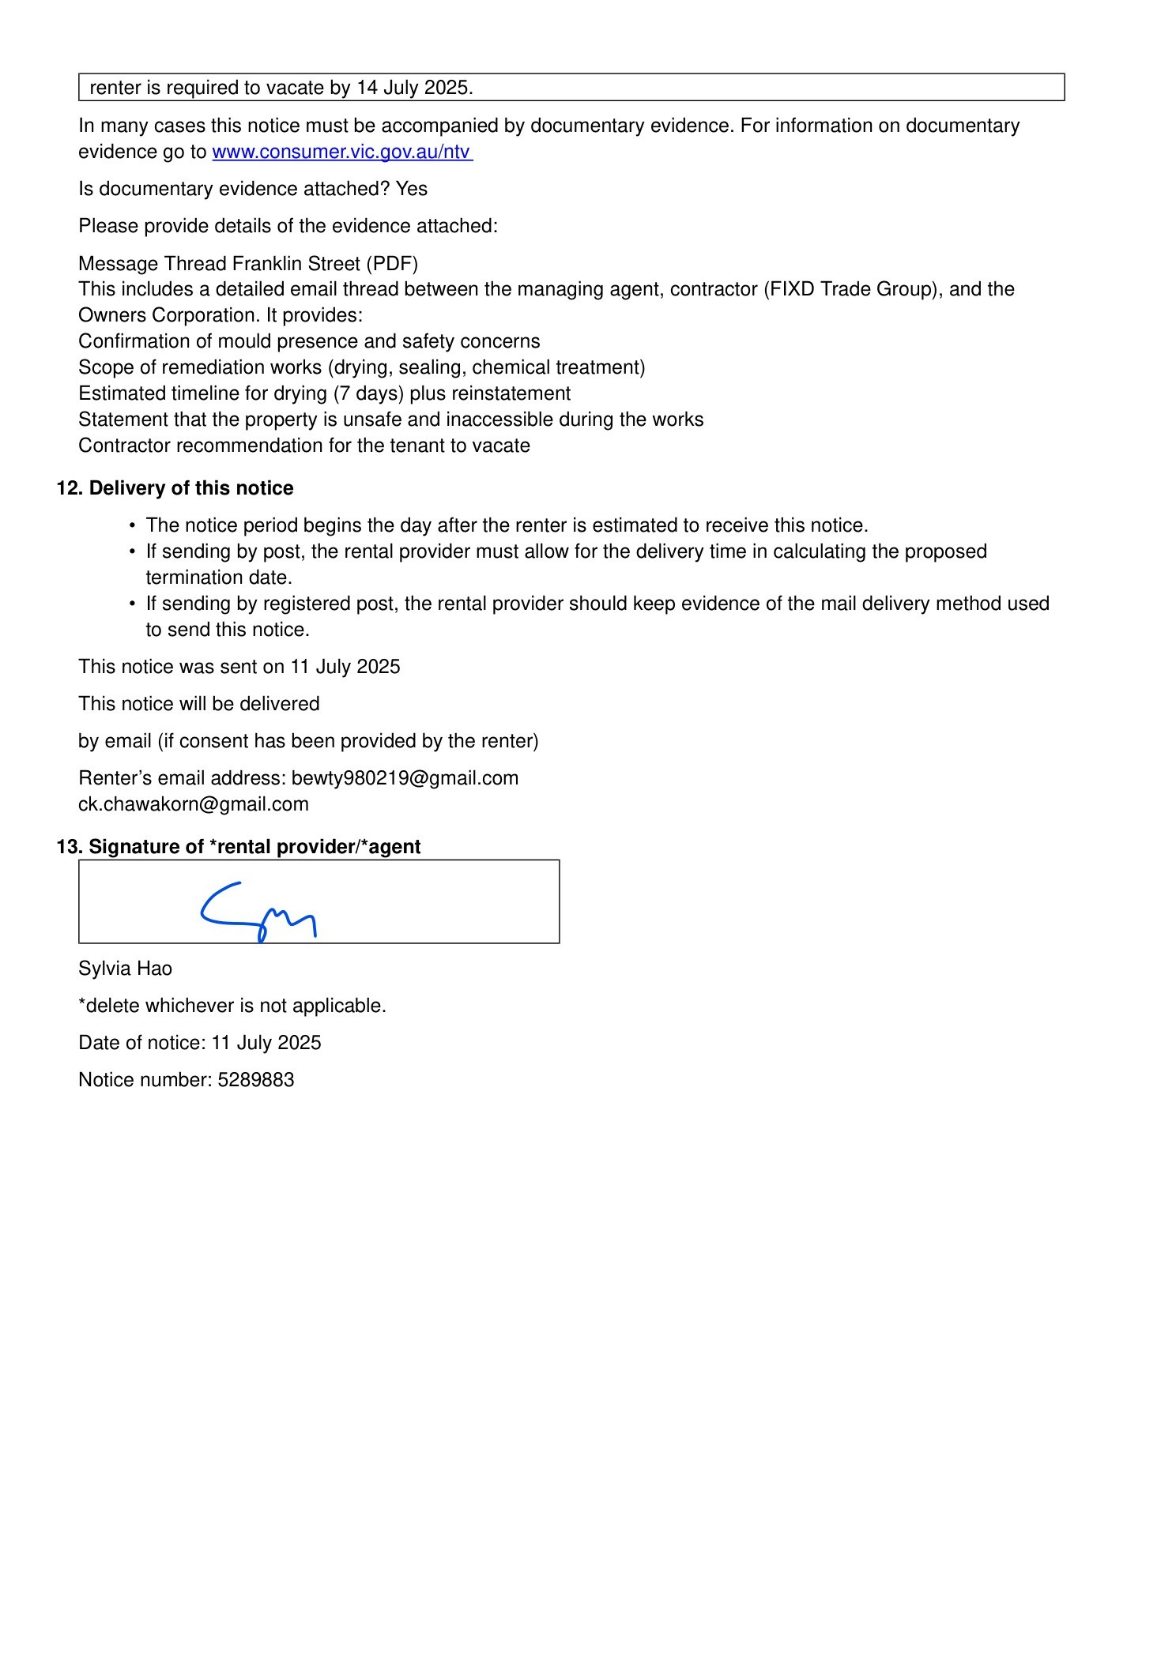
2. Message Thread Franklin Stpdf.pdf
Message Thread Franklin Stpdf.pdf — Page 1/4 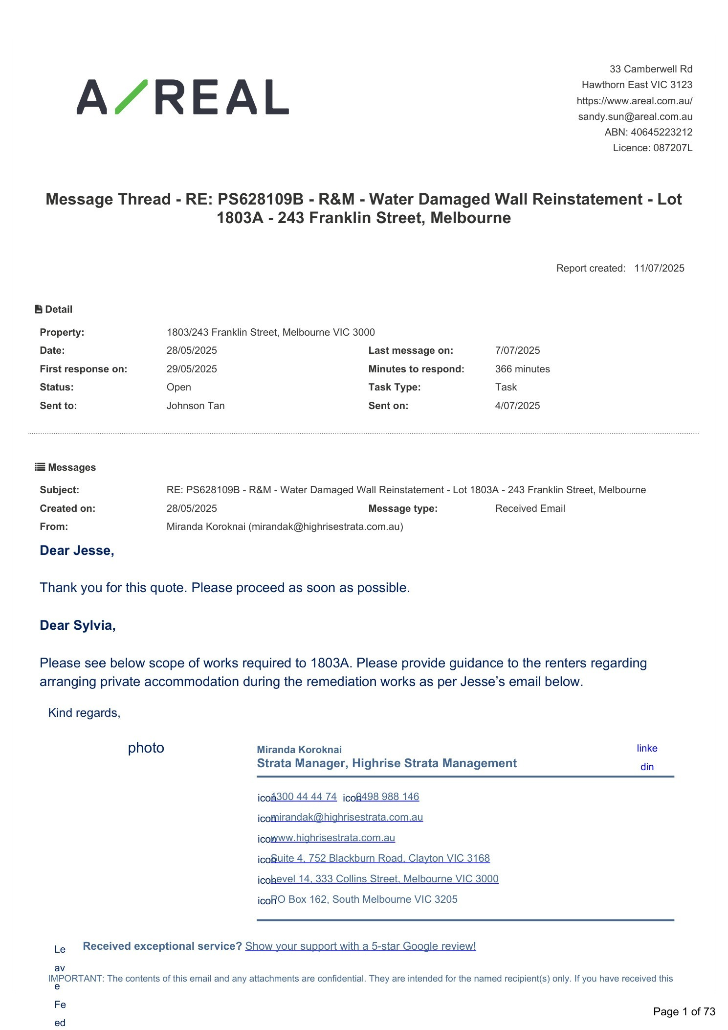 Message Thread Franklin Stpdf.pdf — Page 2/4 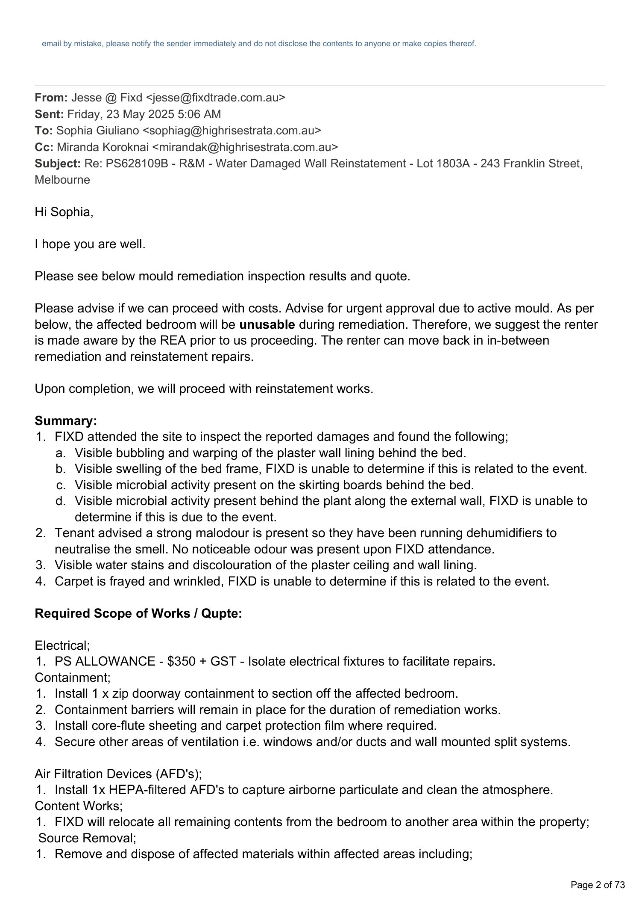 Message Thread Franklin Stpdf.pdf — Page 3/4 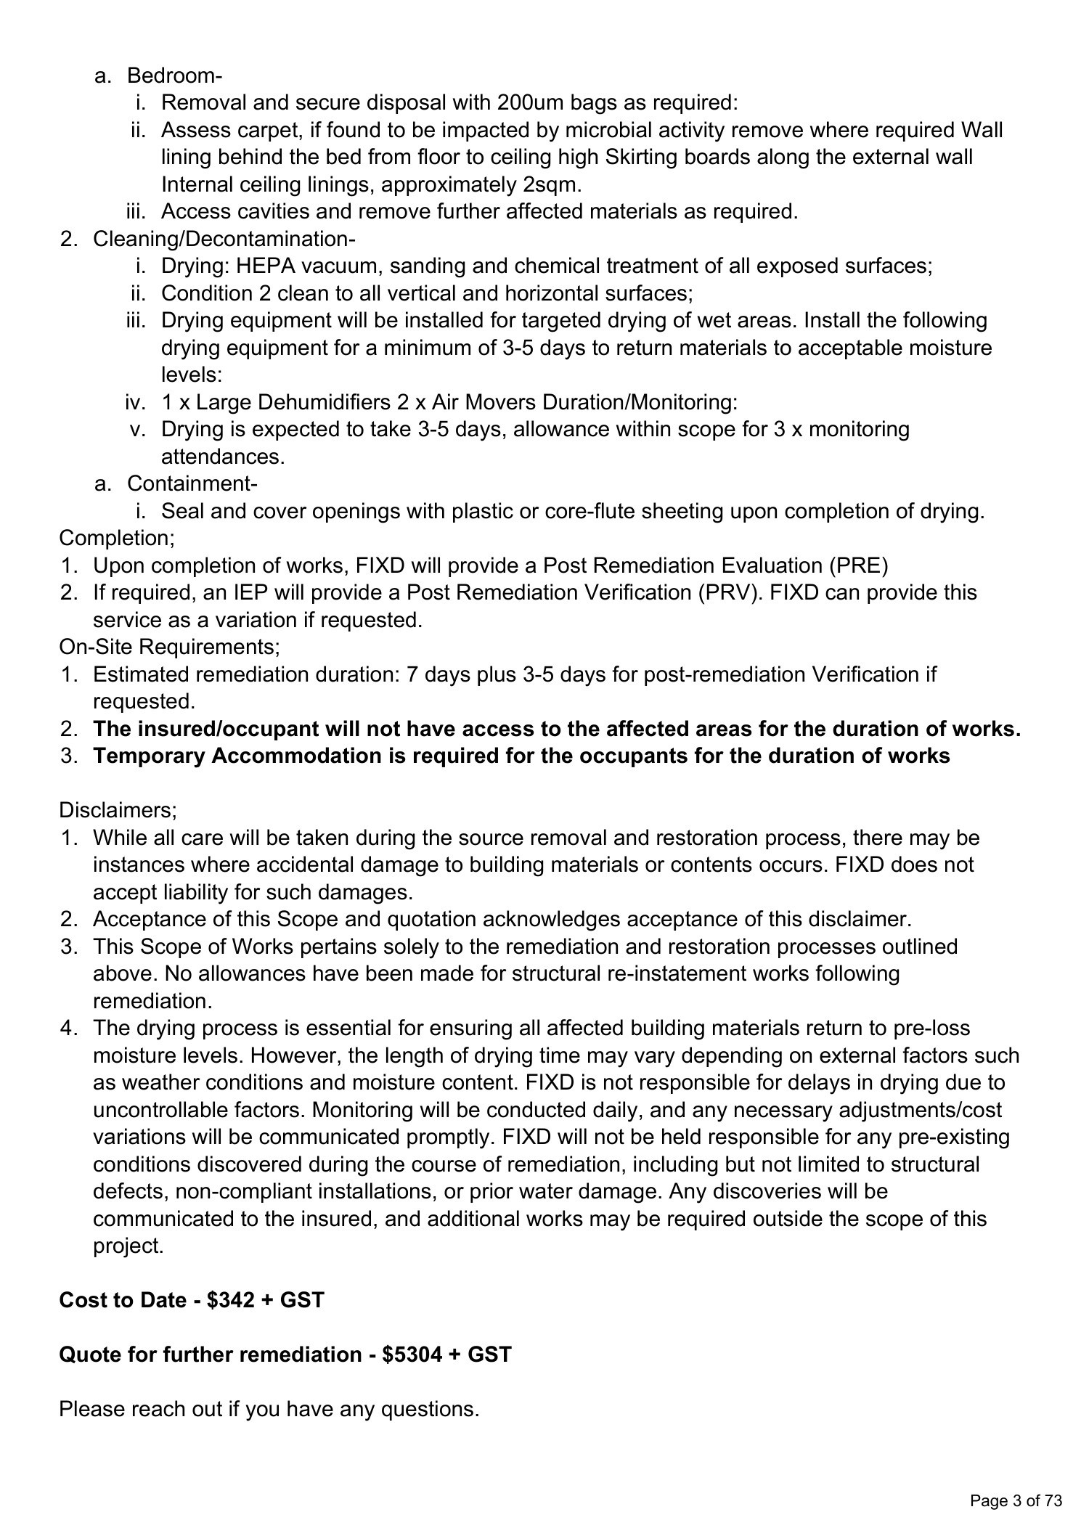 Message Thread Franklin Stpdf.pdf — Page 4/4 