Without Prejudice — Franklin 1803: Settlement Terms (VCAT R2025/18589/00)
Messages: 2

Message 1
Type | ORIG
Sort Date | 2025-08-17 17:11
Header Date | 17/08/2025 17:11 AEST
Header Subject | Without Prejudice — Franklin 1803: Settlement Terms (VCAT R2025/18589/00)
Source .doc | 250817_-__Without_Prejudice___Franklin_1803__Settlement_Terms__VCAT_R2025_18589_00__.doc

Subject | Without Prejudice — Franklin 1803: Settlement Terms (VCAT R2025/18589/00)
From | Chawakorn Kamnuansil <ck.chawakorn@gmail.com>
Date | 17/08/2025 17:11 AEST
To | jamie.ong@areal.com.au

Without Prejudice · Subject to Contract · Save as to Costs
Please confirm acceptance by: 23 August 2025, 17:00 AEST
On acceptance, I will request a VCAT consent order.
Dear Jamie Ong,
VCAT has dismissed the possession application in R202518589/00. I propose the following to conclude this matter efficiently.
Proposed Terms
- Compensation: AUD 10,000 lump sum, payable by bank transfer (details on acceptance).
- Rent freeze: Rent fixed at $2,825/month for 24 months from the acceptance date.
- File management and internal actions:
  - Within 7 days of acceptance, confirm in writing that:
  - Sylvia Hao and Johnson Tan will no longer be involved.
  - Appropriate internal actions have been taken.
  - Documentary confirmation will be provided.
- Bond: Maintain/return in full with no deductions.
- Authority & escalation: See Leverage & Enforcement for authority and escalation requirements.
Leverage & Enforcement
- Time of the essence: Offer expires 23 August 2025, 17:00 AEST.
- Without prejudice — save as to costs: This correspondence may be relied upon as to costs.
- Authority warranty: The signatory warrants authority to bind the agency and rental provider. If authority is limited, escalate to the OIEC/Principal and confirm within 7 days.
- No re-filing: Following acceptance, no further possession action will be taken on the same facts or grounds as R202518589/00.
- Non-retaliation & file controls: No adverse action against the renters. Sylvia Hao and Johnson Tan are removed from any involvement. Confirm file annotations and handover.
- Default consequences: If the deadline passes without acceptance, I will proceed with: (i) a VCAT compensation application with costs and statutory penalty interest under the Penalty Interest Rates Act 1983 (Vic) at the applicable rate, (ii) a complaint to Consumer Affairs Victoria (EARS) and the Business Licensing Authority, and (iii) where applicable, a complaint to the Victorian Ombudsman.
- Confidentiality: Settlement terms to be recorded in a VCAT consent order or deed; confidentiality to the extent permitted by law.
If accepted, these terms will constitute a full and final settlement of the issues raised to date. I will ask VCAT to issue a consent order or strike out the case with a right to apply for reinstatement to ensure enforceability.
Financial Breakdown
Rent reduction baseline: 30% × $2,825 × ~4 months (16 Apr–14 Aug = 120 days) = $3,390.00
VCAT fee paid: $74.10
Post-order rolling abatement (from 15 Aug): $27.85/day* until repair completion & handover
*Calculation: (2,825 × 12 × 30%) / 365 ≈ $27.85/day.
Payment On acceptance, request my EFT details by emailing ck.chawakorn@gmail.com. Cheque or PayID is also acceptable.
Acceptance Instructions
- Email subject: ACCEPTED — Franklin 1803 Settlement
- Body: “Accepted as proposed. Please provide EFT details.”
- Target transfer date: within 3 business days of acceptance.
This proposal is made on a commercial basis, without admission of liability by either party, and is without prejudice and subject to contract.
Reference: Attachment C — Johnson email, 9 Jul 2025.
I am keen to continue the tenancy on a positive footing.
Kind regards,
Chawakorn Kamnuansil Tenant — Unit 1803/243 Franklin St, Melbourne 3000 VCAT Case Ref: R202518589/00 Email: ck.chawakorn@gmail.com
Attachments
- VCAT Order (14 Aug 2025 – possession dismissed)
- Notice to Vacate (11 Jul 2025)
- Attachment C — Johnson email (9 Jul 2025)
- MBOX archive of communications (mbox)
mbox

- _250817_ck.chawakorn@gmail.com__Without_Prejudice___Franklin_1803__Settlement_Terms__VCAT_R2025_18589_00_-292/Screenshot 2025-08-17 at 04.24.45.png
- _250817_ck.chawakorn@gmail.com__Without_Prejudice___Franklin_1803__Settlement_Terms__VCAT_R2025_18589_00_-292/order_194930558979.pdf (SECURED).pdf
- _250817_ck.chawakorn@gmail.com__Without_Prejudice___Franklin_1803__Settlement_Terms__VCAT_R2025_18589_00_-292/NOTICE TO VACATE U1803 243 FRANKLIN ST.pdf
- _250817_ck.chawakorn@gmail.com__Without_Prejudice___Franklin_1803__Settlement_Terms__VCAT_R2025_18589_00_-292/Notice to vacate - 1803:243 Franklin Street, Melbourne VIC 3000.pdf

Attachment Thumbnails
1. Screenshot 2025-08-17 at 04.24.45.png
Screenshot 2025-08-17 at 04.24.45.png — Page 1/1 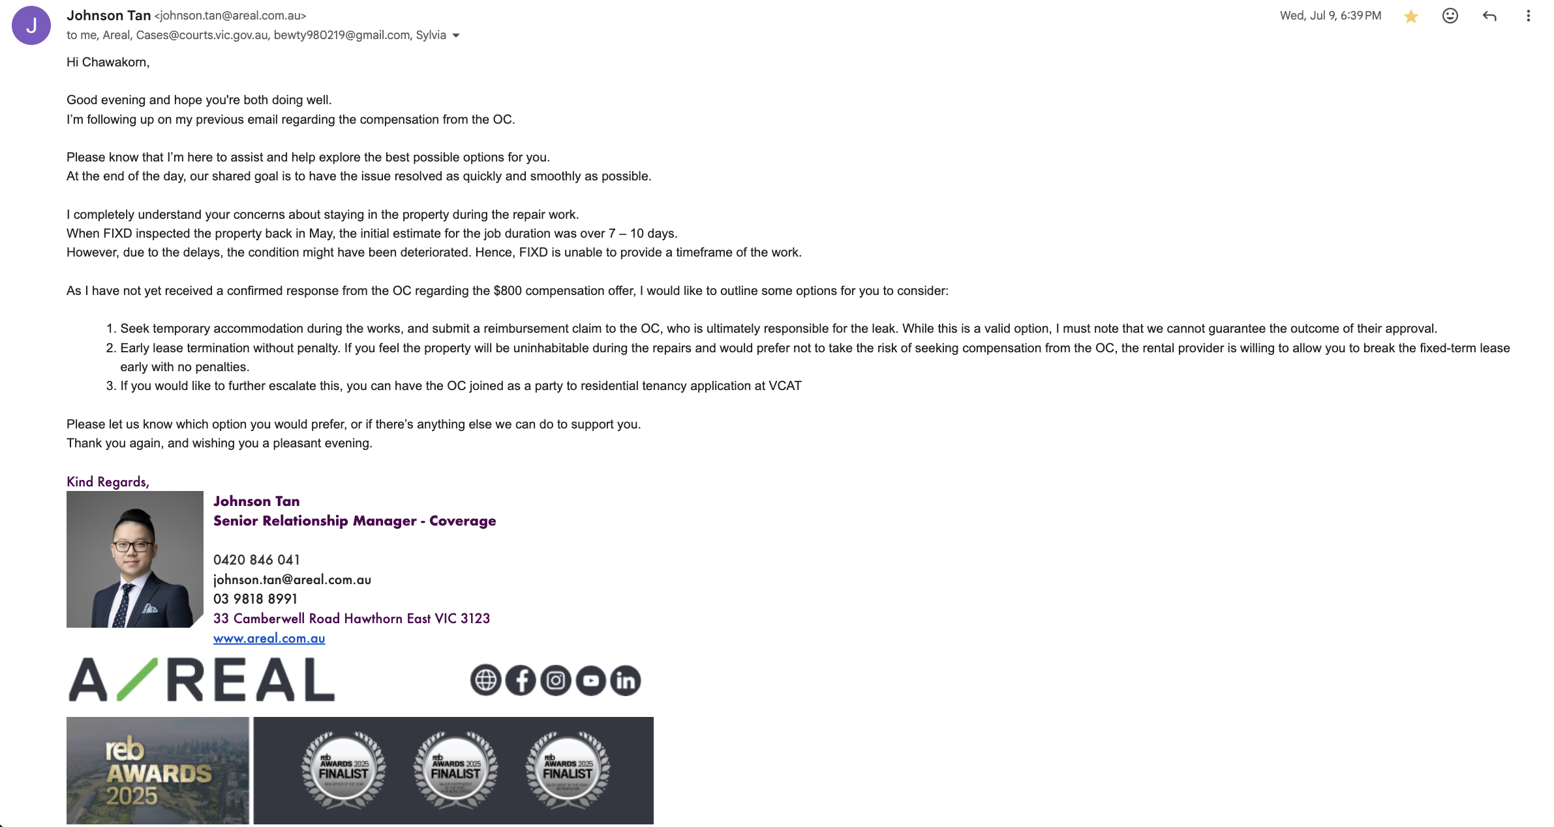
2. order_194930558979.pdf (SECURED).pdf
order_194930558979.pdf (SECURED).pdf — Page 1/1 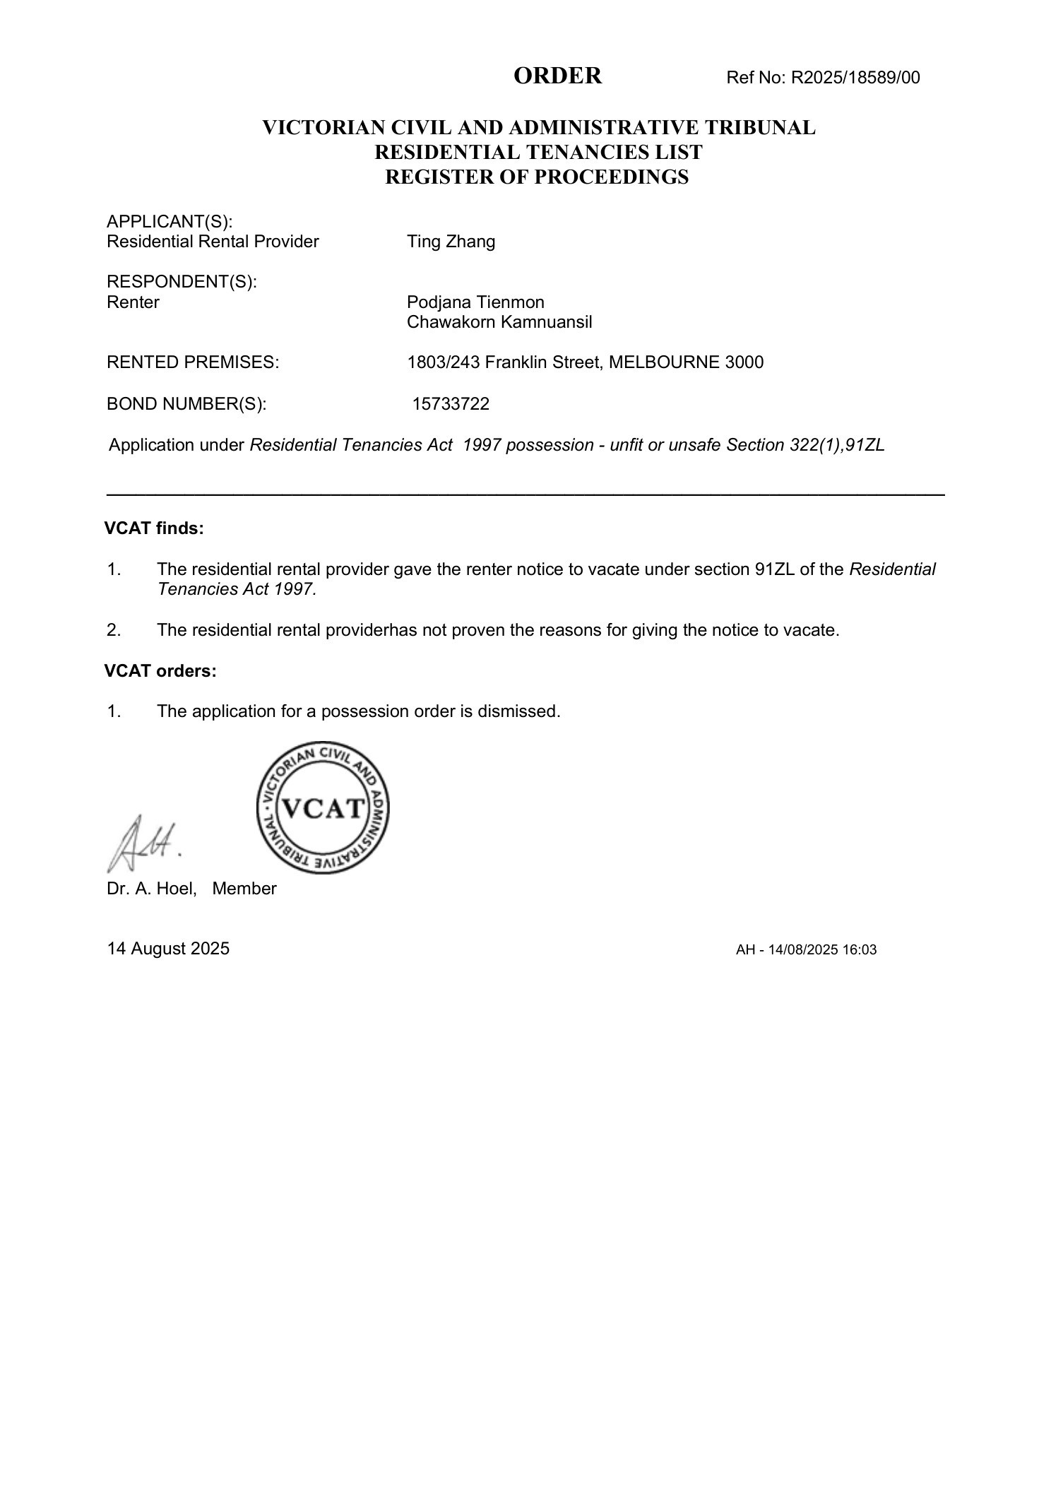
3. NOTICE TO VACATE U1803 243 FRANKLIN ST.pdf
NOTICE TO VACATE U1803 243 FRANKLIN ST.pdf — Page 1/3 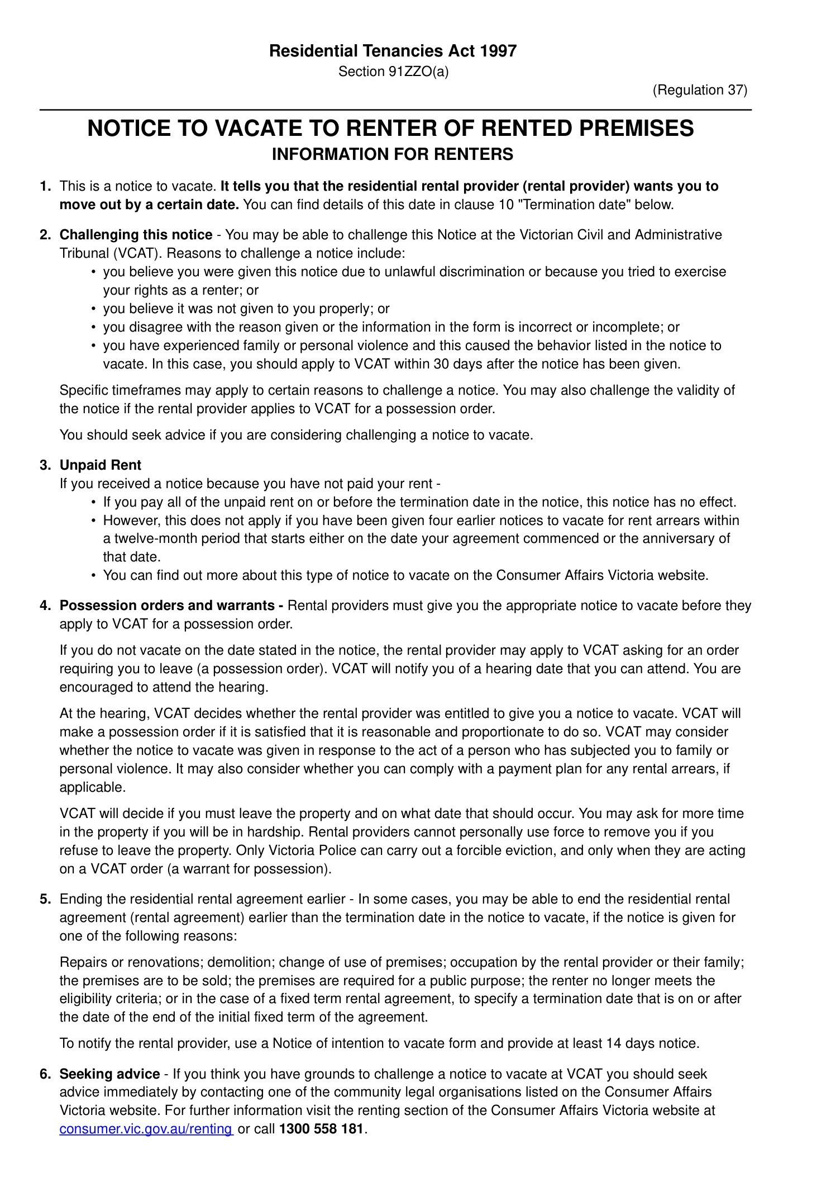 NOTICE TO VACATE U1803 243 FRANKLIN ST.pdf — Page 2/3 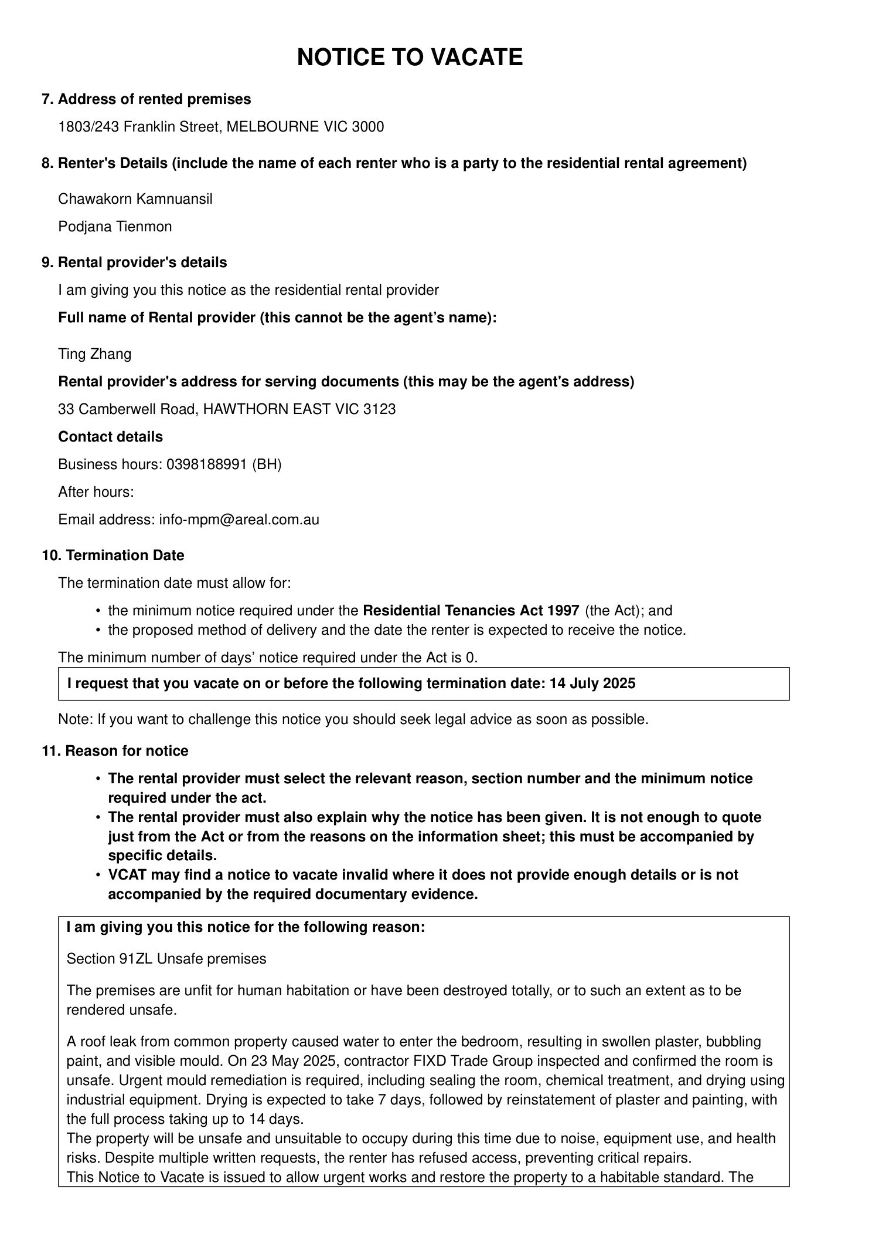 NOTICE TO VACATE U1803 243 FRANKLIN ST.pdf — Page 3/3 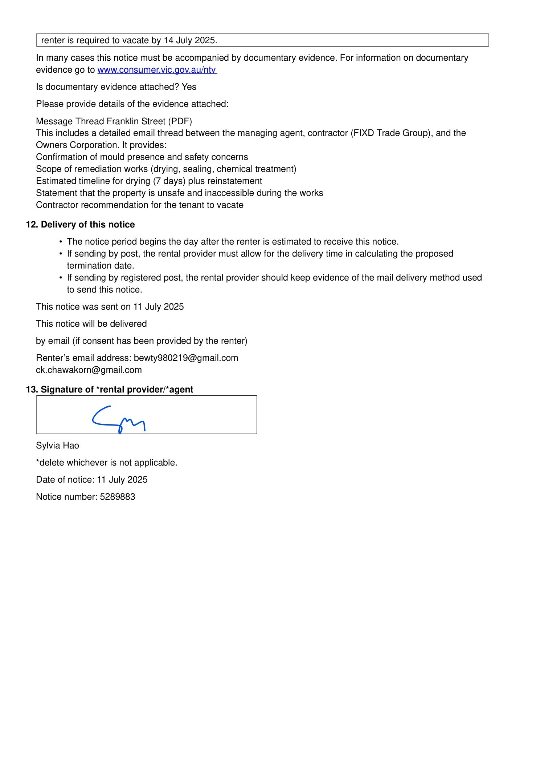
4. Notice to vacate - 1803:243 Franklin Street, Melbourne VIC 3000.pdf
Notice to vacate - 1803:243 Franklin Street, Melbourne VIC 3000.pdf — Page 1/2 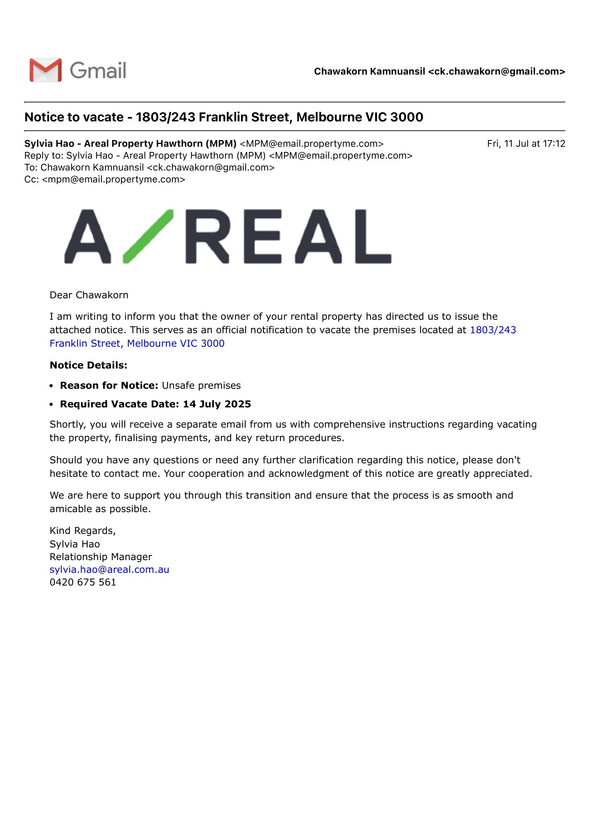 Notice to vacate - 1803:243 Franklin Street, Melbourne VIC 3000.pdf — Page 2/2 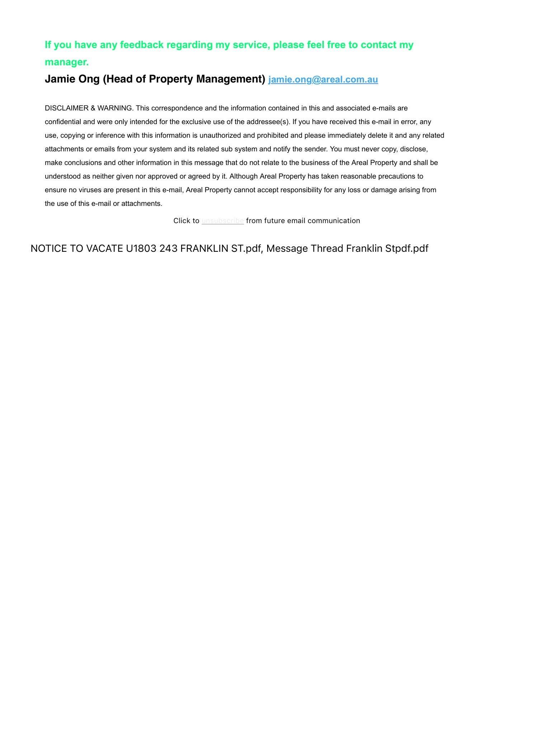

Message 2
Type | RE
Sort Date | 2025-08-19 15:19
Header Date | 19/08/2025 15:19 AEST
Header Subject | RE: Without Prejudice — Franklin 1803: Settlement Terms (VCAT R2025/18589/00)
Source .doc | 250819_-_Re_Without_Prejudice___Franklin_1803__Settlement_Terms__VCAT_R2025_18589_00__.doc

Subject | RE: Without Prejudice — Franklin 1803: Settlement Terms (VCAT R2025/18589/00)
From | Jamie Ong <jamie.ong@areal.com.au>
Date | 19/08/2025 15:19 AEST
To | Chawakorn Kamnuansil <ck.chawakorn@gmail.com>

Dear Chawakorn,

Thank you for your recent email. I understand this has been a frustrating and challenging situation, and I appreciate you taking the time to outline your position.

The damage to the bedroom has resulted from a leak originating from common property. Responsibility for repairing both the source of the leak and the resultant damage lies with the party responsible — in this case, the Owners Corporation. They have taken steps to arrange the necessary works and have offered $800 in compensation to reflect the inconvenience caused to date.

Despite multiple written requests and the issuing of a formal Notice of Entry, access to the property has not yet been provided. We understand you may have concerns, but the works are essential, and the Owners Corporation has been actively trying to resolve the issue. We are currently waiting on a revised date from their trades. Once confirmed, a new Notice of Entry will be issued. On that date, both the agent and trades will attend to carry out the works. If access is again refused, we will proceed with an application to VCAT for a compliance order.

Our preference is to cooperate with you to ensure the repairs can proceed on the earliest available date. The sooner access is granted, the sooner this matter can be resolved.

We remain open to working with you constructively. During the VCAT hearing, the Tribunal member noted that staying in the second bedroom or the lounge room during the repair period would be a reasonable short-term arrangement. While we understand the second bedroom is currently occupied by the other tenant and this may not be ideal, it remains a temporary option to consider. If that arrangement isn’t workable, the option to end the lease early without penalty remains available.

In regard to your proposal, we do not agree to the requested $10,000 lump sum or a 24-month rent freeze. These terms are not proportionate, particularly given that access for repairs has not yet been provided. Any future compensation claim would also be assessed in light of whether reasonable steps were taken to mitigate loss. In this case, the matter could have been resolved some time ago had access been granted.

We’ll be in touch again once the repair date is confirmed. In the meantime, we ask that you confirm your willingness to allow access on the upcoming date, so the matter can be finalised without further escalation.

Kind Regards,

 | Jamie Ong  Head of Property Management  0492 801 841  jamie.ong@areal.com.au  03 9818 8991  33 Camberwell Road Hawthorn East VIC 3123  www.areal.com.au

 | 


DISCLAIMER & WARNING. This correspondence and the information contained in this and associated e-mails are confidential and were only intended for the exclusive use of the addressee(s). If you have received this e-mail in error, any use, copying or inference with this information is unauthorized and prohibited and please immediately delete it and any related attachments or emails from your system and its related sub system and notify the sender. You must never copy, disclose, make conclusions and other information in this message that do not relate to the business of the Areal Property and shall be understood as neither given nor approved or agreed by it. Although Areal Property has taken reasonable precautions to ensure no viruses are present in this e-mail, Areal Property cannot accept responsibility for any loss or damage arising from the use of this e-mail or attachments.

From: Chawakorn Kamnuansil <ck.chawakorn@gmail.com>
Sent: Sunday, 17 August 2025 5:11 PM
To: Jamie Ong <jamie.ong@areal.com.au>
Subject: Without Prejudice — Franklin 1803: Settlement Terms (VCAT R2025/18589/00)

Without Prejudice · Subject to Contract · Save as to Costs
Please confirm acceptance by: 23 August 2025, 17:00 AEST
On acceptance, I will request a VCAT consent order.
Dear Jamie Ong,
VCAT has dismissed the possession application in R202518589/00. I propose the following to conclude this matter efficiently.
Proposed Terms
- Compensation: AUD 10,000 lump sum, payable by bank transfer (details on acceptance).
- Rent freeze: Rent fixed at $2,825/month for 24 months from the acceptance date.
- File management and internal actions:
  - Within 7 days of acceptance, confirm in writing that:
  - Sylvia Hao and Johnson Tan will no longer be involved.
  - Appropriate internal actions have been taken.
  - Documentary confirmation will be provided.
- Bond: Maintain/return in full with no deductions.
- Authority & escalation: See Leverage & Enforcement for authority and escalation requirements.
Leverage & Enforcement
- Time of the essence: Offer expires 23 August 2025, 17:00 AEST.
- Without prejudice — save as to costs: This correspondence may be relied upon as to costs.
- Authority warranty: The signatory warrants authority to bind the agency and rental provider. If authority is limited, escalate to the OIEC/Principal and confirm within 7 days.
- No re-filing: Following acceptance, no further possession action will be taken on the same facts or grounds as R202518589/00.
- Non-retaliation & file controls: No adverse action against the renters. Sylvia Hao and Johnson Tan are removed from any involvement. Confirm file annotations and handover.
- Default consequences: If the deadline passes without acceptance, I will proceed with: (i) a VCAT compensation application with costs and statutory penalty interest under the Penalty Interest Rates Act 1983 (Vic) at the applicable rate, (ii) a complaint to Consumer Affairs Victoria (EARS) and the Business Licensing Authority, and (iii) where applicable, a complaint to the Victorian Ombudsman.
- Confidentiality: Settlement terms to be recorded in a VCAT consent order or deed; confidentiality to the extent permitted by law.
If accepted, these terms will constitute a full and final settlement of the issues raised to date. I will ask VCAT to issue a consent order or strike out the case with a right to apply for reinstatement to ensure enforceability.
Financial Breakdown
Rent reduction baseline: 30% × $2,825 × ~4 months (16 Apr–14 Aug = 120 days) = $3,390.00
VCAT fee paid: $74.10
Post-order rolling abatement (from 15 Aug): $27.85/day* until repair completion & handover
*Calculation: (2,825 × 12 × 30%) / 365 ≈ $27.85/day.
Payment On acceptance, request my EFT details by emailing ck.chawakorn@gmail.com. Cheque or PayID is also acceptable.
Acceptance Instructions
- Email subject: ACCEPTED — Franklin 1803 Settlement
- Body: “Accepted as proposed. Please provide EFT details.”
- Target transfer date: within 3 business days of acceptance.
This proposal is made on a commercial basis, without admission of liability by either party, and is without prejudice and subject to contract.
Reference: Attachment C — Johnson email, 9 Jul 2025.
I am keen to continue the tenancy on a positive footing.
Kind regards,
Chawakorn Kamnuansil Tenant — Unit 1803/243 Franklin St, Melbourne 3000 VCAT Case Ref: R202518589/00 Email: ck.chawakorn@gmail.com
Attachments
- VCAT Order (14 Aug 2025 – possession dismissed)
- Notice to Vacate (11 Jul 2025)
- Attachment C — Johnson email (9 Jul 2025)
- MBOX archive of communications (mbox)
mbox

