VCAT Application – Possession of Property (Ref: R202518589/00)
Messages: 1

Message 1
Type | ORIG
Sort Date | 2025-07-21 15:36
Header Date | 21/07/2025 15:36 AEST
Header Subject | VCAT Application – Possession of Property (Ref: R202518589/00)
Source .doc | 250721_-_VCAT_Application___Possession_of_Property__Ref__R202518589_00__.doc

Subject | VCAT Application – Possession of Property (Ref: R202518589/00)
From | "Sylvia Hao - Areal Property Hawthorn (MPM)" <MPM@email.propertyme.com>
Date | 21/07/2025 15:36 AEST
To | Chawakorn Kamnuansil <ck.chawakorn@gmail.com>, bewty980219@gmail.com
Cc | mpm@email.propertyme.com, renting@vcat.vic.gov.au

Dear Chawakorn Kamnuansil and Podjana Tienmon,
I hope you are both well.
As previously communicated, we issued a Notice to Vacate requiring the return of keys by 14 July 2025. As the keys have not been returned and possession of the property has not been granted, we have now submitted a VCAT application (Ref: R202518589/00) to request possession of the premises, in accordance with the owner's instructions.
Please find attached the VCAT application form and a copy of the Notice to Vacate for your reference.
Should you have any questions or wish to discuss this matter, feel free to contact me.
Kind regards,
Sylvia Hao
Relationship Manager

M 0420 675 561
P 03 9818 8991
A 33 Camberwell Road, Hawthorn East VIC 3123



If you have any feedback regarding my service, please feel free to contact my manager.
Jamie Ong (Head of Property Management) jamie.ong@areal.com.au

DISCLAIMER & WARNING. This correspondence and the information contained in this and associated e-mails are confidential and were only intended for the exclusive use of the addressee(s). If you have received this e-mail in error, any use, copying or inference with this information is unauthorized and prohibited and please immediately delete it and any related attachments or emails from your system and its related sub system and notify the sender. You must never copy, disclose, make conclusions and other information in this message that do not relate to the business of the Areal Property and shall be understood as neither given nor approved or agreed by it. Although Areal Property has taken reasonable precautions to ensure no viruses are present in this e-mail, Areal Property cannot accept responsibility for any loss or damage arising from the use of this e-mail or attachments.

Click to unsubscribe from future email communication

- _250721_MPM@email.propertyme.com_VCAT_Application___Possession_of_Property__Ref__R202518589_00_-286/VCAT APPLICATION - POSSESSION.pdf
- _250721_MPM@email.propertyme.com_VCAT_Application___Possession_of_Property__Ref__R202518589_00_-286/NOTICE TO VACATE U1803 243 FRANKLIN ST.pdf

Attachment Thumbnails
1. VCAT APPLICATION - POSSESSION.pdf
VCAT APPLICATION - POSSESSION.pdf — Page 1/1 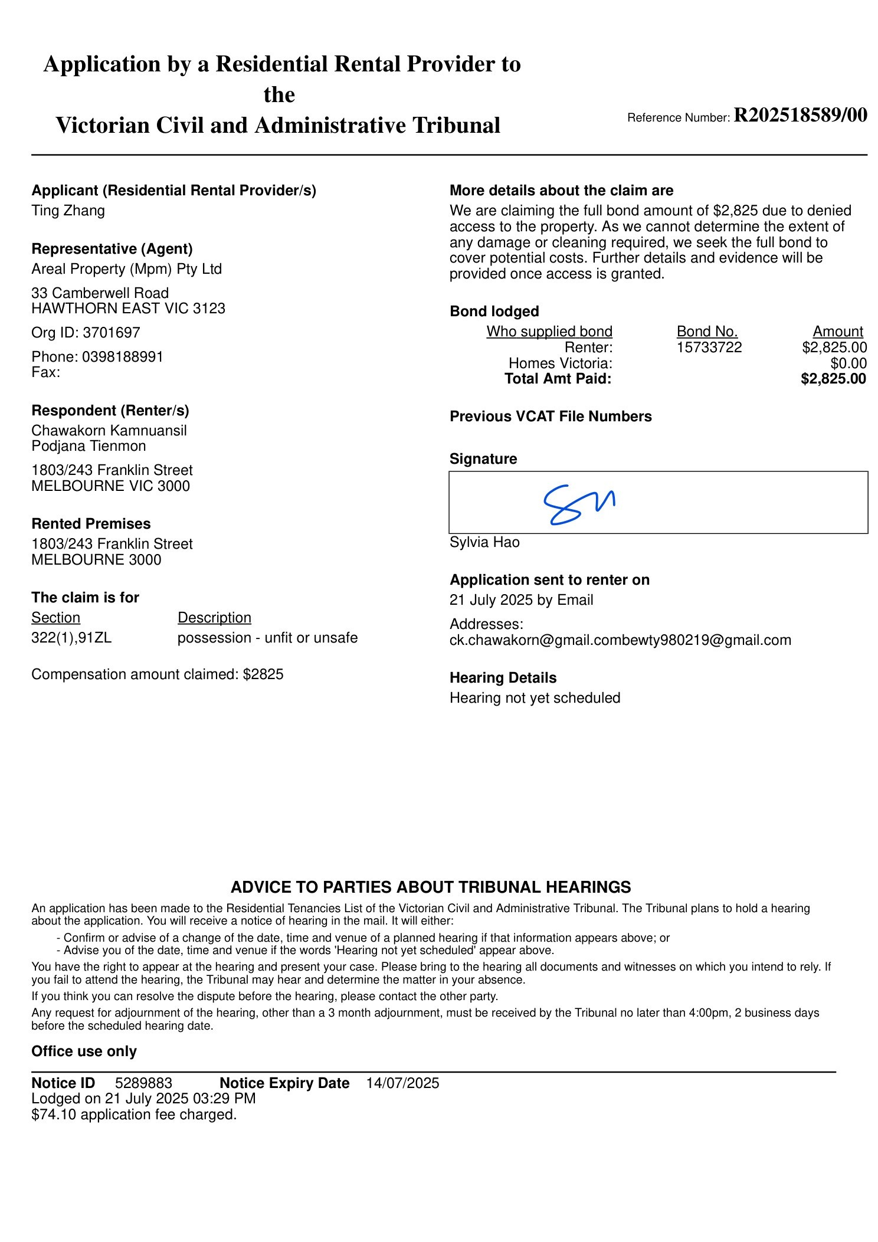
2. NOTICE TO VACATE U1803 243 FRANKLIN ST.pdf
NOTICE TO VACATE U1803 243 FRANKLIN ST.pdf — Page 1/3 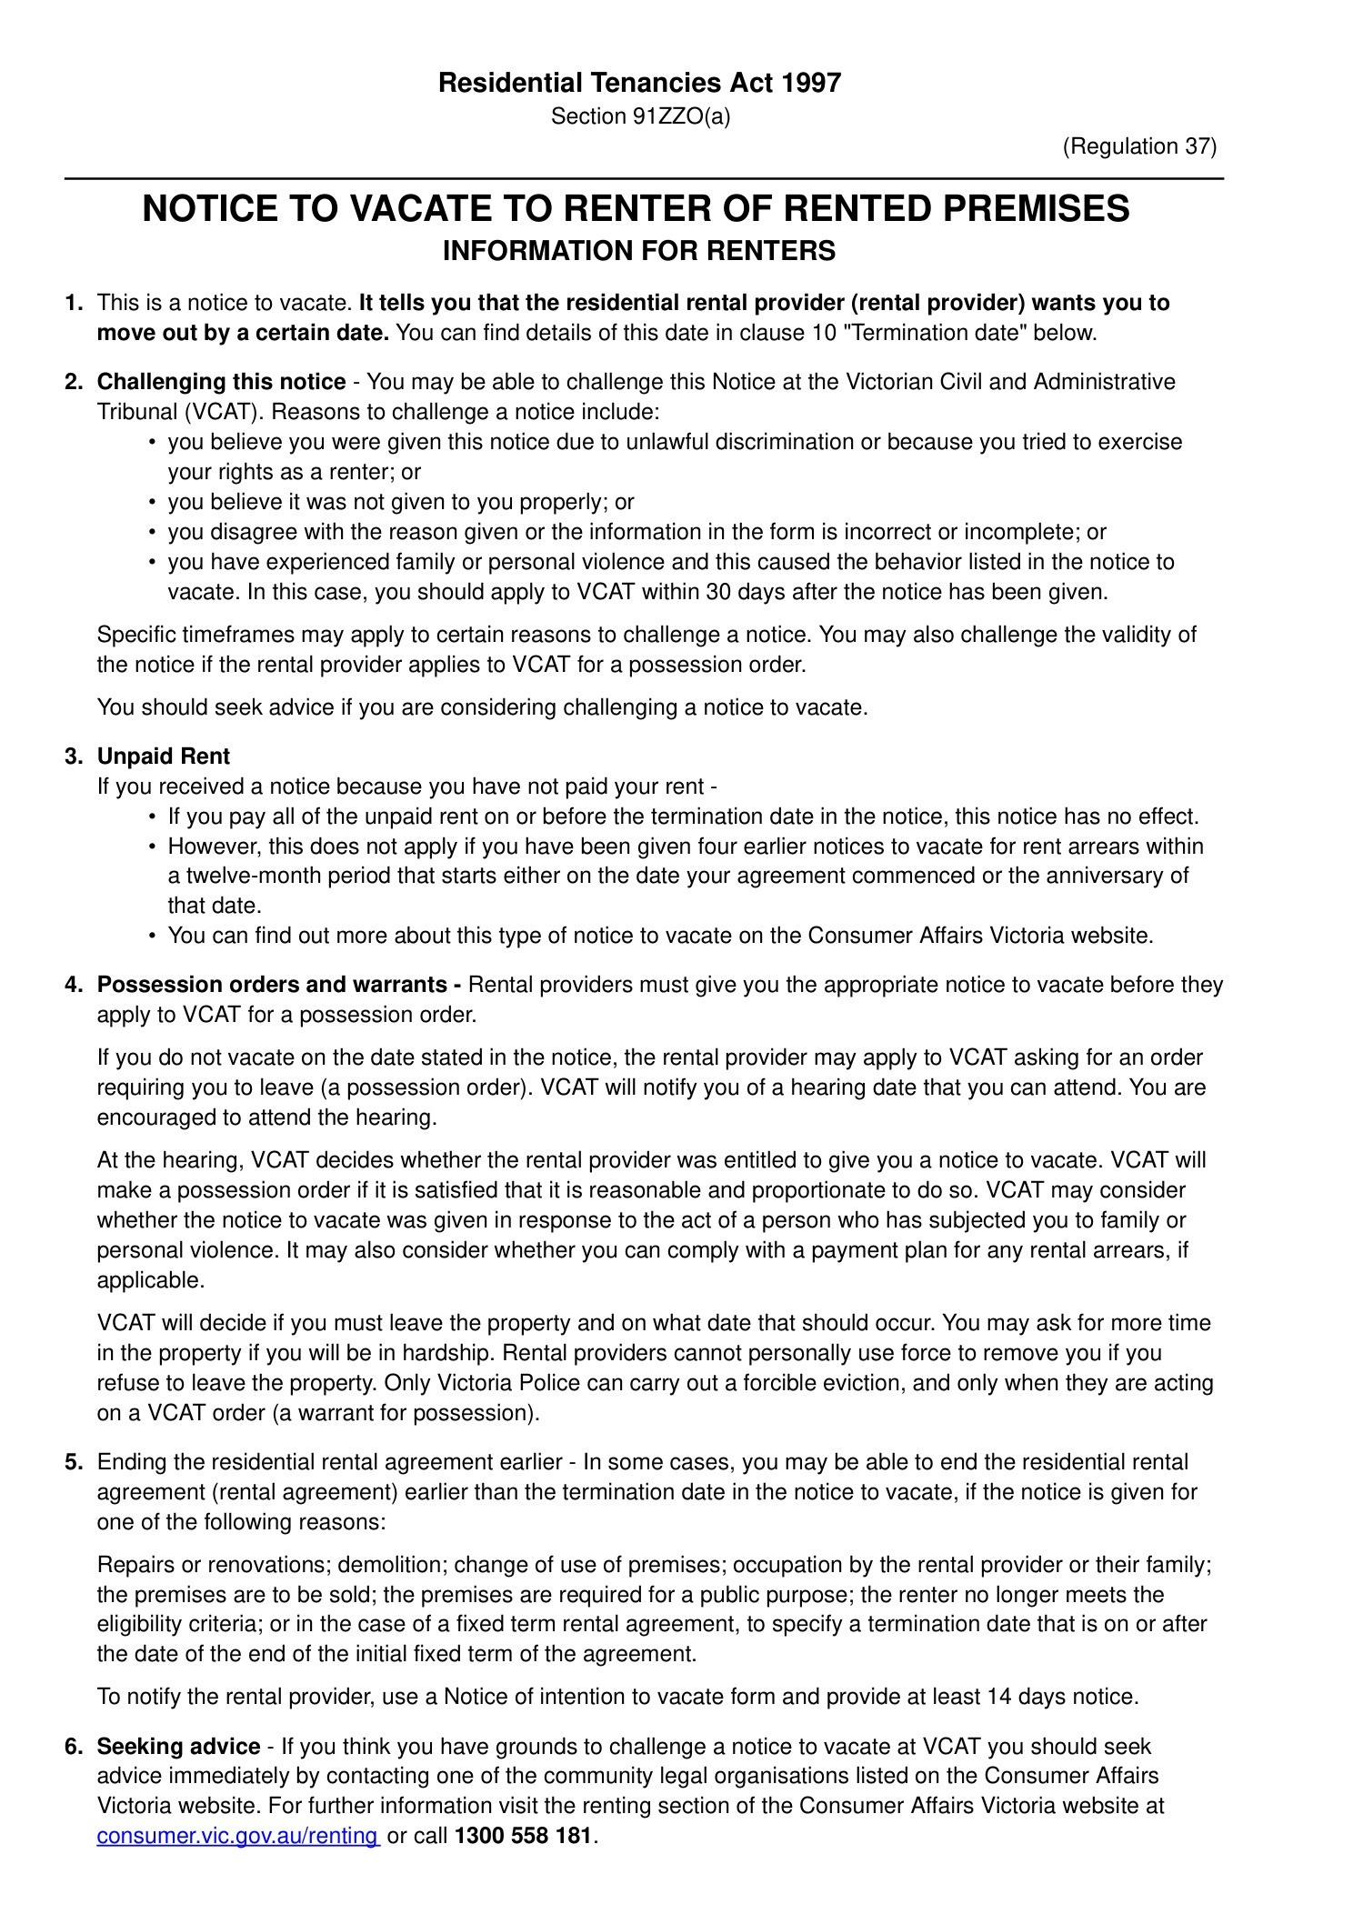 NOTICE TO VACATE U1803 243 FRANKLIN ST.pdf — Page 2/3 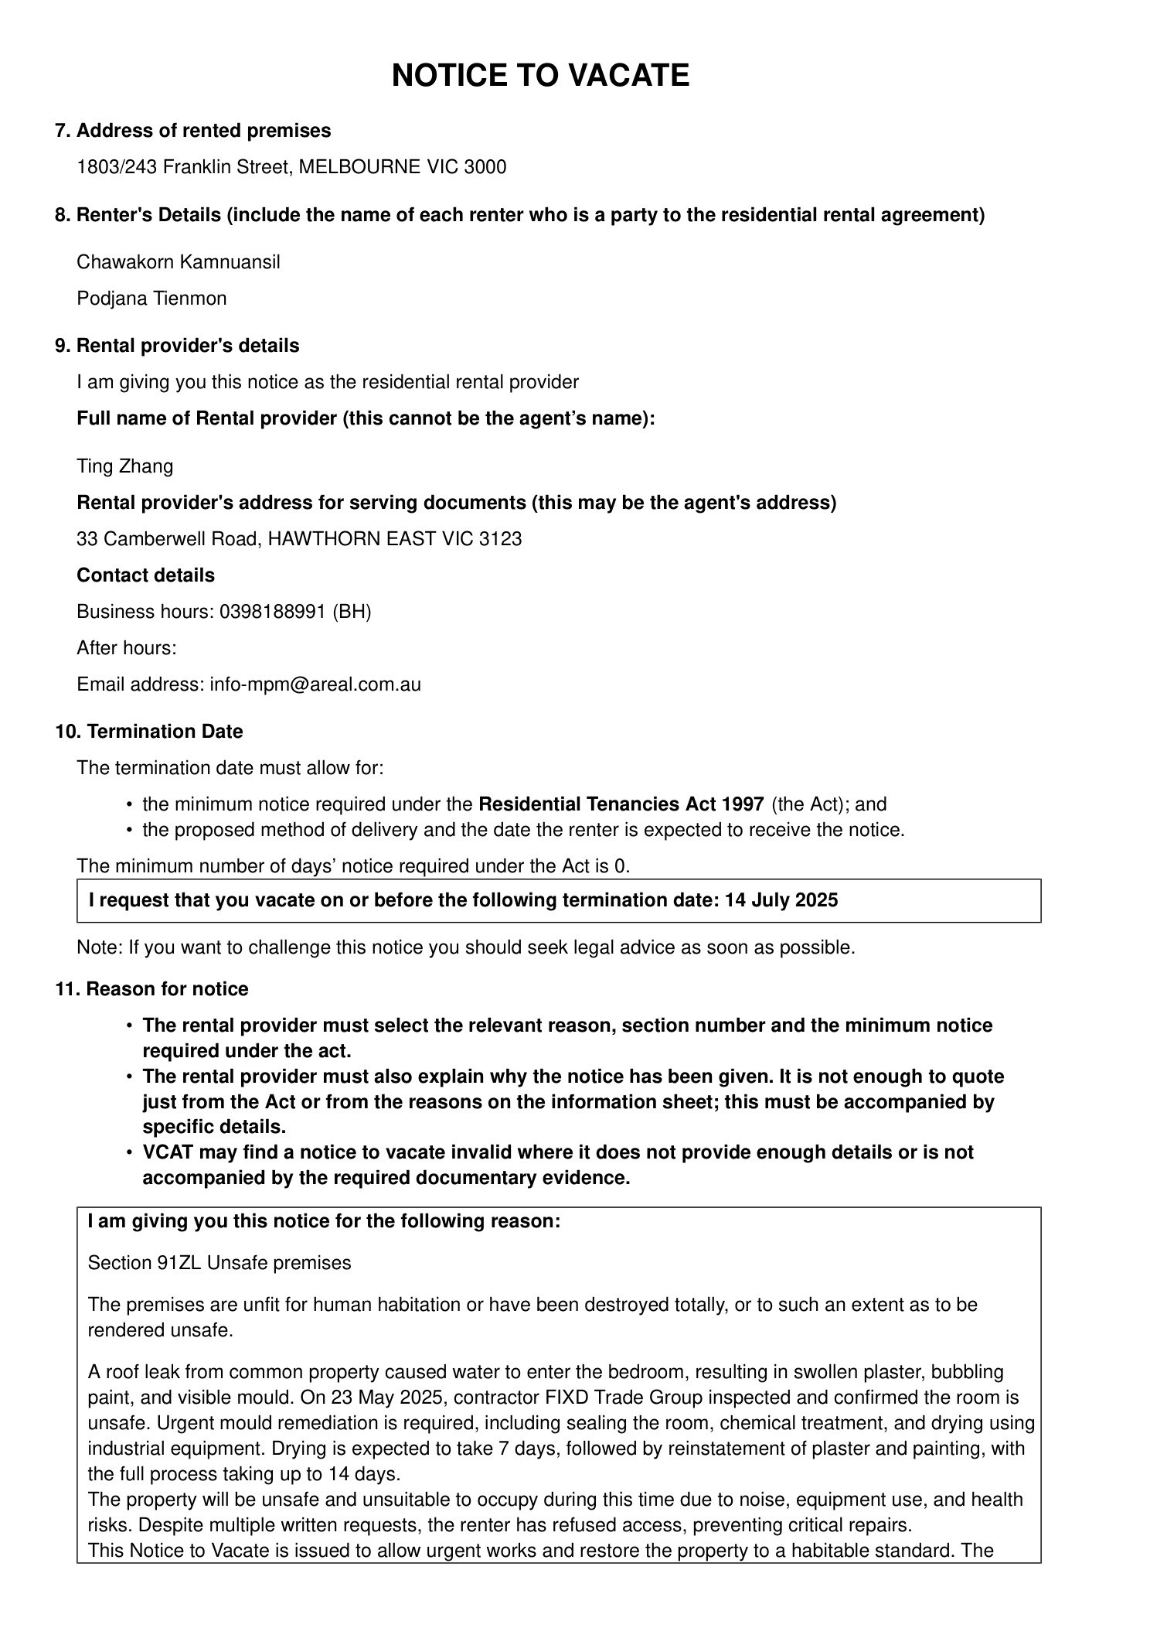 NOTICE TO VACATE U1803 243 FRANKLIN ST.pdf — Page 3/3 