Your VCAT application: more information needed- VCAT reference: R202518214
Messages: 2

Message 1
Type | ORIG
Sort Date | 2025-07-15 10:57
Header Date | 15/07/2025 10:57 AEST
Header Subject | Your VCAT application: more information needed- VCAT reference: R202518214
Source .doc | 250715_-_Your_VCAT_application__more_information_needed-_VCAT_reference__R202518214_.doc

Subject | Your VCAT application: more information needed- VCAT reference: R202518214
From | "CSV-VCAT-RT Inbox (CSV)" <renting@courts.vic.gov.au>
Date | 15/07/2025 10:57 AEST
To | "ck.chawakorn@gmail.com" <ck.chawakorn@gmail.com>, "bewty980219@gmail.com" <bewty980219@gmail.com>

Rented premises: 243 Franklin St

VCAT reference: R202518214

Your VCAT application: more information needed

Good morning,

We have received your application dated <14/07/2025>. The application is incomplete, and we need more information to progress it to the next stage.
What you need to do
By <29/07/2025>:
• Send a copy of the Notice to Vacate.
What happens next
1. When we receive this information and your application is complete, you will receive a Notice of Hearing, which provides the details for your hearing and how to prepare.
2. For more information, see vcat.vic.gov.au/hearings
3. If you do not send the information by the due date, the application cannot progress and may be struck out.
4. If VCAT strikes out your application, once you have given us the information requested, you can apply to reinstate it.
How to send documents
• Email clear scanned copies of documents to renting@vcat.vic.gov.au or
• Mail to GPO Box 5408, Melbourne VIC 3000
If you have any questions, email renting@vcat.vic.gov.au or call 1300 01 8228.

Kind regards,

Harrison
Administrative Officer, Residential Tenancies


Victorian Civil and Administrative Tribunal
55 King Street, Melbourne VIC 3000
1300018228 | renting@courts.vic.gov.au
www.vcat.vic.gov.au
VCAT acknowledges the Aboriginal and Torres Strait Islander peoples as the Traditional Owners and custodians of the land and waterways upon which our lives depend. We acknowledge and pay respects to their Elders and knowledge holders – past and present.

PRIVATE & CONFIDENTIAL
The content of this e-mail and any attachments may be private and confidential, intended only for use of the individual or entity named. If you are not the intended recipient of this message you must not read, forward, print, copy, disclose, use or store in any way the information this e-mail or any attachment contains.
If you are not the intended recipient, please notify the sender immediately and delete or destroy all copies of this e-mail and any attachments.
Our organisation respects the privacy of individuals. For a copy of our privacy policy please go to our website or contact us.

Message 2
Type | RE
Sort Date | 2025-07-15 18:34
Header Date | 15/07/2025 18:34 AEST
Header Subject | Re: Your VCAT application: more information needed- VCAT reference: R202518214
Source .doc | 250715_-_Re_Your_VCAT_application__more_information_needed-_VCAT_reference__R202518214_.doc

Subject | Re: Your VCAT application: more information needed- VCAT reference: R202518214
From | Chawakorn Kamnuansil <ck.chawakorn@gmail.com>
Date | 15/07/2025 18:34 AEST
To | "CSV-VCAT-RT Inbox (CSV)" <renting@courts.vic.gov.au>

Dear VCAT Team,
I am writing to provide you with a copy of the VCAT application I lodged on 14 July 2025, relating to the Notice to Vacate issued on 11 July 2025 for the property:
Unit 1803, 243 Franklin Street, Melbourne VIC 3000.
This application challenges the validity of the Notice to Vacate, on the basis that it constitutes retaliatory eviction following legitimate maintenance complaints.
Attached to this email you will find:
- A copy of the VCAT application form (Reference Number: R202518214/00)
- A copy of the Notice to Vacate
This email serves as formal service of the application as required under VCAT rules.
Please confirm receipt of this email.
If you have any questions, feel free to contact me by email or phone.
Kind regards,
Chawakorn Kamnuansil

- _250715_ck.chawakorn@gmail.com_Re_Your_VCAT_application__more_information_needed-_VCAT_reference__R202518214-272/VCAT Application R202518214_00 – Notice to Vacate Challenge.pdf
- _250715_ck.chawakorn@gmail.com_Re_Your_VCAT_application__more_information_needed-_VCAT_reference__R202518214-272/NOTICE TO VACATE U1803 243 FRANKLIN ST.pdf

Attachment Thumbnails
1. VCAT Application R202518214_00 – Notice to Vacate Challenge.pdf
VCAT Application R202518214_00 – Notice to Vacate Challenge.pdf — Page 1/1 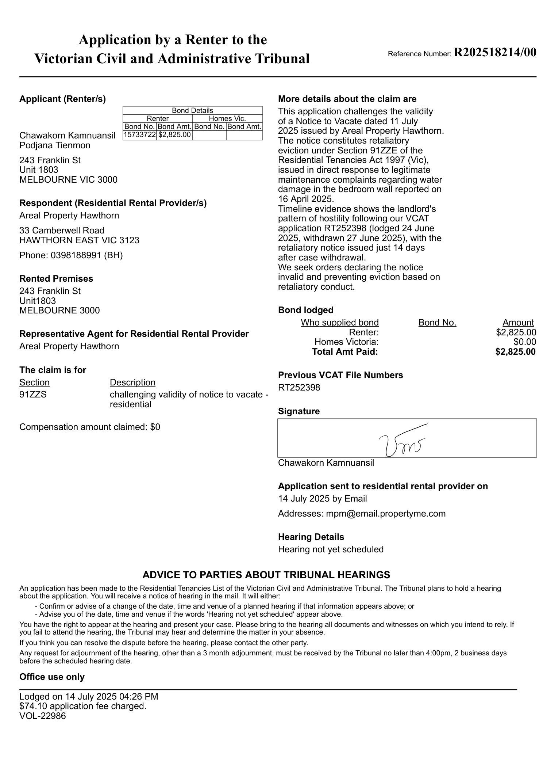
2. NOTICE TO VACATE U1803 243 FRANKLIN ST.pdf
NOTICE TO VACATE U1803 243 FRANKLIN ST.pdf — Page 1/3 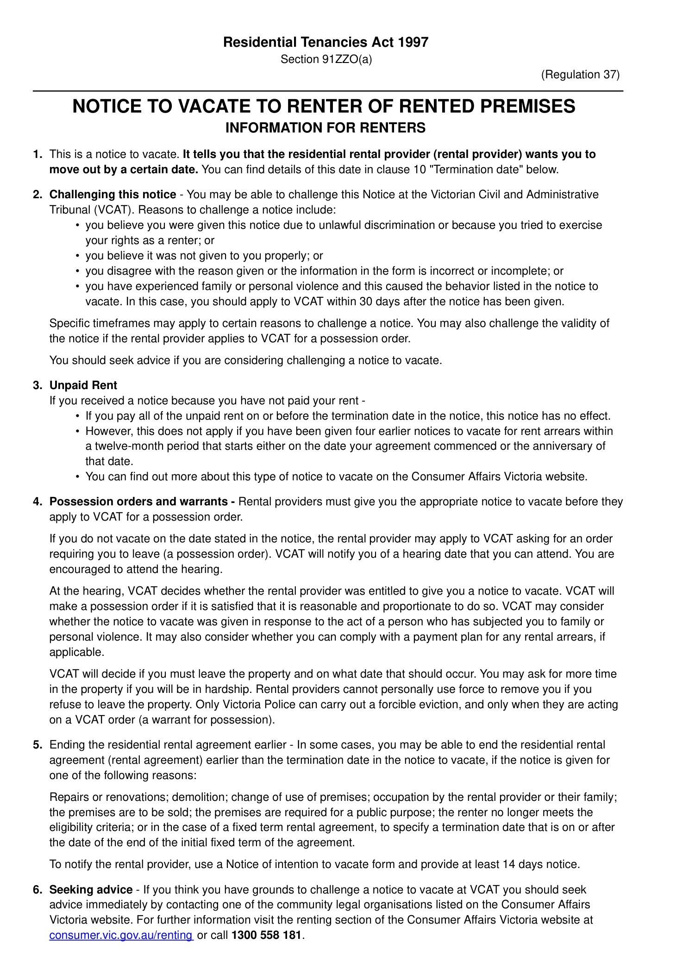 NOTICE TO VACATE U1803 243 FRANKLIN ST.pdf — Page 2/3 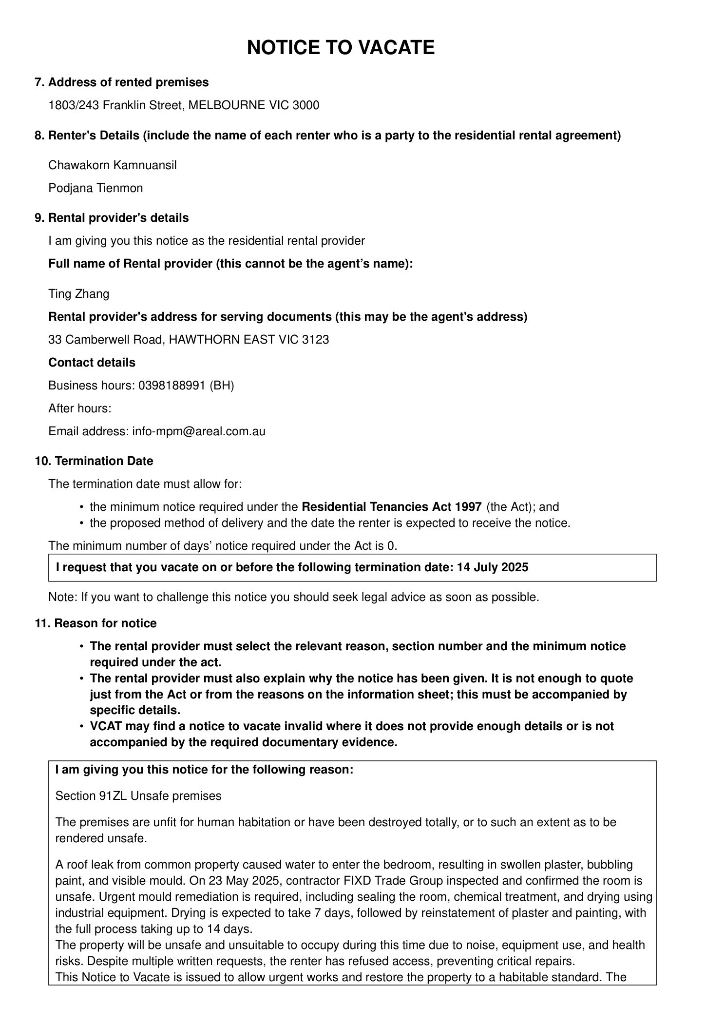 NOTICE TO VACATE U1803 243 FRANKLIN ST.pdf — Page 3/3 