Urgent - Notice to vacate for rental arrears 1803/243 Franklin Street, Melbourne VIC 3000
Messages: 1

Message 1
Type | ORIG
Sort Date | 2026-02-12 17:39
Header Date | 12/02/2026 17:39 AEDT
Header Subject | Urgent - Notice to vacate for rental arrears 1803/243 Franklin Street, Melbourne VIC 3000
Source .doc | 260212_-_Urgent_-_Notice_to_vacate_for_rental_arrears_1803_243_Franklin_Street__Melbourne_.doc

Subject | Urgent - Notice to vacate for rental arrears 1803/243 Franklin Street, Melbourne VIC 3000
From | "Brian Jeon - Areal Property Hawthorn (MPM)" <MPM@email.propertyme.com>
Date | 12/02/2026 17:39 AEDT
To | Chawakorn Kamnuansil <ck.chawakorn@gmail.com>

Hi Chawakorn,
This email is a formal notice regarding the status of your rental payments for 1803/243 Franklin Street, Melbourne VIC 3000.

As of today, our records show that you are 52 days in arrears, with your payments effectively paid to & including 22/12/2025. The total rent amount outstanding is $4,775.41.

As your arrears have reached 14 days or more, we have been instructed by the rental provider to issue a 14-day Notice to Vacate. Attached with this email, you will find the official notice which outlines your obligation to vacate the premises and return the keys by the specified date in the notice.

Important to Note:
- This notice is being issued because your rent payments have fallen significantly behind.
- If you settle the full amount of unpaid rent on or before the termination date mentioned in the notice, this notice will be rendered void.

We urge you to take immediate action regarding this matter. If you have any questions or need to discuss this further, please do not hesitate to contact me.

Kind Regards,
Brian Jeon
Senior Relationship Manager
brian.jeon@areal.com.au
0492 847 287

If you have any feedback regarding my service, please feel free to contact my manager.
Nicky Talbot (Head of Property Management) - nicky.talbot@areal.com.au

DISCLAIMER & WARNING. This correspondence and the information contained in this and associated e-mails are confidential and were only intended for the exclusive use of the addressee(s). If you have received this e-mail in error, any use, copying or inference with this information is unauthorized and prohibited and please immediately delete it and any related attachments or emails from your system and its related sub system and notify the sender. You must never copy, disclose, make conclusions and other information in this message that do not relate to the business of the Areal Property and shall be understood as neither given nor approved or agreed by it. Although Areal Property has taken reasonable precautions to ensure no viruses are present in this e-mail, Areal Property cannot accept responsibility for any loss or damage arising from the use of this e-mail or attachments.

Click to unsubscribe from future email communication

- _260212_MPM@email.propertyme.com_Urgent_-_Notice_to_vacate_for_rental_arrears_1803_243_Franklin_Street__Melbourne_VIC_3000-344/NTV 1st 1803.243 Franklin 27.2.26.pdf

Attachment Thumbnails
1. NTV 1st 1803.243 Franklin 27.2.26.pdf
NTV 1st 1803.243 Franklin 27.2.26.pdf — Page 1/3 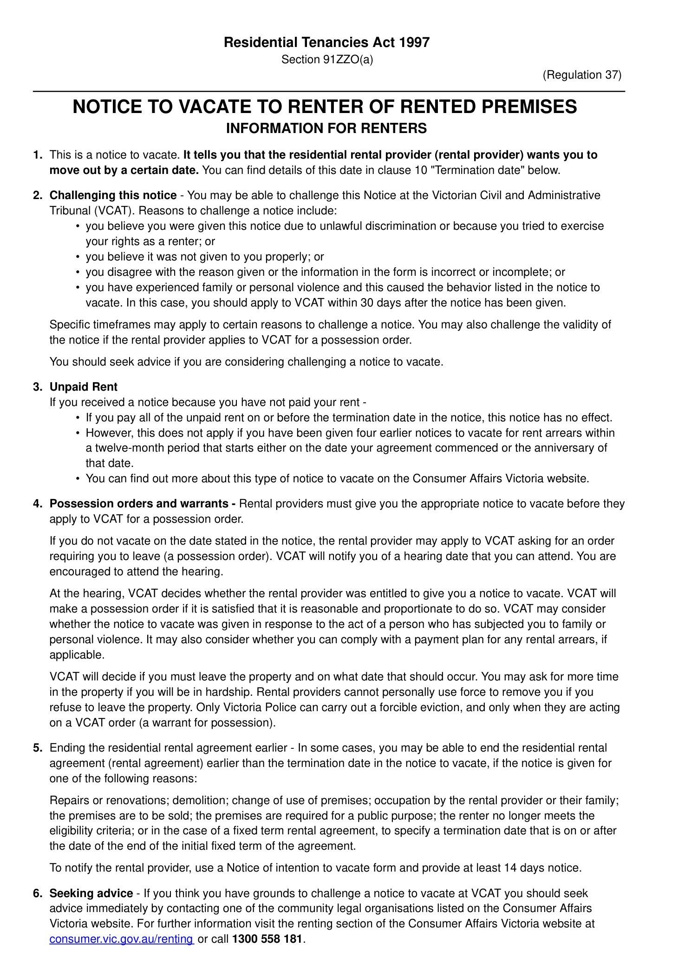 NTV 1st 1803.243 Franklin 27.2.26.pdf — Page 2/3 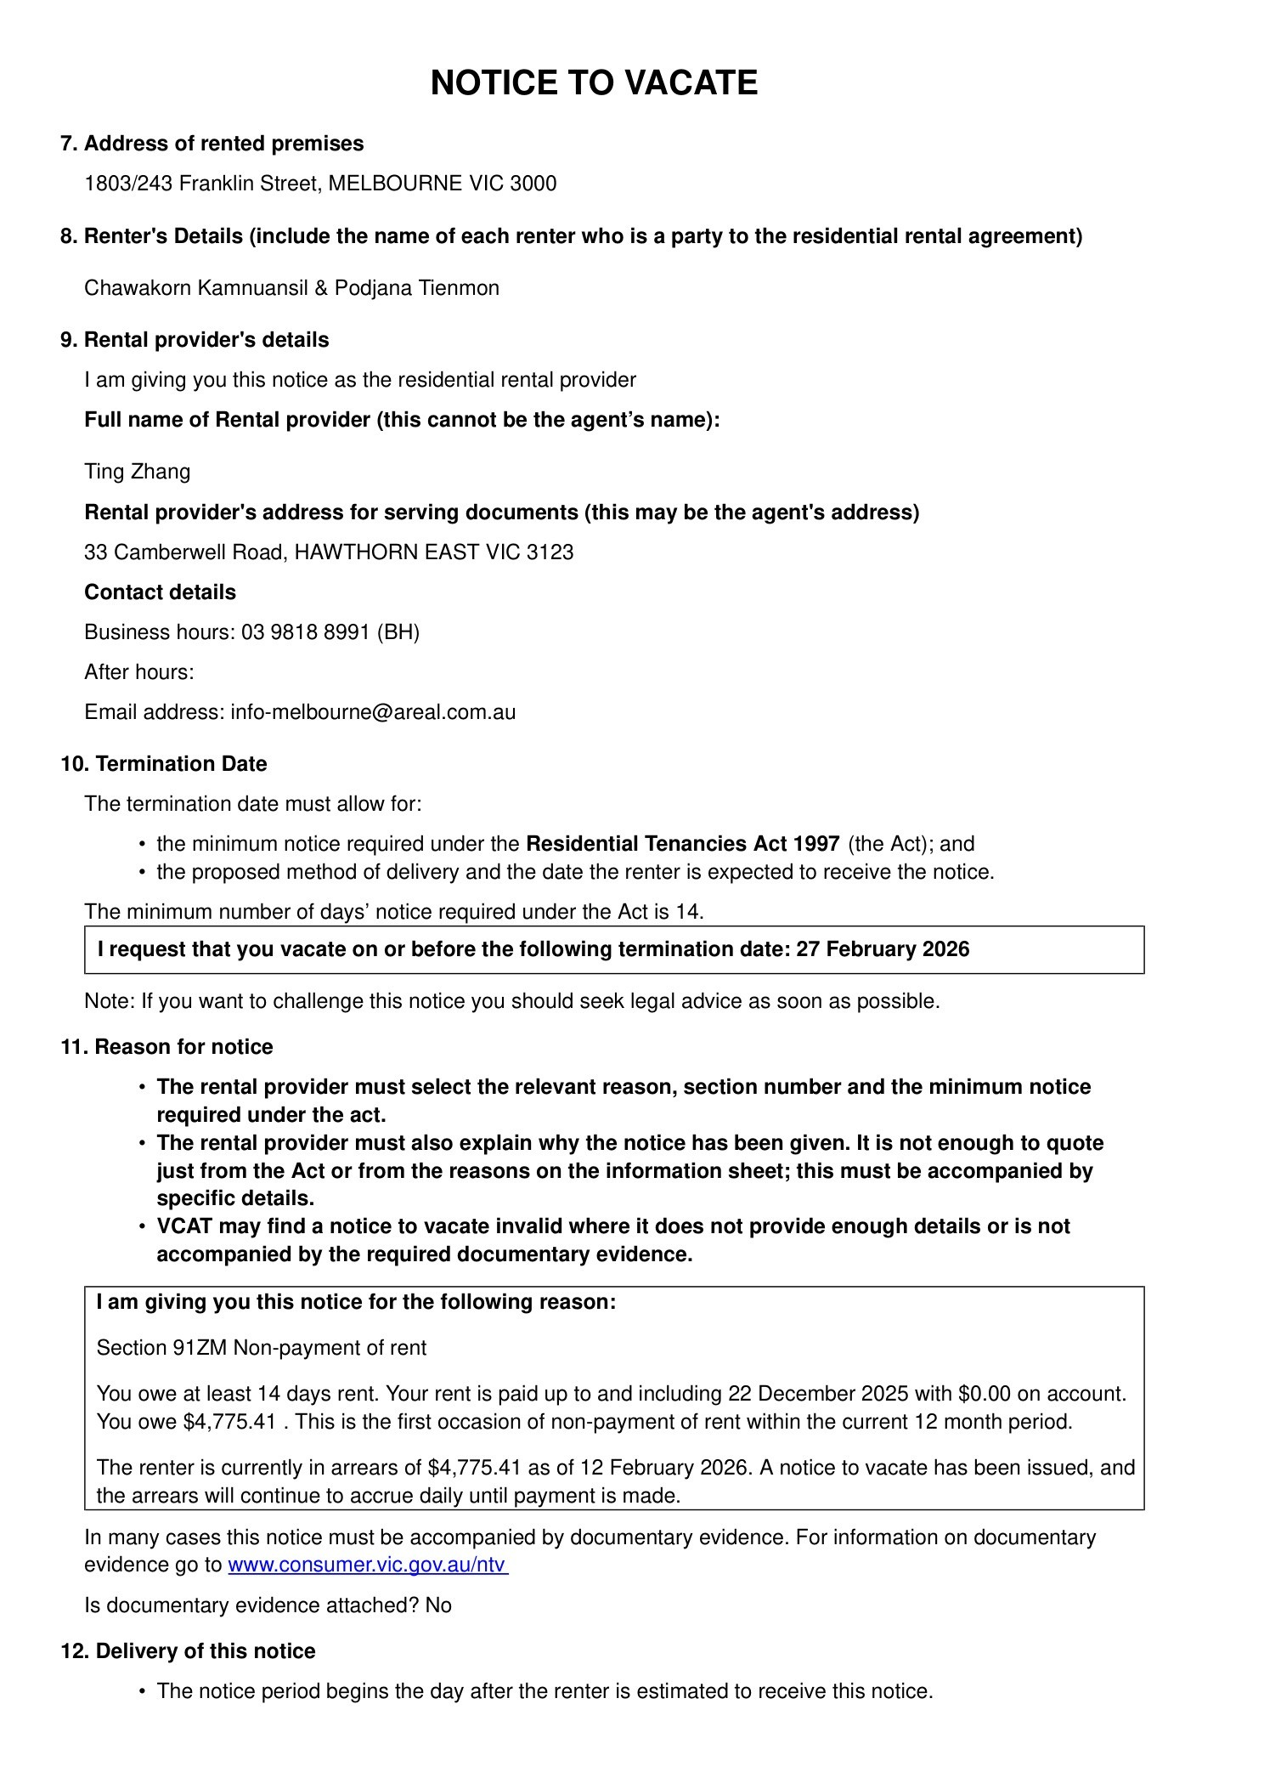 NTV 1st 1803.243 Franklin 27.2.26.pdf — Page 3/3 