RDRV Order - RT252398 CMS:0014256123
Messages: 1

Message 1
Type | ORIG
Sort Date | 2025-06-27 14:33
Header Date | 27/06/2025 14:33 AEST
Header Subject | RDRV Order - RT252398 CMS:0014256123
Source .doc | 250627_-_RDRV_Order_-_RT252398_CMS_0014256123_.doc

Subject | RDRV Order - RT252398 CMS:0014256123
From | "CSV-VCAT-Cases (CSV)" <cases@courts.vic.gov.au>
Date | 27/06/2025 14:33 AEST
To | Chawakorn Kamnuansil <ck.chawakorn@gmail.com>


New order for RT252398

A new order for RT252398 is attached to this email.

If you do not have a myRDRV portal account, you can sign up here
With a myRDRV account you can:
- Get notifications on your case and tasks you need to complete
- See details of your hearings scheduled and orders
- Upload your documents and see documents from other parties
Sign up to myRDRV

Contact RDRV

PRIVATE & CONFIDENTIAL
The content of this e-mail and any attachments may be private and confidential, intended only for use of the individual or entity named. If you are not the intended recipient of this message you must not read, forward, print, copy, disclose, use or store in any way the information this e-mail or any attachment contains.
If you are not the intended recipient, please notify the sender immediately and delete or destroy all copies of this e-mail and any attachments.
Our organisation respects the privacy of individuals. For a copy of our privacy policy please go to our website or contact us.

- _250627_cases@courts.vic.gov.au_RDRV_Order_-_RT252398_CMS_0014256123-263/27-06-2025 - Strike out - Consent order - Order f058873a.pdf

Attachment Thumbnails
1. 27-06-2025 - Strike out - Consent order - Order f058873a.pdf
27-06-2025 - Strike out - Consent order - Order f058873a.pdf — Page 1/2 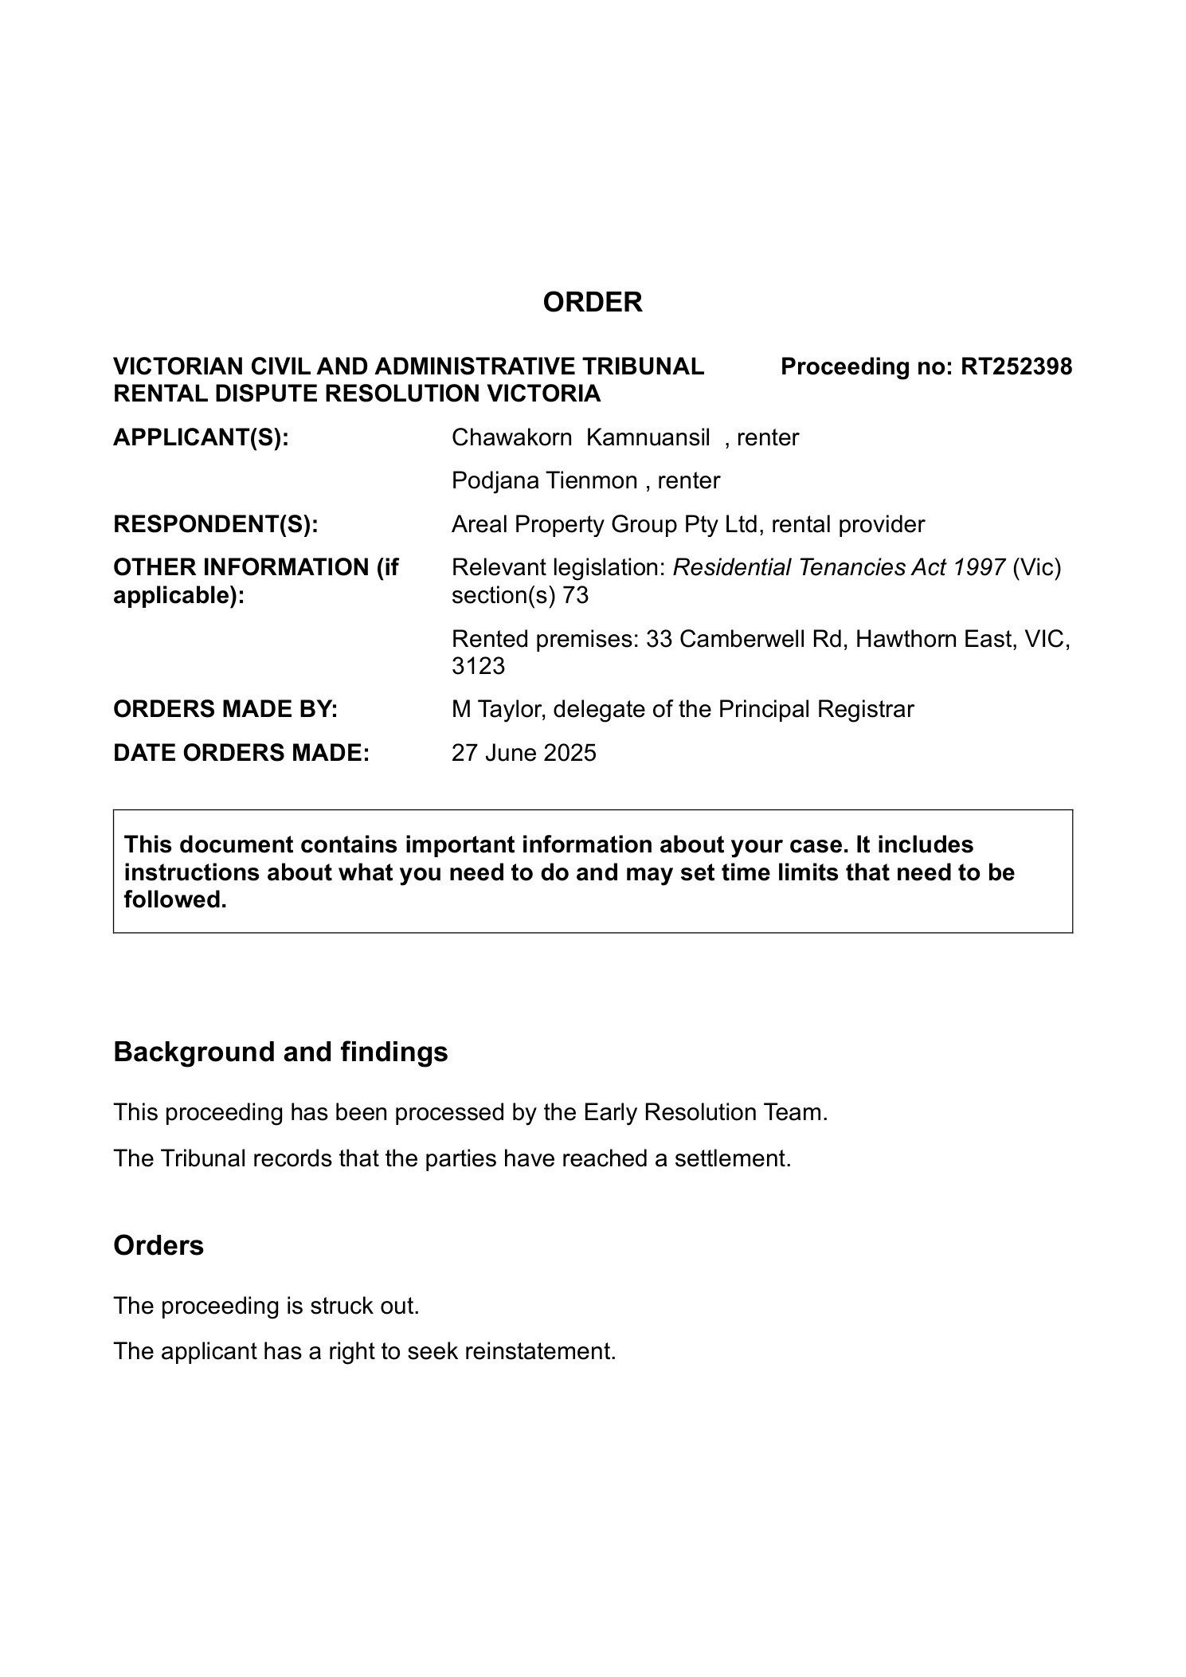 27-06-2025 - Strike out - Consent order - Order f058873a.pdf — Page 2/2 