Follow-up – Formal Demand & Statement Regarding Unresolved Repairs (Unit 1803)
Messages: 15

Message 1
Type | ORIG
Sort Date | 2025-06-06 01:21
Header Date | 06/06/2025 01:21 AEST
Header Subject | Follow-up – Formal Demand & Statement Regarding Unresolved Repairs (Unit 1803)
Source .doc | 250606_-_Follow-up___Formal_Demand___Statement_Regarding_Unresolved_Repairs__Unit_1803__.doc

Subject | Follow-up – Formal Demand & Statement Regarding Unresolved Repairs (Unit 1803)
From | Chawakorn Kamnuansil <ck.chawakorn@gmail.com>
Date | 06/06/2025 01:21 AEST
To | "Sylvia Hao - Areal Property Hawthorn (MPM)" <mpm@email.propertyme.com>

Dear Sylvia,

I am writing with the intent of resolving this matter constructively and without escalation, if possible.

Over the past two months, I have reported the water damage issue multiple times in good faith, cooperated with your office, and done my best to remain in the property despite the difficulties. I am not trying to be confrontational; I simply need a clear and reasonable outcome, supported by appropriate action and communication.

Please find attached:
- A formal demand letter outlining my request for rent compensation, a firm repair timeline, and confirmation of non-liability – based on my rights under the Residential Tenancies Act 1997 (VIC).
- A supporting tenant statement summarising the verbal communication with your office around 2–3 June 2025, including the temporary accommodation proposal and its impractical conditions.

If a fair and written resolution is not reached within five (5) business days, I will have no choice but to initiate proceedings through VCAT. I sincerely hope this can be avoided and that we can achieve a reasonable solution for all parties involved.

I would appreciate your written response at your earliest convenience.

Kind regards,
Chawakorn Kamnuansil
ck.chawakorn@gmail.com

Attachments:
- Formal_Demand_Letter_Chawakorn.pdf
- Tenant_Statement_Chawakorn.pdf

- _250606_ck.chawakorn@gmail.com_Follow-up___Formal_Demand___Statement_Regarding_Unresolved_Repairs__Unit_1803_-227/Formal_Demand_Letter_Chawakorn.pdf
- _250606_ck.chawakorn@gmail.com_Follow-up___Formal_Demand___Statement_Regarding_Unresolved_Repairs__Unit_1803_-227/Tenant_Statement_Chawakorn.pdf

Attachment Thumbnails
1. Formal_Demand_Letter_Chawakorn.pdf
Formal_Demand_Letter_Chawakorn.pdf — Page 1/2 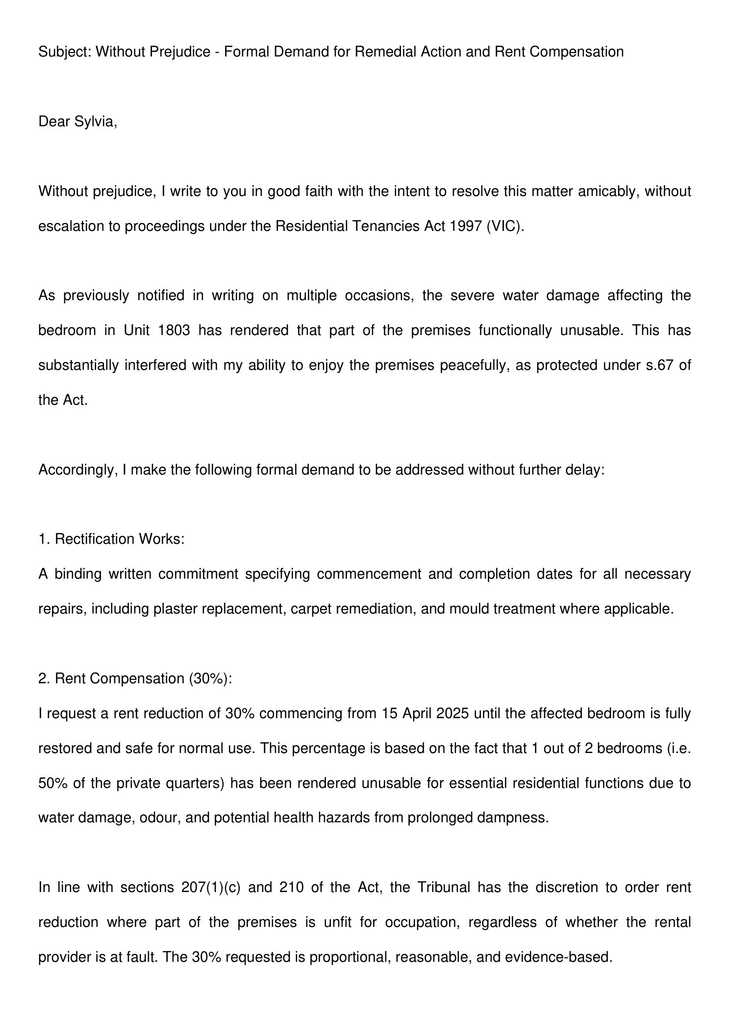 Formal_Demand_Letter_Chawakorn.pdf — Page 2/2 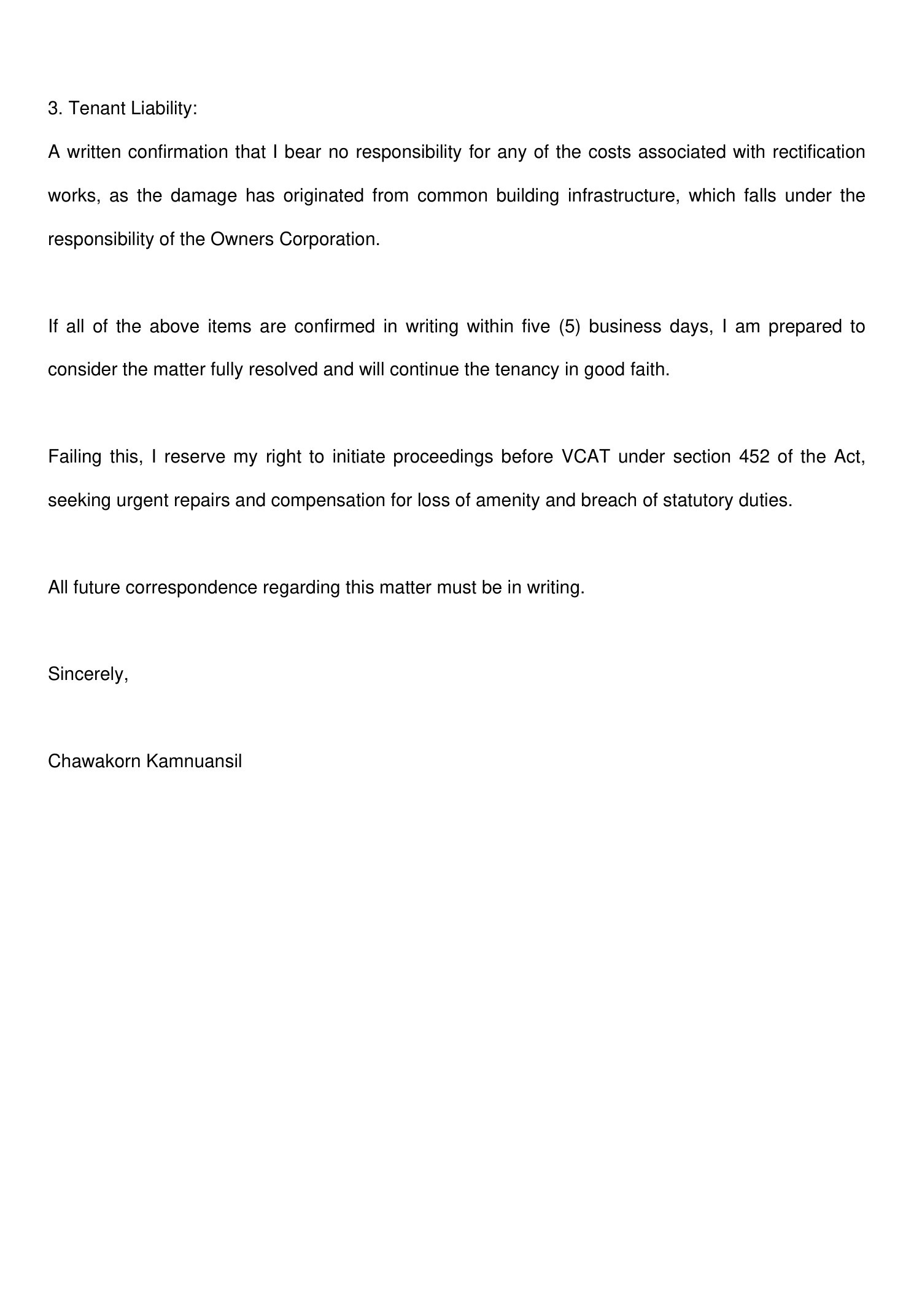
2. Tenant_Statement_Chawakorn.pdf
Tenant_Statement_Chawakorn.pdf — Page 1/2 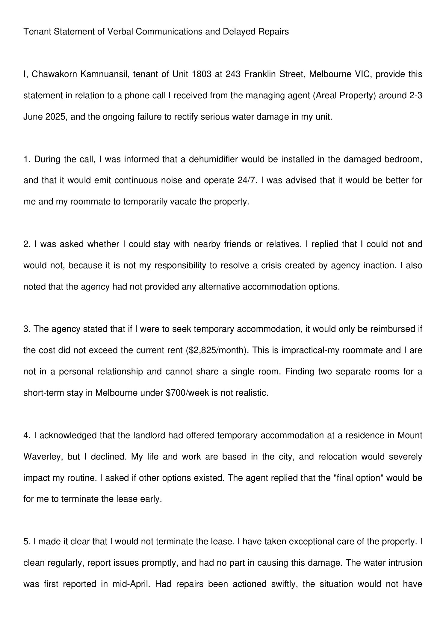 Tenant_Statement_Chawakorn.pdf — Page 2/2 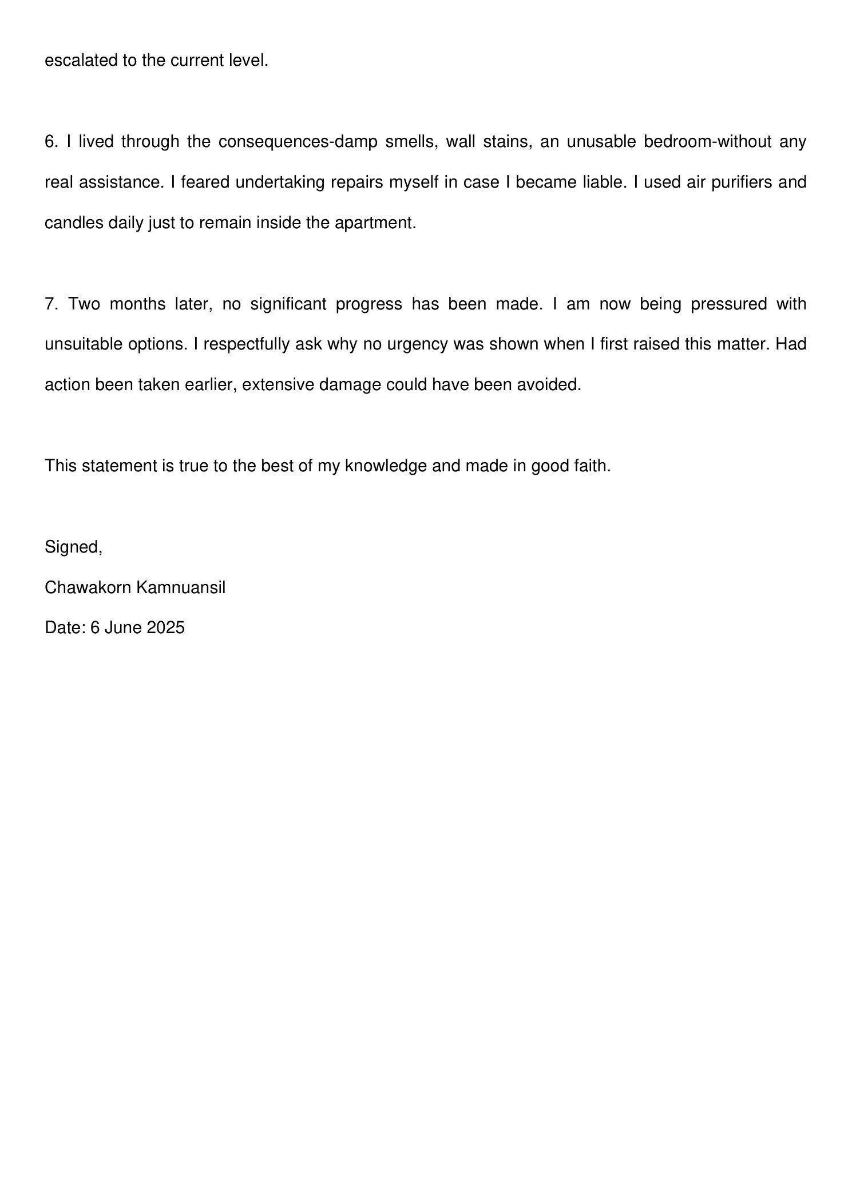

Message 2
Type | RE
Sort Date | 2025-06-06 11:50
Header Date | 06/06/2025 11:50 AEST
Header Subject | Re: Follow-up – Formal Demand & Statement Regarding Unresolved Repairs (Unit 1803)
Source .doc | 250606_-_Re_Follow-up___Formal_Demand___Statement_Regarding_Unresolved_Repairs__Unit_1803_.doc

Subject | Re: Follow-up – Formal Demand & Statement Regarding Unresolved Repairs (Unit 1803)
From | "Sylvia Hao - Areal Property Hawthorn (MPM)" <MPM@email.propertyme.com>
Date | 06/06/2025 11:50 AEST
To | Chawakorn Kamnuansil <ck.chawakorn@gmail.com>

Dear Chawakorn,
Thank you for your email and the supporting documents outlining your concerns and formal request.
We understand the impact this situation has had on your tenancy and appreciate the way you’ve approached the matter. We will now forward your request and documentation to the Owners Corporation for consideration of a rent compensation claim based on the current circumstances.
In the meantime, we are aiming to proceed with the repair works as soon as possible. Could you kindly confirm whether works can commence on Thursday, 6 June 2025, or let us know your earliest availability to provide access?
We will continue to keep you updated as we receive further information from the Owners Corporation.
Kind regards,
Sylvia Hao
Relationship Manager

M 0420 675 561
P 03 9818 8991
A 33 Camberwell Road, Hawthorn East VIC 3123



If you have any feedback regarding my service, please feel free to contact my manager.
Jamie Ong (Head of Property Management) jamie.ong@areal.com.au

DISCLAIMER & WARNING. This correspondence and the information contained in this and associated e-mails are confidential and were only intended for the exclusive use of the addressee(s). If you have received this e-mail in error, any use, copying or inference with this information is unauthorized and prohibited and please immediately delete it and any related attachments or emails from your system and its related sub system and notify the sender. You must never copy, disclose, make conclusions and other information in this message that do not relate to the business of the Areal Property and shall be understood as neither given nor approved or agreed by it. Although Areal Property has taken reasonable precautions to ensure no viruses are present in this e-mail, Areal Property cannot accept responsibility for any loss or damage arising from the use of this e-mail or attachments.

Click to unsubscribe from future email communication

Message 3
Type | RE
Sort Date | 2025-06-06 16:36
Header Date | 06/06/2025 16:36 AEST
Header Subject | Re: Follow-up – Formal Demand & Statement Regarding Unresolved Repairs (Unit 1803)
Source .doc | 250606_-_Re_Follow-up___Formal_Demand___Statement_Regarding_Unresolved_Repairs__Unit_1803_-1.doc

Subject | Re: Follow-up – Formal Demand & Statement Regarding Unresolved Repairs (Unit 1803)
From | Chawakorn Kamnuansil <ck.chawakorn@gmail.com>
Date | 06/06/2025 16:36 AEST
To | "Sylvia Hao - Areal Property Hawthorn (MPM)" <MPM@email.propertyme.com>

Dear Sylvia,
Thank you for your response dated Friday, 6 June 2025 at 11:50am.
As the primary resident of the property who has lived through weeks of unresolved water damage, I must reiterate that no one is more eager than I am to see the situation resolved quickly and properly. However, I am currently unable to provide consent for any repair work to begin.
Firstly, your email referred to repairs commencing on "Thursday, 6 June"a date which had already passed at the time of your message. This inconsistency is not just confusing; it is logistically impossible and calls into question the seriousness of the repair planning. Such unclear and last-minute communication cannot form the basis for valid consent.
Secondly, I must emphasise that I cannot authorise access until the following points are clearly confirmed in writing:
1. A definitive and specific repair timeline, including projected completion date.
2. Whether temporary relocation will be required, and if so, what arrangements or compensation are being offered.
3. Your position on my formal request for rent reduction and confirmation of non-liability, which remain outstanding.
4. Acknowledgment of the impact on my co-tenant, who is also named in the lease agreement, and who will equally be affected by noise and accessibility issues related to the drying equipment.
It is my responsibility to ensure that any agreement made does not inadvertently waive our legal rights or create further hardship. I must act cautiously, especially as the installation of industrial drying equipment operating 24/7 poses real disturbancessomething your office acknowledged in our previous phone call.
If I were to consent now without these matters resolved in writing, it could later be used to suggest that I accepted all resulting conditions, which I absolutely do not.
Therefore, I will only provide access once I receive formal written confirmation addressing all points above. Until then, I consider it unreasonable to demand a commitment from me, especially under these unclear and one-sided circumstances.
As noted in my formal demand, if a resolution is not reached within five (5) calendar daysincluding weekendsI will proceed to file an application with VCAT.
Kind regards,
Chawakorn Kamnuansil
ck.chawakorn@gmail.com

- _250606_ck.chawakorn@gmail.com_Re_Follow-up___Formal_Demand___Statement_Regarding_Unresolved_Repairs__Unit_1803_-248/Chawakorn_Response_Repair_Access.pdf

Attachment Thumbnails
1. Chawakorn_Response_Repair_Access.pdf
Chawakorn_Response_Repair_Access.pdf — Page 1/1 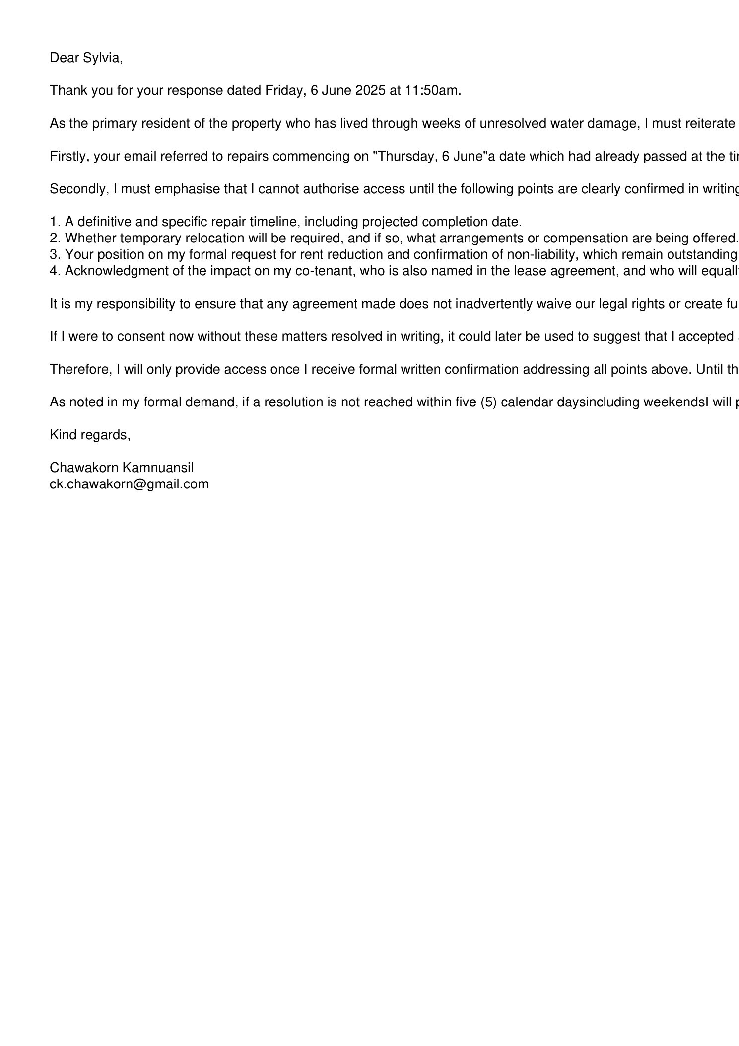

Message 4
Type | RE
Sort Date | 2025-06-10 12:55
Header Date | 10/06/2025 12:55 AEST
Header Subject | Re: Follow-up – Formal Demand & Statement Regarding Unresolved Repairs (Unit 1803)
Source .doc | 250610_-_Re_Follow-up___Formal_Demand___Statement_Regarding_Unresolved_Repairs__Unit_1803_.doc

Subject | Re: Follow-up – Formal Demand & Statement Regarding Unresolved Repairs (Unit 1803)
From | "Sylvia Hao - Areal Property Hawthorn (MPM)" <MPM@email.propertyme.com>
Date | 10/06/2025 12:55 AEST
To | Chawakorn Kamnuansil <ck.chawakorn@gmail.com>, bewty980219@gmail.com
Cc | mpm@email.propertyme.com

Dear Chawakorn,
Thank you for your email and for clearly outlining your concerns. We completely understand the frustration and inconvenience this ongoing issue has caused, and we truly appreciate your patience.
Repair Timeline:
We have formally submitted your 30% rent reduction request to the Owners Corporation and are awaiting their response. Once we receive their feedback, we will provide you with a confirmed repair timeline and projected completion date.
Temporary Relocation:
As discussed, the affected bedroom will need to be vacant during the repair work, including the installation of drying equipment.
Co-Tenant Impact:
We recognize that your co-tenant will also be affected by these repairs. Please rest assured that we will keep both of you informed about the repair schedule and any potential disruptions.
We fully respect your decision to withhold consent until these matters are fully addressed in writing. We are working to resolve this as quickly as possible and will provide all the necessary details as soon as they are available.
If you have any further questions or need additional clarification, please don’t hesitate to reach out.
Kind regards,
Sylvia Hao
Relationship Manager

M 0420 675 561
P 03 9818 8991
A 33 Camberwell Road, Hawthorn East VIC 3123

If you have any feedback regarding my service, please feel free to contact my manager.
Jamie Ong (Head of Property Management) jamie.ong@areal.com.au

DISCLAIMER & WARNING. This correspondence and the information contained in this and associated e-mails are confidential and were only intended for the exclusive use of the addressee(s). If you have received this e-mail in error, any use, copying or inference with this information is unauthorized and prohibited and please immediately delete it and any related attachments or emails from your system and its related sub system and notify the sender. You must never copy, disclose, make conclusions and other information in this message that do not relate to the business of the Areal Property and shall be understood as neither given nor approved or agreed by it. Although Areal Property has taken reasonable precautions to ensure no viruses are present in this e-mail, Areal Property cannot accept responsibility for any loss or damage arising from the use of this e-mail or attachments.

Click to unsubscribe from future email communication

Message 5
Type | RE
Sort Date | 2025-06-10 16:19
Header Date | 10/06/2025 16:19 AEST
Header Subject | Re: Follow-up – Formal Demand & Statement Regarding Unresolved Repairs (Unit 1803)
Source .doc | 250610_-_Re_Follow-up___Formal_Demand___Statement_Regarding_Unresolved_Repairs__Unit_1803_-1.doc

Subject | Re: Follow-up – Formal Demand & Statement Regarding Unresolved Repairs (Unit 1803)
From | "Sylvia Hao - Areal Property Hawthorn (MPM)" <MPM@email.propertyme.com>
Date | 10/06/2025 16:19 AEST
To | Chawakorn Kamnuansil <ck.chawakorn@gmail.com>, bewty980219@gmail.com
Cc | mpm@email.propertyme.com

Dear Chawakorn,
I’ve received confirmation from the Owners Corporation that they are happy to proceed with the previously proposed rent reduction of $800.00.
Could you kindly confirm if you’re happy with this adjustment?
Once confirmed, we’ll proceed accordingly.
Kind regards,
Sylvia Hao
Relationship Manager

M 0420 675 561
P 03 9818 8991
A 33 Camberwell Road, Hawthorn East VIC 3123

If you have any feedback regarding my service, please feel free to contact my manager.
Jamie Ong (Head of Property Management) jamie.ong@areal.com.au

DISCLAIMER & WARNING. This correspondence and the information contained in this and associated e-mails are confidential and were only intended for the exclusive use of the addressee(s). If you have received this e-mail in error, any use, copying or inference with this information is unauthorized and prohibited and please immediately delete it and any related attachments or emails from your system and its related sub system and notify the sender. You must never copy, disclose, make conclusions and other information in this message that do not relate to the business of the Areal Property and shall be understood as neither given nor approved or agreed by it. Although Areal Property has taken reasonable precautions to ensure no viruses are present in this e-mail, Areal Property cannot accept responsibility for any loss or damage arising from the use of this e-mail or attachments.

Click to unsubscribe from future email communication

Message 6
Type | RE
Sort Date | 2025-06-12 15:46
Header Date | 12/06/2025 15:46 AEST
Header Subject | Re: Follow-up – Formal Demand & Statement Regarding Unresolved Repairs (Unit 1803)
Source .doc | 250612_-_Re_Follow-up___Formal_Demand___Statement_Regarding_Unresolved_Repairs__Unit_1803_.doc

Subject | Re: Follow-up – Formal Demand & Statement Regarding Unresolved Repairs (Unit 1803)
From | "Sylvia Hao - Areal Property Hawthorn (MPM)" <MPM@email.propertyme.com>
Date | 12/06/2025 15:46 AEST
To | ck.chawakorn@gmail.com

Dear Chawakorn,
Thank you for your thoughtful response and for your continued openness to resolving this matter collaboratively.
We understand the importance of your questions regarding the proposed rent adjustment, repair timeline, and related concerns. Given the complexity of the situation, we believe an in-person meeting would be the most efficient and constructive way to go through all the details and reach a clear understanding together.
We would like to invite you to our office at 33 Camberwell Road, Hawthorn East, and offer the following options for a meeting on Friday, 13 June:
Any time between 11:30 AM and 12:30 PM, or
Any time between 2:00 PM and 3:00 PM (please let us know your preferred time within that window).
You are welcome to bring your support person, and we’ll ensure all relevant documentation and responses are prepared in advance for review and discussion.
Please confirm your availability at your earliest convenience, and we’ll lock in the time accordingly.
Kind regards,
Sylvia Hao
Relationship Manager

M 0420 675 561
P 03 9818 8991
A 33 Camberwell Road, Hawthorn East VIC 3123

If you have any feedback regarding my service, please feel free to contact my manager.
Jamie Ong (Head of Property Management) jamie.ong@areal.com.au

DISCLAIMER & WARNING. This correspondence and the information contained in this and associated e-mails are confidential and were only intended for the exclusive use of the addressee(s). If you have received this e-mail in error, any use, copying or inference with this information is unauthorized and prohibited and please immediately delete it and any related attachments or emails from your system and its related sub system and notify the sender. You must never copy, disclose, make conclusions and other information in this message that do not relate to the business of the Areal Property and shall be understood as neither given nor approved or agreed by it. Although Areal Property has taken reasonable precautions to ensure no viruses are present in this e-mail, Areal Property cannot accept responsibility for any loss or damage arising from the use of this e-mail or attachments.

Click to unsubscribe from future email communication

Message 7
Type | RE
Sort Date | 2025-06-13 06:19
Header Date | 13/06/2025 06:19 AEST
Header Subject | Re: Follow-up – Formal Demand & Statement Regarding Unresolved Repairs (Unit 1803)
Source .doc | 250613_-_Re_Follow-up___Formal_Demand___Statement_Regarding_Unresolved_Repairs__Unit_1803_-1.doc

Subject | Re: Follow-up – Formal Demand & Statement Regarding Unresolved Repairs (Unit 1803)
From | Chawakorn Kamnuansil <ck.chawakorn@gmail.com>
Date | 13/06/2025 06:19 AEST
To | "Sylvia Hao - Areal Property Hawthorn (MPM)" <MPM@email.propertyme.com>

Message 8
Type | RE
Sort Date | 2025-06-13 17:22
Header Date | 13/06/2025 17:22 AEST
Header Subject | Re: Follow-up – Formal Demand & Statement Regarding Unresolved Repairs (Unit 1803)
Source .doc | 250613_-_Re_Follow-up___Formal_Demand___Statement_Regarding_Unresolved_Repairs__Unit_1803_.doc

Subject | Re: Follow-up – Formal Demand & Statement Regarding Unresolved Repairs (Unit 1803)
From | "Sylvia Hao - Areal Property Hawthorn (MPM)" <MPM@email.propertyme.com>
Date | 13/06/2025 17:22 AEST
To | ck.chawakorn@gmail.com
Cc | mpm@email.propertyme.com

Dear Chawakorn,
I hope you're well, and thank you again for your continued engagement regarding the repair matter.
Following instructions from the rental provider, we are now arranging to proceed with the required repairs to the water-damaged wall and flooring. These works are necessary to prevent further deterioration of the property.
To ensure works can commence without further delay, please expect a formal Notice of Entry to be issued on Monday, 16 June 2025. This is in accordance with the Residential Tenancies Act and will confirm the entry date and time for the Owners Corporation’s contractors to attend.
As previously advised, the repair process is estimated to take approximately 7–12 days. If you have any preferred times or specific availability for the week ahead, please feel free to share this by 12:00 PM Monday, 16 June, and we’ll do our best to coordinate accordingly. However, please note that access must be provided to prevent further damage and comply with maintenance obligations.
In terms of rent compensation, a rent credit of $800 will be applied and reflected on your ledger. This offer has been confirmed by the rental provider as final, with no further compensation to be considered.
If you feel the current tenancy no longer suits your circumstances, the owner is open to discussing a mutual lease termination, without penalty, should you wish to explore that option.
Please don’t hesitate to reach out with any further questions or concerns — we remain committed to a timely and fair resolution.
Warm regards,
Sylvia Hao
Relationship Manager

M 0420 675 561
P 03 9818 8991
A 33 Camberwell Road, Hawthorn East VIC 3123

If you have any feedback regarding my service, please feel free to contact my manager.
Jamie Ong (Head of Property Management) jamie.ong@areal.com.au

DISCLAIMER & WARNING. This correspondence and the information contained in this and associated e-mails are confidential and were only intended for the exclusive use of the addressee(s). If you have received this e-mail in error, any use, copying or inference with this information is unauthorized and prohibited and please immediately delete it and any related attachments or emails from your system and its related sub system and notify the sender. You must never copy, disclose, make conclusions and other information in this message that do not relate to the business of the Areal Property and shall be understood as neither given nor approved or agreed by it. Although Areal Property has taken reasonable precautions to ensure no viruses are present in this e-mail, Areal Property cannot accept responsibility for any loss or damage arising from the use of this e-mail or attachments.

Click to unsubscribe from future email communication

Message 9
Type | RE
Sort Date | 2025-06-16 04:36
Header Date | 16/06/2025 04:36 AEST
Header Subject | Re: Follow-up – Formal Demand & Statement Regarding Unresolved Repairs (Unit 1803)
Source .doc | 250616_-_Re_Follow-up___Formal_Demand___Statement_Regarding_Unresolved_Repairs__Unit_1803_.doc

Subject | Re: Follow-up – Formal Demand & Statement Regarding Unresolved Repairs (Unit 1803)
From | Chawakorn Kamnuansil <ck.chawakorn@gmail.com>
Date | 16/06/2025 04:36 AEST
To | "Sylvia Hao - Areal Property Hawthorn (MPM)" <MPM@email.propertyme.com>

just wondering if there’s any update on the general repair days or schedule?
if you have anything rough before 9:30 monday, feel free to send it through, just so I can sort out what to do

not a big deal either way, just thought I’d check
i’ll probably just reply before 12:00 like you mentioned
might be out of touch after that

thanks
chawakorn

Message 10
Type | RE
Sort Date | 2025-06-16 11:52
Header Date | 16/06/2025 11:52 AEST
Header Subject | Re: Follow-up – Formal Demand & Statement Regarding Unresolved Repairs (Unit 1803)
Source .doc | 250616_-_Re_Follow-up___Formal_Demand___Statement_Regarding_Unresolved_Repairs__Unit_1803_-1.doc

Subject | Re: Follow-up – Formal Demand & Statement Regarding Unresolved Repairs (Unit 1803)
From | "Sylvia Hao - Areal Property Hawthorn (MPM)" <MPM@email.propertyme.com>
Date | 16/06/2025 11:52 AEST
To | Chawakorn Kamnuansil <ck.chawakorn@gmail.com>

Hi Chawakorn,
Thanks so much for checking in and for confirming.
We’re currently following up with the Owners Corporation to lock in the repair schedule, and we’ll send through an update as soon as we hear back from their team.
If anything comes through today, I’ll definitely pass it on.
Thanks again for your patience and understanding — we’re getting closer.
Warm regards,
Sylvia Hao
Relationship Manager

M 0420 675 561
P 03 9818 8991
A 33 Camberwell Road, Hawthorn East VIC 3123

If you have any feedback regarding my service, please feel free to contact my manager.
Jamie Ong (Head of Property Management) jamie.ong@areal.com.au

DISCLAIMER & WARNING. This correspondence and the information contained in this and associated e-mails are confidential and were only intended for the exclusive use of the addressee(s). If you have received this e-mail in error, any use, copying or inference with this information is unauthorized and prohibited and please immediately delete it and any related attachments or emails from your system and its related sub system and notify the sender. You must never copy, disclose, make conclusions and other information in this message that do not relate to the business of the Areal Property and shall be understood as neither given nor approved or agreed by it. Although Areal Property has taken reasonable precautions to ensure no viruses are present in this e-mail, Areal Property cannot accept responsibility for any loss or damage arising from the use of this e-mail or attachments.

Click to unsubscribe from future email communication

Message 11
Type | RE
Sort Date | 2025-06-23 14:35
Header Date | 23/06/2025 14:35 AEST
Header Subject | Re: Follow-up – Formal Demand & Statement Regarding Unresolved Repairs (Unit 1803)
Source .doc | 250623_-_Re_Follow-up___Formal_Demand___Statement_Regarding_Unresolved_Repairs__Unit_1803_.doc

Subject | Re: Follow-up – Formal Demand & Statement Regarding Unresolved Repairs (Unit 1803)
From | "Johnson Tan - Areal Property Hawthorn (MPM)" <MPM@email.propertyme.com>
Date | 23/06/2025 14:35 AEST
To | ck.chawakorn@gmail.com

Hi Chawakorn,

Good afternoon and hope you are well.
Sylvia is currently on leave and will be back on 7 July.

Just a quick reminder that the remediation work will be commenced on tomorrow (24 June) at 8:30AM.
Please ensure you will be able to provide access for the trade.
Thank you very much!

Johnson Tan
Senior Relationship Manager

M 0420 846 041
E johnson.tan@areal.com.au
P 03 9818 8991
A 33 Camberwell Road Hawthorn East VIC 3123

If you have any feedback regarding my service, please feel free to contact my manager.
Jamie Ong (Head of Property Management) jamie.ong@areal.com.au

DISCLAIMER & WARNING. This correspondence and the information contained in this and associated e-mails are confidential and were only intended for the exclusive use of the addressee(s). If you have received this e-mail in error, any use, copying or inference with this information is unauthorized and prohibited and please immediately delete it and any related attachments or emails from your system and its related sub system and notify the sender. You must never copy, disclose, make conclusions and other information in this message that do not relate to the business of the Areal Property and shall be understood as neither given nor approved or agreed by it. Although Areal Property has taken reasonable precautions to ensure no viruses are present in this e-mail, Areal Property cannot accept responsibility for any loss or damage arising from the use of this e-mail or attachments.

Click to unsubscribe from future email communication

Message 12
Type | RE
Sort Date | 2025-06-23 15:37
Header Date | 23/06/2025 15:37 AEST
Header Subject | Re: Follow-up – Formal Demand & Statement Regarding Unresolved Repairs (Unit 1803)
Source .doc | 250623_-_Re_Follow-up___Formal_Demand___Statement_Regarding_Unresolved_Repairs__Unit_1803_-1.doc

Subject | Re: Follow-up – Formal Demand & Statement Regarding Unresolved Repairs (Unit 1803)
From | Chawakorn Kamnuansil <ck.chawakorn@gmail.com>
Date | 23/06/2025 15:37 AEST
To | "Johnson Tan - Areal Property Hawthorn (MPM)" <MPM@email.propertyme.com>

Dear Johnson,

Thank you for your message. And honestly, I’m relieved to hear from someone new, because I don’t feel that Sylvia Hao ever fully understood what I’ve been trying to say from the start.

Happy holiday to Sylvia — I hope she’s having a relaxing break. I wish I could take one too under the current circumstances.

I kindly ask you to take a moment to review my past emails. At no point did I confirm that I agreed to the works or gave consent to proceed. In fact, I’ve repeatedly asked Sylvia for proper information and clarification, which I never received. The only thing I said was that I might be out of touch — which I clearly explained was because I needed a break from all this due to how much stress it had caused me. And now, after several days of silence, I suddenly receive a reminder that the works are happening tomorrow?

I have no idea what’s going to happen to me tomorrow.

You’re asking me to provide access for something I was never truly consulted on. I was not given 14 days’ notice. And more importantly — where do you actually expect me to stay? I just paid $2,825 in rent. I have no money for a second place. I can’t share a bedroom with my co-tenant. And no one from your office, including Sylvia, has ever addressed that properly.

If this is the agency’s internal policy — to carry out major internal works while offering no accommodation or practical alternatives to the tenant — then please confirm that to me clearly. It would actually be helpful for me to have that confirmed, because I have now submitted this matter to VCAT and am preparing to provide a complete record of what’s happened.

Again, I am not refusing access. I am simply asking a question that no one has answered: where am I supposed to stay?

Also, please do not attempt to contact me by phone. I will not answer any calls. All communication must be in writing by email, as phone calls cannot be recorded or documented for evidence purposes.

Regards,
Chawakorn Kamnuansil

Message 13
Type | RE
Sort Date | 2025-06-23 18:17
Header Date | 23/06/2025 18:17 AEST
Header Subject | Re: Follow-up – Formal Demand & Statement Regarding Unresolved Repairs (Unit 1803)
Source .doc | 250623_-_Re_Follow-up___Formal_Demand___Statement_Regarding_Unresolved_Repairs__Unit_1803_-2.doc

Subject | Re: Follow-up – Formal Demand & Statement Regarding Unresolved Repairs (Unit 1803)
From | "Johnson Tan - Areal Property Hawthorn (MPM)" <MPM@email.propertyme.com>
Date | 23/06/2025 18:17 AEST
To | Chawakorn Kamnuansil <ck.chawakorn@gmail.com>

Hi Chawakorn,

Thank you for your reply. I want to start by sincerely apologising for the inconvenience and frustration this ongoing issue has caused you. I truly understand how disruptive this must be, and I appreciate your continued patience throughout.
After reviewing the communication trail, I want to clarify that the source of the leak originates from a common area of the building, which falls under the Owners Corporation's (OC) responsibility. As a result, all scheduling and repair works need to be coordinated through them. Unfortunately, this has contributed to the delays, and I understand how frustrating that can be.
To address your first question: Sylvia did send an email on 18 June 2025 to both you and Podjana once the OC confirmed the appointment details. I’ve attached a screenshot of that email for your reference. It’s possible it was missed, but I’m glad to hear that you’ll be able to provide access tomorrow.
Regarding alternative accommodation, it was my understanding that the agreed $800 compensation was intended to help offset those costs. If I’ve misunderstood or missed anything, please do let me know—there’s been a lot of emails, and I want to ensure nothing important is overlooked. The amount will be set as rent credit once the repair is commenced.
Again, I truly empathise with your situation. From what I’ve seen, Sylvia has been doing her utmost to keep communication flowing between all parties involved—yourself, the rental provider, the OC, and their plumber. Unfortunately, her ability to act is limited when the responsible party is not as responsive as we would hope.
Please rest assured that we will continue to follow up closely and advocate for this to be resolved as quickly as possible.

Johnson Tan
Senior Relationship Manager

M 0420 846 041
E johnson.tan@areal.com.au
P 03 9818 8991
A 33 Camberwell Road Hawthorn East VIC 3123

If you have any feedback regarding my service, please feel free to contact my manager.
Jamie Ong (Head of Property Management) jamie.ong@areal.com.au

DISCLAIMER & WARNING. This correspondence and the information contained in this and associated e-mails are confidential and were only intended for the exclusive use of the addressee(s). If you have received this e-mail in error, any use, copying or inference with this information is unauthorized and prohibited and please immediately delete it and any related attachments or emails from your system and its related sub system and notify the sender. You must never copy, disclose, make conclusions and other information in this message that do not relate to the business of the Areal Property and shall be understood as neither given nor approved or agreed by it. Although Areal Property has taken reasonable precautions to ensure no viruses are present in this e-mail, Areal Property cannot accept responsibility for any loss or damage arising from the use of this e-mail or attachments.

Click to unsubscribe from future email communication

- _250623_MPM@email.propertyme.com_Re_Follow-up___Formal_Demand___Statement_Regarding_Unresolved_Repairs__Unit_1803_-233/Email notification.png

Attachment Thumbnails
1. Email notification.png
Email notification.png — Page 1/1 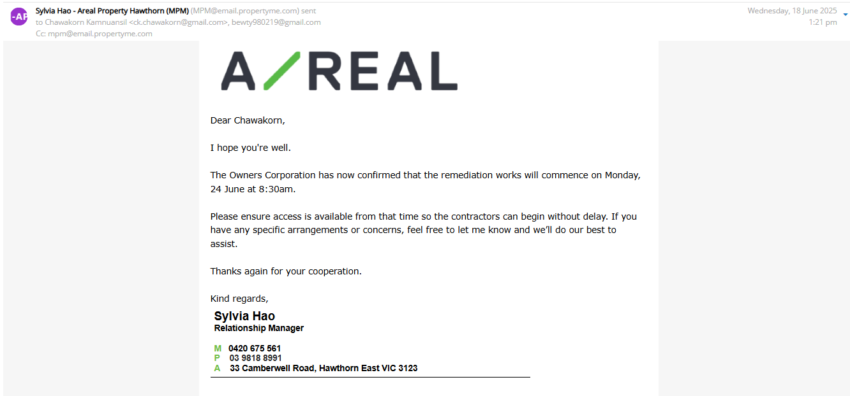

Message 14
Type | RE
Sort Date | 2025-06-24 10:19
Header Date | 24/06/2025 10:19 AEST
Header Subject | Re: Follow-up – Formal Demand & Statement Regarding Unresolved Repairs (Unit 1803)
Source .doc | 250624_-_Re_Follow-up___Formal_Demand___Statement_Regarding_Unresolved_Repairs__Unit_1803_.doc

Subject | Re: Follow-up – Formal Demand & Statement Regarding Unresolved Repairs (Unit 1803)
From | "Johnson Tan - Areal Property Hawthorn (MPM)" <MPM@email.propertyme.com>
Date | 24/06/2025 10:19 AEST
To | ck.chawakorn@gmail.com

Hi Chawakon,

I hope you're both safe and well.
I’ve just been informed by the contractor arranged by the Owners Corporation that they were unable to carry out the scheduled repair work this morning due to an access issue. They mentioned they rang both the intercom and your mobile but unfortunately couldn’t get through.
After waiting for approximately an hour, they had no choice but to leave the building. As a result, they will need to charge the OC for the call-out and arrange a new time for the job to be completed.
Our primary concern is to ensure everything is okay on your end, especially as we haven’t heard from you today.
Please let us know that you're safe when you get a moment, and we’ll work with the OC to coordinate a new appointment as soon as possible.

Johnson Tan
Senior Relationship Manager

M 0420 846 041
E johnson.tan@areal.com.au
P 03 9818 8991
A 33 Camberwell Road Hawthorn East VIC 3123

If you have any feedback regarding my service, please feel free to contact my manager.
Jamie Ong (Head of Property Management) jamie.ong@areal.com.au

DISCLAIMER & WARNING. This correspondence and the information contained in this and associated e-mails are confidential and were only intended for the exclusive use of the addressee(s). If you have received this e-mail in error, any use, copying or inference with this information is unauthorized and prohibited and please immediately delete it and any related attachments or emails from your system and its related sub system and notify the sender. You must never copy, disclose, make conclusions and other information in this message that do not relate to the business of the Areal Property and shall be understood as neither given nor approved or agreed by it. Although Areal Property has taken reasonable precautions to ensure no viruses are present in this e-mail, Areal Property cannot accept responsibility for any loss or damage arising from the use of this e-mail or attachments.

Click to unsubscribe from future email communication

Message 15
Type | RE
Sort Date | 2025-06-24 22:09
Header Date | 24/06/2025 22:09 AEST
Header Subject | Re: Follow-up – Formal Demand & Statement Regarding Unresolved Repairs (Unit 1803)
Source .doc | 250624_-_Re_Follow-up___Formal_Demand___Statement_Regarding_Unresolved_Repairs__Unit_1803_-1.doc

Subject | Re: Follow-up – Formal Demand & Statement Regarding Unresolved Repairs (Unit 1803)
From | Chawakorn Kamnuansil <ck.chawakorn@gmail.com>
Date | 24/06/2025 22:09 AEST
To | "Johnson Tan - Areal Property Hawthorn (MPM)" <MPM@email.propertyme.com>

Dear Johnson,
Thank you for your follow-up regarding events. I sincerely apologize for any inconvenience caused.
I want to clarify that I have never refused access for necessary repairs. The situation on 24 June occurred due to inadequate advance communication about the specific scheduling and requirements, which left me unprepared for the visit.
I genuinely regret that the contractor's time was affected, and I understand this may have caused complications for the scheduling process.
As this matter is now being handled through the formal dispute resolution process (Case RT252398), I believe all repair coordination should proceed through the official RDRV channel to ensure proper documentation and clarity for all parties moving forward.
I remain committed to resolving this matter constructively and cooperatively, and I look forward to working with the Resolution Coordinator to establish an appropriate process that works for everyone involved.
Thank you for your understanding, and I apologize again for yesterday's circumstances.
Regards,
Chawakorn Kamnuansil

