Courtesy Reminder: Upcoming Rent Payment for 1803/243 Franklin Street, Melbourne VIC 3000
Messages: 5

Message 1
Type | ORIG
Sort Date | 2025-10-20 18:39
Header Date | 20/10/2025 18:39 AEDT
Header Subject | Courtesy Reminder: Upcoming Rent Payment for 1803/243 Franklin Street, Melbourne VIC 3000
Source .doc | 251020_-_Courtesy_Reminder__Upcoming_Rent_Payment_for_1803_243_Franklin_Street__Melbourne_.doc

Subject | Courtesy Reminder: Upcoming Rent Payment for 1803/243 Franklin Street, Melbourne VIC 3000
From | "Johnson Tan - Areal Property Hawthorn (MPM)" <MPM@email.propertyme.com>
Date | 20/10/2025 18:39 AEDT
To | Chawakorn Kamnuansil <ck.chawakorn@gmail.com>

Hi Chawakorn,

Just a courtesy reminder that your next rental payment for 1803/243 Franklin Street, Melbourne VIC 3000 falls on 23/10/2025.
Amount: $2,825.00.

Your BPAY details are:
BPAY: AREAL PROPERTY
Biller Code: 358325
Reference Number: 96701

Did you know? You can set up automated recurring payments via BPAY in your online banking app. It’s a set-and-forget option you can update or cancel at any time.

If you’ve already paid or scheduled this, please disregard this reminder. If you’re experiencing financial difficulty, please contact us so we can discuss.

Kind regards,
Johnson Tan
0420 846 041

If you have any feedback regarding my service, please feel free to contact my manager.
Jamie Ong (Head of Property Management) jamie.ong@areal.com.au

DISCLAIMER & WARNING. This correspondence and the information contained in this and associated e-mails are confidential and were only intended for the exclusive use of the addressee(s). If you have received this e-mail in error, any use, copying or inference with this information is unauthorized and prohibited and please immediately delete it and any related attachments or emails from your system and its related sub system and notify the sender. You must never copy, disclose, make conclusions and other information in this message that do not relate to the business of the Areal Property and shall be understood as neither given nor approved or agreed by it. Although Areal Property has taken reasonable precautions to ensure no viruses are present in this e-mail, Areal Property cannot accept responsibility for any loss or damage arising from the use of this e-mail or attachments.

Click to unsubscribe from future email communication

- _251020_MPM@email.propertyme.com_Courtesy_Reminder__Upcoming_Rent_Payment_for_1803_243_Franklin_Street__Melbourne_VIC_3000-318/Rent Invoice #009872.pdf

Attachment Thumbnails
1. Rent Invoice #009872.pdf
Rent Invoice #009872.pdf — Page 1/1 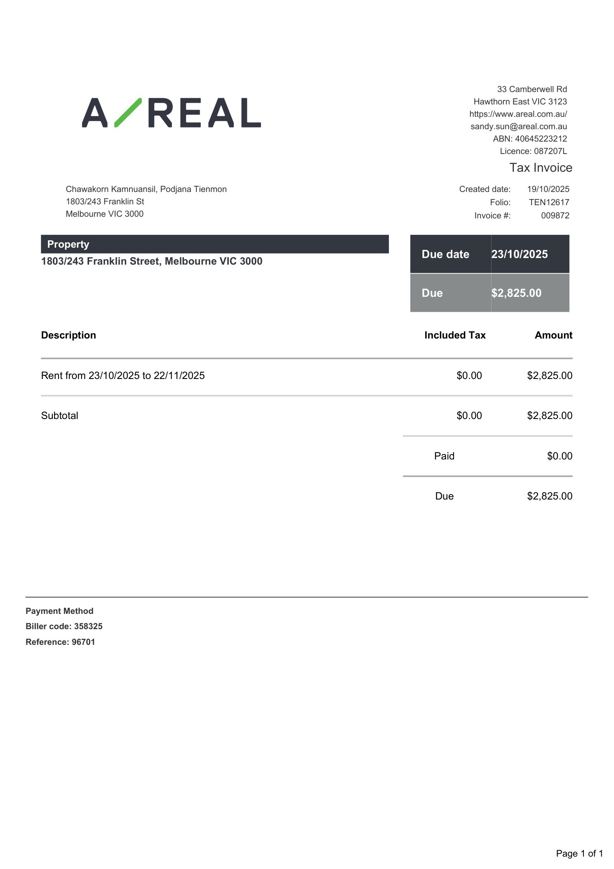

Message 2
Type | ORIG
Sort Date | 2025-11-20 11:22
Header Date | 20/11/2025 11:22 AEDT
Header Subject | Courtesy Reminder: Upcoming Rent Payment for 1803/243 Franklin Street, Melbourne VIC 3000
Source .doc | 251120_-_Courtesy_Reminder__Upcoming_Rent_Payment_for_1803_243_Franklin_Street__Melbourne_.doc

Subject | Courtesy Reminder: Upcoming Rent Payment for 1803/243 Franklin Street, Melbourne VIC 3000
From | "Johnson Tan - Areal Property Hawthorn (MPM)" <MPM@email.propertyme.com>
Date | 20/11/2025 11:22 AEDT
To | Chawakorn Kamnuansil <ck.chawakorn@gmail.com>

Hi Chawakorn,

Just a courtesy reminder that your next rental payment for 1803/243 Franklin Street, Melbourne VIC 3000 falls on 23/11/2025.
Amount: $2,825.00.

Your BPAY details are:
BPAY: AREAL PROPERTY
Biller Code: 358325
Reference Number: 96701

Did you know? You can set up automated recurring payments via BPAY in your online banking app. It’s a set-and-forget option you can update or cancel at any time.

If you’ve already paid or scheduled this, please disregard this reminder. If you’re experiencing financial difficulty, please contact us so we can discuss.

Kind regards,
Johnson Tan
0420 846 041

If you have any feedback regarding my service, please feel free to contact my manager.
Jamima Suter (Head of Department) jamima.suter@areal.com.au

DISCLAIMER & WARNING. This correspondence and the information contained in this and associated e-mails are confidential and were only intended for the exclusive use of the addressee(s). If you have received this e-mail in error, any use, copying or inference with this information is unauthorized and prohibited and please immediately delete it and any related attachments or emails from your system and its related sub system and notify the sender. You must never copy, disclose, make conclusions and other information in this message that do not relate to the business of the Areal Property and shall be understood as neither given nor approved or agreed by it. Although Areal Property has taken reasonable precautions to ensure no viruses are present in this e-mail, Areal Property cannot accept responsibility for any loss or damage arising from the use of this e-mail or attachments.

Click to unsubscribe from future email communication

- _251120_MPM@email.propertyme.com_Courtesy_Reminder__Upcoming_Rent_Payment_for_1803_243_Franklin_Street__Melbourne_VIC_3000-321/Rent Invoice #010956.pdf

Attachment Thumbnails
1. Rent Invoice #010956.pdf
Rent Invoice #010956.pdf — Page 1/1 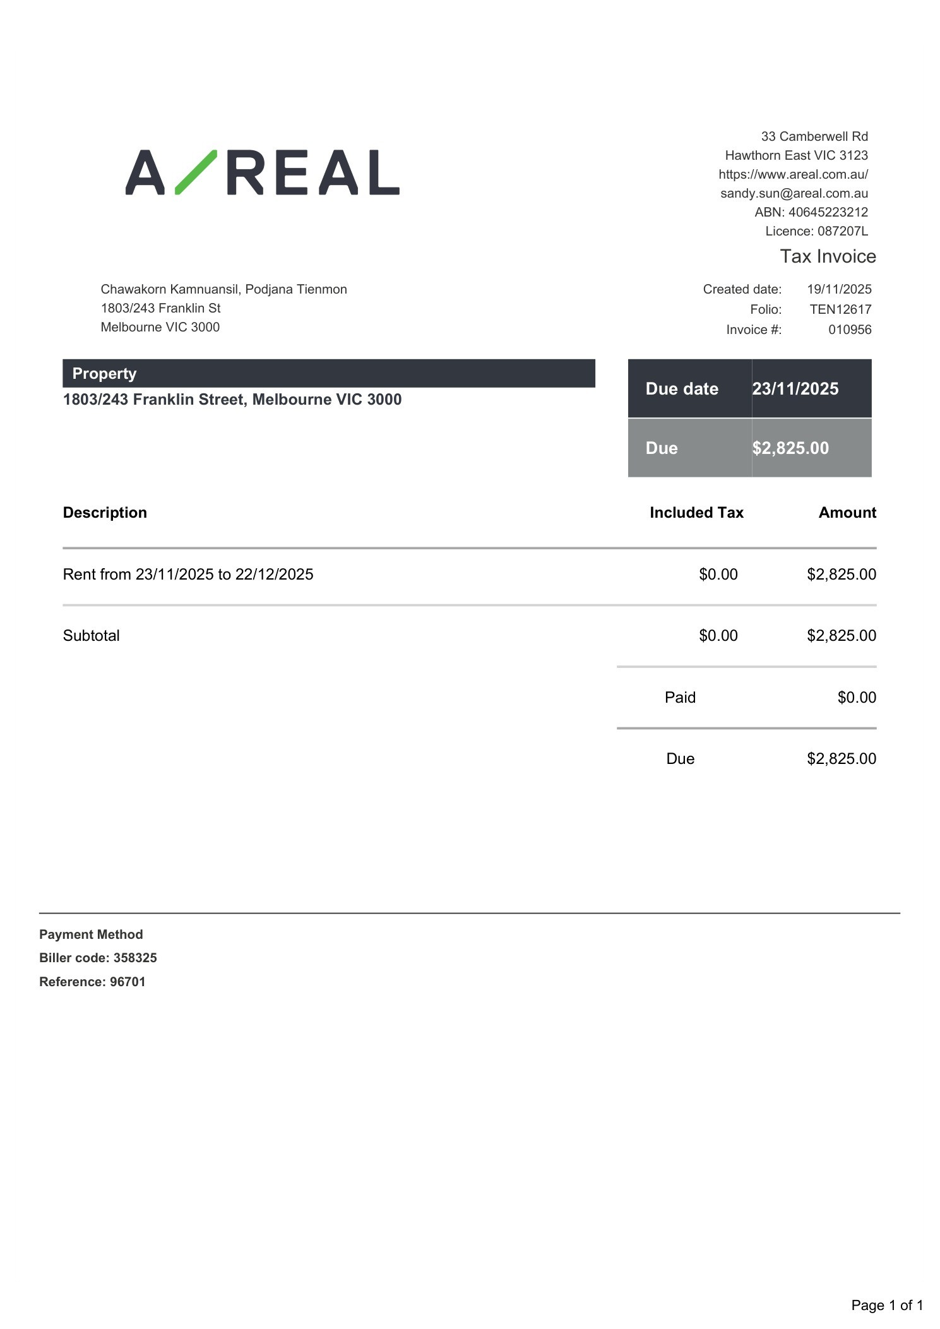

Message 3
Type | ORIG
Sort Date | 2025-12-23 18:23
Header Date | 23/12/2025 18:23 AEDT
Header Subject | Courtesy Reminder: Upcoming Rent Payment for 1803/243 Franklin Street, Melbourne VIC 3000
Source .doc | 251223_-_Courtesy_Reminder__Upcoming_Rent_Payment_for_1803_243_Franklin_Street__Melbourne_.doc

Subject | Courtesy Reminder: Upcoming Rent Payment for 1803/243 Franklin Street, Melbourne VIC 3000
From | "Danielle Symons - Areal Property Hawthorn (MPM)" <MPM@email.propertyme.com>
Date | 23/12/2025 18:23 AEDT
To | Chawakorn Kamnuansil <ck.chawakorn@gmail.com>

Hi Chawakorn,

Just a courtesy reminder that your next rental payment for 1803/243 Franklin Street, Melbourne VIC 3000 falls on 23/12/2025.
Amount: $2,825.00.

Your BPAY details are:
BPAY: AREAL PROPERTY
Biller Code: 358325
Reference Number: 96701

Did you know? You can set up automated recurring payments via BPAY in your online banking app. It’s a set-and-forget option you can update or cancel at any time.

If you’ve already paid or scheduled this, please disregard this reminder. If you’re experiencing financial difficulty, please contact us so we can discuss.

Kind regards,
Danielle Symons
Relationship Manager
0420 675 561

If you have any feedback regarding my service, please feel free to contact my manager.
Nicky Talbot (Head of Property Management) - nicky.talbot@areal.com.au

DISCLAIMER & WARNING. This correspondence and the information contained in this and associated e-mails are confidential and were only intended for the exclusive use of the addressee(s). If you have received this e-mail in error, any use, copying or inference with this information is unauthorized and prohibited and please immediately delete it and any related attachments or emails from your system and its related sub system and notify the sender. You must never copy, disclose, make conclusions and other information in this message that do not relate to the business of the Areal Property and shall be understood as neither given nor approved or agreed by it. Although Areal Property has taken reasonable precautions to ensure no viruses are present in this e-mail, Areal Property cannot accept responsibility for any loss or damage arising from the use of this e-mail or attachments.

Click to unsubscribe from future email communication

- _251223_MPM@email.propertyme.com_Courtesy_Reminder__Upcoming_Rent_Payment_for_1803_243_Franklin_Street__Melbourne_VIC_3000-327/Rent Invoice #012056.pdf

Attachment Thumbnails
1. Rent Invoice #012056.pdf
Rent Invoice #012056.pdf — Page 1/1 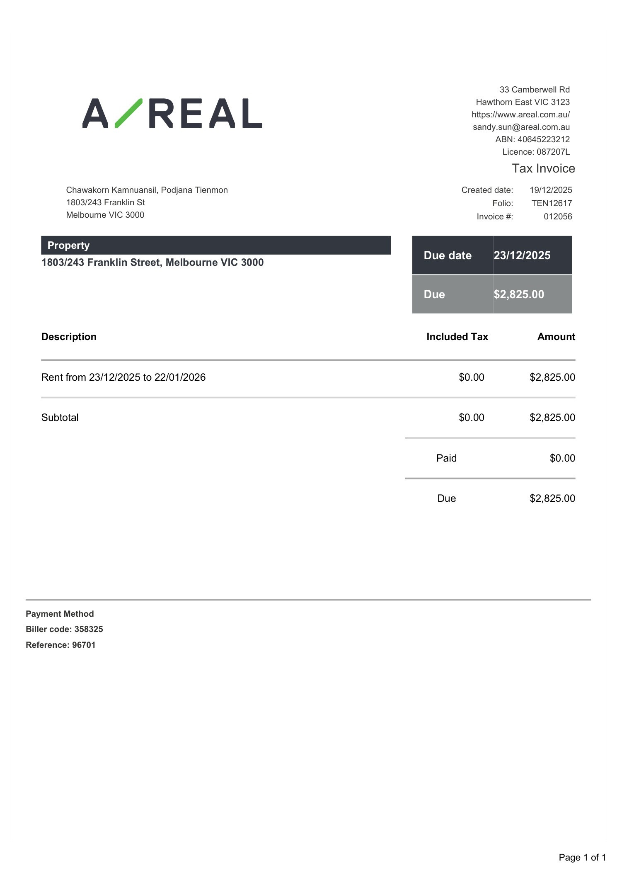

Message 4
Type | ORIG
Sort Date | 2026-01-20 19:17
Header Date | 20/01/2026 19:17 AEDT
Header Subject | Courtesy Reminder: Upcoming Rent Payment for 1803/243 Franklin Street, Melbourne VIC 3000
Source .doc | 260120_-_Courtesy_Reminder__Upcoming_Rent_Payment_for_1803_243_Franklin_Street__Melbourne_.doc

Subject | Courtesy Reminder: Upcoming Rent Payment for 1803/243 Franklin Street, Melbourne VIC 3000
From | "Nicky Talbot - Areal Property Hawthorn (MPM)" <MPM@email.propertyme.com>
Date | 20/01/2026 19:17 AEDT
To | Chawakorn Kamnuansil <ck.chawakorn@gmail.com>

Hi Chawakorn,

Just a courtesy reminder that your next rental payment for 1803/243 Franklin Street, Melbourne VIC 3000 falls on 23/01/2026.
Amount: $2,825.00.

Your BPAY details are:
BPAY: AREAL PROPERTY
Biller Code: 358325
Reference Number: 96701

Did you know? You can set up automated recurring payments via BPAY in your online banking app. It’s a set-and-forget option you can update or cancel at any time.

If you’ve already paid or scheduled this, please disregard this reminder. If you’re experiencing financial difficulty, please contact us so we can discuss.

Kind regards,
Nicky Talbot
Head of Property Management - East
0492 801 841

If you have any feedback regarding my service, please feel free to contact my manager.
Nicky Talbot (Head of Property Management) - nicky.talbot@areal.com.au

DISCLAIMER & WARNING. This correspondence and the information contained in this and associated e-mails are confidential and were only intended for the exclusive use of the addressee(s). If you have received this e-mail in error, any use, copying or inference with this information is unauthorized and prohibited and please immediately delete it and any related attachments or emails from your system and its related sub system and notify the sender. You must never copy, disclose, make conclusions and other information in this message that do not relate to the business of the Areal Property and shall be understood as neither given nor approved or agreed by it. Although Areal Property has taken reasonable precautions to ensure no viruses are present in this e-mail, Areal Property cannot accept responsibility for any loss or damage arising from the use of this e-mail or attachments.

Click to unsubscribe from future email communication

- _260120_MPM@email.propertyme.com_Courtesy_Reminder__Upcoming_Rent_Payment_for_1803_243_Franklin_Street__Melbourne_VIC_3000-329/Rent Invoice #013120.pdf

Attachment Thumbnails
1. Rent Invoice #013120.pdf
Rent Invoice #013120.pdf — Page 1/1 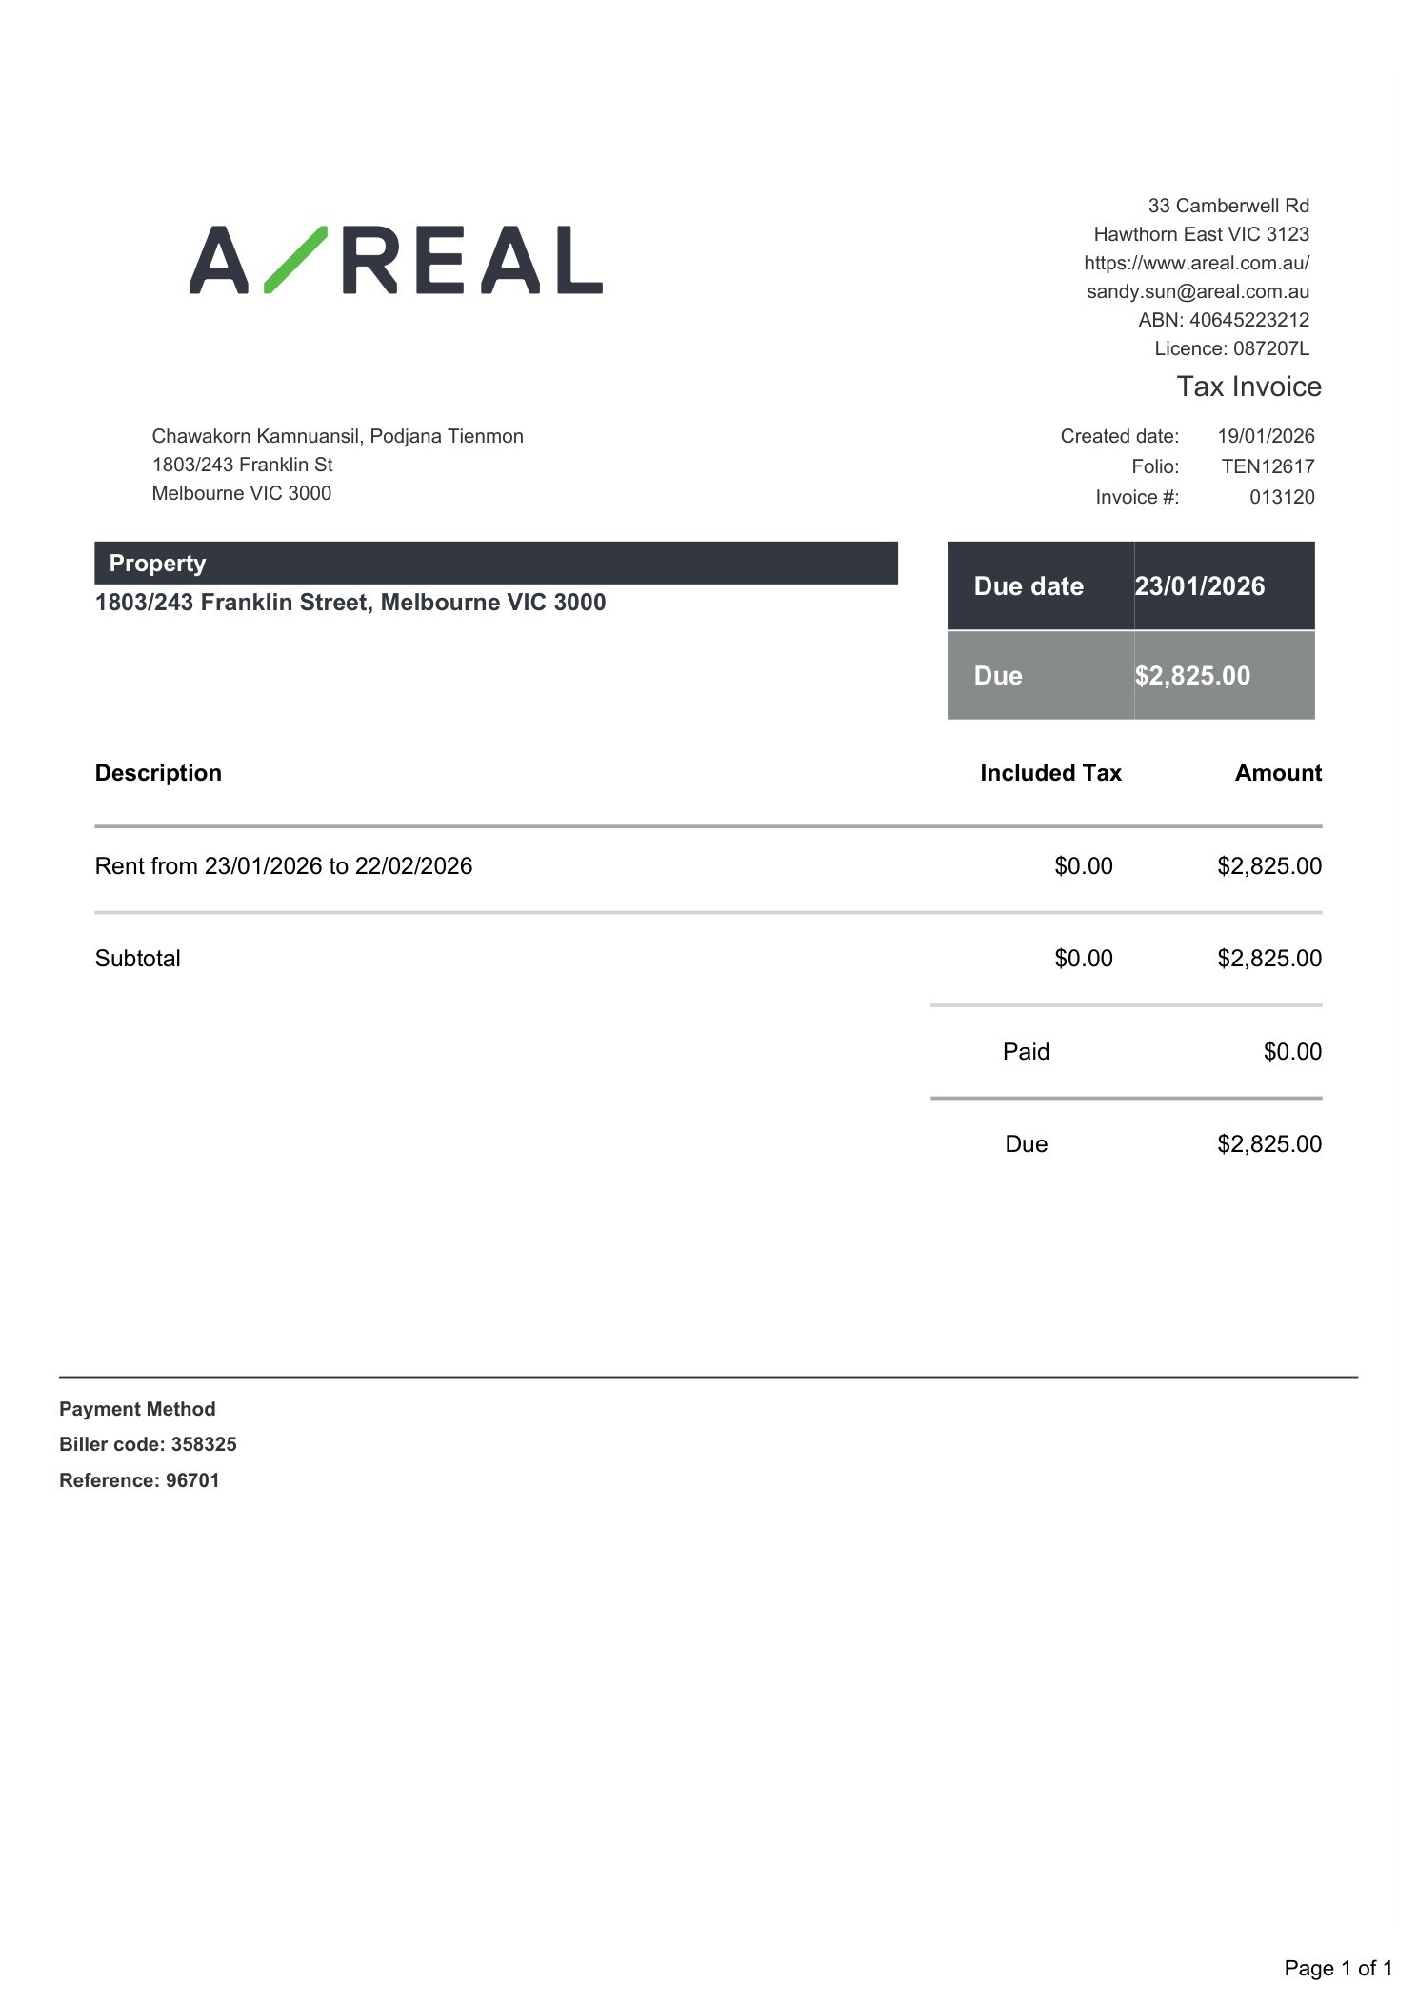

Message 5
Type | ORIG
Sort Date | 2026-02-23 19:56
Header Date | 23/02/2026 19:56 AEDT
Header Subject | Courtesy Reminder: Upcoming Rent Payment for 1803/243 Franklin Street, Melbourne VIC 3000
Source .doc | 260223_-_Courtesy_Reminder__Upcoming_Rent_Payment_for_1803_243_Franklin_Street__Melbourne_.doc

Subject | Courtesy Reminder: Upcoming Rent Payment for 1803/243 Franklin Street, Melbourne VIC 3000
From | "Brian Jeon - Areal Property Hawthorn (MPM)" <MPM@email.propertyme.com>
Date | 23/02/2026 19:56 AEDT
To | Chawakorn Kamnuansil <ck.chawakorn@gmail.com>

Hi Chawakorn,

Just a courtesy reminder that your next rental payment for 1803/243 Franklin Street, Melbourne VIC 3000 falls on 23/02/2026.
Amount: $2,825.00.

Your BPAY details are:
BPAY: AREAL PROPERTY
Biller Code: 358325
Reference Number: 96701

Did you know? You can set up automated recurring payments via BPAY in your online banking app. It’s a set-and-forget option you can update or cancel at any time.

If you’ve already paid or scheduled this, please disregard this reminder. If you’re experiencing financial difficulty, please contact us so we can discuss.

Kind regards,
Brian Jeon
Senior Relationship Manager
0492 847 287

If you have any feedback regarding my service, please feel free to contact my manager.
Nicky Talbot (Head of Property Management) - nicky.talbot@areal.com.au

DISCLAIMER & WARNING. This correspondence and the information contained in this and associated e-mails are confidential and were only intended for the exclusive use of the addressee(s). If you have received this e-mail in error, any use, copying or inference with this information is unauthorized and prohibited and please immediately delete it and any related attachments or emails from your system and its related sub system and notify the sender. You must never copy, disclose, make conclusions and other information in this message that do not relate to the business of the Areal Property and shall be understood as neither given nor approved or agreed by it. Although Areal Property has taken reasonable precautions to ensure no viruses are present in this e-mail, Areal Property cannot accept responsibility for any loss or damage arising from the use of this e-mail or attachments.

Click to unsubscribe from future email communication

- _260223_MPM@email.propertyme.com_Courtesy_Reminder__Upcoming_Rent_Payment_for_1803_243_Franklin_Street__Melbourne_VIC_3000-374/Rent Invoice #014171.pdf

Attachment Thumbnails
1. Rent Invoice #014171.pdf
Rent Invoice #014171.pdf — Page 1/1 