Welcome to Areal Property – Your New Property Management Team
Messages: 1

Message 1
Type | ORIG
Sort Date | 2025-02-07 14:12
Header Date | 07/02/2025 14:12 AEDT
Header Subject | Welcome to Areal Property – Your New Property Management Team
Source .doc | 250207_-_Welcome_to_Areal_Property___Your_New_Property_Management_Team_.doc

Subject | Welcome to Areal Property – Your New Property Management Team
From | "Jessica Xie - Areal Property Hawthorn (MPM)" <MPM@email.propertyme.com>
Date | 07/02/2025 14:12 AEDT
To | Chawakorn Kamnuansil <ck.chawakorn@gmail.com>

Dear Chawakorn,
We’re pleased to welcome you to Areal Property. As of today's date, we will be looking after your tenancy following the transition from BNB Culture.

At Areal Property, we pride ourselves on delivering proactive and responsive property management. Our team is here to support you with any tenancy-related matters, including maintenance requests, rent payments, and general enquiries.

What You Need to Know

Your Property Manager
Your dedicated property manager will be your main point of contact for all tenancy-related matters.
Property Manager: Jessica Xie
Email Address: mpm@email.propertyme.com
Phone Number: 0435 827 411

Rent Payments
Please do not make any further payments to BNB Culture. We recommend removing BNB’s payment details from your banking system to prevent any accidental payments.
Please update your payment details to the following:
BPAY: AREAL PROPERTY
Biller Code: 358325
Reference: 96701
These are the details we have on file from BNB Culture. Please review them and let us know if anything is incorrect. If any areas are blank, it means no information was provided. If there should be details entered, kindly inform us.
Lease Details
- Agreement Start: 23/12/2024
- Agreement Expiry: 22/12/2025
- Move Out Date:

Payment Details
- Paid to Date: 22/02/2025
- Rent Amount: $2,825.00
- Part Payments: $0.00
- Arrears Amount: $0.00
- Rent Increase Amount:
- Rent Increase Date:

Renter Details
- Renters Names: Chawakorn Kamnuansil & Podjana Tienmon
- Your Phone Number: +61458962476
- Your Email Address: ck.chawakorn@gmail.com

Contact Information & Maintenance Requests
For all enquiries and maintenance requests, please contact us at:
Email: mpm@email.propertyme.com
After hours urgent maintenance: Areal Property After-Hours Trades List
Office Phone: 03 9818 8991
Office Address: 33 Camberwell Rd, Hawthorn East VIC 3123
If you are vacating, please return your keys to our Hawthorn Office at 33 Camberwell Rd, Hawthorn East VIC 3123.
We’re committed to making this transition as seamless as possible and look forward to assisting you. If you have any questions, feel free to reach out to us.

We look forward to working with you.
Best regards,
The Areal Property Team

If you have any feedback regarding my service, please feel free to contact my manager.
Jamie Ong (Head of Property Management) jamie.ong@areal.com.au

DISCLAIMER & WARNING. This correspondence and the information contained in this and associated e-mails are confidential and were only intended for the exclusive use of the addressee(s). If you have received this e-mail in error, any use, copying or inference with this information is unauthorized and prohibited and please immediately delete it and any related attachments or emails from your system and its related sub system and notify the sender. You must never copy, disclose, make conclusions and other information in this message that do not relate to the business of the Areal Property and shall be understood as neither given nor approved or agreed by it. Although Areal Property has taken reasonable precautions to ensure no viruses are present in this e-mail, Areal Property cannot accept responsibility for any loss or damage arising from the use of this e-mail or attachments.

Click to unsubscribe from future email communication

- _250207_MPM@email.propertyme.com_Welcome_to_Areal_Property___Your_New_Property_Management_Team-190/Emergency Maintenance Trades Contact List Hawthorn.pdf

Attachment Thumbnails
1. Emergency Maintenance Trades Contact List Hawthorn.pdf
Emergency Maintenance Trades Contact List Hawthorn.pdf — Page 1/2 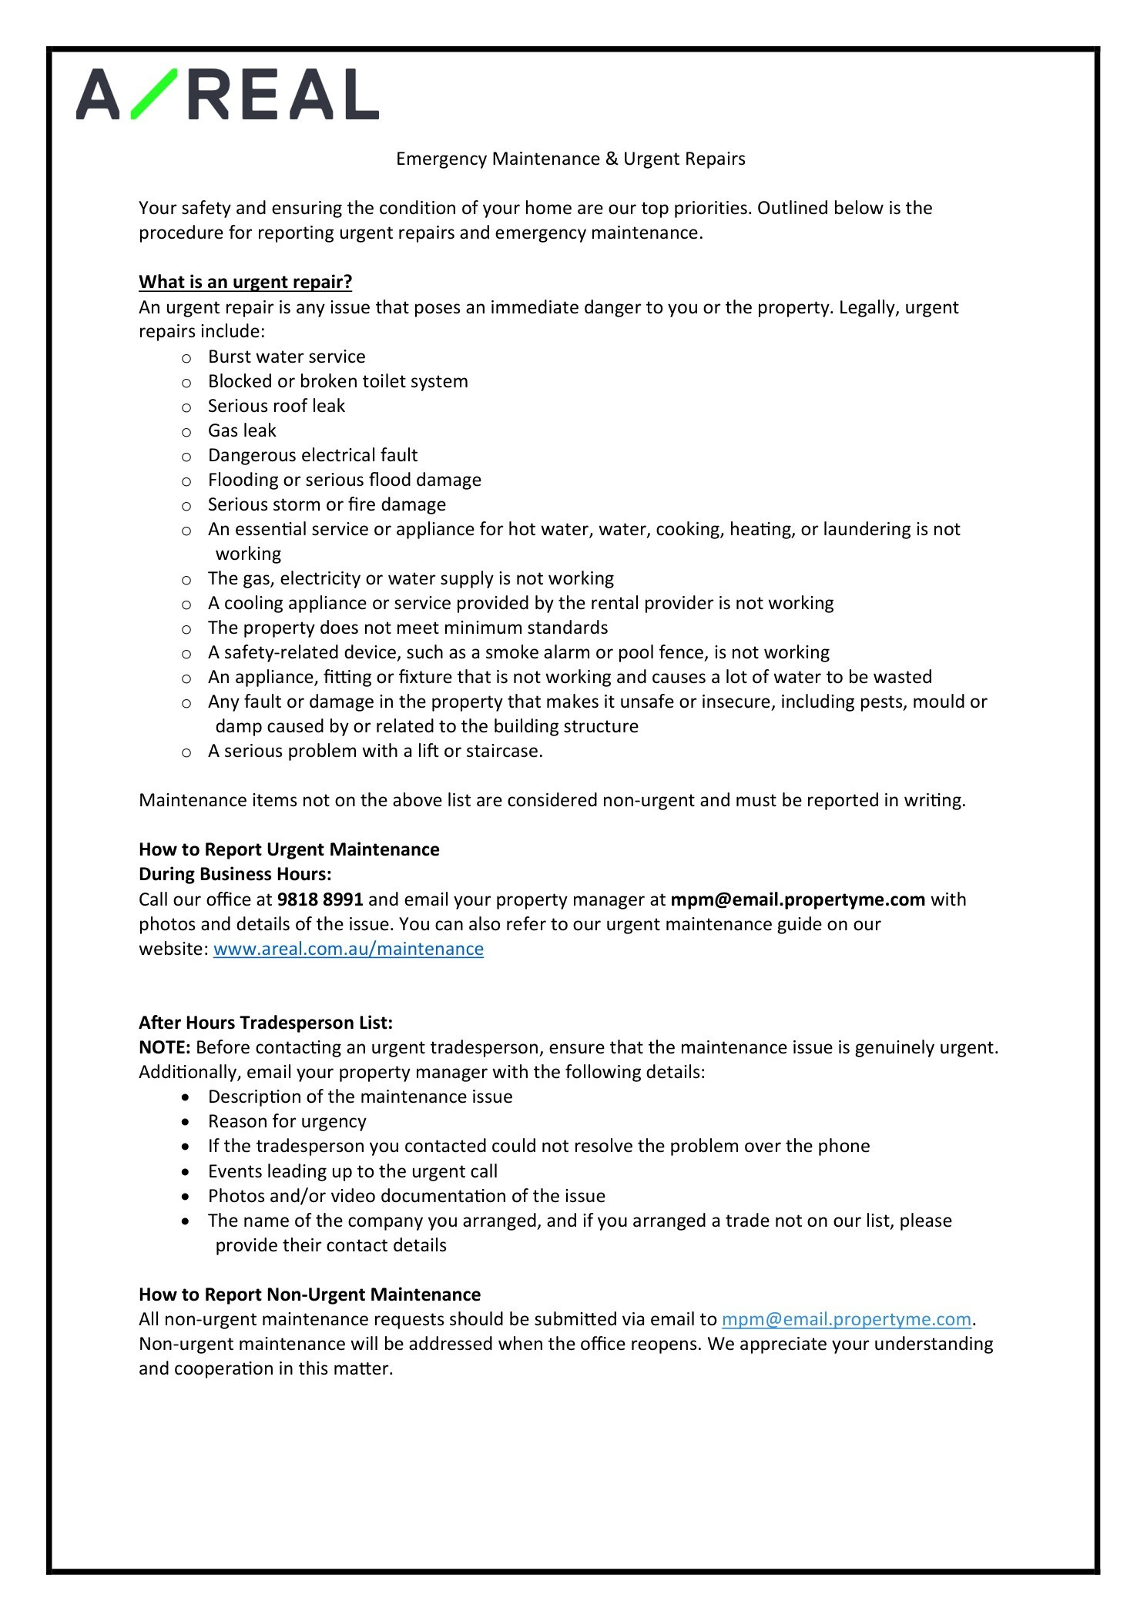 Emergency Maintenance Trades Contact List Hawthorn.pdf — Page 2/2 