Follow-up on Wall and Carpet Damage – 1803/243 Franklin St
Messages: 8

Message 1
Type | ORIG
Sort Date | 2025-05-09 01:56
Header Date | 09/05/2025 01:56 AEST
Header Subject | Follow-up on Wall and Carpet Damage – 1803/243 Franklin St
Source .doc | 250509_-_Follow-up_on_Wall_and_Carpet_Damage___1803_243_Franklin_St_.doc

Subject | Follow-up on Wall and Carpet Damage – 1803/243 Franklin St
From | Chawakorn Kamnuansil <ck.chawakorn@gmail.com>
Date | 09/05/2025 01:56 AEST
To | sylvia.hao@areal.com.au

Hi Sylvia,

It’s been over a week since the plumber attended, and I’ve yet to see any update or progress on the condition of my unit. I had already sent photos clearly showing wall damage — fixing the leak alone doesn’t resolve everything.

This unit is carpeted, and the leak went on for days. It’s only logical to assume the carpet and underlay have been affected too. Does it really make sense to think the issue ends with the hot water pipe?

Also, why has there been complete silence? It’s not even during a public holiday period this time, and yet I’m still left waiting with no information. Is the delay coming from the building manager, or is the owner just not interested in maintaining their own property?

I’ve been patient long enough. Please advise what steps are being taken regarding both the wall and the carpet, and whether an inspection will be arranged.

Regards,
Chawakorn

Message 2
Type | RE
Sort Date | 2025-05-09 14:23
Header Date | 09/05/2025 14:23 AEST
Header Subject | RE: Follow-up on Wall and Carpet Damage – 1803/243 Franklin St
Source .doc | 250509_-_Re_Follow-up_on_Wall_and_Carpet_Damage___1803_243_Franklin_St_.doc

Subject | RE: Follow-up on Wall and Carpet Damage – 1803/243 Franklin St
From | Sylvia Hao <sylvia.hao@areal.com.au>
Date | 09/05/2025 14:23 AEST
To | Chawakorn Kamnuansil <ck.chawakorn@gmail.com>

Hi Chawakorn,

Thank you for your email, and I do apologise for the lack of updates — I understand your concerns and appreciate your continued patience.

The plumber who attended the unit last Wednesday was arranged by the Owner’s Corporation to address the leak from the hot water system. We are currently waiting on their formal report to confirm that the issue has been fully resolved.

In the meantime, could you please let me know if there has been any further water ingress or signs of dampness since their visit? This will help ensure there are no ongoing issues.

Once we receive confirmation that the source of the leak is no longer active, we will arrange for quotations to repair the internal damage, including the wall and potentially affected carpet and underlay.

I understand how frustrating this situation is and will continue to follow up with the relevant parties to ensure the matter is addressed appropriately.

Kind Regards,

 | Sylvia Hao  Relationship Manager  0420 675 561  sylvia.hao@areal.com.au  03 9818 8991  33 Camberwell Road Hawthorn East VIC 3123  www.areal.com.au

 | 


DISCLAIMER & WARNING. This correspondence and the information contained in this and associated e-mails are confidential and were only intended for the exclusive use of the addressee(s). If you have received this e-mail in error, any use, copying or inference with this information is unauthorized and prohibited and please immediately delete it and any related attachments or emails from your system and its related sub system and notify the sender. You must never copy, disclose, make conclusions and other information in this message that do not relate to the business of the Areal Property and shall be understood as neither given nor approved or agreed by it. Although Areal Property has taken reasonable precautions to ensure no viruses are present in this e-mail, Areal Property cannot accept responsibility for any loss or damage arising from the use of this e-mail or attachments.

From: Chawakorn Kamnuansil <ck.chawakorn@gmail.com>
Sent: Friday, 9 May 2025 1:57 AM
To: Sylvia Hao <sylvia.hao@areal.com.au>
Subject: Follow-up on Wall and Carpet Damage – 1803/243 Franklin St

Hi Sylvia,

It’s been over a week since the plumber attended, and I’ve yet to see any update or progress on the condition of my unit. I had already sent photos clearly showing wall damage — fixing the leak alone doesn’t resolve everything.

This unit is carpeted, and the leak went on for days. It’s only logical to assume the carpet and underlay have been affected too. Does it really make sense to think the issue ends with the hot water pipe?

Also, why has there been complete silence? It’s not even during a public holiday period this time, and yet I’m still left waiting with no information. Is the delay coming from the building manager, or is the owner just not interested in maintaining their own property?

I’ve been patient long enough. Please advise what steps are being taken regarding both the wall and the carpet, and whether an inspection will be arranged.

Regards,
Chawakorn

Message 3
Type | RE
Sort Date | 2025-05-10 13:29
Header Date | 10/05/2025 13:29 AEST
Header Subject | Re: Follow-up on Wall and Carpet Damage – 1803/243 Franklin St
Source .doc | 250510_-_Re_Follow-up_on_Wall_and_Carpet_Damage___1803_243_Franklin_St_.doc

Subject | Re: Follow-up on Wall and Carpet Damage – 1803/243 Franklin St
From | Chawakorn Kamnuansil <ck.chawakorn@gmail.com>
Date | 10/05/2025 13:29 AEST
To | Sylvia Hao <sylvia.hao@areal.com.au>

Hi Sylvia,

Thanks for your reply. Here’s an update on the wall — although the water has dried, there is still a visible stain and surface warping, as shown in the attached photo.

I’ve done my best to manage it temporarily using Gumption, but this is clearly not a long-term solution and shouldn’t fall under the tenant’s responsibility.

The wall is still visibly damaged and the room remains unsuitable for normal use. I need to know when someone will be sent to inspect and repair the affected area. This needs to be addressed properly, not just acknowledged.

Also, for record-keeping purposes, all communication regarding this matter must be done via email, as phone calls cannot be documented as evidence if needed.

I expect a response with a clear action plan and timeline.

Best regards,
Chawakorn
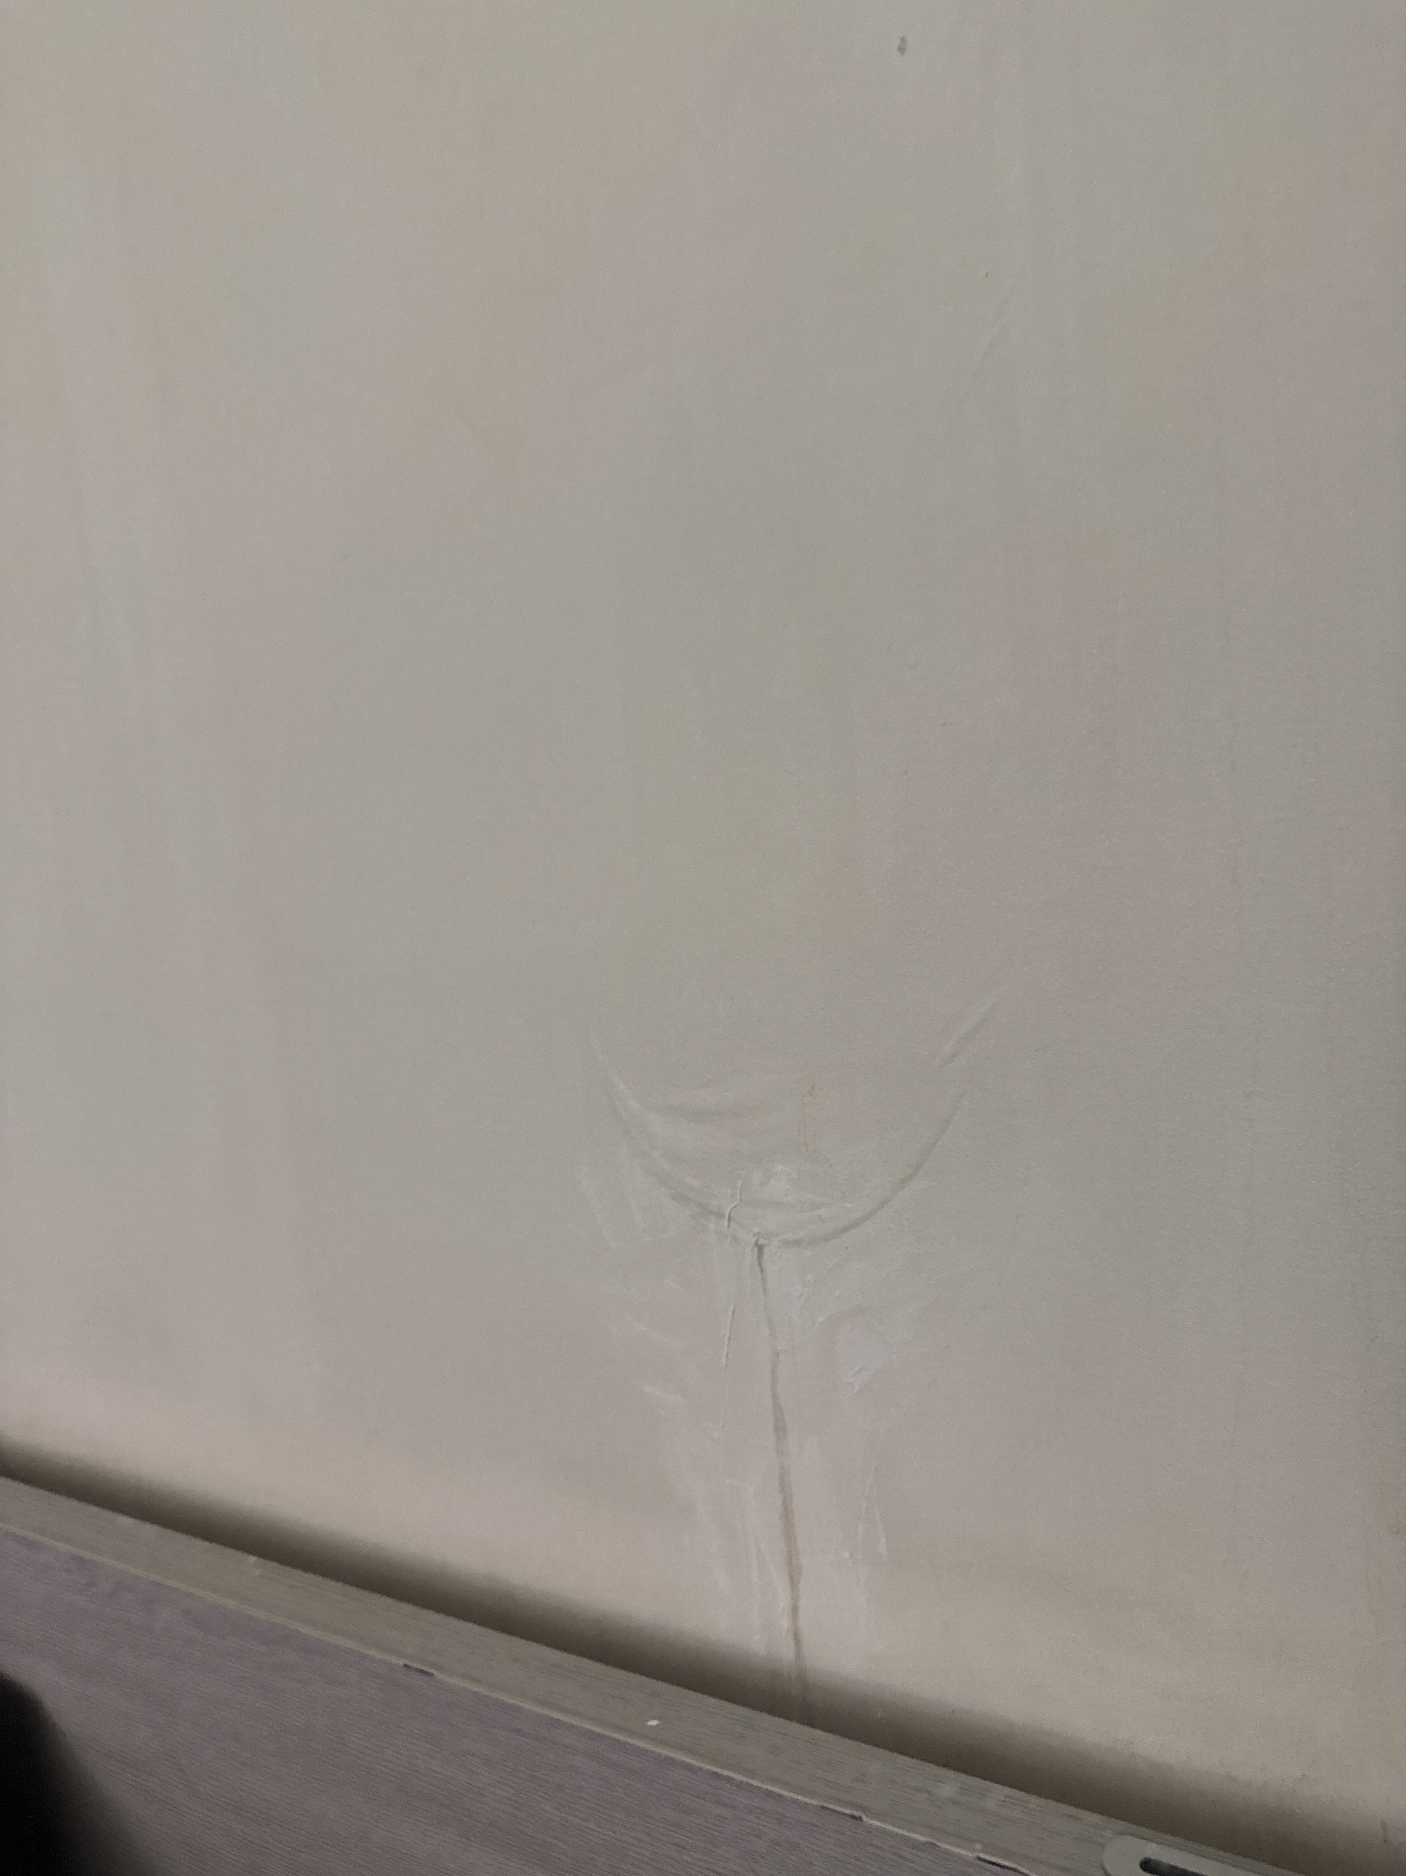

Message 4
Type | RE
Sort Date | 2025-05-12 09:55
Header Date | 12/05/2025 09:55 AEST
Header Subject | Re: FW: Follow-up on Wall and Carpet Damage – 1803/243 Franklin St
Source .doc | 250512_-_Re_FW__Follow-up_on_Wall_and_Carpet_Damage___1803_243_Franklin_St_.doc

Subject | Re: FW: Follow-up on Wall and Carpet Damage – 1803/243 Franklin St
From | "Sylvia Hao - Areal Property Hawthorn (MPM)" <MPM@email.propertyme.com>
Date | 12/05/2025 09:55 AEST
To | ck.chawakorn@gmail.com
Cc | mpm@email.propertyme.com

Hi Chawakorn,
Thank you for your detailed update and the photo.
I’ve followed up with the Owners Corporation to confirm that the leak has been resolved, and I’ve requested that the necessary rectification works be arranged without further delay. I’ve also asked them to provide a clear timeline for inspection and repairs.
I understand the inconvenience this has caused and appreciate your continued patience. I’ll keep you updated as soon as I receive a confirmed plan from their side.
Best regards,
Sylvia Hao
Relationship Manager

M 0420 675 561
P 03 9818 8991
A 33 Camberwell Road, Hawthorn East VIC 3123



If you have any feedback regarding my service, please feel free to contact my manager.
Jamie Ong (Head of Property Management) jamie.ong@areal.com.au

DISCLAIMER & WARNING. This correspondence and the information contained in this and associated e-mails are confidential and were only intended for the exclusive use of the addressee(s). If you have received this e-mail in error, any use, copying or inference with this information is unauthorized and prohibited and please immediately delete it and any related attachments or emails from your system and its related sub system and notify the sender. You must never copy, disclose, make conclusions and other information in this message that do not relate to the business of the Areal Property and shall be understood as neither given nor approved or agreed by it. Although Areal Property has taken reasonable precautions to ensure no viruses are present in this e-mail, Areal Property cannot accept responsibility for any loss or damage arising from the use of this e-mail or attachments.

Click to unsubscribe from future email communication

Message 5
Type | RE
Sort Date | 2025-06-02 16:37
Header Date | 02/06/2025 16:37 AEST
Header Subject | Re: FW: Follow-up on Wall and Carpet Damage – 1803/243 Franklin St
Source .doc | 250602_-_Re_FW__Follow-up_on_Wall_and_Carpet_Damage___1803_243_Franklin_St_.doc

Subject | Re: FW: Follow-up on Wall and Carpet Damage – 1803/243 Franklin St
From | "Sylvia Hao - Areal Property Hawthorn (MPM)" <MPM@email.propertyme.com>
Date | 02/06/2025 16:37 AEST
To | ck.chawakorn@gmail.com
Cc | mpm@email.propertyme.com

Hi Charwakorn,
Just a quick update—OC contractor has confirmed that one of the affected rooms will need to remain inaccessible during the drying process. Drying equipment will be placed in that bedroom, and please note it does emit a moderate level of noise and unfortunately cannot be switched off during operation.
If you prefer not to move out during this period, you're welcome to share the second bedroom or use the living area as a temporary alternative. Could you please confirm if access can be arranged for the drying equipment to be installed?
Let us know what works best for you, and we’ll do our best to assist.
Best regards,
Sylvia Hao
Relationship Manager

M 0420 675 561
P 03 9818 8991
A 33 Camberwell Road, Hawthorn East VIC 3123

If you have any feedback regarding my service, please feel free to contact my manager.
Jamie Ong (Head of Property Management) jamie.ong@areal.com.au

DISCLAIMER & WARNING. This correspondence and the information contained in this and associated e-mails are confidential and were only intended for the exclusive use of the addressee(s). If you have received this e-mail in error, any use, copying or inference with this information is unauthorized and prohibited and please immediately delete it and any related attachments or emails from your system and its related sub system and notify the sender. You must never copy, disclose, make conclusions and other information in this message that do not relate to the business of the Areal Property and shall be understood as neither given nor approved or agreed by it. Although Areal Property has taken reasonable precautions to ensure no viruses are present in this e-mail, Areal Property cannot accept responsibility for any loss or damage arising from the use of this e-mail or attachments.

Click to unsubscribe from future email communication

Message 6
Type | RE
Sort Date | 2025-06-03 13:40
Header Date | 03/06/2025 13:40 AEST
Header Subject | Re: FW: Follow-up on Wall and Carpet Damage – 1803/243 Franklin St
Source .doc | 250603_-_Re_FW__Follow-up_on_Wall_and_Carpet_Damage___1803_243_Franklin_St_-1.doc

Subject | Re: FW: Follow-up on Wall and Carpet Damage – 1803/243 Franklin St
From | "Sylvia Hao - Areal Property Hawthorn (MPM)" <MPM@email.propertyme.com>
Date | 03/06/2025 13:40 AEST
To | ck.chawakorn@gmail.com, bewty980219@gmail.com
Cc | mpm@email.propertyme.com

Hi Podjana,
Thank you for your time on the phone earlier.
As discussed, there is potential mould growth and further damage to the carpet and plaster in the affected bedroom. The building strata and property owners are actively pursuing remediation works to prevent further deterioration.
To move forward, we kindly ask for your confirmation regarding access to the bedroom so that the necessary works can proceed.
Please confirm at your earliest convenience.
Kind regards,
Sylvia Hao
Relationship Manager

M 0420 675 561
P 03 9818 8991
A 33 Camberwell Road, Hawthorn East VIC 3123

If you have any feedback regarding my service, please feel free to contact my manager.
Jamie Ong (Head of Property Management) jamie.ong@areal.com.au

DISCLAIMER & WARNING. This correspondence and the information contained in this and associated e-mails are confidential and were only intended for the exclusive use of the addressee(s). If you have received this e-mail in error, any use, copying or inference with this information is unauthorized and prohibited and please immediately delete it and any related attachments or emails from your system and its related sub system and notify the sender. You must never copy, disclose, make conclusions and other information in this message that do not relate to the business of the Areal Property and shall be understood as neither given nor approved or agreed by it. Although Areal Property has taken reasonable precautions to ensure no viruses are present in this e-mail, Areal Property cannot accept responsibility for any loss or damage arising from the use of this e-mail or attachments.

Click to unsubscribe from future email communication

Message 7
Type | RE
Sort Date | 2025-06-03 15:11
Header Date | 03/06/2025 15:11 AEST
Header Subject | Re: FW: Follow-up on Wall and Carpet Damage – 1803/243 Franklin St
Source .doc | 250603_-_Re_FW__Follow-up_on_Wall_and_Carpet_Damage___1803_243_Franklin_St_.doc

Subject | Re: FW: Follow-up on Wall and Carpet Damage – 1803/243 Franklin St
From | Chawakorn Kamnuansil <ck.chawakorn@gmail.com>
Date | 03/06/2025 15:11 AEST
To | "Sylvia Hao - Areal Property Hawthorn (MPM)" <MPM@email.propertyme.com>

Dear Sylvia,

Thank you for your email.

I confirm that access to the bedroom can be provided as required to facilitate the scheduled repairs. I will ensure that personal items are removed in time.

However, I must formally note that the water intrusion, plaster damage, and associated issues have been ongoing since approximately 15 April 2025. I submitted multiple written reports, yet no action was taken to mitigate the impact for several weeks. This has resulted in substantial disruption and compromised my ability to safely and reasonably occupy the premises.

Given this, I request that your office assess and propose an appropriate rent reduction or compensation, in line with the responsibilities of the rental provider under the Residential Tenancies Act 1997 (VIC). The current circumstances reflect a clear breach of my right to quiet enjoyment, as well as your obligation to attend to urgent repairs in a timely manner.

I also wish to express concern regarding the proposed solution that I relocate for the duration of repairs without any logistical or financial support. It is not reasonable to expect me to independently secure alternative accommodation within a constrained budget. The responsibility for this situation does not rest with me, and I cannot be expected to bear its consequences. Furthermore, while I appreciate the owner’s offer to stay at their Mount Waverley residence, I must respectfully decline. My daily activities, work, and personal needs are based in the city, and any temporary solution must reflect the realities of my lifestyle and commitments.

I will cooperate within reason, but I ask that the proposed solution be revisited in good faith to ensure it does not transfer the burden to me for a matter caused by delays in your agency’s response.

Please also note that I will not accept any further contact by telephone. All future communication must be conducted via email only to avoid disruption to my work and to maintain a written record.

If no compensation or reasonable resolution is offered within five business days, I will consider escalating the matter by submitting a formal application to the Victorian Civil and Administrative Tribunal (VCAT). I remain open to resolving this amicably, but the solution must be fair, timely, and consistent with the facts of the situation.

Kind regards,
Chawakorn Kamnuansil

Message 8
Type | RE
Sort Date | 2025-06-05 14:34
Header Date | 05/06/2025 14:34 AEST
Header Subject | Re: FW: Follow-up on Wall and Carpet Damage – 1803/243 Franklin St
Source .doc | 250605_-_Re_FW__Follow-up_on_Wall_and_Carpet_Damage___1803_243_Franklin_St_.doc

Subject | Re: FW: Follow-up on Wall and Carpet Damage – 1803/243 Franklin St
From | "Sylvia Hao - Areal Property Hawthorn (MPM)" <MPM@email.propertyme.com>
Date | 05/06/2025 14:34 AEST
To | Chawakorn Kamnuansil <ck.chawakorn@gmail.com>

Hi Chawakorn,
I hope you're well.
Following our recent discussions regarding the damage in the bedroom and the upcoming remediation works, I wanted to provide you with an update.
The cause of the leak and damage has been identified as originating from the common roof, which falls under the responsibility of the Owners Corporation (Highrise Strata). We’ve approached them regarding possible rent compensation for the temporary loss of use of the affected bedroom.
While this type of situation doesn’t meet the insurance excess threshold for a formal claim, the Owners Corporation has advised they may consider a rent reduction of approximately 10% to 30% during the works, depending on the impact and supporting documentation.
To proceed, they require a formal written request from you, outlining:
Your request for rent compensation;
The amount requested (e.g., 30%);
A brief explanation (e.g., inability to use the bedroom due to drying equipment or repairs).
I'm more than happy to support a request for the higher end of the range (30%) on your behalf. Please let me know if you’re comfortable with this, and feel free to send me your formal request so we can submit it to the Owners Corporation for review.
If you have any questions or need help wording your request, I’m here to assist.
Looking forward to hearing from you.
Warm regards,
Sylvia Hao
Relationship Manager

M 0420 675 561
P 03 9818 8991
A 33 Camberwell Road, Hawthorn East VIC 3123

If you have any feedback regarding my service, please feel free to contact my manager.
Jamie Ong (Head of Property Management) jamie.ong@areal.com.au

DISCLAIMER & WARNING. This correspondence and the information contained in this and associated e-mails are confidential and were only intended for the exclusive use of the addressee(s). If you have received this e-mail in error, any use, copying or inference with this information is unauthorized and prohibited and please immediately delete it and any related attachments or emails from your system and its related sub system and notify the sender. You must never copy, disclose, make conclusions and other information in this message that do not relate to the business of the Areal Property and shall be understood as neither given nor approved or agreed by it. Although Areal Property has taken reasonable precautions to ensure no viruses are present in this e-mail, Areal Property cannot accept responsibility for any loss or damage arising from the use of this e-mail or attachments.

Click to unsubscribe from future email communication

