VCAT evidence link R202518589 about 1803/243 Franklin Street, MELBOURNE, VIC, 3000
Messages: 1

Message 1
Type | ORIG
Sort Date | 2025-07-24 09:08
Header Date | 24/07/2025 09:08 AEST
Header Subject | VCAT evidence link R202518589 about 1803/243 Franklin Street, MELBOURNE, VIC, 3000
Source .doc | 250724_-_VCAT_evidence_link_R202518589_about_1803_243_Franklin_Street__MELBOURNE__VIC__30_.doc

Subject | VCAT evidence link R202518589 about 1803/243 Franklin Street, MELBOURNE, VIC, 3000
From | "CSV-VCAT-No reply Renting Upload (CSV)" <Noreply_rentingupload@courts.vic.gov.au>
Date | 24/07/2025 09:08 AEST
To | "ck.chawakorn@gmail.com" <ck.chawakorn@gmail.com>



Dear Chawakorn Kamnuansil,
An application has been made to VCAT about the below property.
Please use the link provided in this email to upload a copy of your evidence for this matter.
Link: Click here to open the Document Upload Web Page
PIN: xZr0
Please note that only evidence for your case should be uploaded via the link.
Any requests to VCAT that require actioning (e.g. an update to party details or an adjournment request) must be sent to renting@courts.vic.gov.au,
otherwise it will not be considered.
Please be advised that uploading your evidence through the link provided, replaces any requirements to email your documents to the Tribunal.
Unless your matter has been listed urgently, it is expected that documents for hearing will need to be uploaded at least 3 business days prior to the hearing date.
Important: This link is specific to this VCAT application and must only be used for evidence relating to this matter.
Please note, this link is active for 6 months from today’s date. If your matter is still active after 6 months, you will require a new link.
VCAT Reference for this application: R202518589/00
You must use the VCAT reference number when communicating with VCAT in writing or over the phone.
Rented premises: 1803/243 Franklin Street, MELBOURNE, VIC, 3000
Applicant: Ting Zhang
Respondent: Podjana Tienmon ,Chawakorn Kamnuansil
Section: possession - unfit or unsafe
Important: You will receive a VCAT order or notice of hearing with next steps regarding this application in due course.

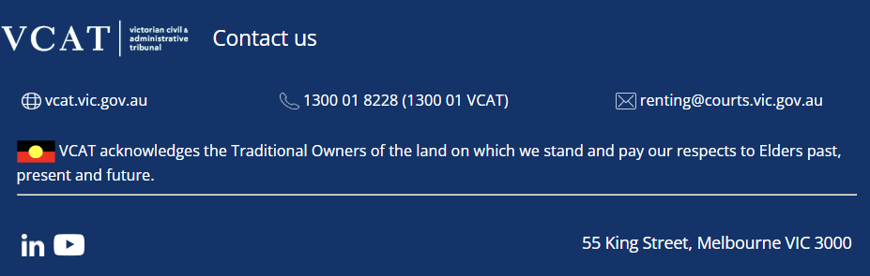

PRIVATE & CONFIDENTIAL
The content of this e-mail and any attachments may be private and confidential, intended only for use of the individual or entity named. If you are not the intended recipient of this message you must not read, forward, print, copy, disclose, use or store in any way the information this e-mail or any attachment contains.
If you are not the intended recipient, please notify the sender immediately and delete or destroy all copies of this e-mail and any attachments.
Our organisation respects the privacy of individuals. For a copy of our privacy policy please go to our website or contact us.

