Receipt of payment for 1803/243 Franklin Street, Melbourne VIC 3000
Messages: 7

Message 1
Type | ORIG
Sort Date | 2025-05-26 12:02
Header Date | 26/05/2025 12:02 AEST
Header Subject | Receipt of payment for 1803/243 Franklin Street, Melbourne VIC 3000
Source .doc | 250526_-_Receipt_of_payment_for_1803_243_Franklin_Street__Melbourne_VIC_3000_.doc

Subject | Receipt of payment for 1803/243 Franklin Street, Melbourne VIC 3000
From | "Sylvia Hao - Areal Property Hawthorn (MPM)" <MPM@email.propertyme.com>
Date | 26/05/2025 12:02 AEST
To | Chawakorn Kamnuansil <ck.chawakorn@gmail.com>

Hi Chawakorn,
Thanks for your recent payment of $2,825.00 that we processed on 23/05/2025. We have attached a payment receipt to this email which details any changes to your rent paid to dates.
Please don't hesitate to contact us should you have any queries.
With thanks,
Sylvia Hao
Areal Property (MPM) Pty Ltd
03 9818 8991
sylvia.hao@areal.com.au
https://www.areal.com.au/

If you have any feedback regarding my service, please feel free to contact my manager.
Jamie Ong (Head of Property Management) jamie.ong@areal.com.au

DISCLAIMER & WARNING. This correspondence and the information contained in this and associated e-mails are confidential and were only intended for the exclusive use of the addressee(s). If you have received this e-mail in error, any use, copying or inference with this information is unauthorized and prohibited and please immediately delete it and any related attachments or emails from your system and its related sub system and notify the sender. You must never copy, disclose, make conclusions and other information in this message that do not relate to the business of the Areal Property and shall be understood as neither given nor approved or agreed by it. Although Areal Property has taken reasonable precautions to ensure no viruses are present in this e-mail, Areal Property cannot accept responsibility for any loss or damage arising from the use of this e-mail or attachments.

Click to unsubscribe from future email communication

- _250526_MPM@email.propertyme.com_Receipt_of_payment_for_1803_243_Franklin_Street__Melbourne_VIC_3000-191/Receipt # 89393.pdf

Attachment Thumbnails
1. Receipt # 89393.pdf
Receipt # 89393.pdf — Page 1/1 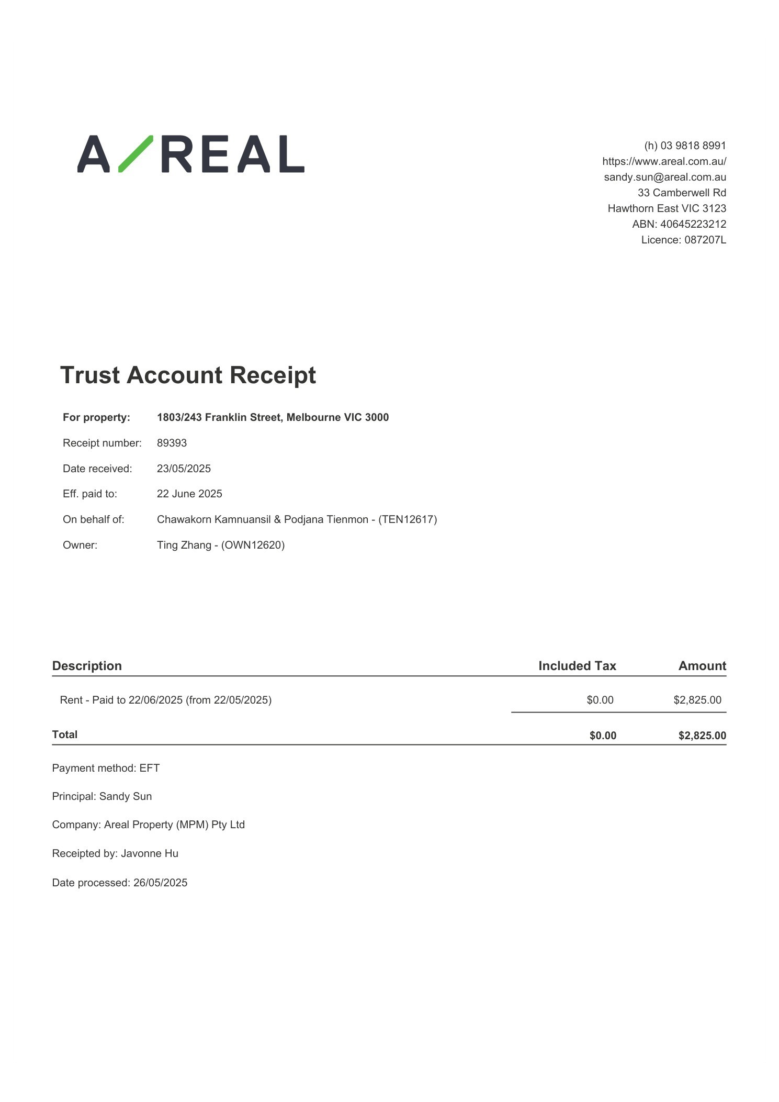

Message 2
Type | ORIG
Sort Date | 2025-06-24 18:12
Header Date | 24/06/2025 18:12 AEST
Header Subject | Receipt of payment for 1803/243 Franklin Street, Melbourne VIC 3000
Source .doc | 250624_-_Receipt_of_payment_for_1803_243_Franklin_Street__Melbourne_VIC_3000_.doc

Subject | Receipt of payment for 1803/243 Franklin Street, Melbourne VIC 3000
From | "Sylvia Hao - Areal Property Hawthorn (MPM)" <MPM@email.propertyme.com>
Date | 24/06/2025 18:12 AEST
To | Chawakorn Kamnuansil <ck.chawakorn@gmail.com>

Hi Chawakorn,
Thanks for your recent payment of $2,825.00 that we processed on 23/06/2025. We have attached a payment receipt to this email which details any changes to your rent paid to dates.
Please don't hesitate to contact us should you have any queries.
With thanks,
Sylvia Hao
Areal Property (MPM) Pty Ltd
03 9818 8991
sylvia.hao@areal.com.au
https://www.areal.com.au/

If you have any feedback regarding my service, please feel free to contact my manager.
Jamie Ong (Head of Property Management) jamie.ong@areal.com.au

DISCLAIMER & WARNING. This correspondence and the information contained in this and associated e-mails are confidential and were only intended for the exclusive use of the addressee(s). If you have received this e-mail in error, any use, copying or inference with this information is unauthorized and prohibited and please immediately delete it and any related attachments or emails from your system and its related sub system and notify the sender. You must never copy, disclose, make conclusions and other information in this message that do not relate to the business of the Areal Property and shall be understood as neither given nor approved or agreed by it. Although Areal Property has taken reasonable precautions to ensure no viruses are present in this e-mail, Areal Property cannot accept responsibility for any loss or damage arising from the use of this e-mail or attachments.

Click to unsubscribe from future email communication

- _250624_MPM@email.propertyme.com_Receipt_of_payment_for_1803_243_Franklin_Street__Melbourne_VIC_3000-204/Receipt # 90497.pdf

Attachment Thumbnails
1. Receipt # 90497.pdf
Receipt # 90497.pdf — Page 1/1 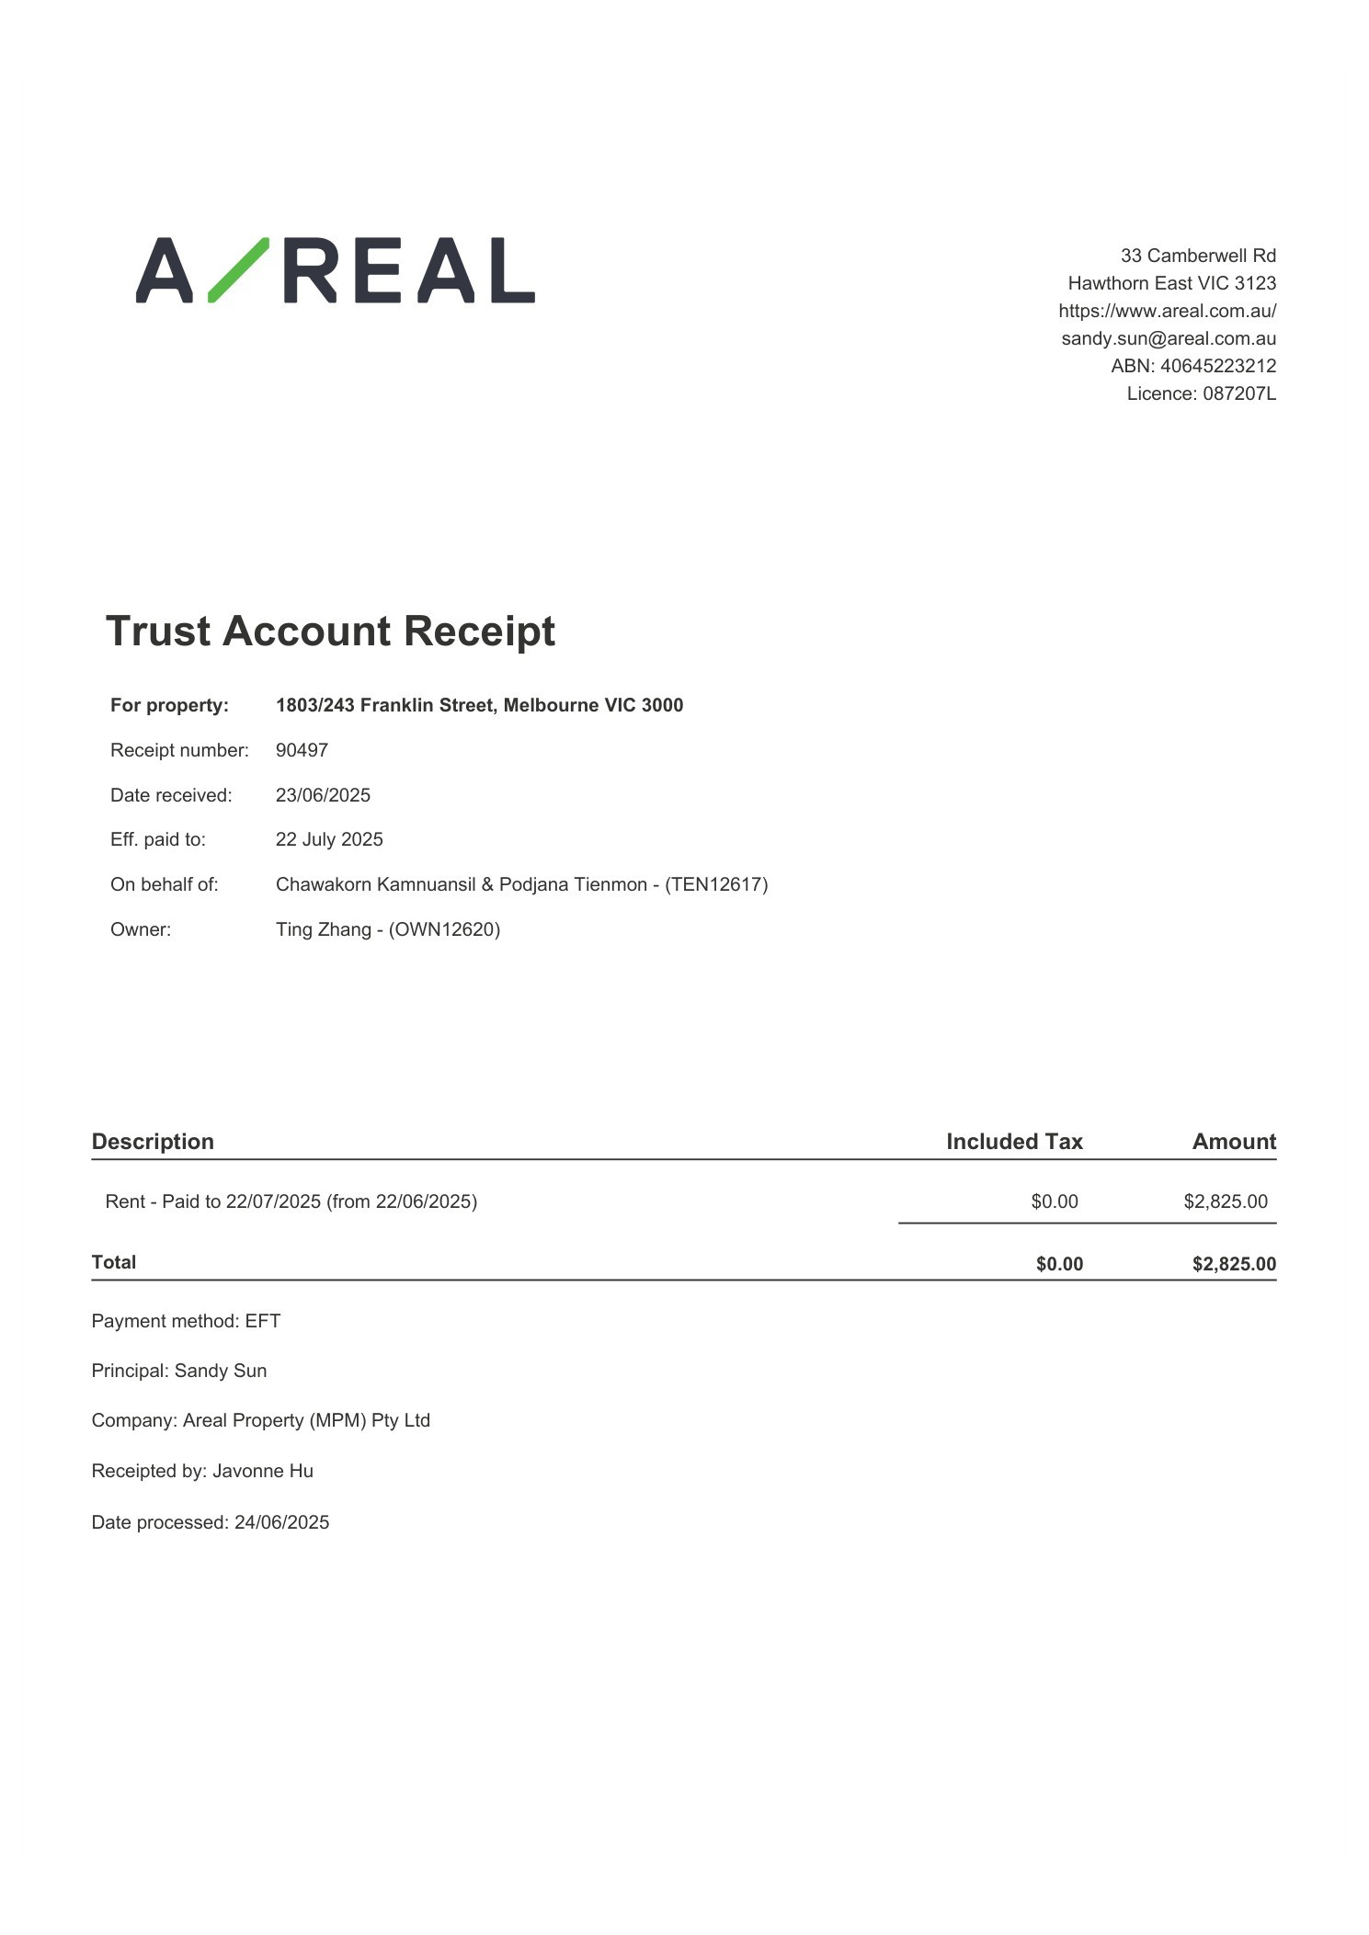

Message 3
Type | ORIG
Sort Date | 2025-07-25 17:42
Header Date | 25/07/2025 17:42 AEST
Header Subject | Receipt of payment for 1803/243 Franklin Street, Melbourne VIC 3000
Source .doc | 250725_-_Receipt_of_payment_for_1803_243_Franklin_Street__Melbourne_VIC_3000_.doc

Subject | Receipt of payment for 1803/243 Franklin Street, Melbourne VIC 3000
From | "Sylvia Hao - Areal Property Hawthorn (MPM)" <MPM@email.propertyme.com>
Date | 25/07/2025 17:42 AEST
To | Chawakorn Kamnuansil <ck.chawakorn@gmail.com>

Hi Chawakorn,
Thanks for your recent payment of $2,825.00 that we processed on 24/07/2025. We have attached a payment receipt to this email which details any changes to your rent paid to dates.
Please don't hesitate to contact us should you have any queries.
With thanks,
Sylvia Hao
Areal Property (MPM) Pty Ltd
03 9818 8991
sylvia.hao@areal.com.au
https://www.areal.com.au/

If you have any feedback regarding my service, please feel free to contact my manager.
Jamie Ong (Head of Property Management) jamie.ong@areal.com.au

DISCLAIMER & WARNING. This correspondence and the information contained in this and associated e-mails are confidential and were only intended for the exclusive use of the addressee(s). If you have received this e-mail in error, any use, copying or inference with this information is unauthorized and prohibited and please immediately delete it and any related attachments or emails from your system and its related sub system and notify the sender. You must never copy, disclose, make conclusions and other information in this message that do not relate to the business of the Areal Property and shall be understood as neither given nor approved or agreed by it. Although Areal Property has taken reasonable precautions to ensure no viruses are present in this e-mail, Areal Property cannot accept responsibility for any loss or damage arising from the use of this e-mail or attachments.

Click to unsubscribe from future email communication

- _250725_MPM@email.propertyme.com_Receipt_of_payment_for_1803_243_Franklin_Street__Melbourne_VIC_3000-299/Receipt # 91716.pdf

Attachment Thumbnails
1. Receipt # 91716.pdf
Receipt # 91716.pdf — Page 1/1 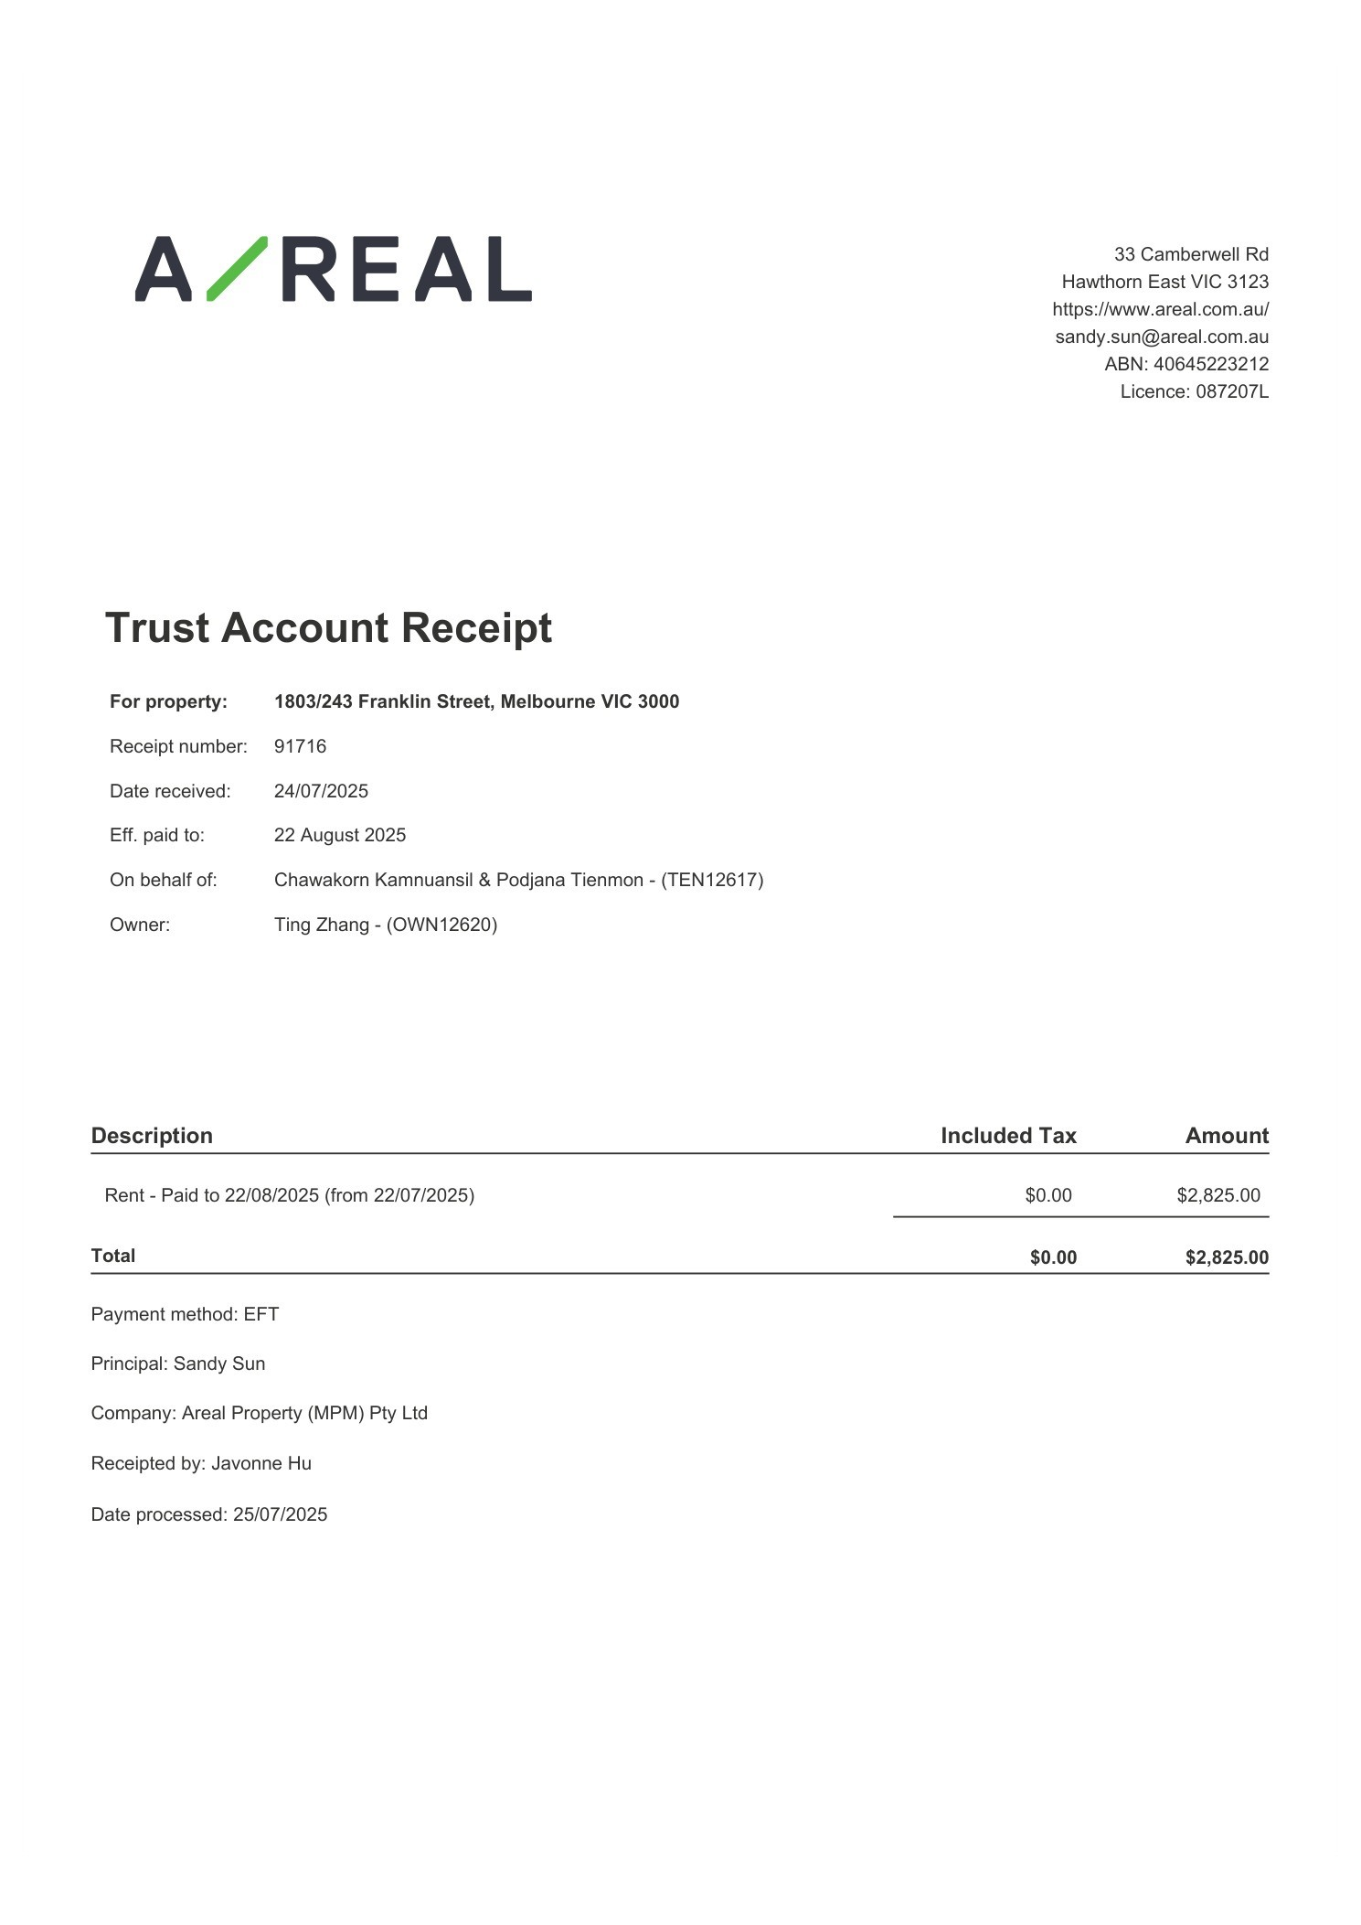

Message 4
Type | ORIG
Sort Date | 2025-08-27 17:47
Header Date | 27/08/2025 17:47 AEST
Header Subject | Receipt of payment for 1803/243 Franklin Street, Melbourne VIC 3000
Source .doc | 250827_-_Receipt_of_payment_for_1803_243_Franklin_Street__Melbourne_VIC_3000_.doc

Subject | Receipt of payment for 1803/243 Franklin Street, Melbourne VIC 3000
From | "Johnson Tan - Areal Property Hawthorn (MPM)" <MPM@email.propertyme.com>
Date | 27/08/2025 17:47 AEST
To | Chawakorn Kamnuansil <ck.chawakorn@gmail.com>

Hi Chawakorn,
Thanks for your recent payment of $2,825.00 that we processed on 25/08/2025. We have attached a payment receipt to this email which details any changes to your rent paid to dates.
Please don't hesitate to contact us should you have any queries.
With thanks,
Johnson Tan
Areal Property (MPM) Pty Ltd
03 9818 8991
johnson.tan@areal.com.au
https://www.areal.com.au/

If you have any feedback regarding my service, please feel free to contact my manager.
Jamie Ong (Head of Property Management) jamie.ong@areal.com.au

DISCLAIMER & WARNING. This correspondence and the information contained in this and associated e-mails are confidential and were only intended for the exclusive use of the addressee(s). If you have received this e-mail in error, any use, copying or inference with this information is unauthorized and prohibited and please immediately delete it and any related attachments or emails from your system and its related sub system and notify the sender. You must never copy, disclose, make conclusions and other information in this message that do not relate to the business of the Areal Property and shall be understood as neither given nor approved or agreed by it. Although Areal Property has taken reasonable precautions to ensure no viruses are present in this e-mail, Areal Property cannot accept responsibility for any loss or damage arising from the use of this e-mail or attachments.

Click to unsubscribe from future email communication

- _250827_MPM@email.propertyme.com_Receipt_of_payment_for_1803_243_Franklin_Street__Melbourne_VIC_3000-309/Receipt # 92863.pdf

Attachment Thumbnails
1. Receipt # 92863.pdf
Receipt # 92863.pdf — Page 1/1 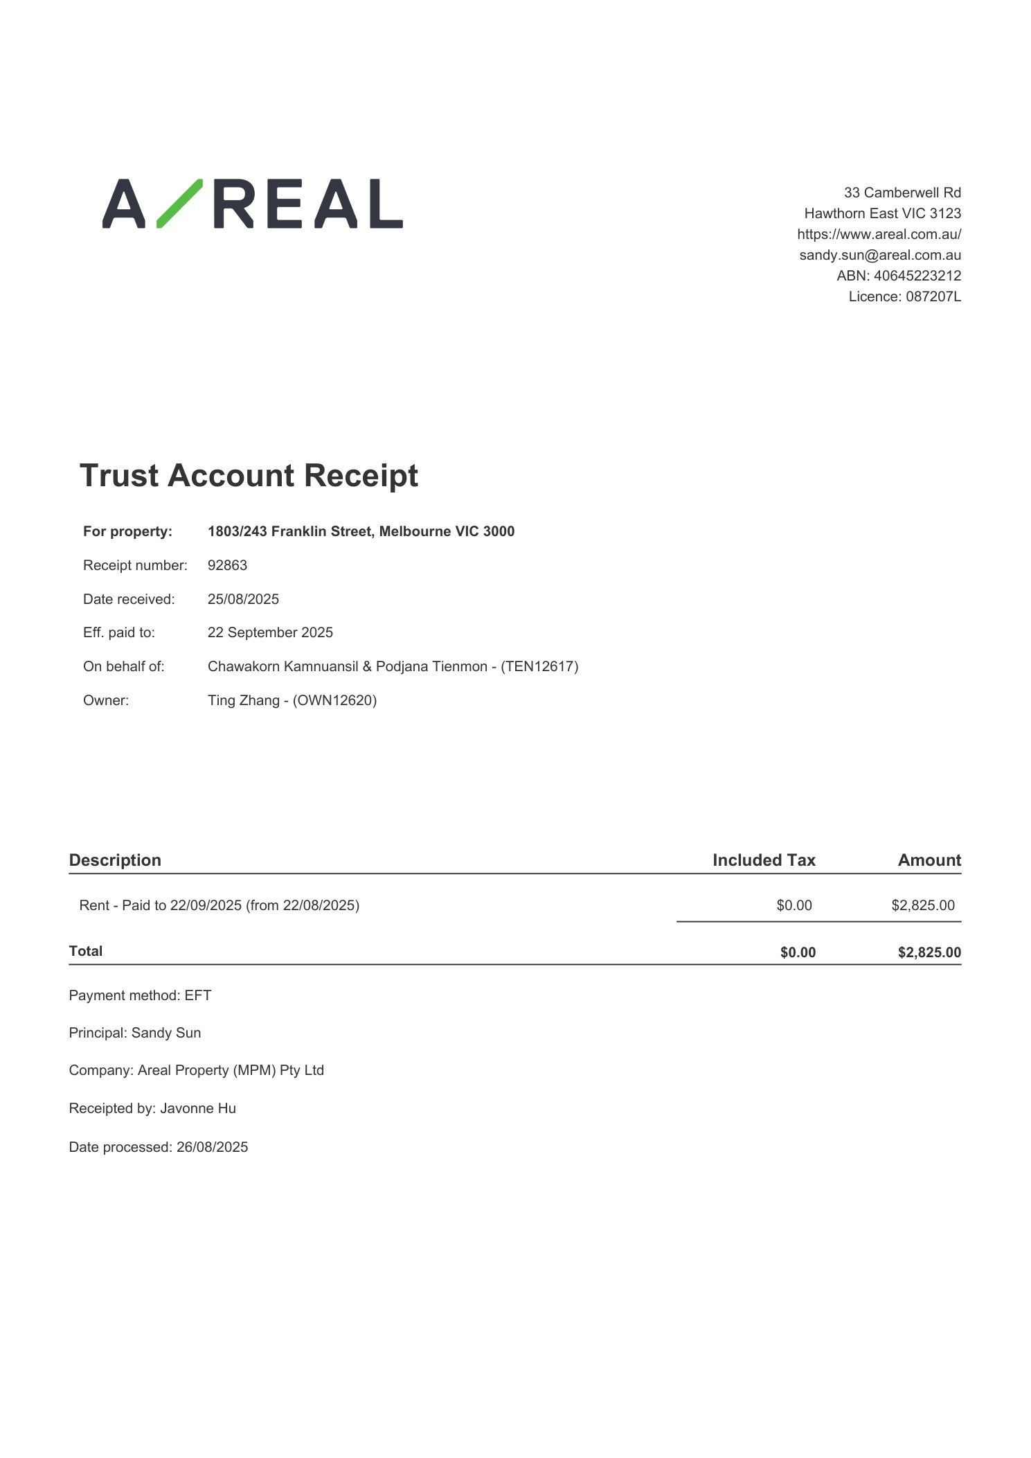

Message 5
Type | ORIG
Sort Date | 2025-09-30 16:32
Header Date | 30/09/2025 16:32 AEST
Header Subject | Receipt of payment for 1803/243 Franklin Street, Melbourne VIC 3000
Source .doc | 250930_-_Receipt_of_payment_for_1803_243_Franklin_Street__Melbourne_VIC_3000_.doc

Subject | Receipt of payment for 1803/243 Franklin Street, Melbourne VIC 3000
From | "Johnson Tan - Areal Property Hawthorn (MPM)" <MPM@email.propertyme.com>
Date | 30/09/2025 16:32 AEST
To | Chawakorn Kamnuansil <ck.chawakorn@gmail.com>

Hi Chawakorn,
Thanks for your recent payment of $2,825.00 that we processed on 29/09/2025. We have attached a payment receipt to this email which details any changes to your rent paid to dates.
Please don't hesitate to contact us should you have any queries.
With thanks,
Johnson Tan
Areal Property (MPM) Pty Ltd
03 9818 8991
johnson.tan@areal.com.au
https://www.areal.com.au/

If you have any feedback regarding my service, please feel free to contact my manager.
Jamie Ong (Head of Property Management) jamie.ong@areal.com.au

DISCLAIMER & WARNING. This correspondence and the information contained in this and associated e-mails are confidential and were only intended for the exclusive use of the addressee(s). If you have received this e-mail in error, any use, copying or inference with this information is unauthorized and prohibited and please immediately delete it and any related attachments or emails from your system and its related sub system and notify the sender. You must never copy, disclose, make conclusions and other information in this message that do not relate to the business of the Areal Property and shall be understood as neither given nor approved or agreed by it. Although Areal Property has taken reasonable precautions to ensure no viruses are present in this e-mail, Areal Property cannot accept responsibility for any loss or damage arising from the use of this e-mail or attachments.

Click to unsubscribe from future email communication

- _250930_MPM@email.propertyme.com_Receipt_of_payment_for_1803_243_Franklin_Street__Melbourne_VIC_3000-312/Receipt # 94202.pdf

Attachment Thumbnails
1. Receipt # 94202.pdf
Receipt # 94202.pdf — Page 1/1 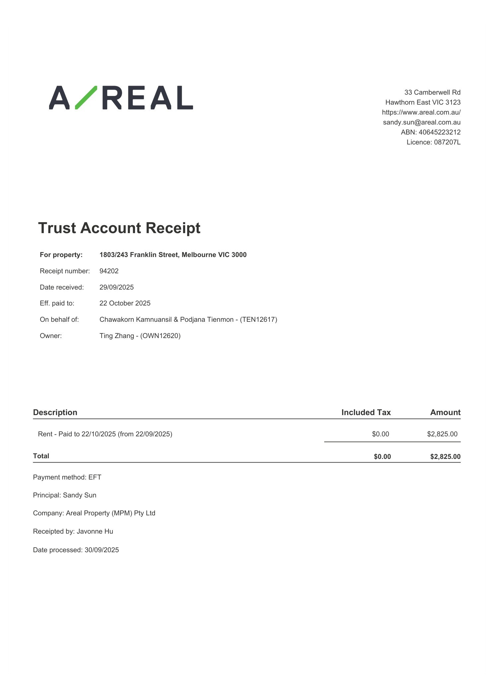

Message 6
Type | ORIG
Sort Date | 2025-10-28 15:20
Header Date | 28/10/2025 15:20 AEDT
Header Subject | Receipt of payment for 1803/243 Franklin Street, Melbourne VIC 3000
Source .doc | 251028_-_Receipt_of_payment_for_1803_243_Franklin_Street__Melbourne_VIC_3000_.doc

Subject | Receipt of payment for 1803/243 Franklin Street, Melbourne VIC 3000
From | "Johnson Tan - Areal Property Hawthorn (MPM)" <MPM@email.propertyme.com>
Date | 28/10/2025 15:20 AEDT
To | Chawakorn Kamnuansil <ck.chawakorn@gmail.com>

Hi Chawakorn,
Thanks for your recent payment of $2,825.00 that we processed on 27/10/2025. We have attached a payment receipt to this email which details any changes to your rent paid to dates.
Please don't hesitate to contact us should you have any queries.
With thanks,
Johnson Tan
Areal Property (MPM) Pty Ltd
03 9818 8991
johnson.tan@areal.com.au
https://www.areal.com.au/

If you have any feedback regarding my service, please feel free to contact my manager.
Jamie Ong (Head of Property Management) jamie.ong@areal.com.au

DISCLAIMER & WARNING. This correspondence and the information contained in this and associated e-mails are confidential and were only intended for the exclusive use of the addressee(s). If you have received this e-mail in error, any use, copying or inference with this information is unauthorized and prohibited and please immediately delete it and any related attachments or emails from your system and its related sub system and notify the sender. You must never copy, disclose, make conclusions and other information in this message that do not relate to the business of the Areal Property and shall be understood as neither given nor approved or agreed by it. Although Areal Property has taken reasonable precautions to ensure no viruses are present in this e-mail, Areal Property cannot accept responsibility for any loss or damage arising from the use of this e-mail or attachments.

Click to unsubscribe from future email communication

- _251028_MPM@email.propertyme.com_Receipt_of_payment_for_1803_243_Franklin_Street__Melbourne_VIC_3000-319/Receipt # 95582.pdf

Attachment Thumbnails
1. Receipt # 95582.pdf
Receipt # 95582.pdf — Page 1/1 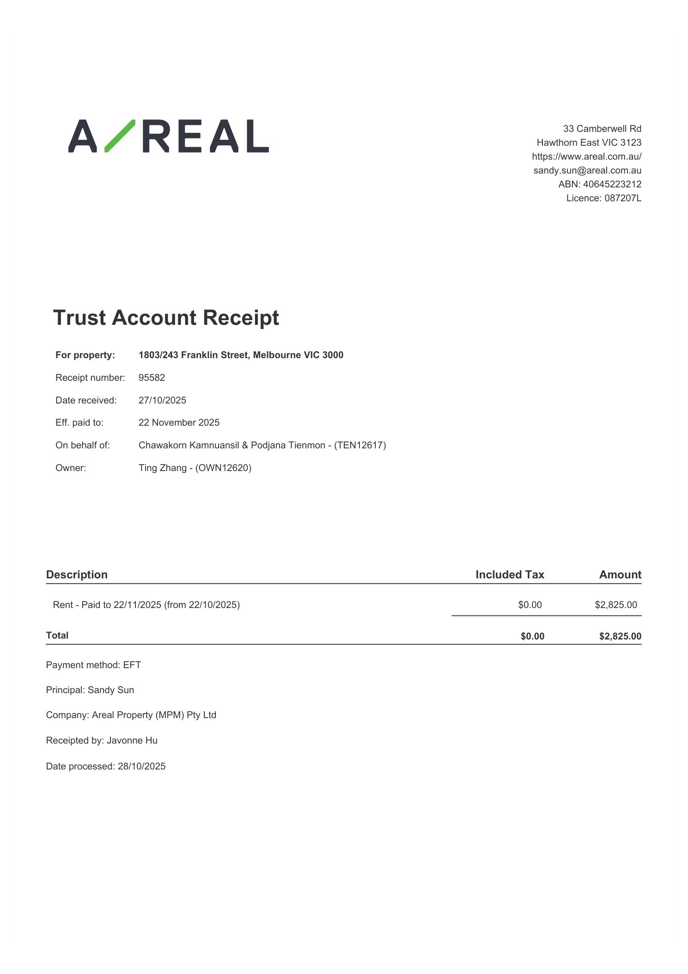

Message 7
Type | ORIG
Sort Date | 2025-12-09 11:47
Header Date | 09/12/2025 11:47 AEDT
Header Subject | Receipt of payment for 1803/243 Franklin Street, Melbourne VIC 3000
Source .doc | 251209_-_Receipt_of_payment_for_1803_243_Franklin_Street__Melbourne_VIC_3000_.doc

Subject | Receipt of payment for 1803/243 Franklin Street, Melbourne VIC 3000
From | "Danielle Symons - Areal Property Hawthorn (MPM)" <MPM@email.propertyme.com>
Date | 09/12/2025 11:47 AEDT
To | Chawakorn Kamnuansil <ck.chawakorn@gmail.com>

Hi Chawakorn,
Thanks for your recent payment of $2,825.00 that we processed on 5/12/2025. We have attached a payment receipt to this email which details any changes to your rent paid to dates.
Please don't hesitate to contact us should you have any queries.
With thanks,
Danielle Symons
Areal Property (MPM) Pty Ltd
03 9818 8991
danielle.symons@areal.com.au
https://www.areal.com.au/

If you have any feedback regarding my service, please feel free to contact my manager.
Jamima Suter (Head of Department) jamima.suter@areal.com.au

DISCLAIMER & WARNING. This correspondence and the information contained in this and associated e-mails are confidential and were only intended for the exclusive use of the addressee(s). If you have received this e-mail in error, any use, copying or inference with this information is unauthorized and prohibited and please immediately delete it and any related attachments or emails from your system and its related sub system and notify the sender. You must never copy, disclose, make conclusions and other information in this message that do not relate to the business of the Areal Property and shall be understood as neither given nor approved or agreed by it. Although Areal Property has taken reasonable precautions to ensure no viruses are present in this e-mail, Areal Property cannot accept responsibility for any loss or damage arising from the use of this e-mail or attachments.

Click to unsubscribe from future email communication

- _251209_MPM@email.propertyme.com_Receipt_of_payment_for_1803_243_Franklin_Street__Melbourne_VIC_3000-326/Receipt # 97492.pdf

Attachment Thumbnails
1. Receipt # 97492.pdf
Receipt # 97492.pdf — Page 1/1 