Residential Tenancies Dispute Submission for RT252398 CMS:0014253156
Messages: 1

Message 1
Type | ORIG
Sort Date | 2025-06-24 05:05
Header Date | 24/06/2025 05:05 AEST
Header Subject | Residential Tenancies Dispute Submission for RT252398 CMS:0014253156
Source .doc | 250624_-_Residential_Tenancies_Dispute_Submission_for_RT252398__CMS_0014253156_.doc

Subject | Residential Tenancies Dispute Submission for RT252398 CMS:0014253156
From | "CSV-VCAT-Cases (CSV)" <cases@courts.vic.gov.au>
Date | 24/06/2025 05:05 AEST
To | Chawakorn Kamnuansil <ck.chawakorn@gmail.com>


Update on RT252398﻿

You have submitted your dispute details
Your case reference number is RT252398﻿

We are assessing the information you’ve provided. We will contact you as soon as we can to discuss the next steps of the process.

If you have requested any support services, we will also contact you about this.
A copy of your application is attached to this email.
You MUST provide a copy of application to everyone else you have named in the application. During the case resolution process you might be asked to show evidence on how you have provided this application to the others.
You should also save a copy for your own records.
Let us know if something looks wrong or you need to update your details.

Contact RDRV

PRIVATE & CONFIDENTIAL
The content of this e-mail and any attachments may be private and confidential, intended only for use of the individual or entity named. If you are not the intended recipient of this message you must not read, forward, print, copy, disclose, use or store in any way the information this e-mail or any attachment contains.
If you are not the intended recipient, please notify the sender immediately and delete or destroy all copies of this e-mail and any attachments.
Our organisation respects the privacy of individuals. For a copy of our privacy policy please go to our website or contact us.

- _250624_cases@courts.vic.gov.au_Residential_Tenancies_Dispute_Submission_for_RT252398__CMS_0014253156-255/24-06-2025 - Applicant 1 - Application.pdf

Attachment Thumbnails
1. 24-06-2025 - Applicant 1 - Application.pdf
24-06-2025 - Applicant 1 - Application.pdf — Page 1/4 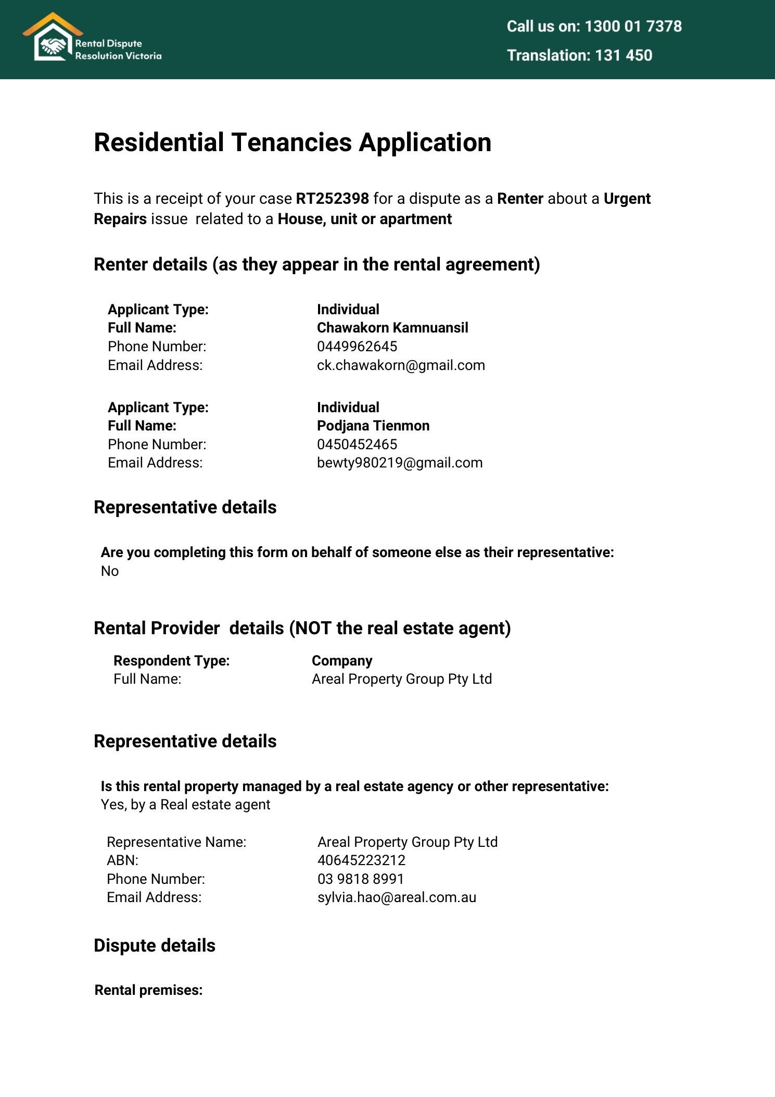 24-06-2025 - Applicant 1 - Application.pdf — Page 2/4 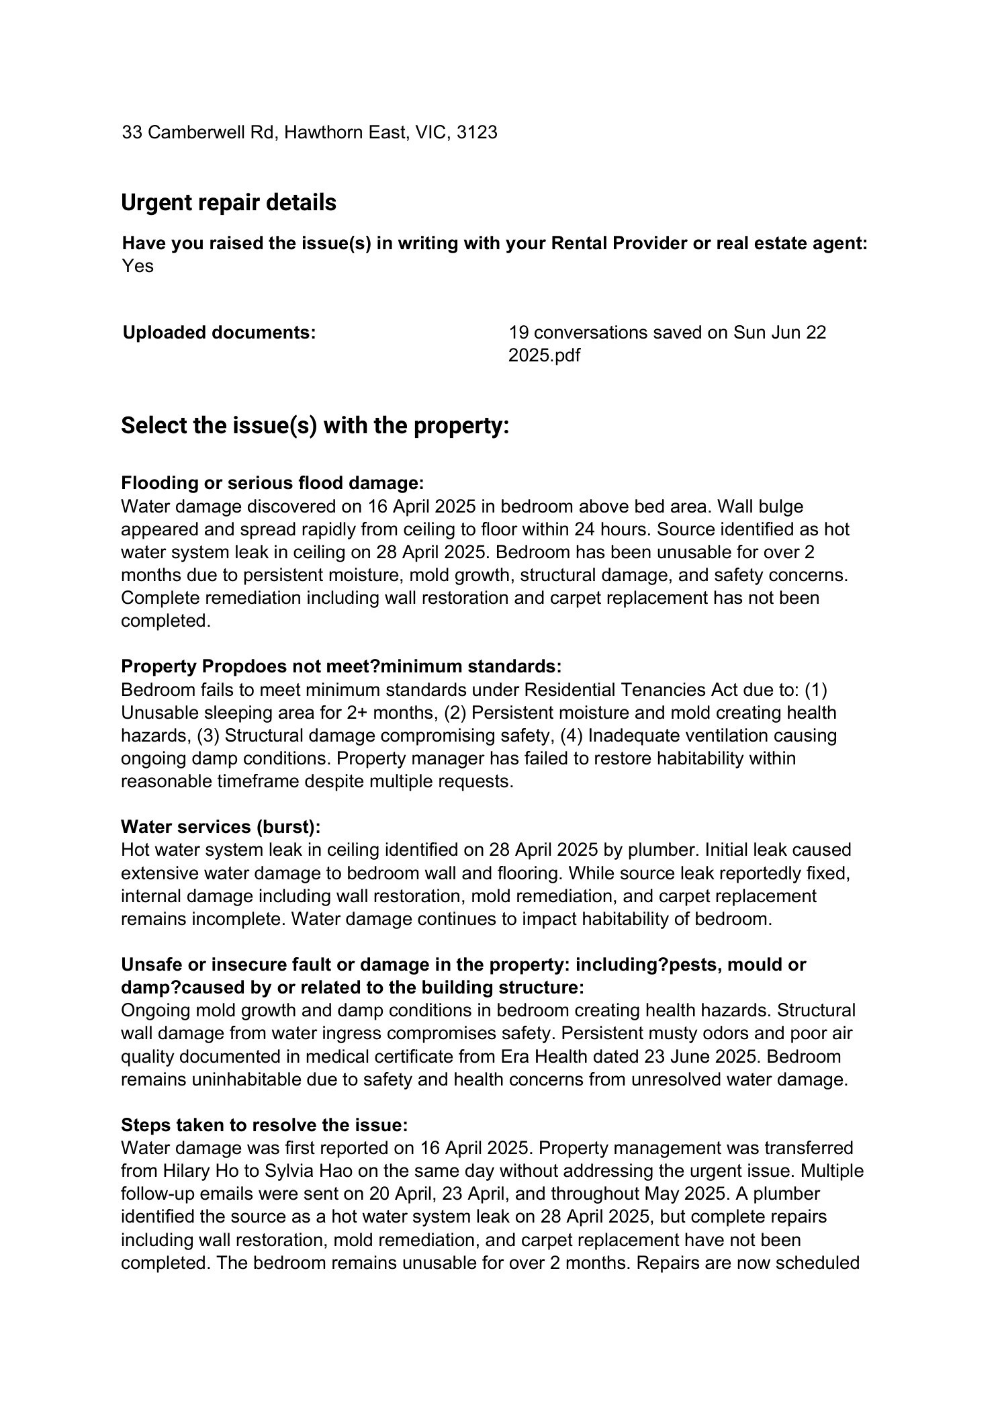 24-06-2025 - Applicant 1 - Application.pdf — Page 3/4 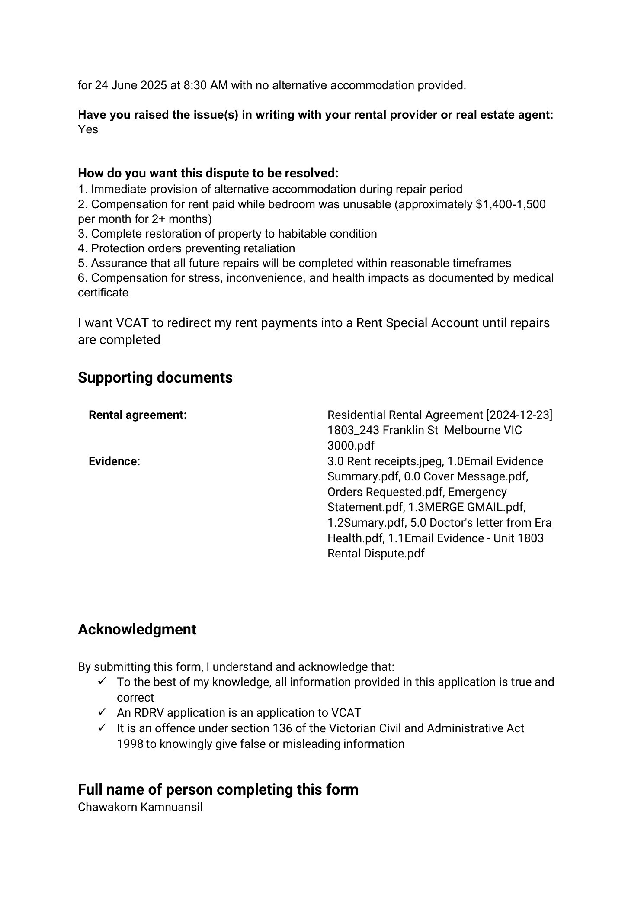 24-06-2025 - Applicant 1 - Application.pdf — Page 4/4 