*Find your NGO* - Vision Document

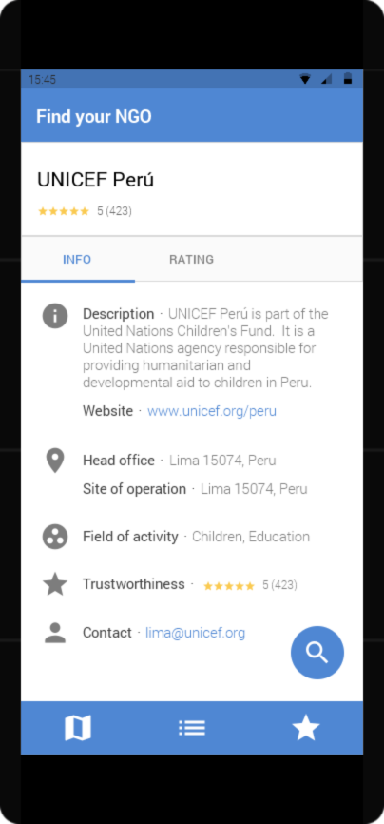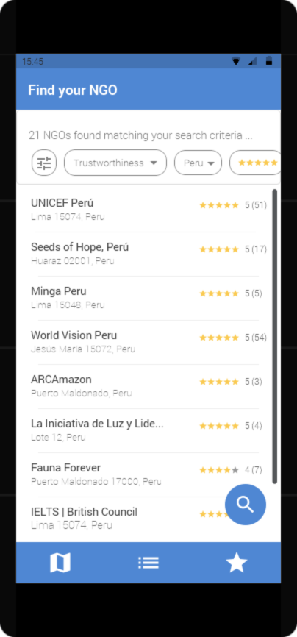Motivation &  
Problem Description

In these currently difficult times, a trend towards solidarity and the will to support is emerging. There are countless organizations that can be financially supported - so many that it is difficult to find the one that matches one's own ideas and ideals. One factor that should not be underestimated is the filtering of trustworthy organizations and those that take advantage of people's good nature. The evaluation of trustworthiness should not only be based on existing accreditations, but also on the experience of donors and volunteers, offering a more personal and up-to-date insight into an NGO’s activities. So how can one find a suitable organization that is also trustworthy? By using *Find your NGO*.

Final Project Goals

The relevant USP of this application is the provision of a trustworthiness calculation by means of relevant sources, which allows users to easily assess the trustworthiness of institutions and thus support those that are worth supporting. Rating and comment functions should furthermore influence this pre-calculated evaluation in order to take individual experiences into account. By means of this interactive approach, an NGO review platform is to be established, which shall put trustworthy and efficient organizations in the foreground and allow potential supporters to get in touch with NGOs and with each other.

In contrast to existing NGO searches such as wango.org or listings of international institutions such as the UNO and UNESCO, a mobile application is to be made available that enables users to find a suitable organization through intuitive search and filter options. Depending on the criteria set, an overview of the organizations is to be presented as well as the possibility to view details of each organization.

Additional features to be provided in the future (optional for the first development cycle):

* Registration options for NGOs
* Map view of all NGOs located in the user’s area
* Expansion of the overview to include non-profit organizations and charities
* Expansion of the overview to include organizations where one can get actively involved
* Integration of payment methods
* Effectiveness rating of NGOs

MVP

The minimal viable product shall include the following functionalities:

|  |  |
| --- | --- |
| **Feature** | **Description** |
| **F-1** | The frontend can display a list of all available NGOs retrieved from the backend. The list is still unfiltered and provides no sorting functionalities. This list has been extracted from existing compilations of NGOs* and stored in the application’s database. |
| **F-2** | The application offers a search mask to find NGOs based on a single search criterion. |
| **F-3** | The application stores the information on NGOs in an internal database. |
| **F-4** | The application provides an initial trustworthiness evaluation of each NGO based on the source of the information about the NGO. |

* The following compilations of NGOs are to be considered as the main possible sources for *Find your NGO*:

|  |  |  |
| --- | --- | --- |
| **Organization** | **Description** | **Source** |
| **Council of Europe** | A list of NGOs comprising their names, location, contact information and further details. * | <http://coe-ngo.org/#/ingos> |
| **World association of non-governmental organizations** | A list of NGOs comprising names and locations. * | [www.wango.org](http://www.wango.org) |
| **United Nations** | A list of NGOs officially accredited to the Conference of States Parties. * | https://bit.ly/3fjP5gX |

Organizations marked with * could be especially useful to evaluate trustworthiness.

The MVP shall be completed by December 22, 2020.

Final Product

The final product version offers the following enhancements of the MVP’s features:

|  |  |
| --- | --- |
| **Feature** | **Enhancement** |
| **F-1** | The list of NGOs can be filtered by various criteria, such as location, field of activity, site of operation and trustworthiness. |
| **F-2** | The search mask offers multiple search criteria to be applied at once, similar to the filter criteria of F-1. |
| **F-3** | The application’s NGO database has been expanded to include more data sources. |
| **F-4** | The trustworthiness calculation has been enhanced to include further factors. |

In addition, the following new features will be implemented:

|  |  |
| --- | --- |
| **Feature** | **Description** |
| **F-5** | The frontend offers the user a way to rate a NGO’s trustworthiness. |
| **F-6** | The frontend provides a detailed view of each NGO, including information on location, field of activity, site of operation, trustworthiness and user comments (where available). |
| **F-7** | The user can comment on an NGO; the comment can be persisted. |
| **F-8** | The backend provides detailed information for a given NGO. |

The final application version shall be completed by March 9, 2020.

Technology Stack and Architecture

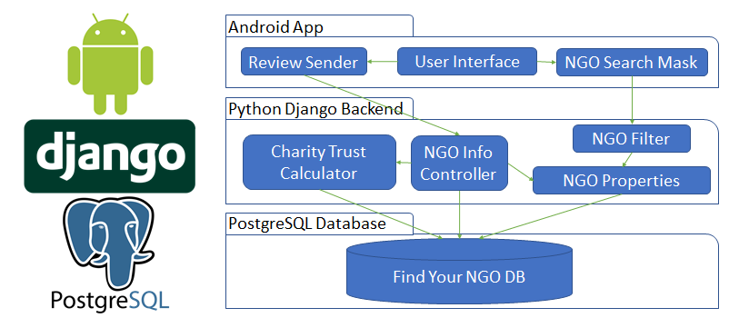

It has been decided that the user interface of this project shall be realized as an **Android App**. The app will be developed in conjunction with **Django**, a high-level **Python** web framework, and **PostgreSQL**, an open-source relational database management system. This combination has been chosen to increase development efficiency by using bleeding edge technologies that have been proven in many projects. The android app shall be developed using the programming language Kotlin, which highly improves the development speed and correctness, due to being statically typed, concise and null safe.

The Python Django backend shall be used with type annotations to make use of benefits that are provided by statically typed languages. Django also provides many critical functions that are necessary for the user experience, such as object relational mapping for communication with a database amongst other things, and a user management system.

Finally, PostgreSQL shall be used as the database to hold data pertaining to NGOs and to hold the collected user feedback. PostgreSQL has been chosen because it is open-source, free of charge and reliable, which ensures safe data storage and lower development costs.