Writing this on September 12th, 2010
This road is familiar to me, I can even walk it home when I'm closing my eyes.

Huh? Why is the sky dark? I remember it was very bright before. And where is everyone? Where's the kids, the cars, etc?
Opening the phone, I see there's no connection. The sights are the same, meaning that it is probably the same location.
Opening my laptop


Good old Bliss, I have used this for 7 years. Nevermind, let's talk about what's happening.
It is 5:39PM, it's dusk normally, but... the sky looks like it is midnight. I tried opening cmd (Windows Command Processor) and typed: ping google.com
Huh? It can't ping. It says: "Host identity not found in this timeline". Normally my Windows XP Professional wouldn't say this. Is it just a joke and someone hacked my laptop?

I had 2 options that I normally would bugfix:
1. If I don't have wireless connection, so anyone couldn't hack my laptop live. Therefore, hacking is ruled out.
2. If the malware has been in the machine all the time, I have to check, the startup folder and I restart. The total check took me ~2 minutes.
A black fog appeared out of nowhere, seeing a bird fly inside the fog, and before going inside the fog, it collapsed...?!
It started coming towards me
My laptop is very heavy, so I have to leave it behind. Goodbye Bliss.
I ran at my best, at intersections it blocked me at every crossings. I suspect it is guiding me somewhere.
I got hooked on that song, so I put it on loop lol.
Huh? I see the entrance of the expressway?! The nearest expressway entrance from that street is at least 1 hour on car. But not only I run, but I feel like it's 15 minutes.
The sign says: CT01, Bùng – Vạn Ninh.
Seen a bottle of Coke, it says expire date: October 5th, 2021.
Why can someone possible make a product that has the difference between release date and expire date that differs 1 decade?
And this year is 2010, I guess it is a manufacturing error. They should have replace that 2021 with 2011.
Entering the expressway with confusion, I started running, but not for my life now, though the black fog still chases me, but not frantically as before.
After running for a while, I encountered a toll plaza, inside one of the booth, there is some food left. I ate and drank quickly because I was exhausted and dehydrated. I guess I have to stay here for the day.
Looking to the another booth, I see the sign of ETC, I don't know what it means. But the one I'm staying inside says: "Manual".
Having nothing to do, I just browse the web.
I watch Youtube, it has many interesting video published by thousands of creators. While scrolling, I encountered a videos saying: "Windows 10 22H2 is getting end of life"
I wonder, what is Windows 10? I guess it is just a spinoff from Windows XP.
Searching for Windows 10 in Chrome, I got from search that I gathered: Windows 10 is an Operating System released in 2015 by Microsoft.
Wait... this is just 2010 and that is 2015?! And now it's getting "killed"? Like Windows Me getting end of life too?
Windows Me has been from 2000, and got depricated in 2006, meaning 6 years of active.
But that OS is from 2015, I expect it is in 2015 + 6 = 2021, which is coincidentally 2021 from that bottle of coke before.
This is getting more and more strange. I guess I'm moving through time....
I found an old laptop in the booth, which was running Windows 8.1. What the heck is Windows 8.1 again?
Again, searching, I found out that Windows 8.1 was the OS before Windows 10, release in 2013.
Where's the start menu? At least I can browse on this somewhat Microsoft Edge.
The owner should have left this kind of trash behind, but it is kind of valuable in "my era" having 4GB RAM and i5-7200U.
Another knowledge about i5-7200U is a 2c-4t CPU.
Back to the real life, let's not talk about any specs now.
I'm getting tired, so sleeping time. But before sleep, I think that is is approximately 10:00PM because my internal clock told so.

This is supposedly September 13th, 2010 right?
As I woke up, something inside me urged to keep running. As if I'm predicting that it's going to chase me again.
Grabbing the laptop, shoved the leftover meal into my bag, and kicked open the booth door.
Looking at what I haved travelled, CT01 stretched much further into the black mist. No engine, no birds, no wind. The plaza is slowly being absorbed by the foggy "substance".
I guess I have entered a limbo of time.
As I was running, I see the road expanding... And it eventually, I saw it, in total it has 8 lanes, (four on each). I suppose on each, 3 lanes, 1 emergency lane. I encountered a sign saying....
"Fully operational, start construction: 2023, fully complete: 2031"
But... today is only 2010 right? So what I'm running is from the future?! This further confirms my hypothesis of time warp.
A 2021 expire date, 2013 operating system, 2025 news, a road that pierced through the supposedly wheat farms.
The black fog wasn't just chasing me through space, it is really driving me forward decades of history.
Sometimes, it seems to be hesitating or somewhat like that.
A humming sound from the fog takes me back to reality of course. Acknowledging it's now swallowing the pavement, so I hastened my pace.
Noticing the polymer in the road, it is very different from what I would normally see. But I had come to the conclusion of time limbo so that checks out.
My legs pulled harder, lungs working as if it's burning as I sweeping through the polymer.
Overhead, streetlights are starting to turn off because it's getting kind of dawn. Integrated solar power is attached to "speed measurer" or camera.
Ahead, there's an orange terminal box. It is the only thing that gives me motivation ever since.
Slamming into the terminal into its graphical user interface. It's Bliss! And Windows XP! I guess they used Windows XP for stability lol.
It flickered:
Expressway Sector CT-01
2038-Jan-19th 03:14:07UTC or 10:14:07 of my time zone of UTC + 7
Tick.... it's 03:14:09 now.
I have been standing here for a few minutes playing with its registry editor (regedit), this has been rolled out for ages. Therefore, I have to distance the black fog. So keep running is my main objective.
"It seems that I run faster than it approximately 20%
Or 1/5 of its speed, so to rest 10 minutes, I need 10 / (1 / 5) = 10 * 5 = 50 minutes minimum
But adding 10 minutes for backup.
So I have to run 1 more hour."
That's what I thought when I'm running because I have nothing to do.

Anyone have to have water right? So I have to pause for 10 seconds to drink some water. I hope this is still in the backup time.
I sucked like half the bottle into my body and it got refreshed.

I can't trust myself so I set up an alarm for 1 hour.
When the alarm rang, I immediately sit down and open the laptop.
Wait... the user interface changed again.
I used winver, it says Windows 12 Home Single Language, build 10.1.14200.7663.
Opening task manager, it says, CPU: i7-17800HK, 28c-56t, RAM: 64GB DDR7, Disk: NVME 8.0, Wifi 8 adapter, RTX 7090, 4k monitor @ 120 Hz
I don't what even a CPU with double digits in cores, more than 16GB RAM, NVME?!, RTX 7090 is.
Though I know that the naming convention of Windows + number, but what the heck is Home Single Language suffix?
I have never heard about it before, I only know: Starter, Home, Professional, Enterprise, Ultimate.
Nevermind, but it sounds futuristic not gonna lie.

Times up, all 10 minutes is wasted trying to play with cmd.
The fog has closed the gap, I can already see (not really clearly) that it's coming in the horizon.
Putting the monster into the bag, I continue my steady pace.
But I want to rest more! So I have to overclock myself. Measure! At my max I can force myself into running 2x than the fog for a short time, and then slowly decrease until the floor of 0.75x.
I'm going to pull some algebra here, so dear math-phobists, please avoid this section
Suppose rest-time-overclock = 1.2 * rest-time-steady
time-overclock = t1
velocity-overclock = ~1.5 * velocity-steady
velocity-rest = ~0.8 * velocity-steady
time-rest = t2
accelerate then t1*vel-overclock then deccelerate then t2*vel-rest
Suppose accelerate and deccelerate cancel each other
t1*vel-overclock > t2*vel-rest
t1*1.5*vel-steady > t2*0.8*vel-steady
Since vel-steady is not zero or lower so
t1*1.5>t2*0.8
t1>t2*0.8/1.5
t1>t2*8/15
approx t1>t2*1/2
or t1>t2*0.5
So overclock time must be at least 0.5x more than time rest
real-rest-time = t1-t2/2
So to real rest 10 minutes, and rest from overclock approx 6 minutes so I have to overclock 13 minutes.
Forgot to mention, I'm seeing the exit named Việt Trung, and before that, I saw another named Cự Nẫm.

Time flies as if it's leaving me. Now it's dusk. There's no toll plaza that I can see, but I can take the exit and get into someone's house to get some food.
Near the exit, like 1 kilometers from it, there're houses. In a restaurant, I see some food. I think the black fog made everything frozen in place, or is it?
I see some processed-food. It is delicious, and I fancy it, if I escaped, I'd eat this on a regular basis! After eating that, I went to "bed", though there's no bed here. But I'll sleep on the floor.
I immediatelly fall into NREM level 3 (just a fancy way of saying sleep, but I'm technical lol).

My body clock told me to wake up at 6.30AM because I have programmed to be frequent to 5.30AM so it might deviate, but not much.
I need to stay here to make up a plan for escaping the black fog. Just wishing the mist not move when I'm just standing. Like speed should be a*my-speed (0<a<1) not speed = const
But unfortunately, it is constant speed or a*my-speed + const speed. That's the reason I can't stop.
While running without direction and google map like I usually do, I have to search:
"Bung - Van Ninh expressway"
then I get to the Wikipedia page to get information, it said:
"Bung - Van Ninh Expressway, having the name of the whole line is CT.01 and CT.02 is an expressway in the system of expressways from North to South in the East side and the North Side in the region of Quang Binh."
Accessing the path, it said this section of expressway contains 4 exits, I have already passed two, the next one is Nhật Lệ 2. Lucky for me, the entrance is only 10 kilometers from Việt Trung exit.
Ahead of me, a mist appeared, yes, a mist, but it is not black, it is just like any normal phenomenon.
My phone, I haven't touched it for a while, because I think laptops are better. Huh? Where are the tiles, now it's an Iphone 19?! Haven't heard of an Iphone before. I guess this is a phone brand from the future.
If you're asking, why I knew the model of the phone in the first place, not because I'm a god, but you know?, you can use the settings just like ver in Windows.
Where's Yahoo/Chrome? Oh, here it is, this is Chrome, I think its icon is minimalist. Searching Google Maps as I used to, typed:
"The entrance of Nhật Lệ 2 CT01 Bung - Van Ninh"
WHAT THE HELL IS THIS? A star shaped icon appeared in my browser, saying it's Gemini.
Nevermind, if it gives information, don't bother fixing it.
It said:
Location found! Route: CT.01, Distance from current position: ~10km, Status: Open, Traffic: 0.0%
According to somewhat star, I should go on DT.563 to get to the city of Đồng Hới.
I think that when I'm sleeping, the anomaly won't chase me.
Looking at the city, I see many buildings, infrastructure.
Though it is not dusk yet, but I intend to stay here to plan for the future.

Wait... as I remembered, in Physics, you have learnt in grade 10 that the boyle's theorem that:
P1 * V1 = P2 * V2
I have left the mist quite far, like ~15km, in these 2 days, I have never stopped running (expect hygienic events)
Talking about hygneic events, I realised that I haven't shower for 2 days. Dandruffs and lice might appear on my head soon.
Wandering through the city of Đồng Hới, as I walk, I hunt for hotels (that are 2 stars + of course)
Hotels to hotels, until I found a room without being locked.
Having not bringing anything except very essential neccessities, I have to use the hotel's factilities. The wifi has been cutted, it means that I have to use the hotel's wifi.
Searching for a tape on the wall, I can't see it, so while bathing, I set up a brute-force program to find the hotel's password. I'm an experienced programmer

I have to use the hotel's shampoo, it was a terrible experience, but I didn't care, because I cared about my life more.
After showering, I immediately checked my laptop, it has brute-forced the wi-fi for ages
SSID: Hoang Anh Hotel
Password: KsHoangAnh
It is quite hard because it has 10 characters, but my laptop is the best I have seen.

Like normal, I checked the speed, it is Wifi 7, and I'm having a maximum 46 Gbps, it means that I could install Windows 7 iso in under 1 second. Nevermind, let's just talk about my survival not specs of my laptop.
I have noticed in the first places: the city where I started being chased. The black fog is black as if it's Super-Black (An optical coating made from a nickel-phosphorus alloy etched with microscopic pits)
But now, at Đồng Hới, I see it as clearer, but still dark, I guess it is still lethal. So I have to run more for the fog to dilute.
Wait... why did I know the presence of expressway when the first one is built in 2023? That can also be explained by my hypothesis of time limbo, it's like layering multiple memories from different timelines.

The fog is coming. I have to run now. As I used parkour to get down the stairs fast (I know it might be dangerous), but the fog is more prioritised for me now.

After an approximated time of 5 minutes, I have arrived at the entrance of IC Nhật Lệ 2.
The road leading to the expressway is kind of circular so I can just travel in a square for better time.
Merged in CT.01 again. Now it's not 2038 anymore. It's 2035. The pattern before is just travelling forward in time. Now it's probable travelling backwards. I wonder why.
I have to run more southern, the next exit is IC Vạn Ninh, which is 20 kilometers away.
That's kind of long, but I have participated in a marathon competition which is even double the length between my location and my destination.
Easy for me lol, while running, I sometimes look backwards to see the position of the fog so I could estimate when I could rest (though I wouldn't need rest for this 20 kilometers, but who doesn't want to rest?)
The fog is grey, not completely black anymore, it's like an optical prism that dis-focus photons from my eyes. That, in fact, just the formal definition for this. But there's more, it's kind of being sunlight in a weird, shimmering angles, as if it's a higher-dimensional creature.
Just being funny: You know the ritonavir case? Yeah, it looks like a hazy substance.
17 kilometers... 15 kilometers... 10 kilometers... 5 kilometers... 2 kilometers... 1 kilometer... 800 meters... 200 meters... 100 meters... 10 meters... 1 meter...
0 meters, I have got to IC Vạn Ninh at kilometer 673.8
As expected, I opened my phone, I saw the clock decreased to Jan 9th, 2032.
Vạn Ninh is also in the city of Đồng Hới, but further away for the centre and the time got reversed, so Vạn Ninh doesn't have as much as tall building when I see it in Nhật Lệ 2 exit.
Oooh, I see another section called Vạn Ninh – Cam Lộ Expressway. I guess it is adajacent to the Bùng – Vạn Ninh Expressway.
But it's not dusk yet, so goodbye Vạn Ninh, I'll go to IC Kim Ngân or IC Bến Quan. Goodbye Vạn Ninh.
13 kilometers to go.
As I run, I observed that the further I go, the smaller the road gets.
13 kilometers is too easy, so I'd better skip this part because, who knows? Modern humans might be addicted to immediate dopamine, I don't understand why.
13 kilos... 0 meter, I skipped because what I mentioned earlier. I arrived at IC Kim Ngân of Km 690.5
I guess I'll sleep here. Today is September 11th, 2024. It leaped. Should expected it to be 2028, but... now it's 2024, so there must have been also a fundamental change in the fog's or you can call it higher dimensional creature's properties.
It is kind of night now. Checking my laptop, it said 8:93 PM
How is it possible? I can just resolve it by thinking: 8:93 PM is 8:33 + 60' = 8:33 + 1hr = 9:33
I think it's a driver problem.
Fixing drivers is just as easy as I did on Windows XP.

Ahh, time.windows.com malfunctioned and driver misunderstood it. Accessing time.windows.com not by HTTP or HTTPS, I used a special to access it by NTP (Network Time Processor)
I see it saying 8:98 PM. So I have to change the time myself, to 9:38 PM.

I have to find some hotels at Kim Ngân. Oooh, here it is, a hotel, looking it hasn't been touch for a month. But a month is still not bad... So I guess I'll have to fighting some weeds for convenience.
A month of neglect is not terrible, no major structure collapse, not much dust, just a quite building in the dark.
I hope they didn't move away. Pushing through main entrance, through the receptionist's table, I immediately see a room with an alias of 101. Just for fun: 101 in binary is 5 in decimal.
Opening the door, my first impression is just... filthy. But it is not that bad, there is just a few fungi and mushroom. The bathroom and bedroom is perfectly okay.
They, in fact, hadn't moved the water supply away, so there is still some water for me to bathe.
This hotel has wi-fi, but I don't care, because I just need to run simulation linking with my situation on my laptop locally.
Looking at my laptop, as I have predicted, it also got degraded back.
Its specs: 1920x1080 @ 60 FPS (extremely good in my era), Windows 10 Pro 22H2 build 10.0.19045.4529, i7-14700K (20c-28t), RTX 4090, 32GB RAM DDR4, SATA SSD, Wifi 6 adapter.
If you're asking how I knew exactly the build number. Just goto Win + R (Run) then type winver and and it'll say
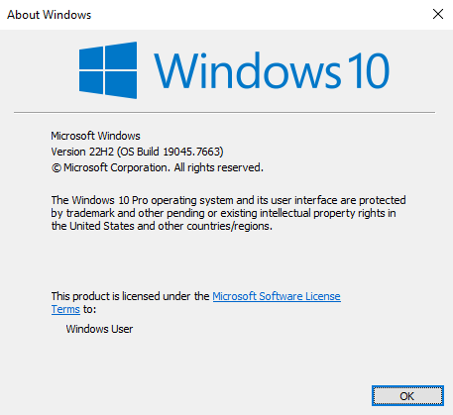

What I took from the internet.
Before sleep, I wondered, is it really true that the fog doesn't chase when you're sleeping?
So I approximated that the fog speed is a m/s, I sleep for 6 hours at least so every hour the fog goes 3600a m/hr or 3.6a km/h, total distance 3.6 * 3 = 10.8km
It's like if it's at IC Vạn Ninh, you're at IC Kim Ngân, let me demonstrate it for you.
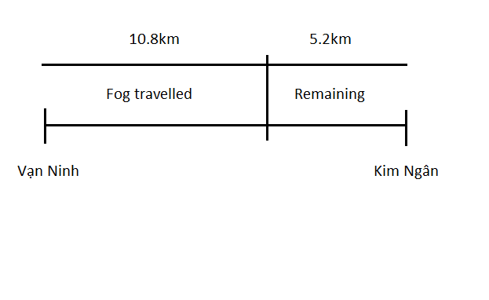
I just multiplied by only 3 because who know, I might sleep less than 6, so I'll set it to the human's limit.
It's like the distance between you and it has dis-tripled (*3^-1) (5.2/16).
I quickly fell into sleep after that.

I set my alarm to 6:30 AM. And I woke up just on time of 6:31.
Quickly brush my teeth, as I usually do, I immediately have to hunt for some food in the hotel.
Fortunately for me, there's some food already put in place in the room which consisted of Lays, Pringles, Coke, some instant noodle and coffee (powder)
So I have to somehow trick the fog into thinking that I'm sleeping but I'm not, just like dolphins.
But nevermind, I have to run southern.
As I step out of the hotel, I see the black fog behind my back. In the front too?!
You know the squeeze function or the sqeeze theorem? I have only heard of it, but never have solved it because it hasn't been introduced in college and high schools.

I have to come up with the solution fast.

Ah! The highway is considered a 1d line from north to south and I'm trapped, so I just need to access the second dimension of north/west.
But I have seen that the creature is 4D (width-length-height-time), so it might not be that easy yet.
But I think that not everything has infinite volume to chase me, (please don't talk about fractals here.)
So that makes up my mind, if the fog has infinite volume, it would definitely mess up the local gravitational field, and I'm feeling normal here, so this has to be false. Thus the fog has to have finite volume, that also means that finite width (the distance I have to run east/west.)
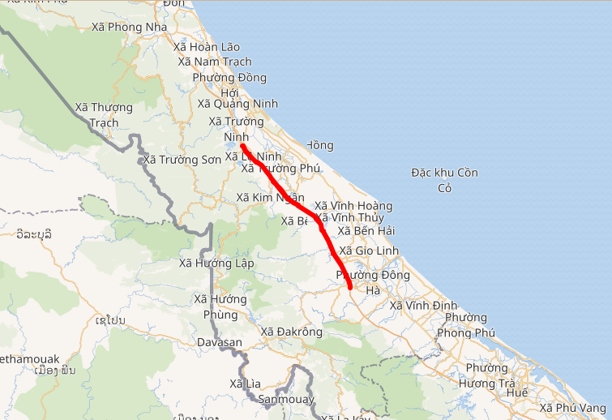
The map, which told me to go west because going east I will encounter the East Sea.

Normally, on expressways, people aren't permitted to go out of the road except on exits. But I'm not using cars, I'm using my foot.
Talking cars, I immediatelly imagine of some vehicles that I can use. Most vehicles needs fuel and key to use it, so I'll target taking a vehicle which still has its key on it.
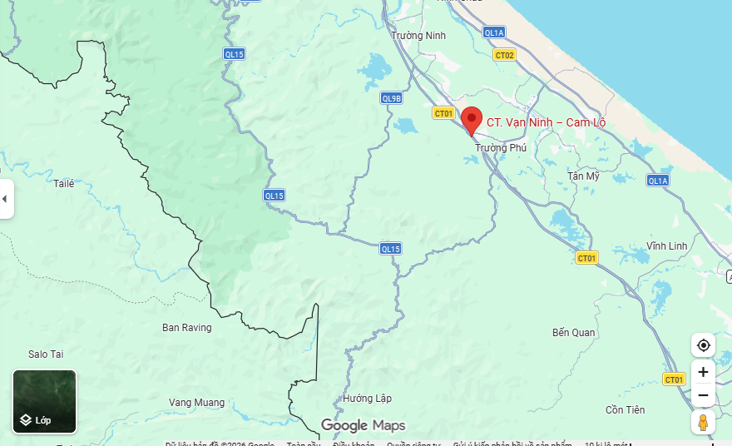
According to somewhat Gemini again, I should take the QL15 and go west until I encounter countries borders.
I have already passed QL9B, which in my opinion, is faster, but I don't want to waste my progress, so I have to take QL15 and follow it, then turn right.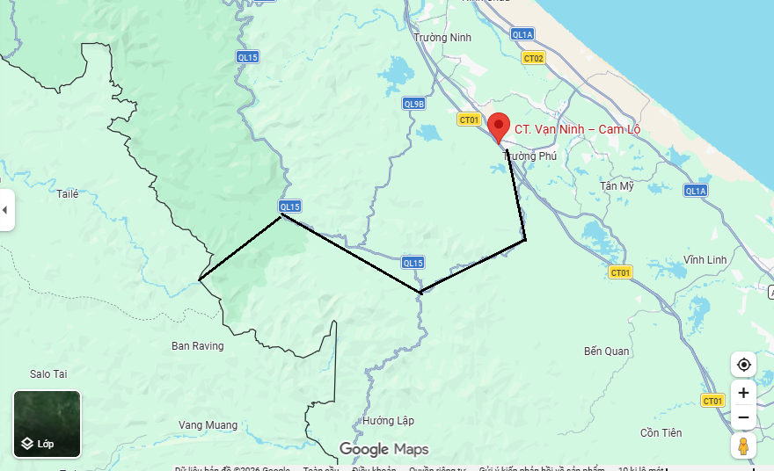

There is still, in fact, houses on my way, but as I walk to find transportation, the houses become less dense. 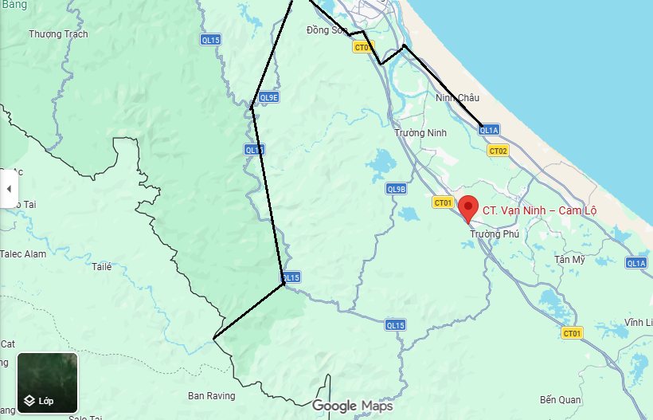

Ah ha! Here it is, a motorcycle with its key attached to it.
Fortunate for me, it seems to have ~90% fuel, nice! Let's ride it, vehicle's capacity = 120kph, for safety speed = 70kph (I have motorcycle driving license), total beneficial speed = 30kph
At first, I'm going south, so the timestamp keeps decreasing, at its from 2024 then 2022, then all the way to 2018.
Since it has passed 2020, and I have read articles about important events worldwide, I have already prepared some masks for the outbreak.
Then I turned right, as in the plan, now the year number is increasing again, from 2018, 2019, all to the year 2022, (because that border I accessed is southern-er than the place I've crossed the railings.)
Standing on the top of a hill, I observed that the black fog, as expected, its width is finite, and I fleed to the border of Vietnamese-Laos, so I escaped the north black fog by just a few kilometers.
But I still have to account for the south fog going north, I need to stay here for a few days. Sorry border-protecting soldier, but I have to eat your food for days, I hope their supply doesn't run out.
The southern fog is approaching my location, it's too easy: just ride QL9E
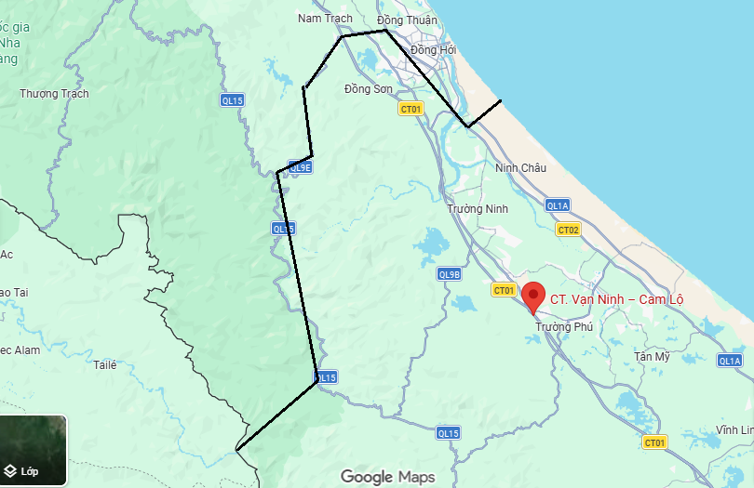
As I ride, the time don't spike anymore, but rather slowly decreasing. I watched as the southern fog swallowed the hill and the soldier's place.
Arriving at the beach, I went inside some hotels near the beach, having nothing to worry about. The facilies is brand new, so I decided to stay here for a day. I hope that the mist doesn't reverse its direction.

Being such a nice person, I decided to return the vehicle, it's a daunting task, but morally good after all.

After returning the vehicle, everyone appeared as if nothing happened, and a suitcase appeared in front of me, containing my Windows XP laptop, Windows 12 laptop and I already holding the Windows 10 laptop. After all, I have 3 laptops, yah, like a reward.

Opening my phone, calling a taxi to deliver me home.
While being transported, I checked my phone, it's September 20th, 2010. Meaning that I have gone missing for a week. Hoping my family doesn't get too panicked.

In conclusion, everything is okay for now.

Somewhere else, 2 people are suddenly transported into an un-manifestated with people, one: Cam Lộ – La Sơn to La Sơn – Túy Loan and another: Vũng Áng – Bùng to Hàm Nghi – Vũng Áng.

