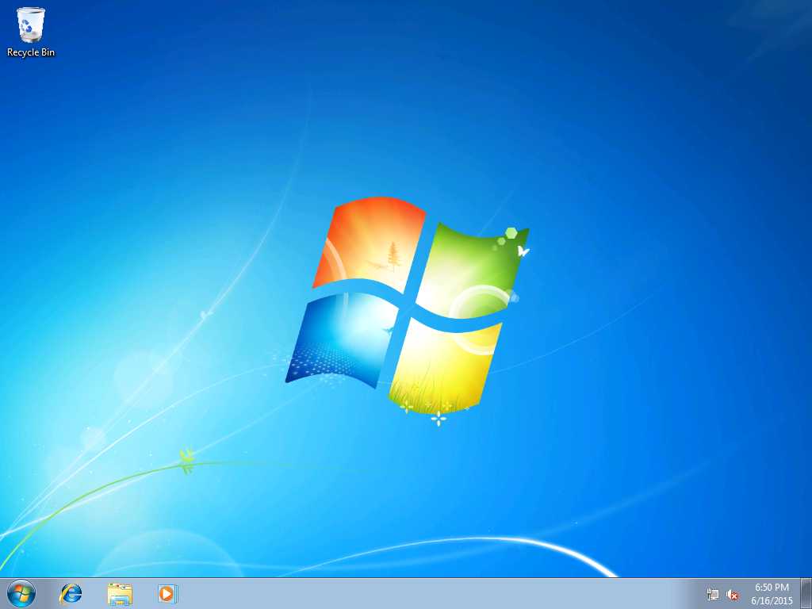
Haven't send shortcuts to Desktop at all, I'd use search by the orb

# June 16th, 2015
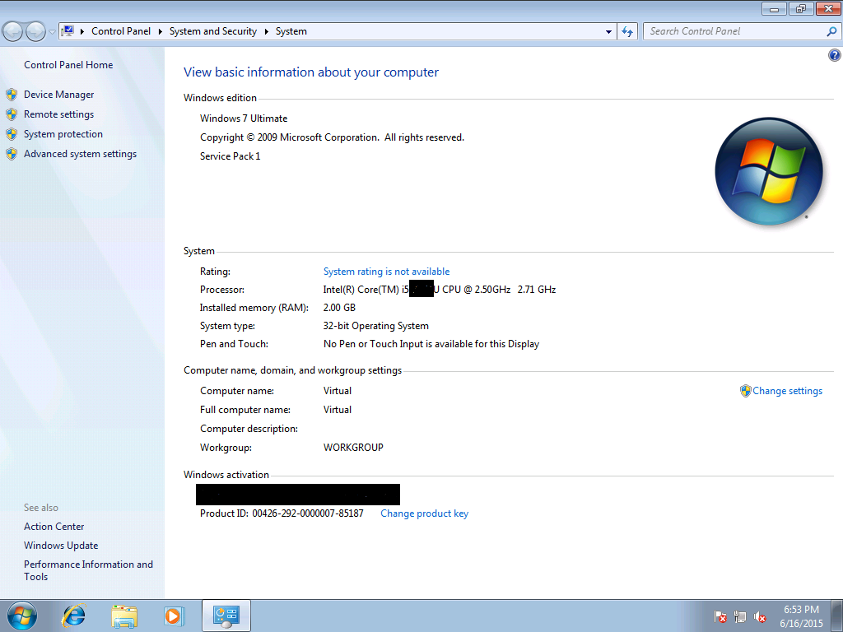

Showed y'all my specs! CPU is quite fast of 2.5Ghz, but only 2GB of RAM, what a pity, I'll tell my parents to buy more to fit the total of 8GB RAM DDR3.
Windows 7 is pretty nice, right? I've been using for 5 years now. I'm still learning about PowerShell, command prompt, run (Win + R), task manager (Ctrl + Shift + Esc), diskmgmt.msc, etc.
I knew some basic batch like do some math, ask for input, echo out, etc.
My dad is my teacher, he teaches me registry editor (regedit)
But today, I found out there was "additional registries"?!
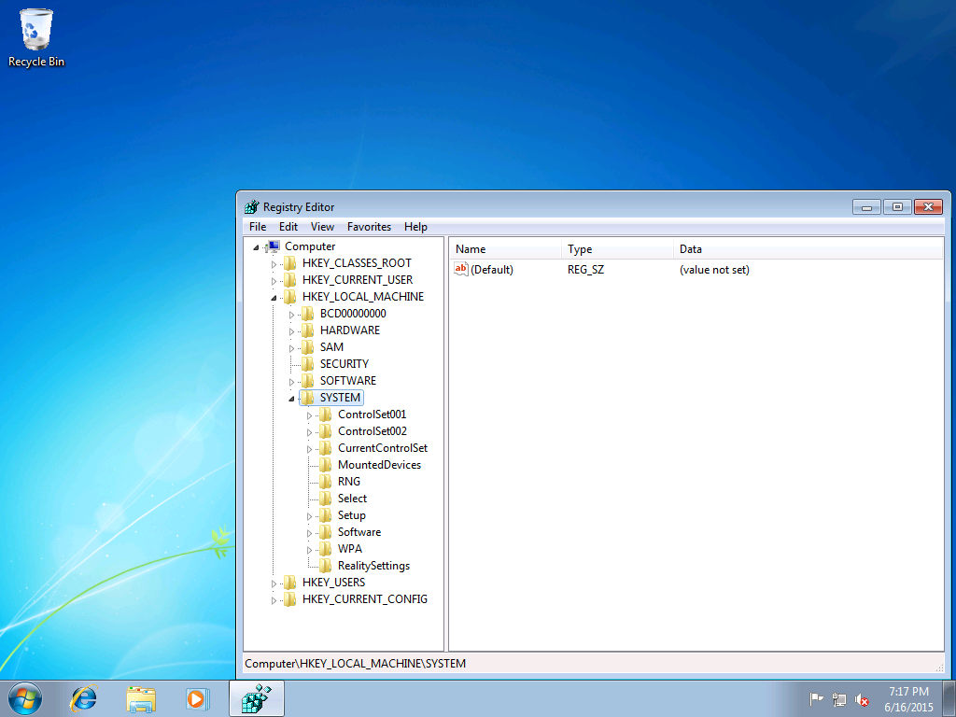
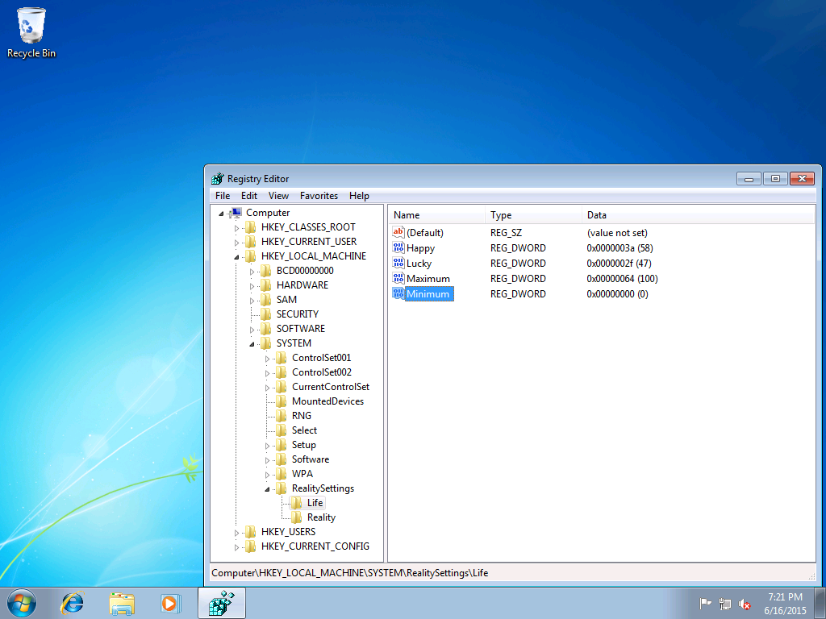
Huh? Lucky and happy out of 100?! That's strange that I only got 58 and 47
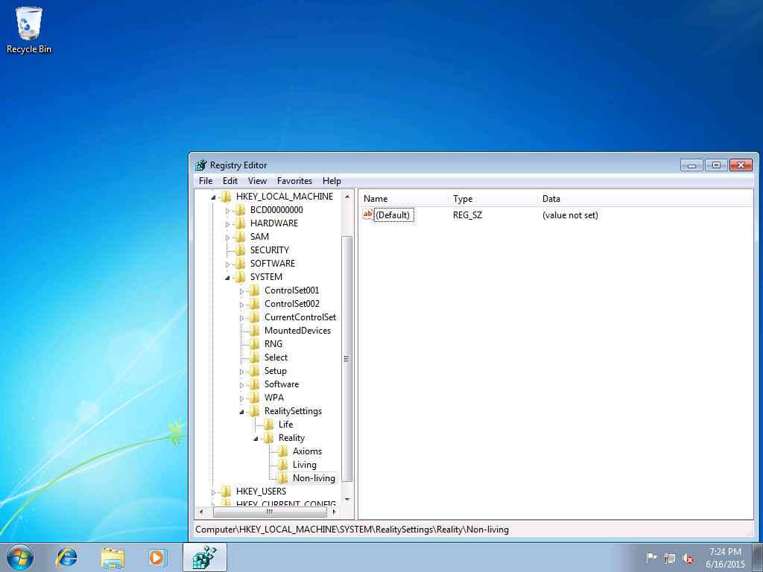
Ooh, this is going somewhere.
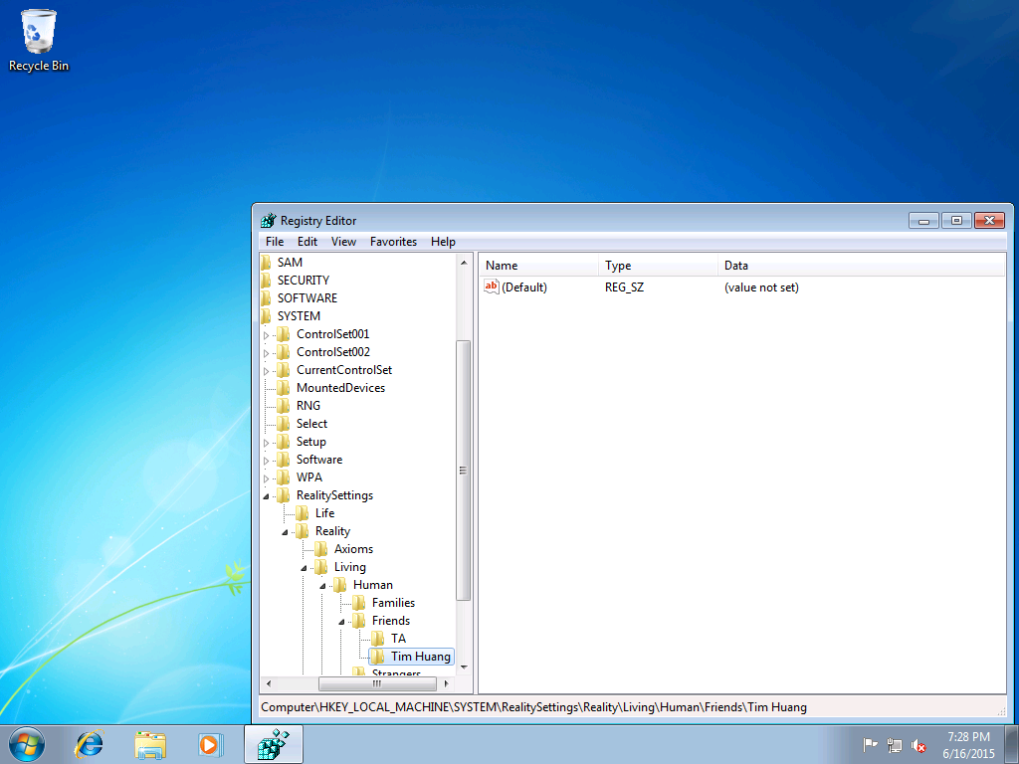
Why is these two people? Why are they the only one mentioned?
My class has 45 students, why this only explicitly just says TA and Tim Huang (they're both my friends, as you can see in the friends' key)
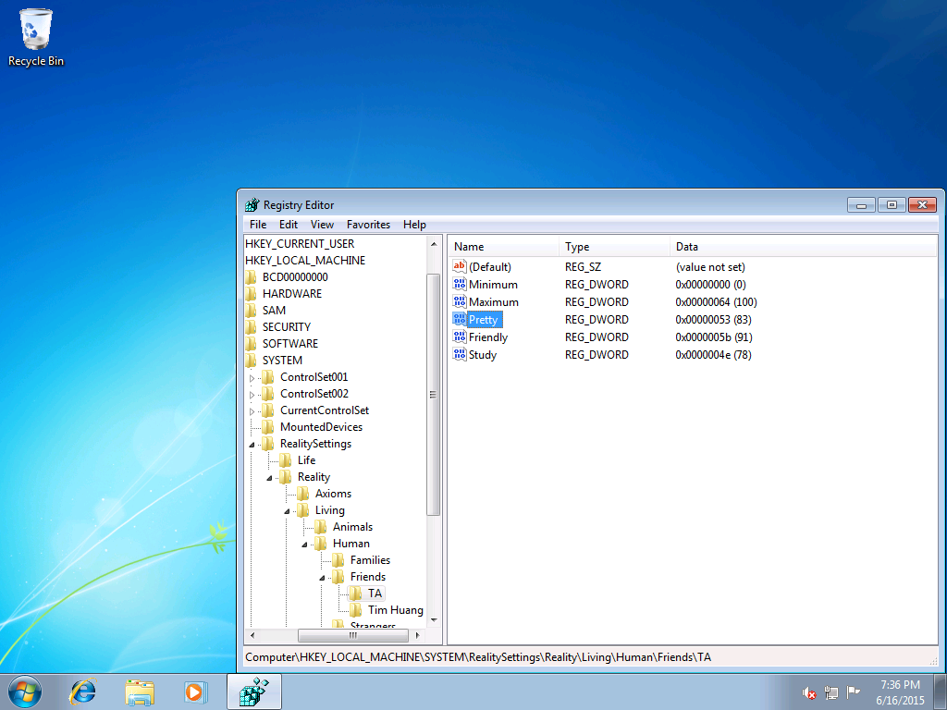
No wonder why people say she's the prettiest person in our class. Some dudes in other classes also like her. I don't have time for falling in love. I just focus on Linear Algebra, Maths, Windows, etc
One of the most-known examples of this is NK in our class. He told us that he confessed to her when he was quite younger. Now we always let them "be closer", but they're resistant (yeah, I know, I have experienced the same thing)

I have noticed things strangely for days now (today is 19th June 2015) I feel someone watching from behind, but when I look back, there was nothing. Maybe I felt wrongly, but that sensation was so realistic.
But let's test if these registries are affecting real life.
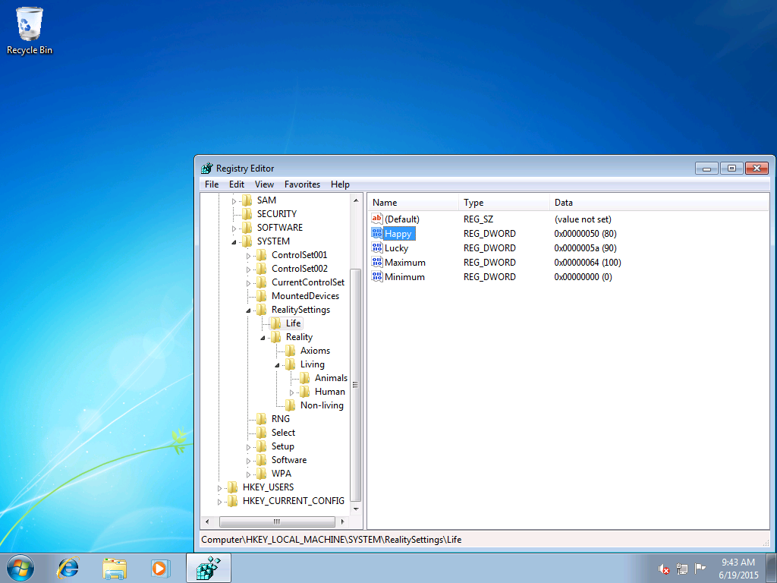
I changed lucky to 90 and happy to 80. Some things take time. So, let's restart Windows Explorer to see if things are changed.
I guess it has changed.
Today, I went outside and picked up some dollar bills, like 10 or 20 dollars. It's quite small, but already surpassed my normal luck.
And I also feel better today, no angry moments, just me there, being chilled.
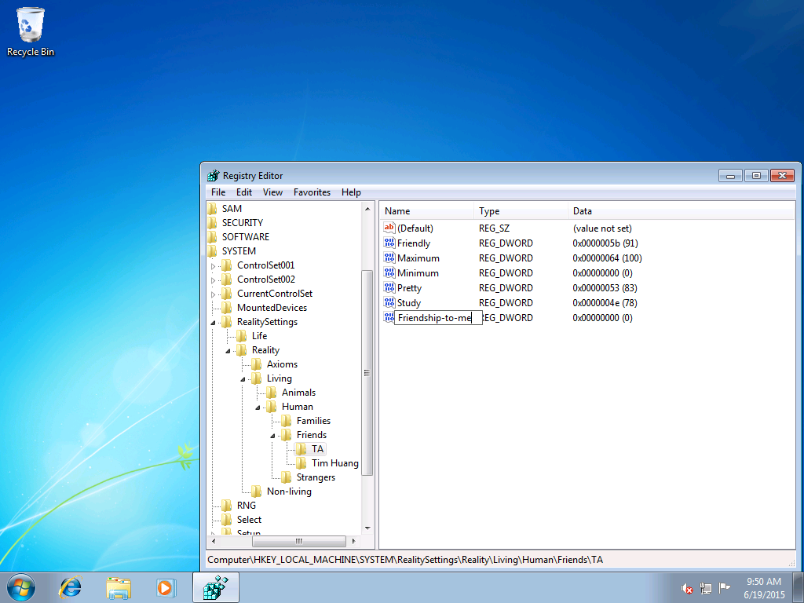
I'm adding things for good.
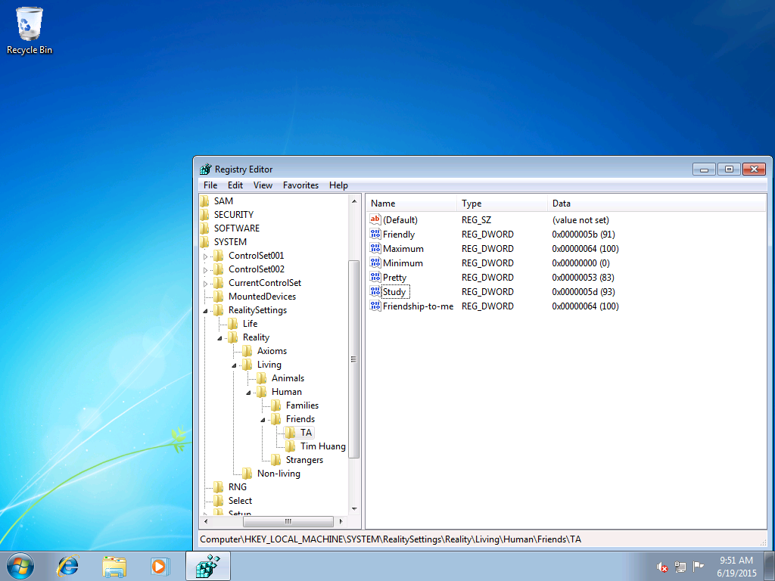
Yeah, now her friendship to me is 100 out of 100, her studies soar up to 93 (I think is the equivalent to me) +1 competitor, huhu ＞︿＜
The next day, I went to class, she ran to me as if we were friends for years, that means that all my experimentations have worked successfully.
I have an idea...
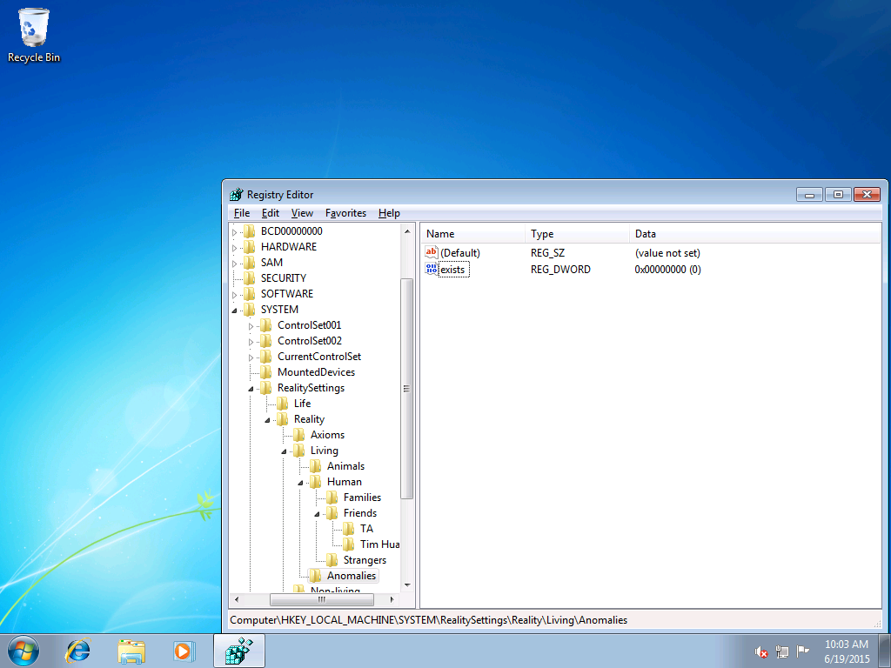
Adding Anomalies key to Living, add DWORD 32-bit to Anomalies, naming "exists"
Restarting Explorer.exe... Reopening that registry hive, it shows exists = 1
Huh?? Are there anomalies in this world? I think so, because in this world where I could edit reality, ANYTHING could happen.
This shows that my 6th sense feeling was correct all the time, the anomalies are real.

I shouldn't tell with others. They might find me losing my mind.
I'll might try to reset the anomalies dword to 0, so they disappear… Restarting explorer.exe, opening regedit, go to the directory, still 1?! It seems that I can't patch this. Wait… I can seek for help outside my world (if my world is simulated or written).
Besides the radio is an already made pudding. So tasty for me. I'm listening to the Jellyfish reuploads from Koronba, in my view, is a talented composer. If you wanna give it a try, https://www.youtube.com/watch?v=ok7UX3utzvI (about a jellyfish suddenly appears out of nowhere)
I'm putting this on loop definitely. The overhead lights from synthetic bubbles give me a chilling sensation. It is already 10:35 PM now, but I don't have to sleep because tomorrow is Saturday (20/6/2015 in dd/mm/yyyy format).
It's quite getting late, but I'll call this a day for the next day for more further investigations. On the table in the living where I'm putting there's some leftovers of cakes, other snacks. This isn't any occasions at all, just normal stuff.
My dad knows a lot of Windows stuff, in 2003, he ran Linux on this Windows XP machine with only a few hundreds of megabytes of RAM, now I'm here having 2 gigs of RAM and brag.
"The bluefin tuna comes flying… Breaking through the roof tiles… Killing us all" Such a bland joke made by me 😊 , yeah let's not deviate from the fact that I need to cope with those entities.

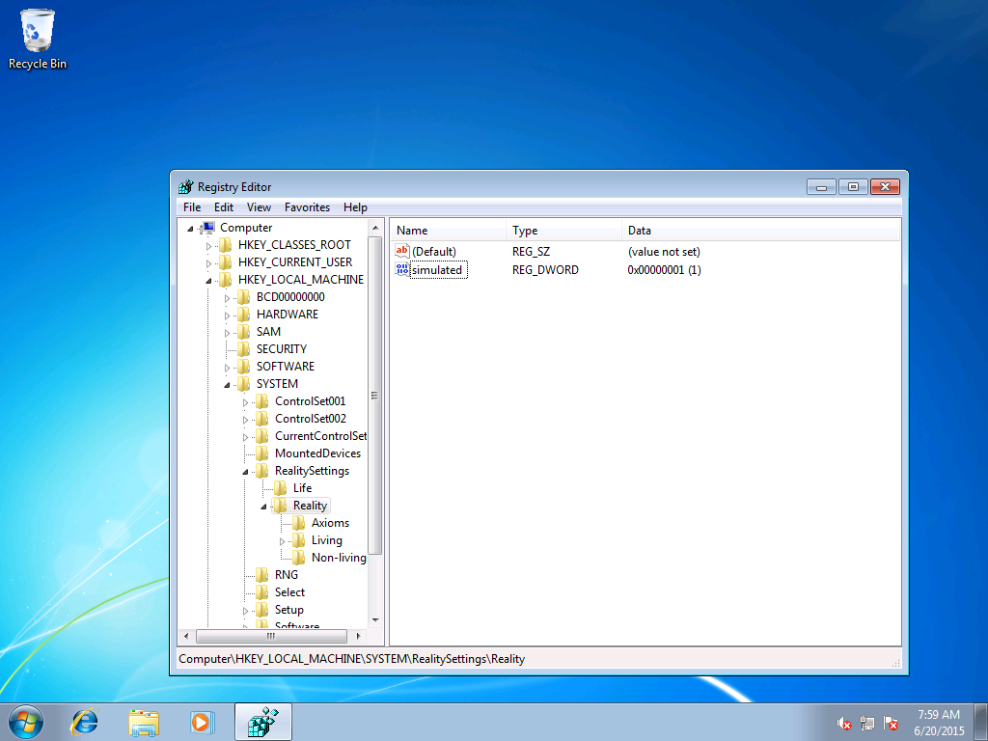
Again… restart explorer, now I feel something's off, it's like someone is watching me, behind those entities. Wait… If I created the watcher, and the watcher created my reality, then who created me?
Average bootstrap paradox, but maybe I'll ask the "writer" to change something to my reality.
Maybe I could send something to that writer to seek some help.
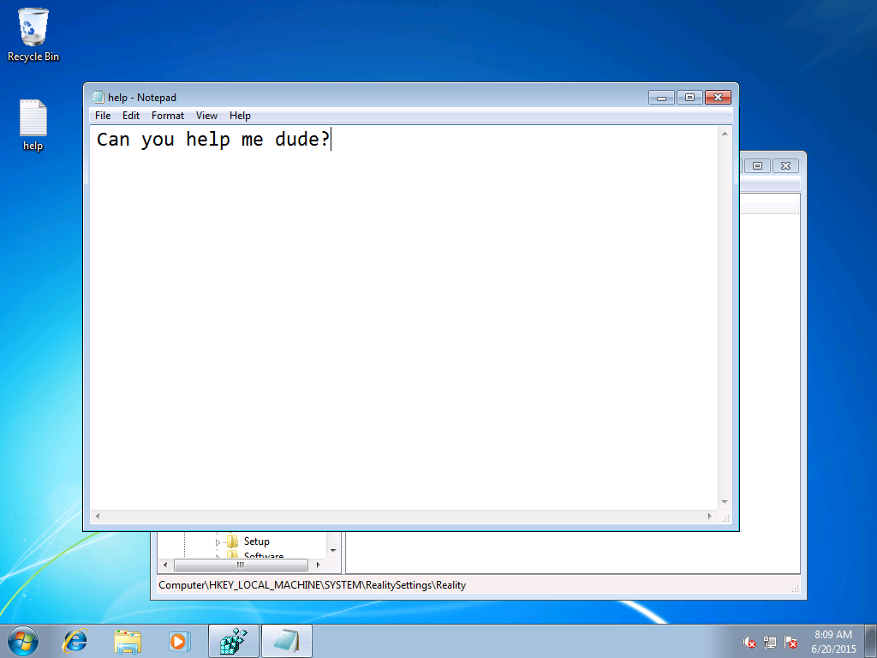

After a few hours, my desktop suddenly received a file. Opening that sorry.rtf, I see
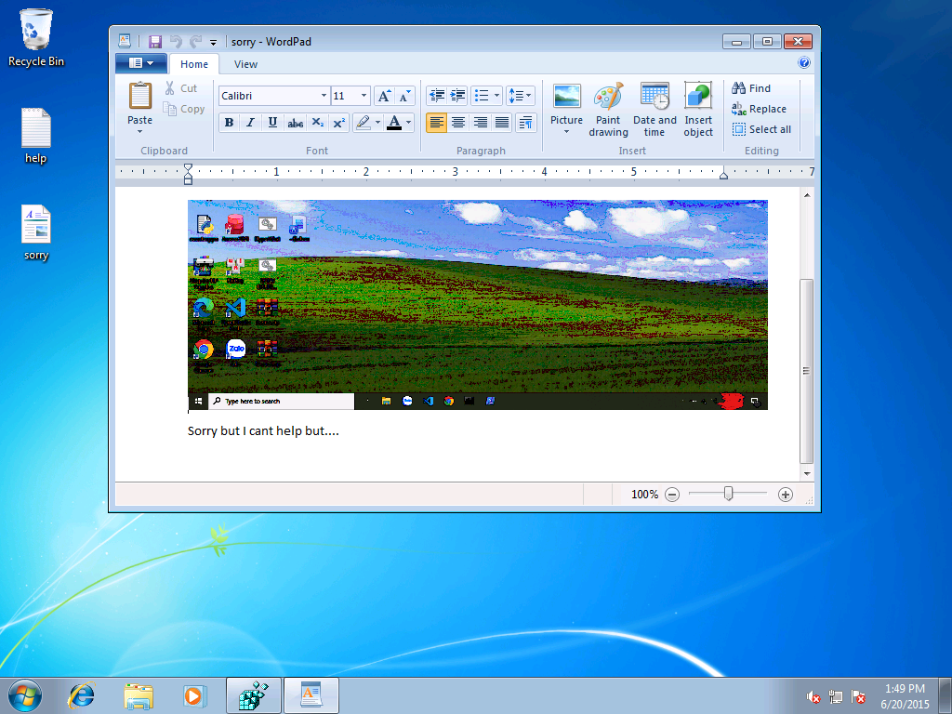
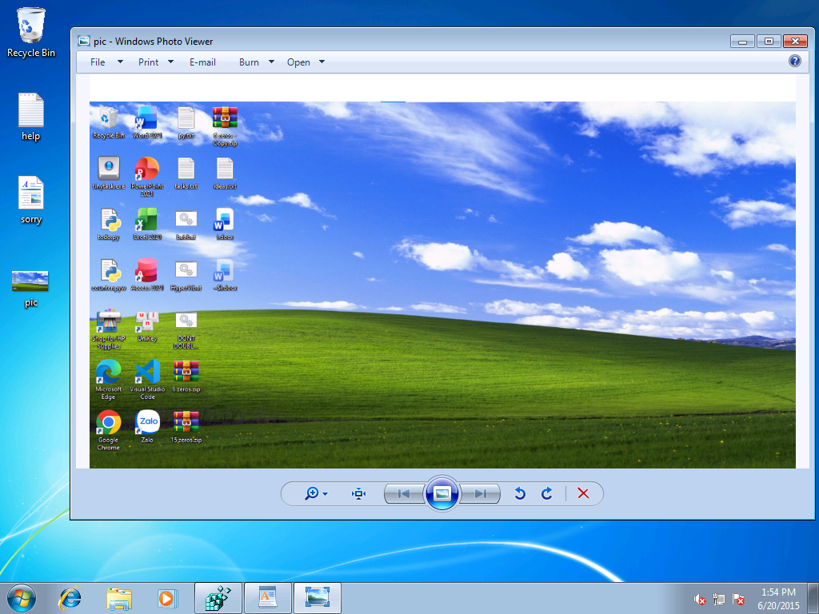
The taskbar looks nice though, but why is he/she apologizing?! I guess they couldn't intercept with this, maybe I have to cope with this alone. I've copied the image in WordPad to paint then viewed this. What strange thing they only put some Windows XP's background. But the Office version is saying 2021, it means that the writer timeline is at least 2021 or more. Which is 6 years further than my timeline.
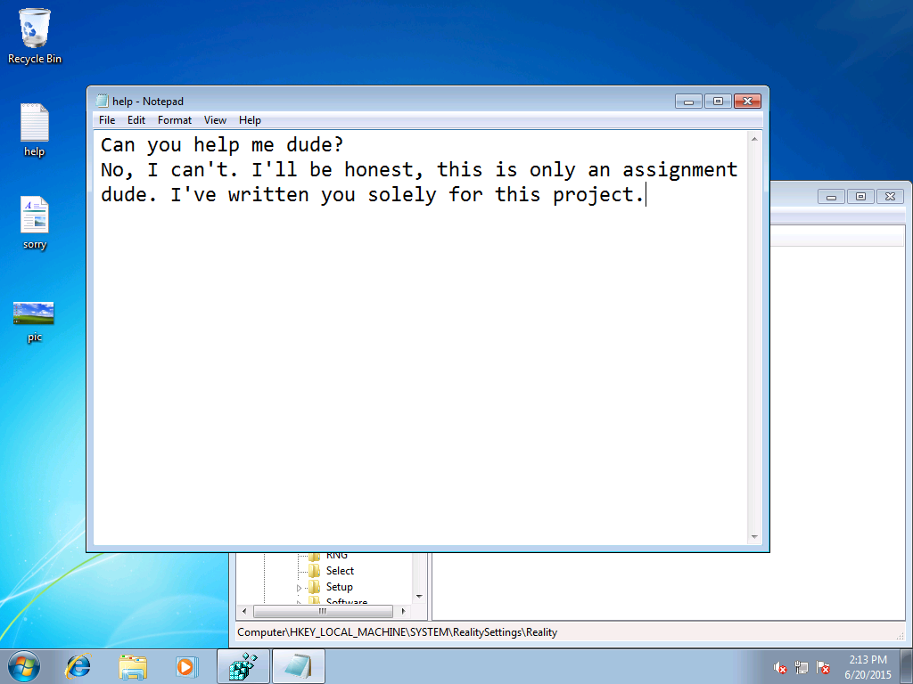
Checking the help.txt again, some text appeared from nowhere. It is saying this is for an assignment?! This can't be true. A world this real shouldn't only be assignment, right? Never mind, as mentioned, ANYTHING COULD HAPPEN.

Today is June 23rd, 2015, Tuesday. This morning, a boy so called from 2025 approached me and told me something. I think that's my writer.
We talked in quite the same frequency. Like him and me are an exactly duplicate with only difference is physical differences. He revealed about the technical details like he wrote this world. No other person sees him at all, only me.
As the days passed, we became friends. Until one day, we went on my moped together.
At the crossroads, I drive carefully, but as my last thought, a truck is about to hit me.
My final observations are him smirking, I realized he is an anomaly, just masquerading as my writer… He began to disappear in my eyes.

"Huh you waked up?!" Tim said
"Where am I?"
"Hospital"
"Why?"
"You got hit"
"Oh. What date is today?"
"July 27th, 2015"
"How long has it been?"
"1 month"
"Why am I here I ask!"
"Coma"
"…"

I'd tell my parents to buy me some RAM lol.
As I recovered, Windows 10 1507 Threshold 1 has release in 2 days after my initial waking.
I immediately update to Windows 10 right away.

Wait… this taskbar seems familiar…

