Watch this first: https://www.youtube.com/watch?v=2RmhTbVinV4. Story starts
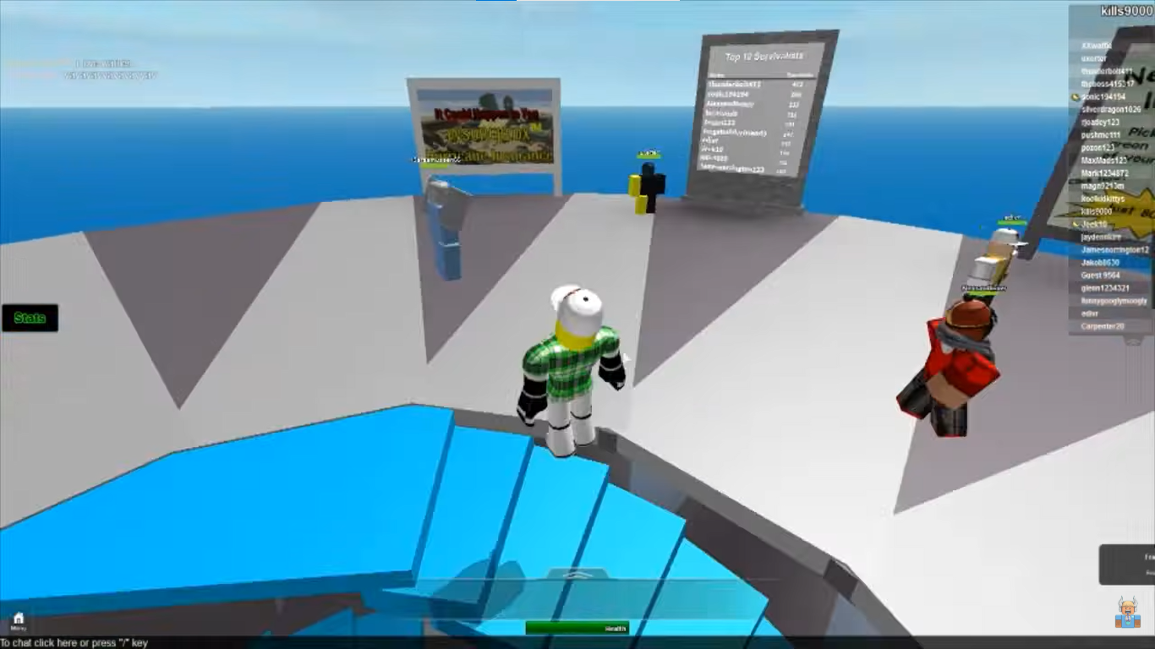
I wrote this on the 4th of March, 2014. This footage is not very sharp. Though I miss that Natural Disaster Survival because I have been grounded for a month. It is very nice and fun! Just got upgraded from Windows 7 to this freaking Windows 8.1, I think it is wasting my performance. It was faster, so lemme search. "Windows 8.1 is faster, lighter on system resources, and more secure than Windows 7.", wait... How come this happen, I thought newer is heavier lol. I really miss that Aero.
Everyday is the same, wake up at 5.30 AM, do homework, breakfast, then put on uniform, and go to school. Study then go home, eat dinner, play soccer with my friends. One of them is Tim, Tim Cook, hah, just joking, Tim Huang.
I remember him being not so erratic, but I asked others classmates, they said he is erratic though, maybe I have mis-remembered with someone who is more stable, like Windows 7, joking again, like... I don't know lol. A week earlier, somehow this finger got detached. He approached to me, said:
"At the park I usually go to, there's a trail I have never seen before.
Weeds thrive and it looks deserted, it leads to the back of the hill.
I felt bored so I decided to follow the trail.
After a few minutes, a strange tunnel appeared in front of my eyes.
Having nothing to do, so I went inside.
Looking at the wall, there’s a hole inside.
I put my finger to it, ...
... And it ... was cutted immediately.
I was scared so I ran home. It made me feel insecure.
I heard a frog's croak, so I hastened my pace.
And tripped while running."
At first, I thought he was just being making a stunt again. But looking at his lost finger and he was convincing so, I believed him only this time. That’s the first time I have ever heard about a forgotten trail in the park. So we ultimately arrived at the decision of accompanying each other.
Though I'm feeling a little bit anxious, I have to step forward. And before getting to that tunnel which I have been told, we encountered a traffic cone blocking our path. Removing the obstacle, we keep moving forward. That road is what I have never seen before. And we arrived at the mouth of the tunnel. When we step inside the tunnel, there's a yellow warning sign, only consisting of an exclamation mark: "!". The atmosphere here is humid, but there's a strange smell in the air.
He didn't notice there's a deep hole in the ground, so he fell downwards. I did tried to help him to escape that pithole. When I glanced at him, his body has already started to melt. Normally, I would have made the joke of pH level = -1, but this is involved in my friend's life so I had to try as much as possible to help him.
I was frightened so I ran home. That made I felt insecure. I heard a frog's croak, so I hastened my pace, and tripped while running.
I was frightened so I ran home. That made I felt insecure. I heard a frog's croak, so I hastened my pace, and tripped while running.
I was frightened so I ran home. That made I felt insecure. I heard a frog's croak, so I hastened my pace, and tripped while running.
I was frightened so I ran home. That made I felt insecure. I heard a frog's croak, so I hastened my pace, and tripped while running.

As I woke up, it was 5.30AM 3rd of March, 2014 again?! I think it is a dream but why... I can see texts clearly, slapped myself: felt the pain, clocks ain't distorted. It means that I have got myself time-travelled back to the point of time where everything hasn't happened yet.
So have to protect Tim by any cost. Putting on uniform and going to school. First lecture of the morning is Maths.
f(x) = x² + 3x – 7
Find the area of under the curve of the function f(x) from -10 to 10
$$\int_{-10}^{10}{f\left(x\right) dx}$$
So we have to determine that antiderivative of f(x):
$$\int{f\left(x\right)}$$
= $\frac{x^{3}}{3}$ + $\frac{{3x}^{2}}{2}$ – $7x+C$
Call that g(x)
So the answer is g(10) – g(-10)
= (1000/3 + 300/2 – 70 + C) – (-1000/3 + 300/2 + 70 + C)
= 2000/3 – 140 = 2000/3 – 420/3 = 1580/3
Mid-way through, I heard a frog's croak during the middle of the lesson. Wait... It was the same frog from the tunnel, I remember being stucked in a undetermined limbo.
After the lesson, Tim approached me and said what I have expected: he has lost his finger. He said we should go together to what's happening under the hood. Knowing what would happen, I convinced him not to go, but he insist on 'broadening his horizons'. No matter what I said, he still doesn’t change his opinion. With nothing to defense myself, because nobody would believe someone saying that they know the near-future. As they might interpret it is 'mental illness'.
So as you know, the same thing happened again, I tried to warn him countlessly, but he still didn't mind me, so he got melted again, I somehow got tripped many times and still ended up in that limbo. Maybe I have also got melted in the first place but my consciousness was kept?!
I waked up again, this time is earlier, March 2nd, 2014. Tim hasn’t lost his finger. Putting on uniform, going to school, today’s first lesson is Music, though I have to sing, but I have no mind to bear that. The notes start blurring, everything's spinning. I HAVE TO SAVE TIM. There's no time. Fortunately, I didn't get any serious illnesses.
At the break, I approached Tim, telling him that I'll go with him eating something and I pay the whole. He seemed very excited. That evening, after school, he didn't wander at the park anymore. While eating, he asked:
"You are so generous today, did you win the lottery?"
"Nah, you think, if I had won the lottery, I would have walked you to a 3-stars Michelin restaurant, not here."
"Thank you so much for this meal"
Deeply I thought:
"At least he didn't melt"
After the meal, I went home, and I tripped... Just joking. But my senses kept deteriorating, from vision, hearing, now smell, I scent a strange smell in my room.
Wait... There wasn't any Tim at all, it was just me all the time. As I realized, I have already melted.

