Watch this first: https://www.youtube.com/watch?v=2RmhTbVinV4. Story starts
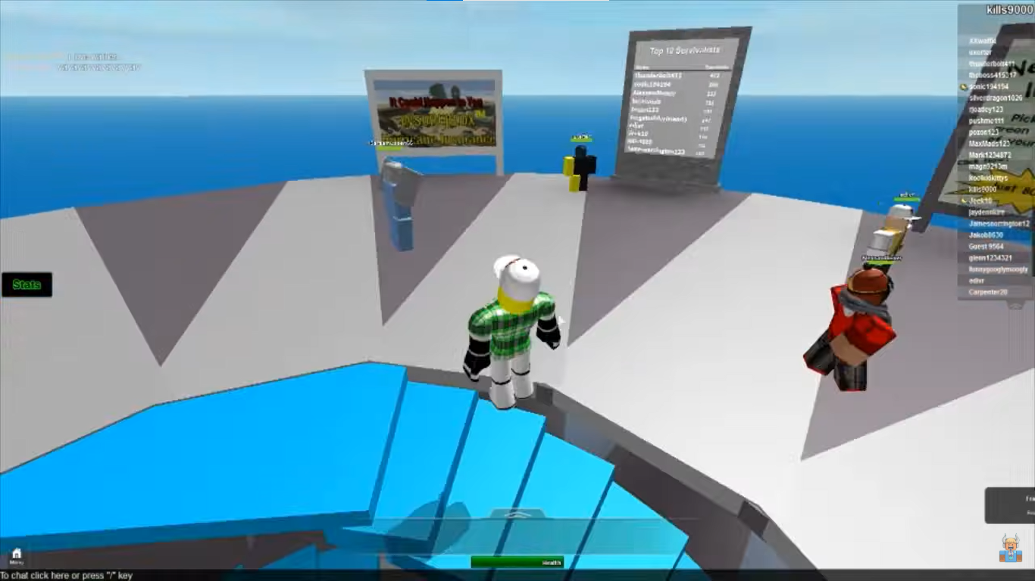
I wrote this on the 4th of March, 2014. This footage is not very sharp. Though I miss that Natural Disaster Survival because I have been grounded for a month. It is very nice and fun! Just got upgraded from Windows 7 to this freaking Windows 8.1, I think it is wasting my performance. It was faster, so lemme search. "Windows 8.1 is faster, lighter on system resources, and more secure than Windows 7.", wait... How come this happen, I thought newer is heavier lol. I really miss that Aero.
Everyday is the same, wake up at 5.30 AM, do homework, breakfast, then put on uniform, and go to school. Study then go home, eat dinner, play soccer with my friends. One of them is Tim, Tim Cook, hah, just joking, Tim Huang.
I remember him being not so erratic, but I asked others classmates, they said he is erratic though, maybe I have mis-remembered with someone who is more stable, like Windows 7, joking again, like... I don't know lol. A week earlier, somehow this finger got detached. He approached to me, said:
"At the park I usually go to, there's a trail I have never seen before.
Weeds thrive and it looks deserted, it leads to the back of the hill.
I felt bored so I decided to follow the trail.
After a few minutes, a strange tunnel appeared in front of my eyes.
Having nothing to do, so I went inside.
Looking at the wall, there’s a hole inside.
I put my finger to it, ...
... And it ... was cutted immediately.
I was scared so I ran home. It made me feel insecure.
I heard a frog's croak, so I hastened my pace.
And tripped while running."
At first, I thought he was just being making a stunt again. But looking at his lost finger and he was convincing so, I believed him only this time. That’s the first time I have ever heard about a forgotten trail in the park. So we ultimately arrived at the decision of accompanying each other.
Though I'm feeling a little bit anxious, I have to step forward. And before getting to that tunnel which I have been told, we encountered a traffic cone blocking our path. Removing the obstacle, we keep moving forward. That road is what I have never seen before. And we arrived at the mouth of the tunnel. When we step inside the tunnel, there's a yellow warning sign, only consisting of an exclamation mark: "!". The atmosphere here is humid, but there's a strange smell in the air.
He didn't notice there's a deep hole in the ground, so he fell downwards. I did tried to help him to escape that pithole. When I glanced at him, his body has already started to melt. Normally, I would have made the joke of pH level = -1, but this is involved in my friend's life so I had to try as much as possible to help him.
I was frightened so I ran home. That made I felt insecure. I heard a frog's croak, so I hastened my pace, and tripped while running.
I was frightened so I ran home. That made I felt insecure. I heard a frog's croak, so I hastened my pace, and tripped while running.
I was frightened so I ran home. That made I felt insecure. I heard a frog's croak, so I hastened my pace, and tripped while running.
I was frightened so I ran home. That made I felt insecure. I heard a frog's croak, so I hastened my pace, and tripped while running.

