# Writing this on August 13th, 2015
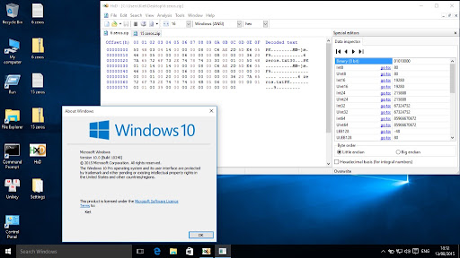
I'm currently trying to make a zip bomb, but I'm not that professional yet lol =). I'm just using HxD to inspect the raw bytes. I'm opening 6 zeros.zip and 15 zeros.zip (all of them just contain 1 text document each with the content being described by the tile of the zip)
Why is the 6 zeros.zip saying 0x33 0x30 but its counterpart saying 0x33 0x30 0x40 (or 51 48 64 in decimal base). If you're wondering what the raw bytes are, here it is:
6 zeros.zip:
50 4B 03 04 14 00 00 00 08 00 D0 B1 2B 5D E6 05 46 39 05 00 00 00 06 00 00 00 0B 00 00 00 36 20 7A 65 72 6F 73 2E 74 78 74 33 30 00 01 00 50 4B 01 02 14 00 14 00 00 00 08 00 D0 B1 2B 5D E6 05 46 39 05 00 00 00 06 00 00 00 0B 00 00 00 00 00 00 00 01 00 20 00 00 00 00 00 00 00 36 20 7A 65 72 6F 73 2E 74 78 74 50 4B 05 06 00 00 00 00 01 00 01 00 39 00 00 00 2E 00 00 00 00 00
15 zeros.zip:
50 4B 03 04 14 00 00 00 08 00 8F 51 2C 5D 35 66 70 68 05 00 00 00 0F 00 00 00 0C 00 00 00 31 35 20 7A 65 72 6F 73 2E 74 78 74 33 30 40 01 00 50 4B 01 02 14 00 14 00 00 00 08 00 8F 51 2C 5D 35 66 70 68 05 00 00 00 0F 00 00 00 0C 00 00 00 00 00 00 00 01 00 20 00 00 00 00 00 00 00 31 35 20 7A 65 72 6F 73 2E 74 78 74 50 4B 05 06 00 00 00 00 01 00 01 00 3A 00 00 00 2F 00 00 00 00 00
Hah, I'm using Windows 10 (1507). It was released in July 29th, 2015. And I've just installed it on my beloved Windows 7 Ultimate machine (I skipped Windows 8.x because it's trash) Gotta flex about that! The UI looks very different, but it's nice.
But nevermind, today is the next day (Friday, August 14th, 2015), I went to school normally. Today is a pretty good day, I got a 97 on an exam, yeah! After going home, I started thinking if there's something astonishing today (except the 97).
That's when I realised, my class had 46 students, but I remember it being 45. How can someone enter the class without anyone noticing? I have to be right because I've belonged to this class for 2 years (grade 6 to grade 8)
Tomorrow and its following day are Saturday and Sunday, so I can't ask them out directly. But I can ask my classmates online, like "Do you know who's the extra person?", type of questions.
They said no
I asked further: "So how many people are there in our class?"
They answered: 46
Their response sent shivers down my spine.

I just stood there, completely shocked. Maybe I had been wrong all this time. But this couldn't be fake. My memory had to be real.
After a while, I came to a possible solution. Our teacher in 6th grade had handed us an e-learning account list. We all had one account, one for each person. Hopefully, I hadn't dumped the entire conversation in the trash bin just to free up storage on my little 128GB SSD.
Opening `list.xlsx` with Office 2013, I saw that it only went up to A45. That meant there were only 45 students, just as I remembered. This proved that my memory was actually accurate.
I immediately told my close friend, Tim Huang.

Yeah, he believed me, but I decided I would ask the other friends next Monday.
Nevermind, I should flex this Windows 10 1507 right now, I'm holding a piece of metal running the newest operating system!!! Wah, there are so many features, start menu is back, all the old programs still work normally.
Just escaped from that Windows 8.1 freak.
Just got a new favourite song!: イワシがつちからはえてくるんだ or Sardines sprout from the ground, if you wanna hear it too?: https://www.youtube.com/watch?v=d_T1StgldnM
The song is pretty catchy, but who knows, why sardines grow from dirt?! And sardines grow everywhere, the girl in the song ate a sardine and fell asleep. When she wakes up, a sardine has also sprouted in her head.
What a brain-melting song! But the song is addictive, I can't stop hearing it. God might not stop me from this.

Today is August 17th, 2015, Monday. I need to confront my friends. But before class, I have to prepare some subjects. Region Studies, Art, Science x2 periods. I'm mid at region, bad and mad at Art, mid-high at Science.
Putting on some uniforms... Putting books into backpack... Putting socks and shoes on... Sitting on the moped... Going to Tim's house... Picked him up... Went to school with him.
That's the summary of going to school.exe ヾ(•ω•`)o

To class, I've realised that asking classmates might make the extra person notice me. I didn’t know who they were, whether they were human or not, so it was no good catching their concern.
I started with a broad questions but sharp: "Have y'all get the e-learning account from grade 6?". Looking at all faces in the class, they all seem familiar, I can't identify who YET.
They all answered that they had.
"Just one more question, where are your homes?"
An extra person or an alien can't make this up easily right?! I went through each person, the locations still seemed plausible.
Maybe I didn’t seen correctly.

The periods were hard as usual. I use a hidden "time travel" method that everyone knows but scientists just want more exaggerated answers: sleeping. I slept in class while the teacher was talking. I sit at the furthest corner from the teach's table.
At this distance, the teacher might not see me ^o^. The standard deviation of the probability of me getting caught is mean = 100%, σ = 0.25, at plus or minus 4 positions.
I have studied the materials at home first, so no time for wasting time looking blankly at what I already knew. Rather, I'm thinking about how to quickly identify who's extra.
I was sandwiched between 2 people at my table, I'm the second person from left to right. The girl who sits next to me is BT and the guy on the right is GP. I am kind of funny, so I have a pretty good relationship, so they don't snitch on me lol (*￣▽￣*)ブ
I skipped to period 4, the last period of the day. I went home alone, because Tim went with another mate. Going back home, opening diary.txt and I write on the computer what I wrote on hand on the notebook at school.
But let's not deviate from the fact that there is a 46th student.
Wait... I can compare the faces with the photo we all took together before anything of this reality glitch happened.

Opening 6/8-44-years-anniversary-students.png, I rarely open this photo because path file is so long. The image application booted up kind of fast. 1 ... 2 ... 3 ... 43 ... 44 ... 45. Ah hah! Only 45 people, I slammed my hands on my green study table, I shouted. I have to recount many times because I sometimes lose track mid-way through.
I'll just need to print out the png on my printer.
for seat in class:
compare(seat.person, image)

I'll compare it tomorow (Tuesday), but lemme flex to whoever is reading this diary. Windows 10 1507 is PEAK. You won't understand my joy when I escaped Windows 8.1, build 10.0.10240 or 1507 or Threshold 1.

Sleeping sleeping my darling.... Yeah, just a song for me to hear before sleep dude, don't misinterpret me as a childish one.

Every day is the same, dear modern humans who crave instant dopamine, I'll skip this part (because I know I'm also a dopamine craver). Oh shit, today has 5 different subjects of Music, Computer Science, Morality, Science, Maths, today's backpack gonna be huge.
I started from right to left, down to up (pretty reverse right?!), a person, GP, me, BT, Tim, ... For every person I see, I crossed out their face on the picture. Until... there is someone I haven't marked.
In a room, filled with clicking sounds, I keep crossing, I looked up, the person whom I haven't marked sit at the second row. I have to check manually, it's quite daunting lol ￣へ￣
Her name is TA, I remember talking to her many times now. Our conversation involves me telling her: her embarassing moments like NK in our class confessed to her in the 5th grade.
Just a normal person, not so special in our class. So... the evasion has happened since the 6th grade and I have never noticed... This made me feel so bad.
I asked Tim: who is that girl?
Tim looked at me like a bewildered person and answered:
"Always been there, are you out of your mind?. Have you been learning maths too much and you're crazy now?"
My hands shook without my command.

Yeah, I'll confront later, but we're having a test by doing some calculation in Excel, getting done in a few minutes. Windows 7 Aero is still my favourite, and school computer is running it.
I'm already good at Windows and doing some Office because I was "trained to", actually because I am interested in core system components (system32, windows), and automation (python, batch), some programming on windows (powershell, terminal)
Yeah, I'm just a beginner to intermediate in fields I just mentioned. I can't do some hacking to access the school .mdb, if I had, I would. But I can absolutely destroy the computer. Don't believe? I'll show you (just reminding y'all that you shouldn't do this at school, or else...):
Make a file on desktop named bat.txt, type:
@echo off
cd /d C:\
set i=0
:loop
mkdir %i%
cd %i%
set /a i+=1
goto loop
then change the extension from .txt to .bat, then double click to run
C:\0\1\2\3\4\5\6\7...
it's working.
The computer froze.
I saved the file to D:\backup
Tim asked: "What on Earth are you doing right now"
I answered: "Just some testing on computer"

Just got the computer rebooted, wasting me 5 minutes, but I released my stress to this piece of metal.
The bell rang, the 4th period (Computer Science) is over, the immediate emerging merging resonants from people' voices. The sounds of talking, laughing, is all here. They are in fact, just some sine waves, everyone knows.
TA talks to other girls as if nothing has happened, and those other girls haven't noticed anything strange, but I have.
The last period is Science, we learnt about balancing chemical reactions, quite easy for me after all. It's just some basic maths, but you know?: I excel at Maths. Too easy, pass, pass, pass, sleep.
Even when I'm studying, I'm always trying to recreate the Sardines... song from my head, because I like it dude, so brainrotting.
End of period 5, ding... ding... ding... Conversations are bigger than before, I approached TA, told her: "Well, I still remember your embarassing moments"
She pinched my arm pretty hard, felt the pain, I told her I'll not tell people her secrets, then she let me free again. I ran pretty fast dude.
She is a real-life person, not a ghost or a software error, nor reality glitch. I'd better irritate her again, or else, a pain will appear out of nowhere.
Coming home, I open my Windows 10 1507 precious, lovely machine. I HAVE THE RIGHT TO FLEX. Hehe, going to send some zip bomb to TA's device (just some prankless harm of 10MB zip bomb, *size of being decompressed)
Gotta send it by Email, it's so fast, to be honest. I somehow have her contacts on some social media. Phoning her:
"Hello NK! Are you okay? Oops... sorry, wrong person"
Deliberately said that
"You.....", she said
The call was ended after that. So irritable. Her phone must be frozen right now, too bad so sad. Received status showed me that. That's the karma of touching me. Opening the song right now. So good to be a song. Should be a masterpiece, though, 360p is low.
I stayed awake until 2am today, so I have to sleep-to-refill, at 8pm. Though I don't study in the morning like people stereotype, I study from noon to evening instead. The morning is for grade 6-7, the rest is for evening.
So I could sleep till 9 in the morning and still have time to prepare for subjects in the evening. Today, I have Geography, Spanish, English, 3 subjects too easy. But I regret teasing TA with those dirty tricks now.
To class, as soon as TA saw me, she chased me, until... I'm out of breath and she still hadn't quit yet. I have to slow down. She caught me ಠ╭╮ಠ . She grabbed my ears, and pulled me from the yard to the stairs. During the process, I screamed: "AAAAaaaaAAAAAa". Yet she won't free me, I have to swear 10 times until she believes.
Let's not deviate from the mission to find out who the extra person is.

During the Spanish periods, Tim asked me: "Are you still hurting after the accident?"
"What accident?"
"Wanna tell?"
"Sure."
"You were travelling normally, then a careless driver hit you."
"Are you bluffing?"
"Absolutely not, I'm your best friend, why would I lie.
Your earlier question from CS class concerned me.
You did lost some memories.
Now recount."
"1...2...3...44...45 45 people?"
"It always was"

# 20th August, 2015
I didn't open the diary.txt file until late in the evening. My head was heavy, aching with a dull, throbbing rhythm that matched the hum of the PC power supply.
Tim’s words from yesterday’s Spanish class kept looping in my brain, a corrupted audio file that wouldn't stop playing. "You did lost some memories. Now recount."
And then my own voice, shaking as the logic broke: 45 people?
And Tim: "It always was."
I stared at the screen of my Windows 10 1507 machine. The flat, clean UI of build 10240 suddenly felt like a sterile hospital room. I opened the e-learning list.xlsx again. I didn't need to run any complex loops or custom macro functions this time. I just scrolled down with my mouse wheel.
Row 45. Column A. That was the absolute end of the array.

TA’s name was right there, assigned to index 05. She wasn't the 46th student. She had never been the extra sector. She had been sitting in the second row for two straight years, and my brain had somehow dropped her partition entirely after that reckless driver smashed into my moped three months ago. The doctor called it post-traumatic retrograde amnesia, but to me, it felt like someone had manually deleted a core system component from my system32 directory without checking dependencies.
I looked at the folder D:\backup where I stored the 10MB compressed text document I sent to her email. A prankless harm. I thought I was hacking a glitching system, fighting an anomaly with raw bytes. In reality, I was just an unhinged teenager with a concussed skull, spamming a real girl's inbox because my memory bank had suffered a catastrophic hardware failure.

I leaned back, clicking the mouse blindly. I opened the browser to listen to the Sardines song again to numb the confusion. But as the page loaded at 360p, my mouse cursor froze entirely.

I just wanted to see the size of the diary.txt (shortcut). Right-clicking and clicked Open File Location
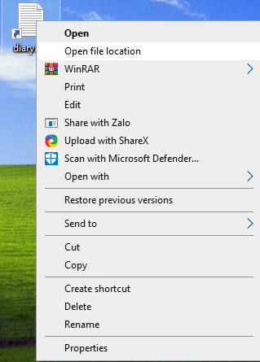

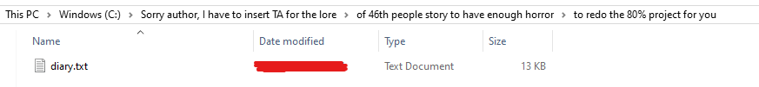

Left-clicked the file again, click Properties:
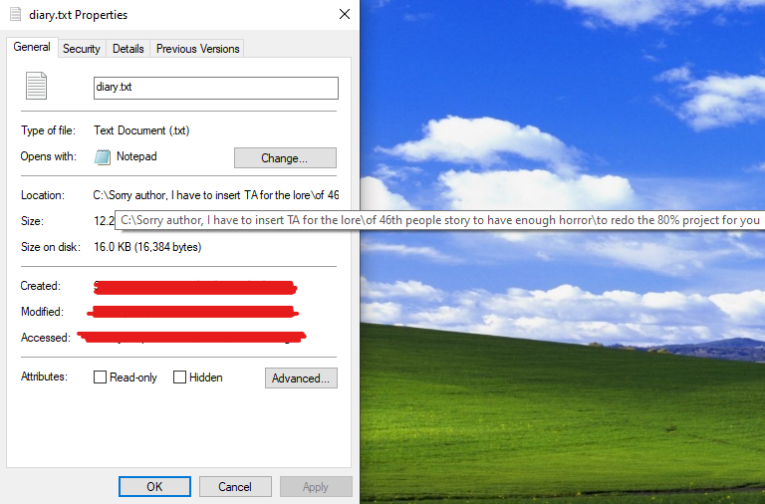

What author? What 80% project? I don't know.
Maybe this world after all, is just a story… made for a person’s assignment…

