# **Statistics: The Science of Decisions Project Instructions**

# **Background Information**

In a Stroop task, participants are presented with a list of words, with each word displayed in a color of ink. The participant’s task is to say out loud the *color of the ink* in which the word is printed. The task has two conditions: a congruent words condition, and an incongruent words condition. In the *congruent words* condition, the words being displayed are color words whose names match the colors in which they are printed: for example RED, BLUE. In the *incongruent words* condition, the words displayed are color words whose names do not match the colors in which they are printed: for example PURPLE, ORANGE. In each case, we measure the time it takes to name the ink colors in equally-sized lists. Each participant will go through and record a time from each condition.

# **Questions For Investigation**

As a general note, be sure to keep a record of any resources that you use or refer to in the creation of your project. You will need to report your sources as part of the project submission.

1. What is our independent variable? What is our dependent variable?

independent variables: the list of words given to the participants,

dependent variables: time for the participants to name the ink colors

2. What is an appropriate set of hypotheses for this task? What kind of statistical test do you expect to perform? Justify your choices.

Now it’s your chance to try out the Stroop task for yourself. Go to [this link](https://faculty.washington.edu/chudler/java/ready.html), which has a Java-based applet for performing the Stroop task. Record the times that you received on the task (you do not need to submit your times to the site.) Now, download [this dataset](https://drive.google.com/file/d/0B9Yf01UaIbUgQXpYb2NhZ29yX1U/view?usp=sharing) which contains results from a number of participants in the task. Each row of the dataset contains the performance for one participant, with the first number their results on the congruent task and the second number their performance on the incongruent task.

$H_{0}$: $μ_{C}=μ_{I}$

$Ha$: $μ_{C}≠μ{}_{I}$,where

$μ_{C}$ = Mean time for saying congruent words

$μ_{I}$ = Mean time for saying incongruent words

T-test should be used here since we have only the sample statistics.

3. Report some descriptive statistics regarding this dataset. Include at least one measure of central tendency and at least one measure of variability.

Central tendency:

Mean of congruent group = 14.05s

Mean of incongruent group = 22.02s

That means, it requires more time for the incongruent group

Central tendency:

Standard deviation of congruent group = 3.56

Standard deviation of incongruent group = 4.80

That means the incongruent group has a wider range of values while values of the congruent group are more closer to the mean.

4. Provide one or two visualizations that show the distribution of the sample data. Write one or two sentences noting what you observe about the plot or plots.

First we have the histograms for both groups with bucket size 2. With small bin size, we have better details on the data set. For the congruent group, you can see it is normally distributed with mean value at 15 and have outliers between 22 and 24. For the incongruent group, it is also normally distributed with mean value at 21 and have outliers between 34 and 36.

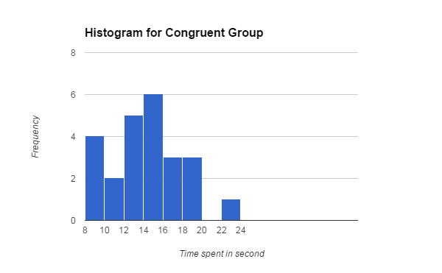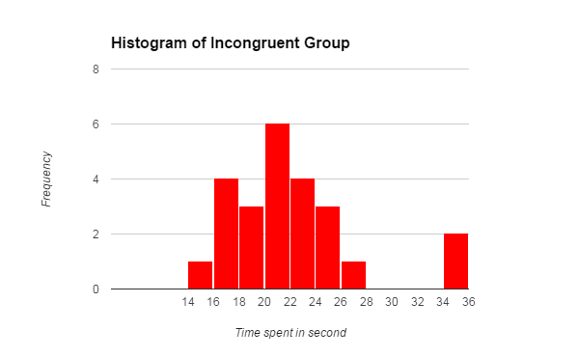

Then we have the histograms for both groups with bucket size 4. With larger bin size, we have lost some details on the data set but the mean value in this case become close to our calculated mean. For the congruent group, you can see it is normally distributed with mean value at 14. For the incongruent group, it is also normally distributed with mean value at 22.

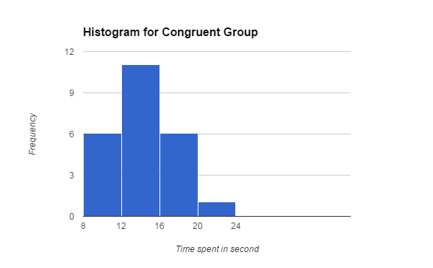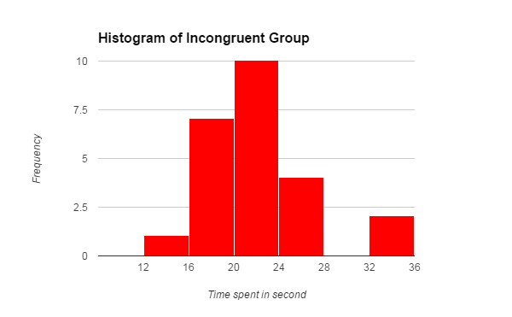

5. Now, perform the statistical test and report your results. What is your confidence level and your critical statistic value? Do you reject the null hypothesis or fail to reject it? Come to a conclusion in terms of the experiment task. Did the results match up with your expectations?

n=24

$μ_{C}=14.05$

$μ_{I}= 22.02$

$μ_{C}- μ_{I}=14.05 - 22.02 = -7.96$

$S_{μ_{C}- μ_{I}}= 4.86$

$t = -7.96 / (4.86 / \sqrt{24}) = -8.02$

With confidence level of 95%, $α=0.05$, and we are using 2-tail test in this case, critical t-value would be -2.06 and +2.06. Since t value for our sample, -8.02 is less than -2.064, we can reject our null hypotheses. It is expected that incongruent words would be harder to read.

6. Optional: What do you think is responsible for the effects observed? Can you think of an alternative or similar task that would result in a similar effect? Some research about the problem will be helpful for thinking about these two questions!

It would be the brain that being more sensitive and responsive to color. Determining a colour is faster than reading words.

A similar test for example can be shape and words. Showing words such as ‘Circle’ inside a circle and square for congruent group and incongruent group respectively, and record the time required to name the shape for the 2 groups.