data ex14_23;

    do ph=4 to 7;

        do calcium=100 to 300 by 100;

            do rep=1 to 3;

                input diameter;

                output;

            end;

        end;

    end;

    cards;

    5.2

    5.9

    6.3

    7.4

    7.0

    7.6

    6.3

    6.7

    6.1

    7.1

    7.4

    7.5

    7.4

    7.3

    7.1

    7.3

    7.5

    7.2

    7.6

    7.2

    7.4

    7.6

    7.5

    7.8

    7.2

    7.3

    7.

    7.2

    7.5

    7.2

    7.4

    7.0

    6.9

    6.8

    6.6

    6.4

run;

**proc** **print** data=ex14_23;

**run**;

**proc** **gplot** data=ex14_23;

plot diameter * ph=calcium;

**run**;

**proc** **glm** data=ex14_23;

class ph calcium;

model diameter=ph calcium ph*calcium;

**run**;

|  |  |  |  |  |  |
| --- | --- | --- | --- | --- | --- |
| **Source** | **DF** | **Sum of Squares** | **Mean Square** | **F Value** | **Pr > F** |
| **Model** | 11 | 9.18305556 | 0.83482323 | 12.32 | <.0001 |
| **Error** | 24 | 1.62666667 | 0.06777778 |  |  |
| **Corrected Total** | 35 | 10.80972222 |  |  |  |

|  |  |  |  |
| --- | --- | --- | --- |
| **R-Square** | **Coeff Var** | **Root MSE** | **diameter Mean** |
| 0.849518 | 3.691335 | 0.260342 | 7.052778 |

|  |  |  |  |  |  |
| --- | --- | --- | --- | --- | --- |
| **Source** | **DF** | **Type I SS** | **Mean Square** | **F Value** | **Pr > F** |
| **ph** | 3 | 4.46083333 | 1.48694444 | 21.94 | <.0001 |
| **calcium** | 2 | 1.46722222 | 0.73361111 | 10.82 | 0.0004 |
| **ph*calcium** | 6 | 3.25500000 | 0.54250000 | 8.00 | <.0001 |

|  |  |  |  |  |  |
| --- | --- | --- | --- | --- | --- |
| **Source** | **DF** | **Type III SS** | **Mean Square** | **F Value** | **Pr > F** |
| **ph** | 3 | 4.46083333 | 1.48694444 | 21.94 | <.0001 |
| **calcium** | 2 | 1.46722222 | 0.73361111 | 10.82 | 0.0004 |
| **ph*calcium** | 6 | 3.25500000 | 0.54250000 | 8.00 | <.0001 |

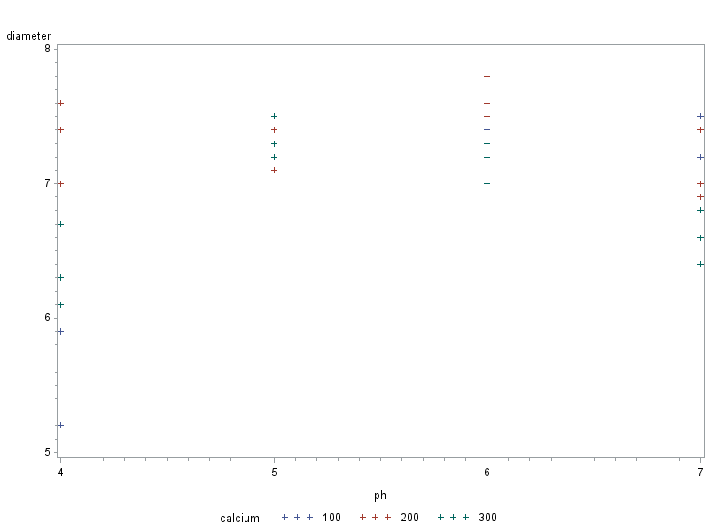

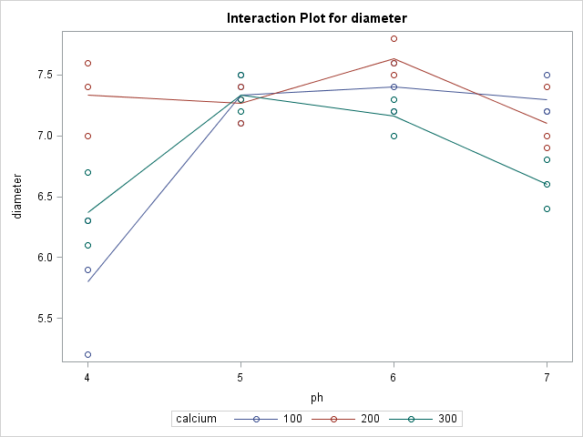

lsmeans diameter / adjust=tukey pdiff;

**run**;

|  |  |  |  |
| --- | --- | --- | --- |
| **Least Squares Means for effect calcium**  **Pr > |t| for H0: LSMean(i)=LSMean(j)**  **Dependent Variable: diameter** | | | |
| **i/j** | **1** | **2** | **3** |
| **1** |  | 0.0047 | 0.6686 |
| **2** | 0.0047 |  | 0.0006 |
| **3** | 0.6686 | 0.0006 |  |

|  |  |  |  |  |
| --- | --- | --- | --- | --- |
| **Least Squares Means for effect ph**  **Pr > |t| for H0: LSMean(i)=LSMean(j)**  **Dependent Variable: diameter** | | | | |
| **i/j** | **1** | **2** | **3** | **4** |
| **1** |  | <.0001 | <.0001 | 0.0023 |
| **2** | <.0001 |  | 0.8864 | 0.0796 |
| **3** | <.0001 | 0.8864 |  | 0.0164 |
| **4** | 0.0023 | 0.0796 | 0.0164 |  |

data ex14_28;

do medication 1 to 9;

       do severity 1 to 3;

           do rep=1 to 5;

               input temperature;

               output;

           end;

       end;

    end;

    cards;

97.8

97.2

97.6

97.2

97.6

97.6

97.4

97.3

97.5

97.5

97.5

97.9

97.6

97.6

97.7

98.1

98.1

98.0

97.7

97.7

97.8

97.7

97.6

97.7

97.7

97.6

97.7

97.9

97.9

97.8

98.0

97.8

98.1

97.8

97.9

97.9

98.1

97.8

97.8

97.6

98.0

97.8

98.1

97.7

98.7

97.3

97.3

97.5

97.5

97.6

97.5

97.4

97.5

97.6

97.7

97.9

97.8

97.8

97.8

97.6

97.9

97.8

97.8

97.7

97.8

97.8

97.8

97.7

97.7

97.8

97.7

97.8

97.9

98.0

98.1

97.9

97.9

97.8

97.8

97.6

97.0

97.7

97.8

97.9

97.8

97.9

98.0

97.7

97.9

97.9

97.1

97.6

97.3

97.7

97.5

97.6

97.5

97.9

97.5

97.3

97.4

97.8

97.4

97.6

97.6

98.0

97.8

98.0

97.9

98.0

97.9

98.0

97.9

97.9

97.8

97.8

97.8

98.0

97.9

97.8

97.8

98.0

97.7

97.9

97.8

98.0

97.6

98.0

97.9

97.9

98.0

98.1

97.9

98.1

97.9

run;

proc print data=ex14_28;

run;

proc print data=ex14_28;

run;

proc gplot data=ex14_28;

plot temperature * medication=severity;

run;

proc glm data=ex14_28;

class medication severity;

model temperature=medication severity medication*severity;

run;

lsmeans ph / adjust=tukey pdiff;

run;

data ex14u28;

do medication 1 to 9;

       do severity 1 to 3;

           do rep=1 to 5;

               input temperature;

               output;

           end;

       end;

    end;

cards;

97.8

97.2

97.6

97.2

97.6

97.6

97.4

97.3

97.5

97.5

97.5

97.9

97.6

97.6

97.7

98.1

98.1

98.0

97.7

97.7

97.8

97.7

97.6

97.7

97.7

97.6

97.7

97.9

97.9

97.8

98.0

97.8

98.1

97.8

97.9

97.9

98.1

97.8

97.8

97.6

98.0

97.8

98.1

97.7

98.7

97.3

97.3

97.5

97.5

97.6

97.5

97.4

97.5

97.6

97.7

97.9

97.8

97.8

97.8

97.6

97.9

97.8

97.8

97.7

97.8

97.8

97.8

97.7

97.7

97.8

97.7

97.8

97.9

98.0

98.1

97.9

97.9

97.8

97.8

97.6

97.0

97.7

97.8

97.9

97.8

97.9

98.0

97.7

97.9

97.9

97.1

97.6

97.3

97.7

97.5

97.6

97.5

97.9

97.5

97.3

97.4

97.8

97.4

97.6

97.6

98.0

97.8

98.0

97.9

98.0

97.9

98.0

97.9

97.9

97.8

97.8

97.8

98.0

97.9

97.8

97.8

98.0

97.7

97.9

97.8

98.0

97.6

98.0

97.9

97.9

98.0

98.1

97.9

98.1

97.9

run;

proc print data=ex14u28;

run;

proc gplot data=ex14u28;

plot temperature * medication=severity;

run;

proc glm data=ex14u28;

class medication severity;

model temperature=medication severity medication*severity;

run;

*lsmeans ph / adjust=tukey pdiff;

*run;

|  |  |  |  |  |  |
| --- | --- | --- | --- | --- | --- |
| **Source** | **DF** | **Sum of Squares** | **Mean Square** | **F Value** | **Pr > F** |
| **Model** | 26 | 4.27200000 | 0.16430769 | 5.44 | <.0001 |
| **Error** | 108 | 3.26400000 | 0.03022222 |  |  |
| **Corrected Total** | 134 | 7.53600000 |  |  |  |

|  |  |  |  |
| --- | --- | --- | --- |
| **R-Square** | **Coeff Var** | **Root MSE** | **temperature Mean** |
| 0.566879 | 0.177841 | 0.173845 | 97.75333 |

|  |  |  |  |  |  |
| --- | --- | --- | --- | --- | --- |
| **Source** | **DF** | **Type I SS** | **Mean Square** | **F Value** | **Pr > F** |
| **medication** | 8 | 3.26266667 | 0.40783333 | 13.49 | <.0001 |
| **severity** | 2 | 0.43333333 | 0.21666667 | 7.17 | 0.0012 |
| **medication*severity** | 16 | 0.57600000 | 0.03600000 | 1.19 | 0.2867 |

|  |  |  |  |  |  |
| --- | --- | --- | --- | --- | --- |
| **Source** | **DF** | **Type III SS** | **Mean Square** | **F Value** | **Pr > F** |
| **medication** | 8 | 3.26266667 | 0.40783333 | 13.49 | <.0001 |
| **severity** | 2 | 0.43333333 | 0.21666667 | 7.17 | 0.0012 |
| **medication*severity** | 16 | 0.57600000 | 0.03600000 | 1.19 | 0.2867 |

|  |  |  |  |  |  |  |  |  |  |
| --- | --- | --- | --- | --- | --- | --- | --- | --- | --- |
| **Least Squares Means for effect medication**  **Pr > |t| for H0: LSMean(i)=LSMean(j)**  **Dependent Variable: temperature** | | | | | | | | | |
| **i/j** | **1** | **2** | **3** | **4** | **5** | **6** | **7** | **8** | **9** |
| **1** |  | 0.0017 | <.0001 | 0.9953 | 0.0005 | 0.0076 | 1.0000 | <.0001 | <.0001 |
| **2** | 0.0017 |  | 0.4097 | 0.0286 | 1.0000 | 1.0000 | 0.0008 | 0.8160 | 0.7571 |
| **3** | <.0001 | 0.4097 |  | <.0001 | 0.6218 | 0.1885 | <.0001 | 0.9994 | 0.9998 |
| **4** | 0.9953 | 0.0286 | <.0001 |  | 0.0108 | 0.0906 | 0.9798 | <.0001 | <.0001 |
| **5** | 0.0005 | 1.0000 | 0.6218 | 0.0108 |  | 0.9982 | 0.0002 | 0.9404 | 0.9082 |
| **6** | 0.0076 | 1.0000 | 0.1885 | 0.0906 | 0.9982 |  | 0.0037 | 0.5500 | 0.4786 |
| **7** | 1.0000 | 0.0008 | <.0001 | 0.9798 | 0.0002 | 0.0037 |  | <.0001 | <.0001 |
| **8** | <.0001 | 0.8160 | 0.9994 | <.0001 | 0.9404 | 0.5500 | <.0001 |  | 1.0000 |
| **9** | <.0001 | 0.7571 | 0.9998 | <.0001 | 0.9082 | 0.4786 | <.0001 | 1.0000 |  |

