Nested Effects for mechanical strength of XXXX (the product):

We test the strength of 5 machines (A through E), and randomly sample 4 heads from each machine.

Because each head is dependent upon the machine from whence it came, this is nested model; as such:



Where Y is the strength; \mu is the grand mean; \tau_{i} is the mean effect of the ith machine, it is a fixed effect; \beta_{j(i)} is the mean effect caused by jth head nested in the ith machine, it is a random effect; \epsilon_{ijk} is the random error associated with each observation, they are independent and normally distributed with mean 0 and constant variance (\epsilon_{ijk} iid N(0, \sigma^2)

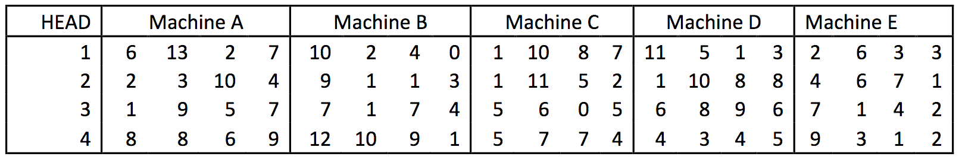

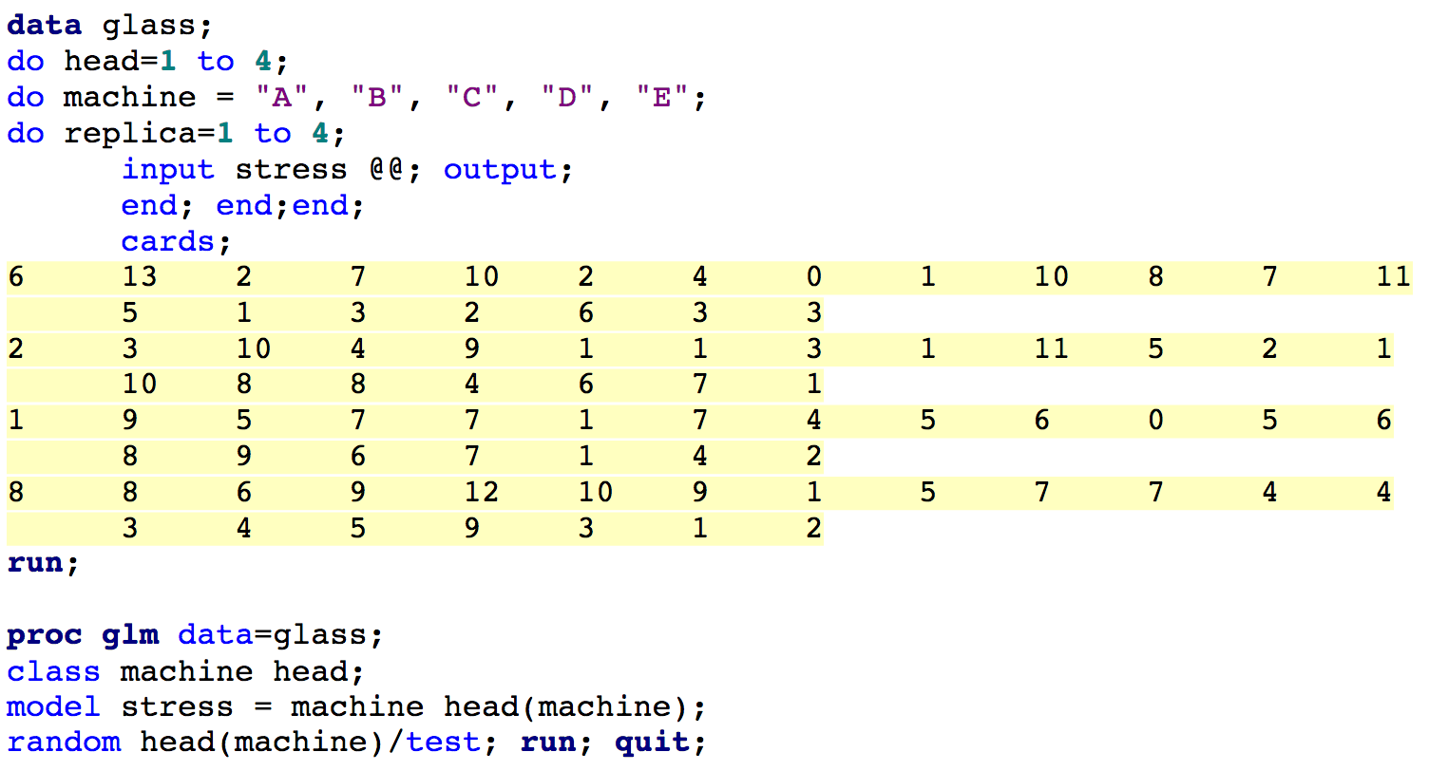

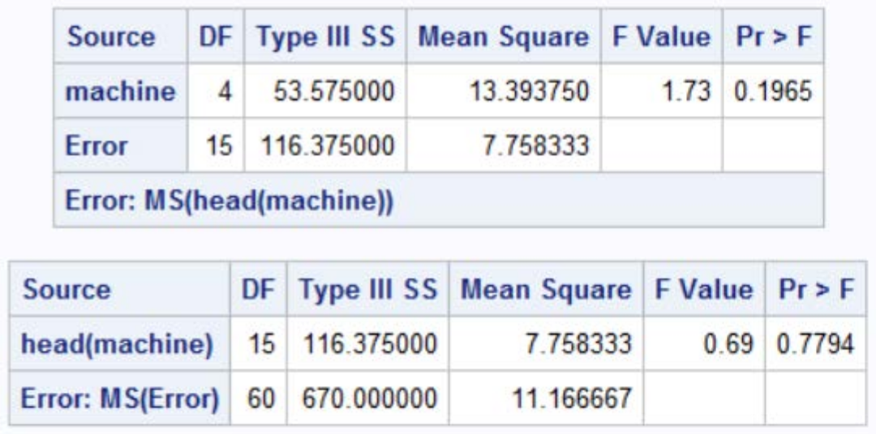

Null hypothesis 1: 

Alternative hypothesis 1: At least one (1) 



This F statistic has an associated p-value of 0.1965. Therefore, we fail to reject the null hypothesis, and thus conclude that there are no statistically significant differences across machines

Null hypothesis 2: 

Alternative hypothesis 2: 



This F statistic has an associated p-value of 0.7794. Therefore, we fail to reject the null hypothesis, and thus conclude that the variability across heads (nested within machines) does not statistically differ from 0.