Chris Kalra

Econ 610

Hw 2

1. a) For each additional cigarette smoked per day by the mother, her baby’s expected birthweight decreases by 2 grams

b) i) Mother’s age; as mothers get older, they tend to give birth to less healthier babies, thus creating a negative correlation between mother’s age and her baby’s birthweight

ii) Number of alcoholic drinks the mother consumed per week during pregnancy; an expecting mother’s alcohol consumption is known to have an effect on the birthweight and overall health of babies, meaning the more alcoholic drinks she consumes, the lower we would expect her baby’s birthweight (resulting in a negative correlation)

iii) Income may have an effect on the baby’s birthweight, in that an expecting mother can afford more goods that may result in a healthier (and thus, a likely heavier) baby, such as dietary supplements and a wide variety of foods. Furthermore, she may be able to financially afford take more time off work, and thus be less stressed than an expecting mother who must maintain a full time working schedule. Therefore, income and birthweight are positively correlated.

c) Yes it will; as all else is being held equal, the only entity being changed is number of cigarettes smoked daily. Therefore, any changes in birthweight can be attributed to the number of cigarettes smoked daily. The only exception would be if there were some genetic component where mothers who have this gene (or set of genes) are far more predisposed to smoke, and this same gene or set of genes is what causes lower birthweight. However, this is rather farfetched.

1. a) See *Table 1* in the appendix for the calculations

 = 2.9246 + –0.739\*price

The relationship is negative; we can see this clearly because our estimate for β1 is negative, meaning that our variables (cups and price) move in different directions. The intercept does not have a useful meaning in this case, as that would be considering the case when coffee is $0 per pound. I imagine that if coffee were free, people would be consuming coffee until they were satiated, as price would no longer be a factor. If the price of coffee increases by a dollar per pound, we would predict that the consumer would drink .739 fewer cups of coffee per day.

b)

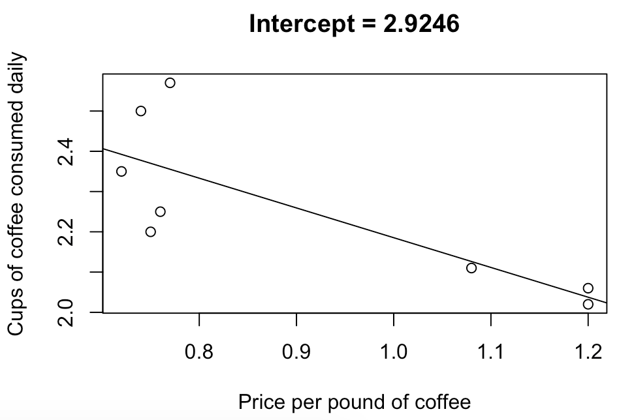

c)

Fitted Values:

1 2 3 4 5 6 7 8

2.355442 2.377617 2.392401 2.362834 2.126295 2.037593 2.037593 2.370225

Sum of residuals: -9.020562e-17 , which is 0 with some rounding error

d) 2.9246-.7392\*2 = 1.4462  
So we predict that the consumer will purchase 1.4462 cups of coffee on average when the price is $2 per pound

e) This is the R2 value, which is .6302, meaning that roughly 63% of the variation in *cups* can be explained by *price*

f) Via *Table 2*, we have shown that this sum is 0 (although we have a little bit of rounding error).

This is important because it is a necessary condition to show independence between the data (each xi) and errors (ui).

1. a) Average airfare is $178.7968, along with an average distance of 989.745 miles

b) The minimum airfare paid is $37, and the maximum airfare paid is $522

c) 

d) When the distance is 0 miles, the cost of the flight is $103.26. Clearly this is nonsensical, as there are no ways to pay for a flight that does not go anywhere.

For each additional mile flown, the predicted price of the fare increases by $.07632

e)

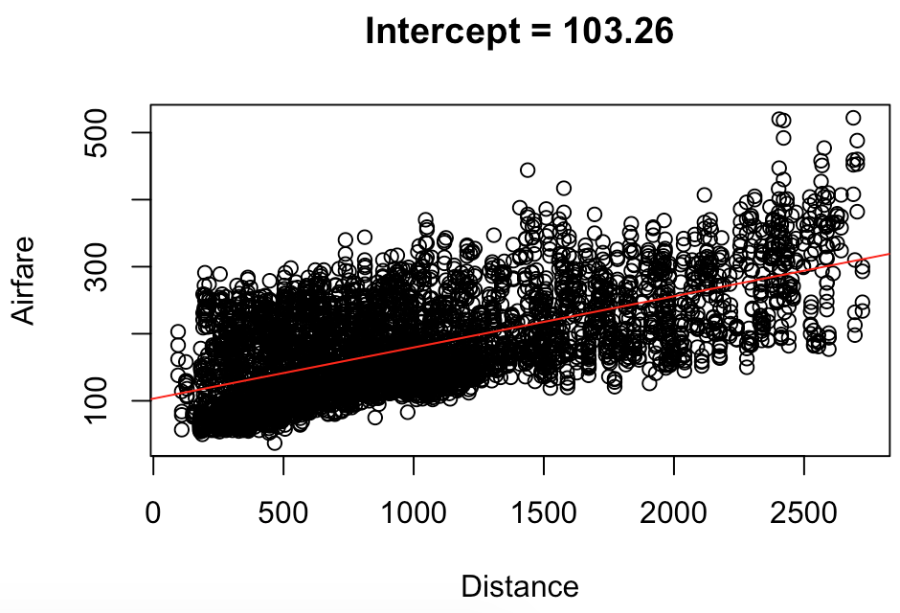

f) 103.26137 + (.07632\*500) = 141.42137

We predict a flight of 500 miles would cost $141.42

g) Approximately 38.88% of the variation in *fare* is explained by *distance*. This is not as much as I would have thought, seeing as, to my knowledge, an increase in distance flown would be the most costly change in price out of all relevant variables. However, there are a lot of confounding variables in play that do also have an impact on the airfare

h) One potentially confounding variable that comes to mind is how long before a flight the ticket was purchased. I image that not too many people would make a spur of the moment decision and purchase an international flight without serious consideration, whereas someone may impulsively purchase a ticket to a nearby area (or at least within the same country) for a weekend getaway. This is likely also correlated with the airfare, as it is widely believed that purchasing an airline ticket roughly 2 weeks before the scheduled flight is when the tickets become most expensive, and the same tickets are likely less expensive when purchased much further in advance.

Another potentially confounding variable would be cost of in-flight purchases. If the flight were further (and therefore longer), the passenger would be more likely to purchase something to keep themselves satisfied, be it food, drinks, or headphones for the movie[s]. Likewise, if the flight were more expensive, the passenger would likely have less money in their travel budget for this trip, so they would be less likely to purchase any in-flight goodies.

i) For every 1 percent change in *distance*, we predict a  percent change in *airfare*

j) For each additional unit change in x, we predict an approximate percent change in *airfare* equal to 

Appendix

Table 1

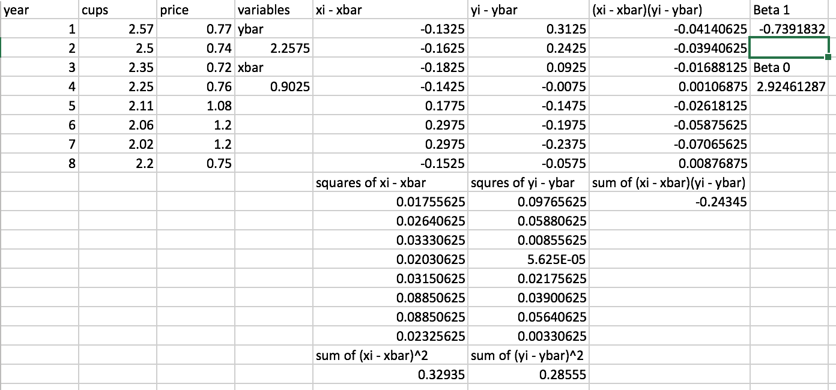

Table 2

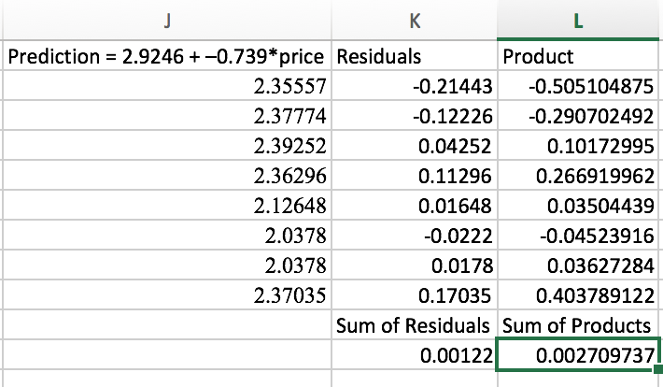

R Code:

2) # Preliminary code

cups=c(2.57, 2.5, 2.35, 2.25, 2.11, 2.06, 2.02, 2.2)

price=c(.77, .74, .72, .76, 1.08, 1.2, 1.2, .75)

regr=lm(cups~price)

2b) plot(price, cups, xlab="Price per pound of coffee", ylab="Cups of coffee consumed daily",

main = "Intercept = 2.9246")

abline(regr)

2c) fitted(regr) ; sum(resid(regr))

2e) summary(regr)

3a) mean(data$fare) ; mean(data$dist)

3b) min(data$fare) ; max(data$fare)

3c) airplane=lm(data$fare ~ data$dist) ; airplane

3e) plot(data$dist, data$fare, xlab = "Distance", ylab = "Fare", main = "Intercept = 103.26")

abline(airplane, col="red")

3g) summary(airplane)