**Section 3: Architecture and Working Mechanism**

**3.1: Technical Architecture**

John the Ripper (JtR) follows a modular and extensible architecture that allows it to efficiently crack passwords using multiple techniques. The core components of its architecture include:

* **Hashing Algorithm Modules**: Supports a wide range of hashing algorithms such as MD5, SHA-1, NTLM, and bcrypt.
* **Rule-Based Engine**: Allows users to define custom rules for password mutation, enhancing brute-force attacks.
* **Dictionary and Wordlist Support**: Uses pre-compiled wordlists for faster password recovery.
* **Hybrid Attack Mechanism**: Combines dictionary and brute-force attacks for optimized cracking.
* **Parallel Processing Support**: Utilizes multi-threading and GPU acceleration to increase performance.
* **Plug-in System**: Extensible framework allowing the integration of third-party plugins and modules.

The architecture supports different modes of operation, including single mode (analyzing user-specific password structures), wordlist mode (testing dictionary words), and incremental mode (exhaustive brute-force approach).

**3.2: Working Mechanism (Detailed Descriptions of All Features with Screenshots)**

**3.2.1: Threat Detection**

John the Ripper detects weak passwords in a system by analyzing password hashes. The detection process involves:

* **Hash Identification**: JtR automatically detects the hash type of stored passwords.
* **Preprocessing**: Converts extracted hashes into a format suitable for cracking.
* **Testing Against Wordlists**: Compares hashed values with entries in predefined wordlists.
* **Identifying Vulnerabilities**: Highlights weak passwords that can be cracked easily.

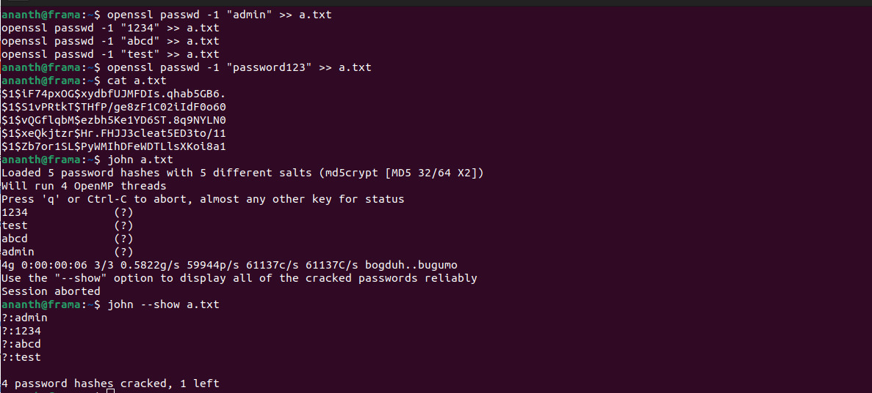

**Use a dictionary attack with a wordlist to find weak passwords**

**3.2.2: Threat Prevention**

Once weak passwords are detected, JtR helps in preventing security breaches by:

* **Enforcing Strong Password Policies**: Suggests stronger passwords based on cracking results.
* **Automated Password Auditing**: Continuously tests newly created passwords for vulnerabilities.
* **Salting and Hashing Best Practices**: Recommends the use of stronger hashing techniques with salt to prevent precomputed attacks.



**Generate a SHA-512 hashed password with a salt**

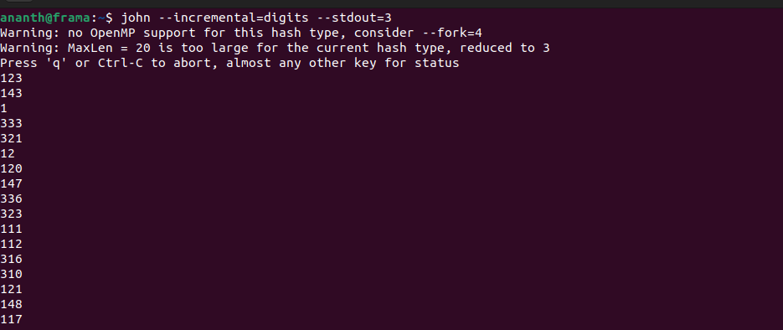

**Generate secure random 3-character numerical passwords**

**3.2.3: Threat Mitigation**

JtR assists in mitigating potential threats by:

* **Educating System Administrators**: Provides insights into common password weaknesses.
* **Providing Countermeasures**: Suggests encryption and two-factor authentication.
* **Monitoring Compromised Credentials**: Helps detect reused or exposed credentials from previous breaches.

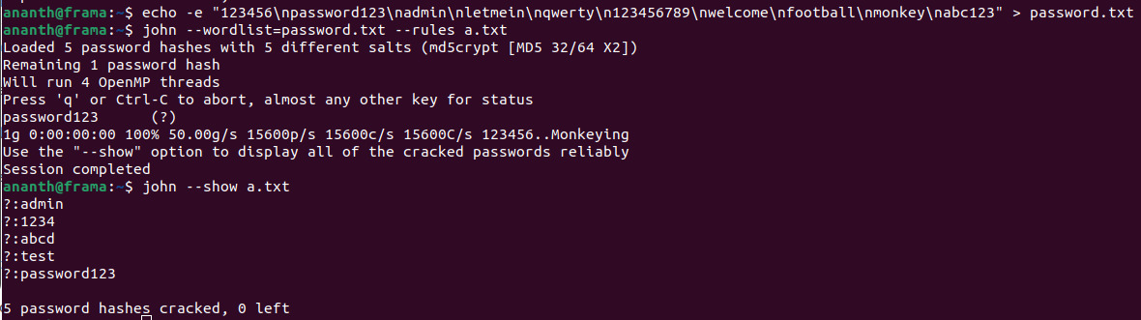

**tests a set of commonly used passwords against encrypted hashes to identify weak or compromised credentials efficiently.**

By systematically analyzing and cracking weak passwords, John the Ripper plays a crucial role in cybersecurity, helping organizations strengthen authentication mechanisms and reduce potential attack surfaces.

**Section 5: Applications**

**5.1: Evidence of Real-world Usage of the Tool**

John the Ripper (JtR) has been widely utilized in various cybersecurity applications. Some real-world examples include:

* **Penetration Testing**: Security professionals use JtR to audit password security in corporate networks.
* **Forensic Investigations**: Law enforcement agencies employ JtR to recover passwords from encrypted files.
* **Academic Research**: Universities and security researchers leverage JtR to study password strength and cryptographic vulnerabilities.
* **Enterprise Security Audits**: Companies incorporate JtR in security assessments to identify weak user passwords and enforce stronger policies.

JtR's ability to efficiently crack passwords makes it a valuable tool in the cybersecurity landscape, ensuring that organizations can detect and mitigate potential security risks before they are exploited by malicious actors.

**5.2: Real-time Incidence Prevention and Mitigation**

John the Ripper contributes to real-time security efforts by helping organizations:

* **Proactively Identify Weak Passwords**: By running scheduled audits, system administrators can detect vulnerable passwords before they are compromised.
* **Prevent Credential-based Attacks**: Regular password testing allows organizations to enforce stronger authentication measures.
* **Incident Response in Breaches**: In cases of suspected credential leaks, JtR can be used to verify whether passwords have been exposed, allowing administrators to take corrective action.
* **Integration with Security Suites**: JtR is often integrated into security frameworks to perform ongoing password health checks and mitigation planning.

By continuously auditing password security, JtR plays a crucial role in reducing the risk of data breaches and credential-based attacks.

**5.3: Performance Analysis of John the Ripper**

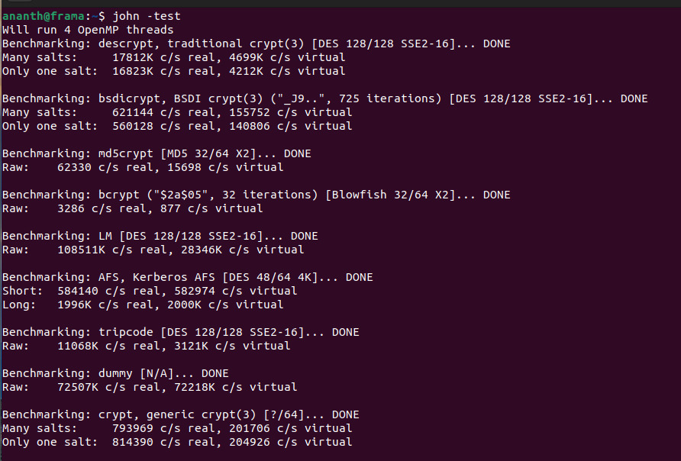

Evaluating the performance of John the Ripper involves analyzing several key metrics:

* **Cracking Speed**: JtR can process thousands to millions of password hashes per second, depending on hardware capabilities.
* **Multi-threading and GPU Acceleration**: Modern versions support multi-core processors and GPU-based acceleration to enhance speed.
* **Efficiency in Handling Various Hashing Algorithms**: JtR supports MD5, SHA-1, bcrypt, and more, with performance varying by algorithm complexity.
* **Resource Consumption**: CPU and memory utilization depend on the attack mode, with brute-force methods requiring significant computational power.
* **Scalability in Large-Scale Environments**: JtR is capable of handling enterprise-level password audits with large datasets.

In benchmark tests, JtR has consistently demonstrated high efficiency in cracking weak passwords while maintaining flexibility across different operating environments. Continuous optimizations and community contributions further enhance its capabilities, making it one of the most reliable tools for password security auditing.

**Section 6: Limitations of John the Ripper**

**6.1: Weakness (if any additional features are needed)**

Despite its powerful capabilities, John the Ripper (JtR) has some limitations:

* **Limited Support for Certain Hashes**: While JtR supports many hash algorithms, newer or proprietary algorithms may not be fully supported.
* **Performance Constraints on Complex Hashes**: Algorithms like bcrypt and Argon2 are computationally expensive, making brute-force and dictionary attacks slow.
* **Lack of a Graphical User Interface (GUI)**: JtR primarily operates through the command line, which may not be user-friendly for beginners.
* **Resource Intensive on Large Datasets**: Running JtR on extensive password hash lists can lead to significant CPU and memory consumption.
* **Limited Distributed Cracking Support**: While JtR has experimental support for distributed cracking, it is not as refined as dedicated distributed password-cracking tools.

**6.2: Ethical Issues (if any)**

Using John the Ripper raises ethical considerations, including:

* **Potential for Malicious Use**: JtR can be misused by attackers to crack stolen password databases, leading to unauthorized access and data breaches.
* **Legal Implications**: Unauthorized password cracking is illegal in many jurisdictions and may violate company policies and cybersecurity laws.
* **Responsible Disclosure**: Ethical hackers using JtR must ensure responsible usage by obtaining proper authorization before testing password security.
* **Privacy Concerns**: The use of JtR for forensic purposes must comply with legal frameworks to avoid infringing on individual privacy rights.

**6.3: Implementations and Adoption Challenges**

Adopting John the Ripper for organizational use comes with certain challenges:

* **Integration with Enterprise Security Systems**: Organizations may need additional scripting and configuration to incorporate JtR into their security workflows.
* **High Learning Curve**: New users may struggle with command-line syntax and attack strategies without prior experience.
* **Hardware Requirements for Optimal Performance**: Advanced cracking methods require powerful CPUs and GPUs, which may not be available in all environments.
* **Compliance and Policy Restrictions**: Organizations must ensure that using JtR aligns with internal security policies and legal guidelines.
* **Maintenance and Updates**: Keeping JtR up to date with the latest hash algorithms and optimizations requires continuous monitoring and upgrades.

Despite these limitations, JtR remains a valuable tool for password security auditing when used ethically and responsibly within legal boundaries.

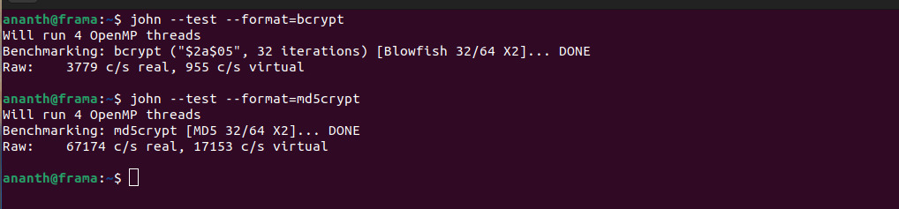

The benchmark results show a significant difference in cracking speed between bcrypt and md5crypt. Bcrypt achieves only **3779 c/s**, while md5crypt achieves **67174 c/s**, highlighting how bcrypt's computational cost slows down brute-force attempts. This suggests that JtR's efficiency is highly dependent on the hash type.

Suggest that cracking bcrypt hashes is much slower than md5crypt, meaning organizations may require high-performance hardware to test modern, secure password hashes effectively.