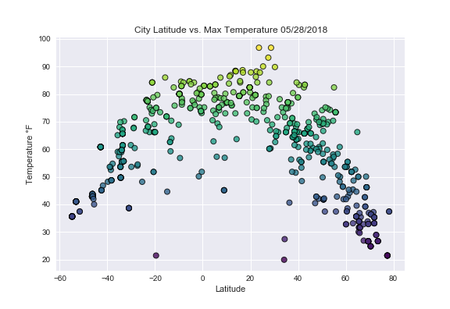

1. The cities near equator (0 latitude) have higher maximum temperature, with temperature falling down as the cities go farther from equator.

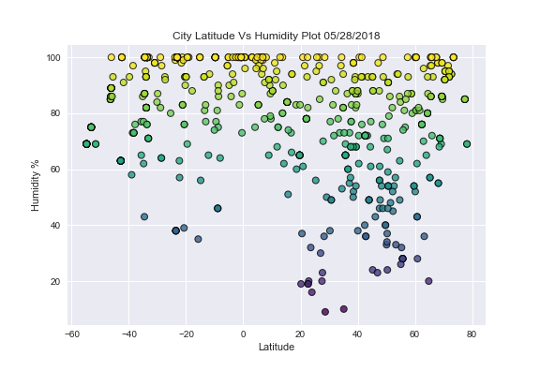

2. Humidity and cloudiness show no correlation to the latitudes. Here the data is evenly distributed.

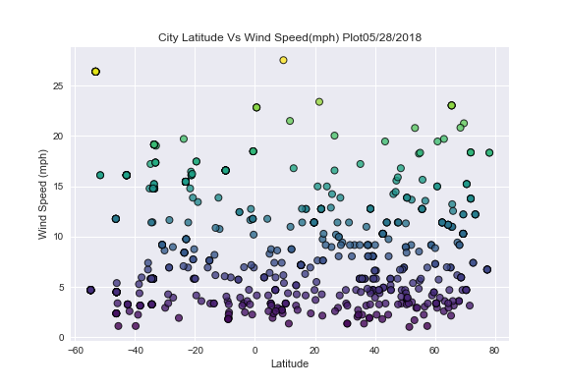

3. Wind speed in most cities are less than 15mph which shows good mild weather today for most places. However some places have wind speed in higher range (15-25mph).