/\*

\*Author: Curtis Kargus – CIS150

\*Creation Date: 9/13/2016

\*Modification Date: 9/13/2016

\*Purpose: Hello World

\*/

#include <iostream>

using namespace std;

int main()

{

cout << "Hello World!" << endl;

cout << "CIS 150 – Fall 2016" << endl;

system("pause");

return 0;

}

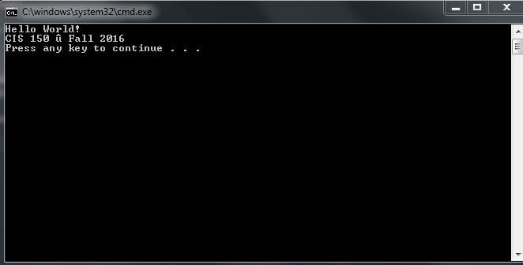

/\*

\*Author: Curtis Kargus – CIS150

\*Creation Date: 9/13/2016

\*Modification Date: 9/13/2016

\*Purpose: Chrismas Tree

\*/

#include <iostream>

using namespace std;

int main()

{

cout << " \*" << endl;

cout << " \*\*\*" << endl;

cout << " \*\*\*\*\*" << endl;

cout << "\*\*\*\*\*\*\*" << endl;

cout << " \*\*\*" << endl;

system("pause");

return 0;

}

For this program I had to make sure each one of the lines was on a new line so “endl” was required at the end of each line of code. I also knew there would be a spacing issue and noticed that each line need one extra space from the longest line and added the appropriate spaces.

