Lab-01

Curtis Kargus

|  |  |  |  |
| --- | --- | --- | --- |
| Reason for test case | Input Values | Expected Output | Observed Output |
| Make sure program works | Pennies:35  Nickels:4  Dimes:3  Quarters:3  Dollars:2 | Current Total: 0.35  Current Total: 0.55  Current Total: 0.85  Current Total: 1.6  Total: 3.6 | Current Total: 0.35  Current Total: 0.55  Current Total: 0.85  Current Total: 1.6  Total: 3.6 |
| Test Positives as input | Pennies:52  Nickels:6  Dimes:7  Quarters:20  Dollars:7 | Current Total: 0.52  Current Total: 0.82  Current Total: 1.52  Current Total: 6.52  Total: 13.52 | Current Total: 0.52  Current Total: 0.82  Current Total: 1.52  Current Total: 6.52  Total: 13.52 |
| Test all being zero | Pennies:0  Nickels:0  Dimes:0  Quarters:0  Dollars:0 | Current Total: 0.0  Current Total: 0.0  Current Total: 0.0  Current Total: 0.0  Total: 0.0 | Current Total: 0  Current Total: 0  Current Total: 0  Current Total: 0  Total: 0 |
| test all being negative | Pennies: -23  Nickels: -85  Dimes: -65  Quarters: -52  Dollars: -10 | Current Total: -0.23  Current Total: -4.48  Current Total: -10.98  Current Total: -23.98  Total: -33.98 | Current Total: -0.23  Current Total: -4.48  Current Total: -10.98  Current Total: -23.98  Total: -33.98 |

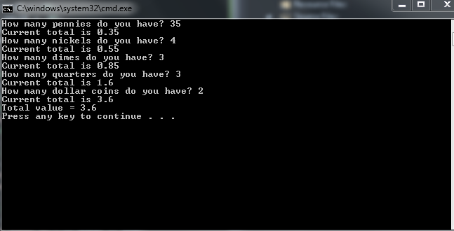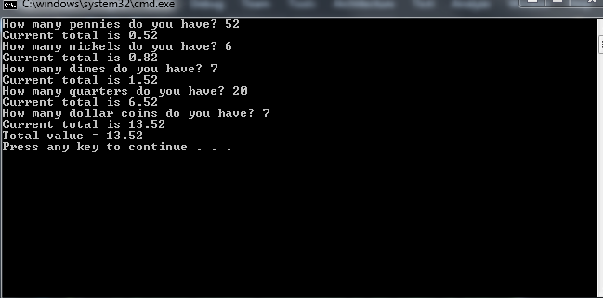

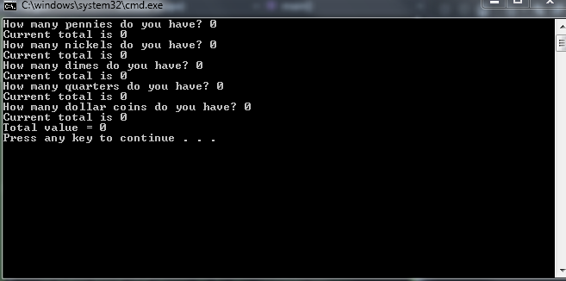

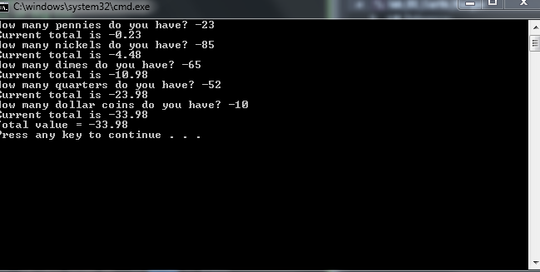

Question 2

//Name: Curtis Kargus

// Lab-01

// Professor: Rafi

// 9/20/16

// program asks the users for two different numbers then adds them together and displays the result

#include <iostream>;

using namespace std;

int main()

{

int x, y, z; // declare three variables x, y, and z of type int

cout << "Please enter your first number." << endl; // display a message using cout asking the user to enter a first integer

cin >> x; // use cin to prompt the user for a value for x

cout << "Please enter your second number." << endl; // display a message using cout asking the user to enter a second int

cin >> y; // use cin to prompt the user for a value for y

z = x + y;// write a statement that assign x + y to z

cout << "the sum of the two numbers is: " << z << endl;// display a message using cout displaying the message

// The sum of the two integers is : put the content of z here

return 0;

}

