Question 1

#include <string>

#include <iostream>

using namespace std;

int main()

{

string first_name = "John";

string last_name = "Doe";

string name;

name = first_name + " " + last_name;

cout << "Good Morning " << name << endl;

return 0;

}

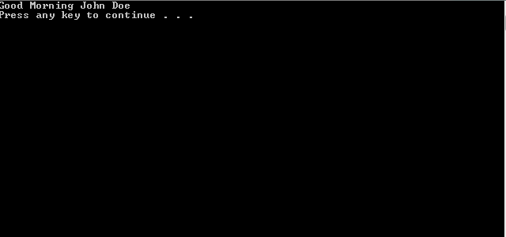

Question 2

#include <iostream>

#include <iomanip>; // library needed for setw()

#include <string>;

using namespace std;

int main()

{

string product;

int quantity;

double unitPrice;

double totalPrice;

/* To be filled in for data input from keyboard */

cout << "Please enter the product name:";

cin >> product;

cout << endl;

cout << "Please enter the quantity:";

cin >> quantity;

cout << endl;

cout << "Please enter the unit price ($):";

cin >> unitPrice;

cout << endl << endl;

// setw() is used to format display

cout << "Product" << setw(16) << "Quantity"

<< setw(19) << "Unit Price($)" << endl;

cout << product << setw(15) << quantity << setw(15) << unitPrice << endl

<< endl;

// to be filled: formula to compute the total price

totalPrice = unitPrice * quantity;

cout << "The total price is : $" << totalPrice << endl;

return 0;

}

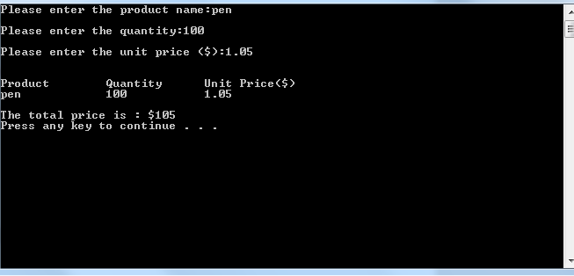

Question 3

#include <iostream>;

#include <string>;

using namespace std;

int main()

{

const double GALLON_COVERAGE = 400;

int height = 0;

int width = 0;

int wallArea = 0;

cout << "Enter wall height (feet):";

cin >> height;

cout << endl;

cout << "Enter wall width (feet):";

cin >> width;

cout << endl;

wallArea = height * width;

cout << "Wall area : " << wallArea << " square feet" << endl;;

cout << "Paint needed: " << wallArea / GALLON_COVERAGE << " gallons to paint this wall." << endl;;

return 0;

}

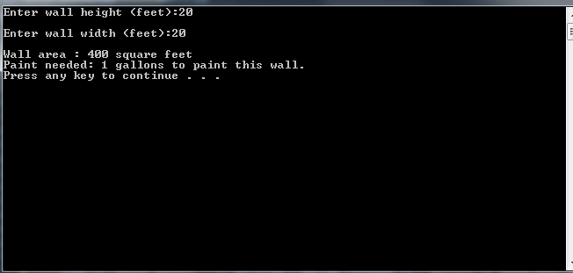

Question 4

/* Author: Curtis Kargus

Creation Date: 9/27/2016

Last Modification Date:9/27/2016

Purpose:

*/

#include <iostream>;

#include <string>;

using namespace std;

int main()

{

string firstName;

string lastName;

string name;

int numberOfCharacters;

cout << "Please enter your first name : ";

cin >> firstName;

cout << "Please enter your last name : ";

cin >> lastName;

name = firstName + " " + lastName;

numberOfCharacters = firstName.length() + lastName.length(); // use length to compute the number

// of characters in the name

cout << "Good Morning " << name << endl;

// you need to display the first character of the first name and the first

//character of the last name

cout << "Your initials are " << firstName[0] << " and " << lastName[0] << endl;

cout << "The number of characters in your name is " << numberOfCharacters << endl;

system("pause");

return 0;

}

