Question 1

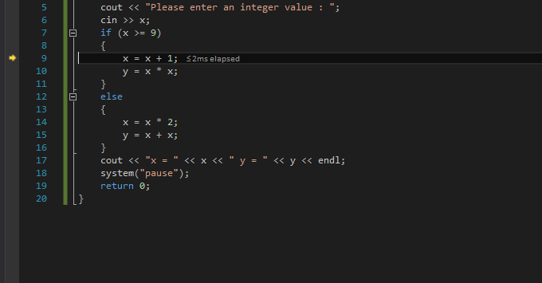

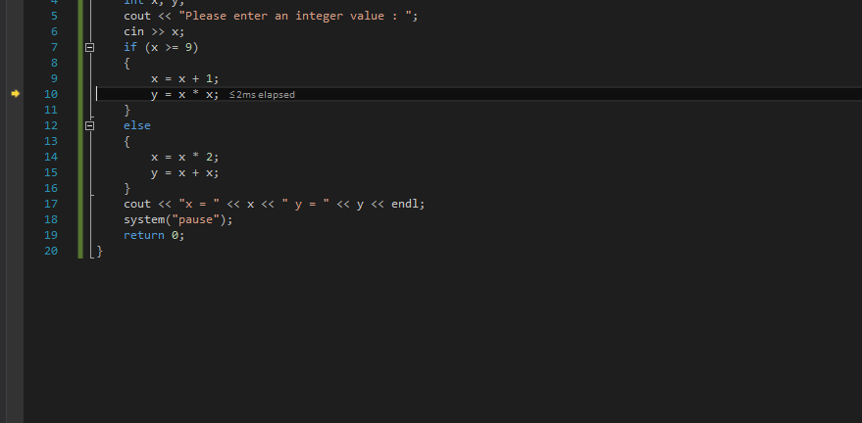

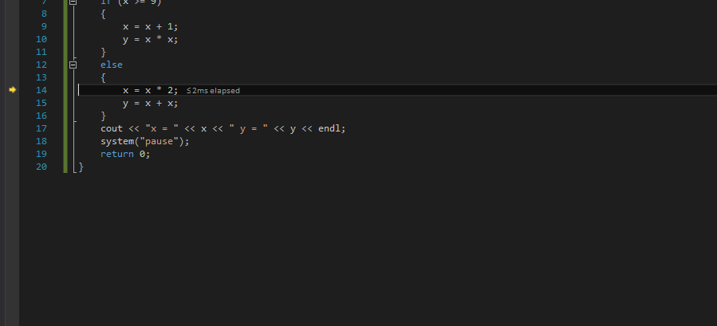

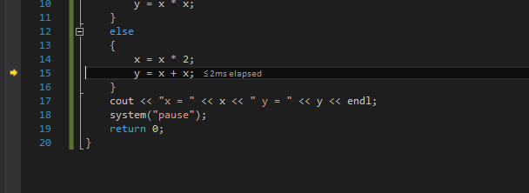

Question 2

#include <iostream>;

#include <string>;

using namespace std;

int main()

{

int age;

cout << "Please enter your age : ";

cin >> age;

if (age >= 18)

cout << "Congratulations! Your vote registration was successfully processed" << endl;

else if (age < 18 && age >= 0)

cout << "You are not eligible to vote" << endl;

else

cout << "Please enter a vaild age." << endl;

return 0;

}

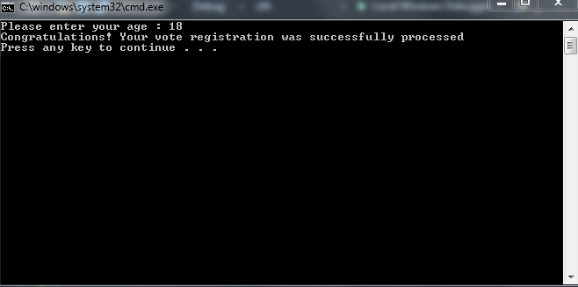

Question 3

#include <iostream>;

#include <string>;

using namespace std;

int main()

{

double hours;

double payRate;

int weeklyPay;

cout << "Enter the hours worked and the pay rate: " << endl;

cin >> hours;

cin >> payRate;

if (hours <= 40 && hours >= 0 && payRate >= 0)

{

weeklyPay = hours \* payRate;

cout << "The weekly pay is: " << weeklyPay << endl;

}

else if (hours > 40 && payRate >= 0)

{

weeklyPay = 40 \* payRate;

weeklyPay += (hours - 40) \* payRate \* 1.5;

cout << "The weekly pay is: " << weeklyPay << endl;

}

else

{

cout << "Please enter a valid pay rate or valid hours" << endl;

}

return 0;

}

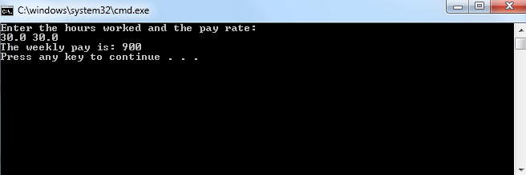

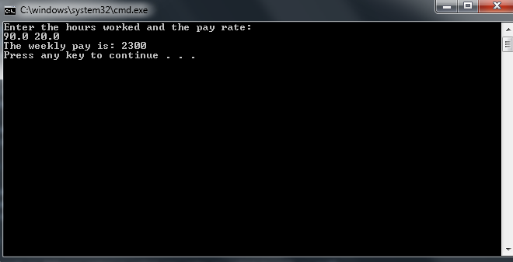

Question 4

#include <iostream>;

#include <cmath>;

using namespace std;

int main()

{

int a;

int b;

int c;

double root1;

double root2;

cout << "Enter a, b and c which represent the coefficients in the quadratic equation ax ^ 2+ bx + c = 0 : ";

cin >> a;

cin >> b;

cin >> c;

if ((pow(b, 2) - (4 \* a\*c)) >= 0 && a)

{

root1 = (-b + sqrt(pow(b, 2) - (4 \* a\*c))) / (2 \* a);

root2 = (-b - sqrt(pow(b, 2) - (4 \* a\*c))) / (2 \* a);

cout << "Root1 is " << root1 << endl;

cout << "Root2 is " << root2 << endl;

}

else

{

cout << "No real root" << endl;;

}

return 0;

}

