Curtis Kargus

Question 1

#include <iostream>

#include <string>

using namespace std;

int main()

{

int temperature;

cout << "Please enter the current temperature(F) : ";

cin >> temperature;

if (temperature > 90)

cout << "Visit a neighbor." << endl;

else if (temperature <= 90 && temperature > 80)

cout << "Turn on air conditioning." << endl;

else if (temperature <= 80 && temperature > 70)

cout << "Do nothing." << endl;

else if (temperature <= 70 && temperature > 55)

cout << "Turn on heat." << endl;

else if (temperature <= 55 && temperature > 30)

{

cout << "Wear a heavy coat." << endl;;

}

else if (temperature <= 30 && temperature > 0)

{

cout << "Wear gloves." << endl;

}

else

{

cout << "Stay home." << endl;

}

system("pause");

return 0;

}

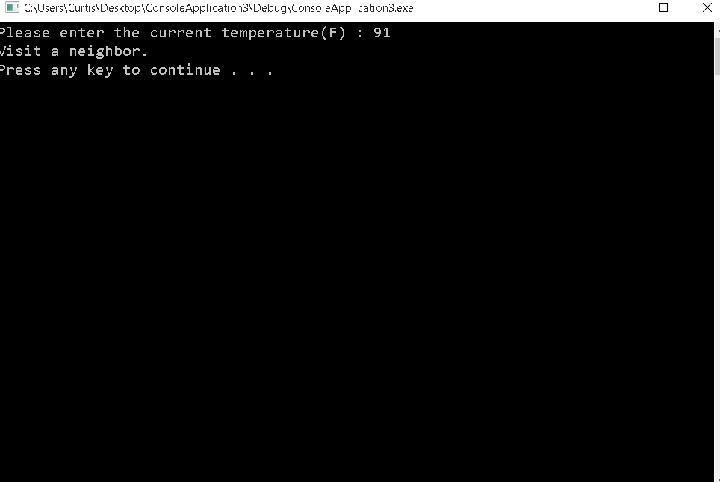

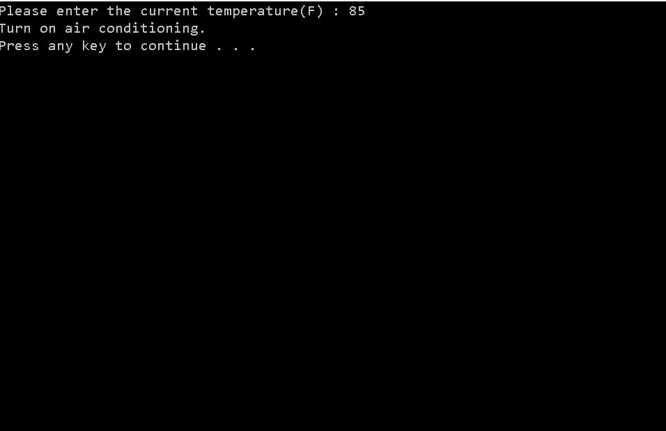

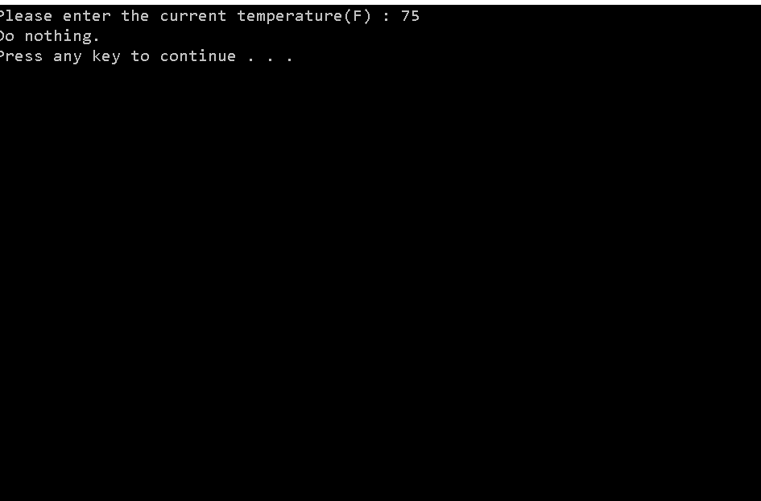

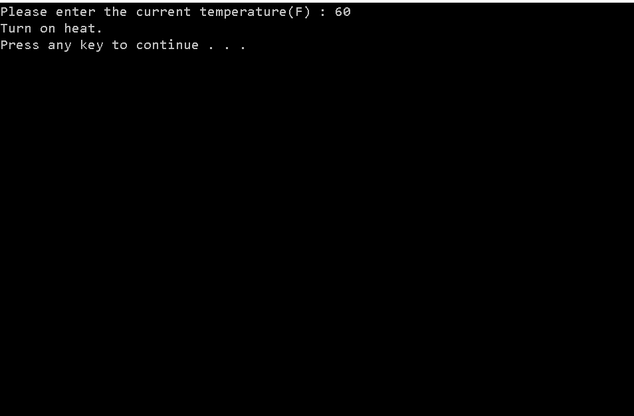

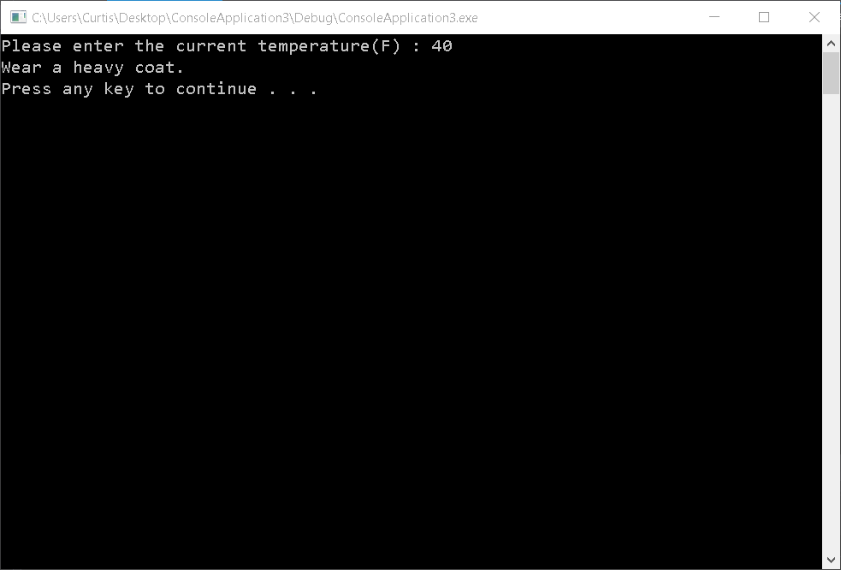

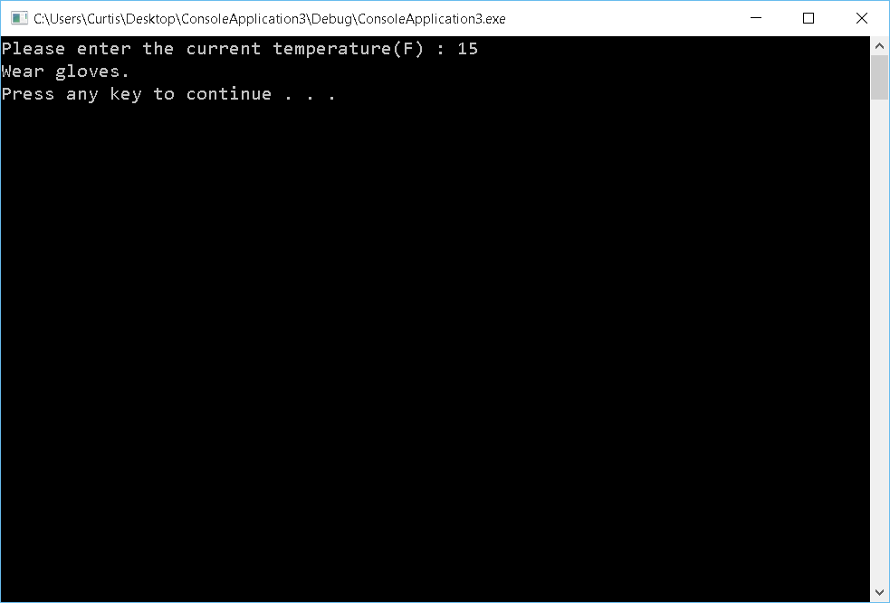

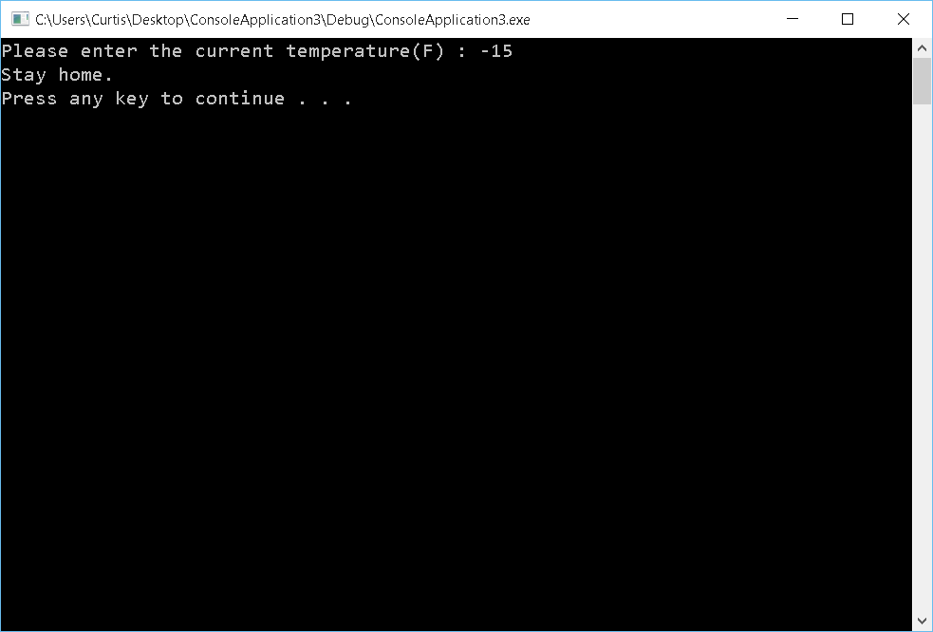

Question 2

#include <iostream>

#include <string>

#include <cctype>

using namespace std;

int main()

{

char letter;

cout << "Enter your letter grade";

cin >> letter;

letter = tolower(letter);

switch (letter)

{

case 'a':

cout << "Average" << endl;

break;

case 'b':

cout << "Below average" << endl;

break;

case 'c':

cout << "Can’t have dinner" << endl;

break;

case 'd':

case 'e':

cout << "Don’t come home" << endl;

break;

case 'f':

cout << "Fail" << endl;

break;

default:

cout << "Find a new family" << endl;

break;

}

system("pause");

return 0;

}

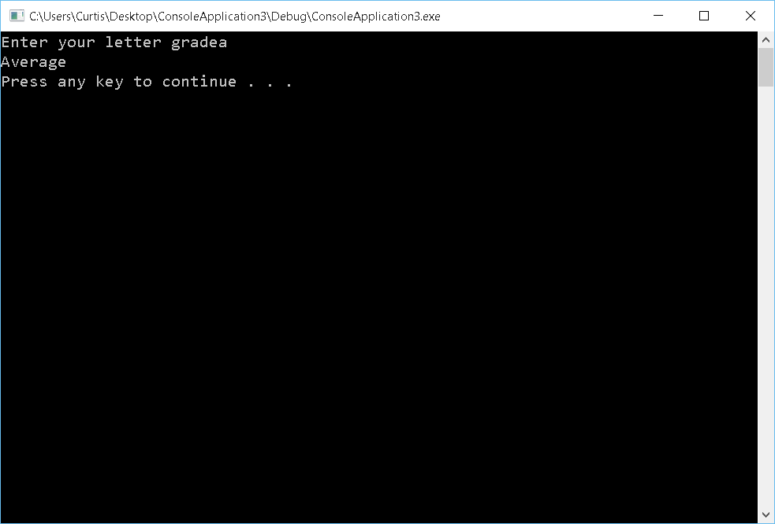

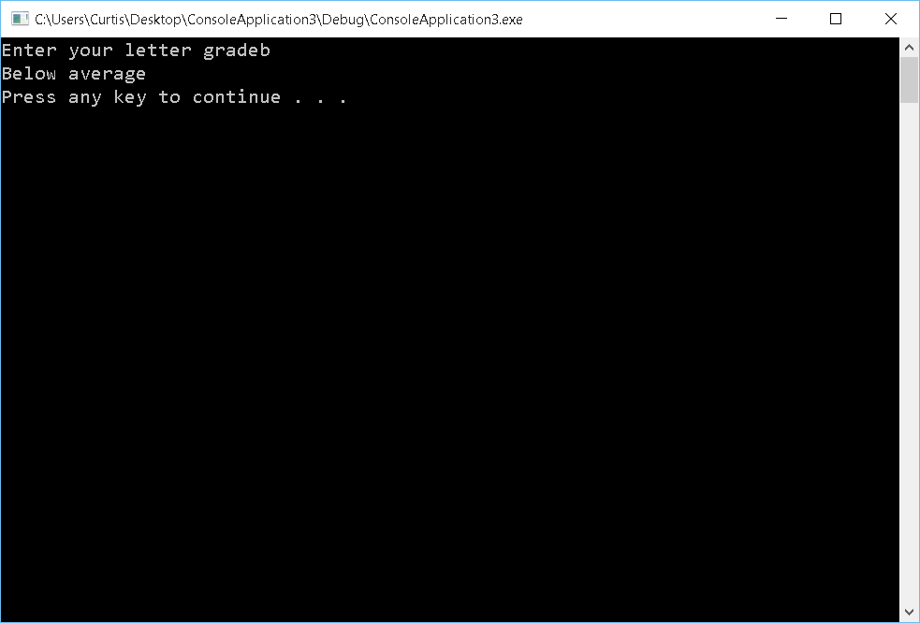

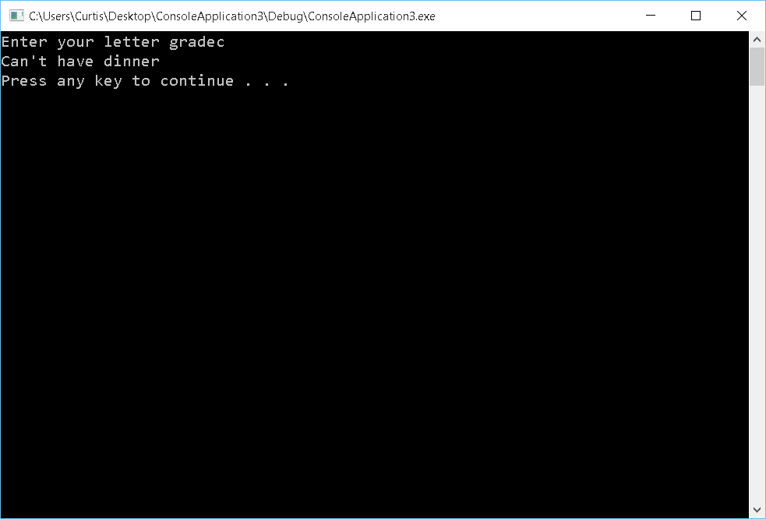

Question 3

#include <iostream>

using namespace std;

int main()

{

int w = 20, x = 20;

int y = 5, z = 5;

y = y + (++x); // makes the variable y = the value of x + 1 + y

z = z + (w++); // makes the value of z = the value of z + w

cout << "x=" << x << " and y=" << y << endl;

cout << "w=" << w << "and z=" << z << endl;

system("pause");

return 0;

}

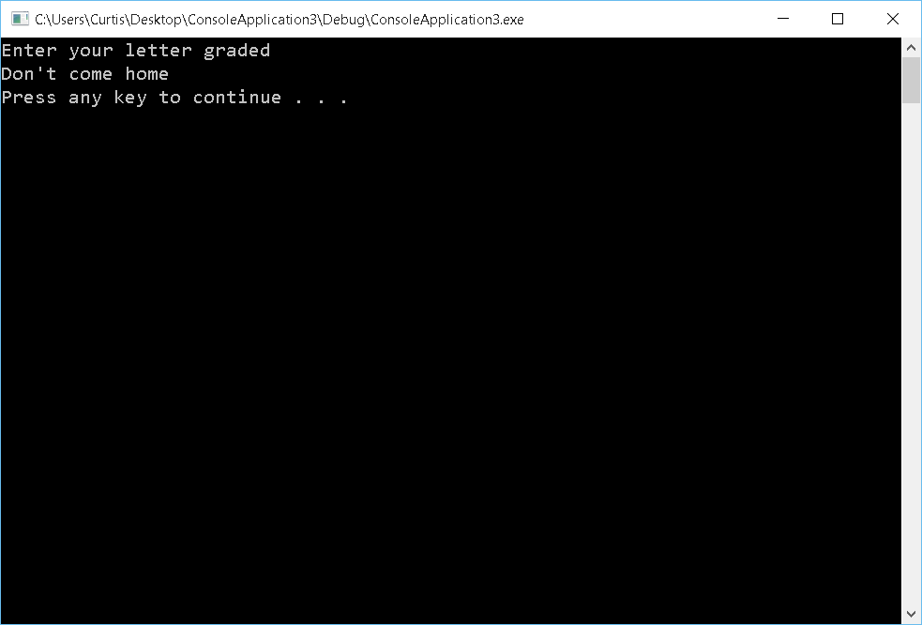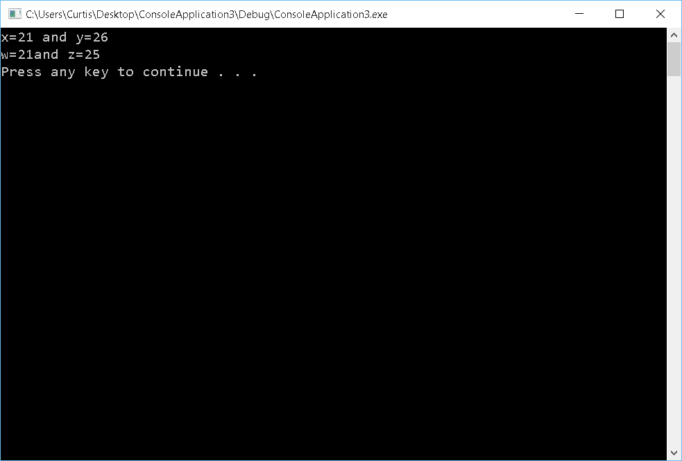

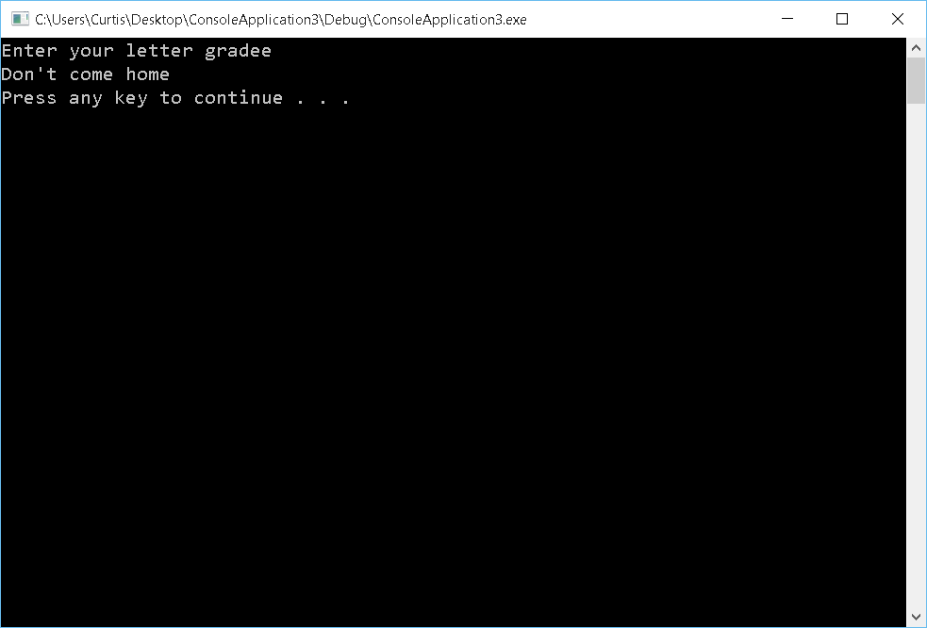

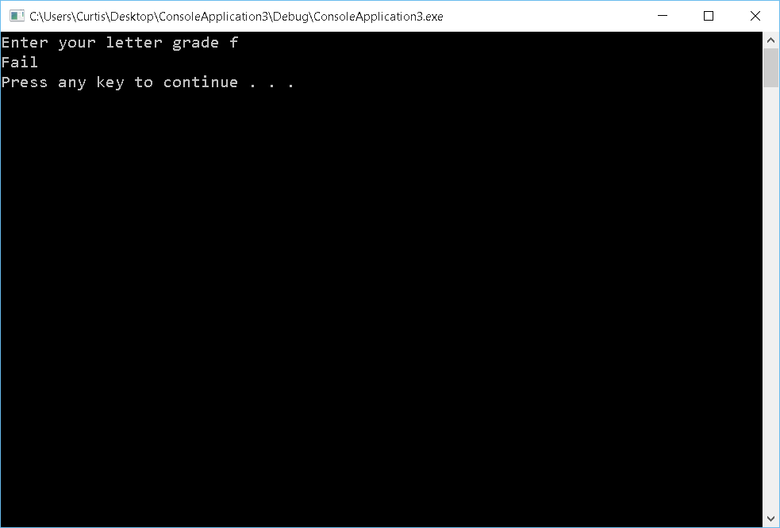

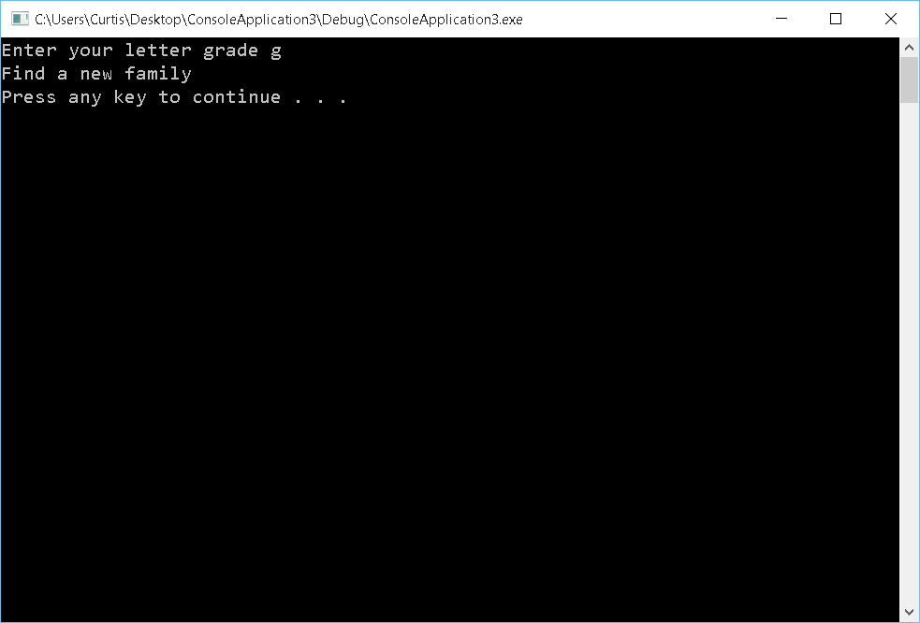

Question 4

#include <iostream>

#include <string>

using namespace std;

int main()

{

char character; // character the user wanted to repeat to make a right triangle

int rows; // total rows

int cRows = 0; // current row;

cout << "Enter a character: ";

cin >> character;

cout << "Enter a number: ";

cin >> rows;

while (cRows < rows)

{

for (int i = 0; i <= cRows; i++)

{

cout << character; // prints number of charcters equal to 1 + cRows

}

cout << endl;

cRows++;

}

system("pause");

return 0;

}

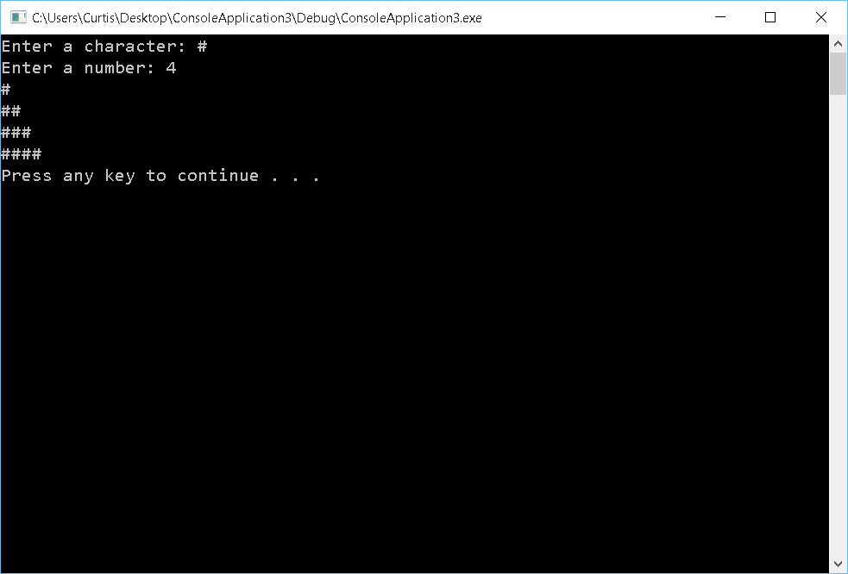

Question 5

#include <iostream>

#include <string>

using namespace std;

int main()

{

int times; // number of times the loop needs to run

int product = 1; // stores the end result

int currentNum; // value of what the current number the program is asking for

cout << "how many numbers do you want to multiply: ";

cin >> times;

for (int i = 0; i < times; i++)

{

cout << "enter a number: ";

cin >> currentNum;

product \*= currentNum;

}

if (times > 0)

cout << "The product is " << product << endl;

system("pause");

return 0;

}

