Question 1

1.1 There are 5 functions total.

1.2 int addition (int, int );

int subtraction (int , int );

void directions();

void printResult(int , int , int , string);

1.3 addition - int a, int b

Subtraction - int a, int b

Directions - none

printResult - int a, int b, int r, string operator

1.4

#include <iostream>

#include <string>

using namespace std;

int addition(int, int);

int subtraction(int, int);

void directions();

void printResult(int, int, int, string);

int main()

{

int x, y, r;

directions();

cout << "Please enter the first integer: ";

cin >> x;

cout << "Please enter the second integer: ";

cin >> y;

r = addition(x, y);

printResult(x, y, r, "+");

r = subtraction(x, y);

printResult(x, y, r, "-");

system("pause");

return 0;

}

int addition(int a, int b)

{

int r;

r = a + b;

return (r);

}

int subtraction(int a, int b)

{

int r;

r = a - b;

return (r);

}

void directions()

{

cout << "\*\*\*\*\*\*\*\*\*\*\*\*\*\*\*\*\*\*\*\*\*\*\*\*\*\*\*\*\*\*\*\*\*\*\*\*\*\*\*\*\*\*\*\*\*\*\*\*\*\*\*\*\*\*\*\*" << endl

<< "Hello!" << endl

<< "This Program asks the user for two integers, then prints the sum and difference" << endl

<< "\*\*\*\*\*\*\*\*\*\*\*\*\*\*\*\*\*\*\*\*\*\*\*\*\*\*\*\*\*\*\*\*\*\*\*\*\*\*\*\*\*\*\*\*\*\*\*\*\*\*\*\*\*\*" << endl << endl;

}

void printResult(int a, int b, int result, string operation)

{

cout << a << " " << operation << " " << b << " = " << result << endl;

}

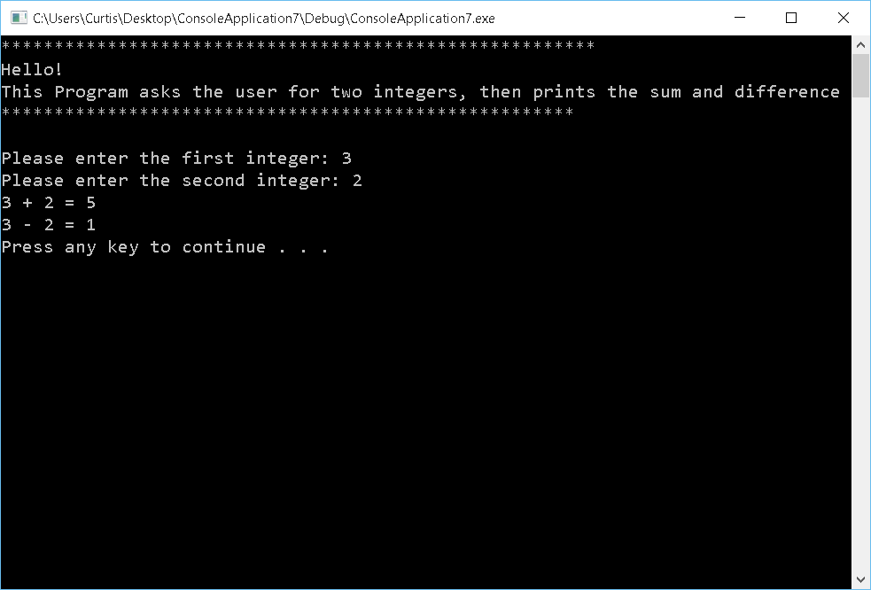

Question 2

#include <iostream>

#include <string>

using namespace std;

double classAverage(int classSize)

{

int counter = 0;

double totalGrade = 0.0;

double temp = 0.0;

while (counter < classSize)

{

cout << "Enter the grade of a student: ";

cin >> temp;

totalGrade += temp;

counter++;

}

totalGrade = totalGrade / classSize;

return totalGrade;

}

int main()

{

int classSize = 0;

double average = 0.0;

cout << "What is the size of your class: ";

cin >> classSize;

average = classAverage(classSize);

if (classSize > 0)

cout << "Class average is " << average << endl;

system("pause");

return 0;

}

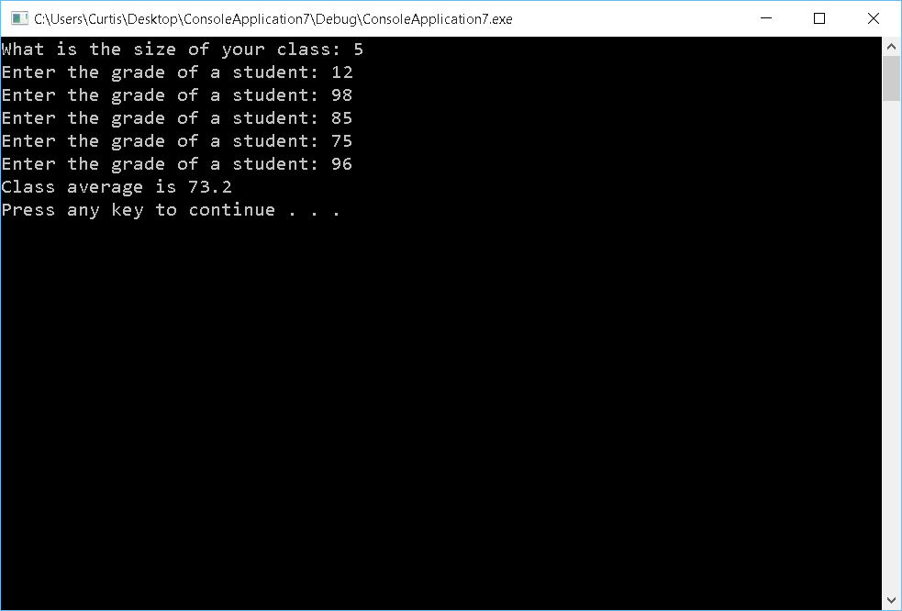

Question 3

#include <iostream>

#include <string>

using namespace std;

int main()

{

int total = 0;

int number = 0;

do

{

cout << "Enter a value or 0 to quit : ";

cin >> number;

total += number;

}while (number != 0);

cout << "The total is " << total << endl;

system("pause");

return 0;

}

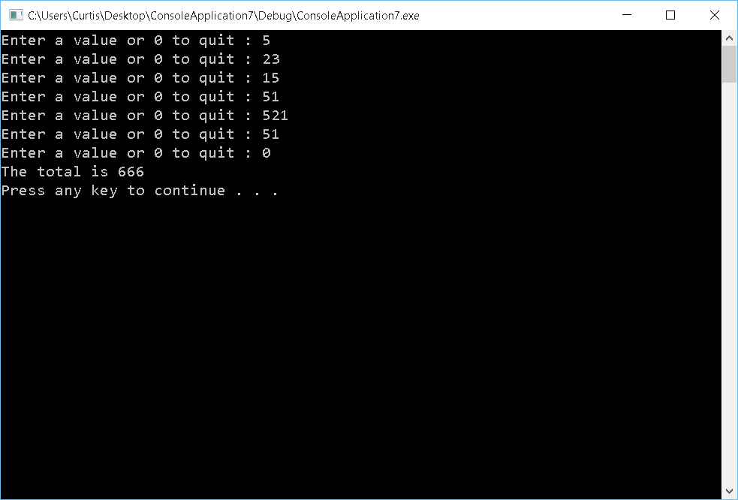

Question 4

Case 1.

e = (a + b) \* c / d

e = (15 + 20) \* 25 / 5

e = (35) \* 25 / 5

e = 875 / 5

e = 175

Case 2.

e = a + b \* c / d

e = 15 + 20 \* 25 / 5

e = 15 + 500 / 5

e = 15 + 100

e = 115

Case 3.

e = (a + (b \* c)) / d

e = (15 + (20 \* 25)) / 5

e = (15 + (500)) / 5

e = ((515)) / 5

e = 103

Case 4.

e = (a + b) \* (c / d)

e = (15 + 20) \* (25 / 5)

e = (35) \* (25 / 5)

e = (35) \* (5)

e = 175

Case 5.

e = a + (b \* c) / d

e = 15 + (20 \* 25) / 5

e = 15 + 500 / 5

e = 15 + 100

e = 115

Question 5

#include <iostream>

#include <string>

using namespace std;

void Welcome()

{

cout << "==========================================================" << endl;

cout << " WELCOME" << endl;

cout << "==========================================================" << endl;

}

void Closing()

{

cout << "==========================================================" << endl;

cout << " Closing" << endl;

cout << "==========================================================" << endl;

}

void Case1(double a, double b, double c, double d)

{

double e;

e = (a + b) \* c / d;

cout << "Value of (a + b) \* c / d is: " << e << endl;

}

void Case2(double a, double b, double c, double d)

{

double e;

e = a + b \* c / d;

cout << "Value of a + b \* c / d is: " << e << endl;

}

void Case3(double a, double b, double c, double d)

{

double e;

e = (a + (b \* c)) / d;

cout << "Value of (a + (b \* c)) / d is: " << e << endl;

}

void Case4(double a, double b, double c, double d)

{

double e;

e = (a + b) \* (c / d);

cout << "Value of (a + b) \* (c / d) is: " << e << endl;

}

void Case5(double a, double b, double c, double d)

{

double e;

e = a + (b \* c) / d;

cout << "Value of a + (b \* c) / d is: " << e << endl;

}

int main()

{

double a = 15;

double b = 20;

double c = 25;

double d = 5;

double e;

Welcome();

Case1(a, b, c, d);

Case2(a, b, c, d);

Case3(a, b, c, d);

Case4(a, b, c, d);

Case5(a, b, c, d);

Closing();

system("pause");

return 0;

}

