Question 1

#include <iostream>

#include <string>

using namespace std;

void Winner(int team1, int team2)

{

if (team1 == team2)

{

cout << "It's a tie game" << endl;

}

else if (team1 > team2)

{

cout << "Team 1 has won the game" << endl;

}

else if (team1 < team2)

{

cout << "Team 2 won the game " << endl;

}

}

int main()

{

int team1 = 0;

int team2 = 0;

cout << "Enter score of team 1 ";

cin >> team1;

cout << "Enter the score of team 2 ";

cin >> team2;

Winner(team1, team2);

system("pause");

return 0;

}

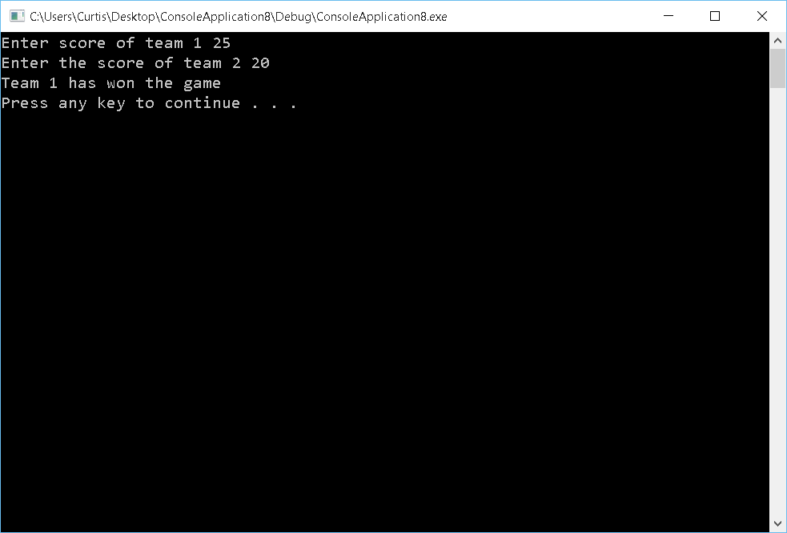

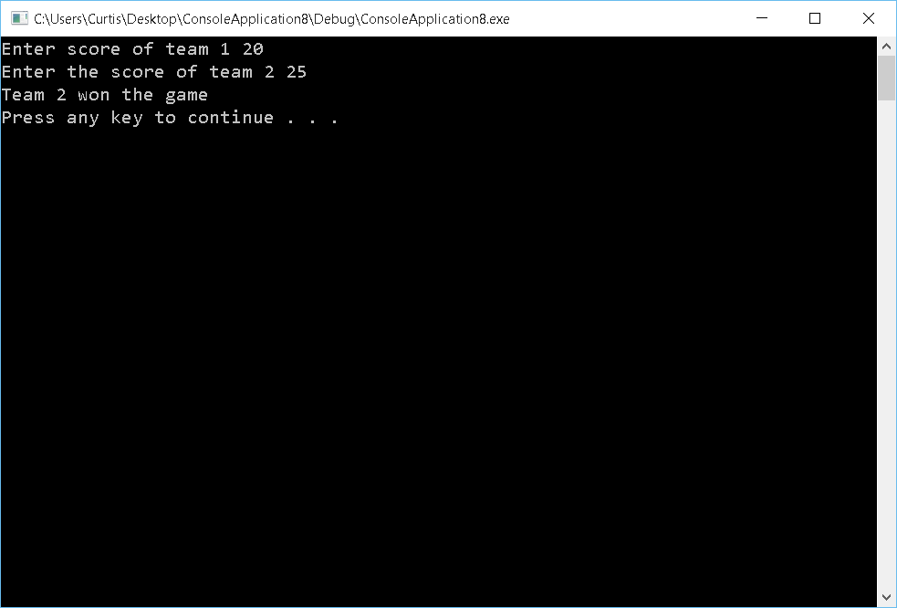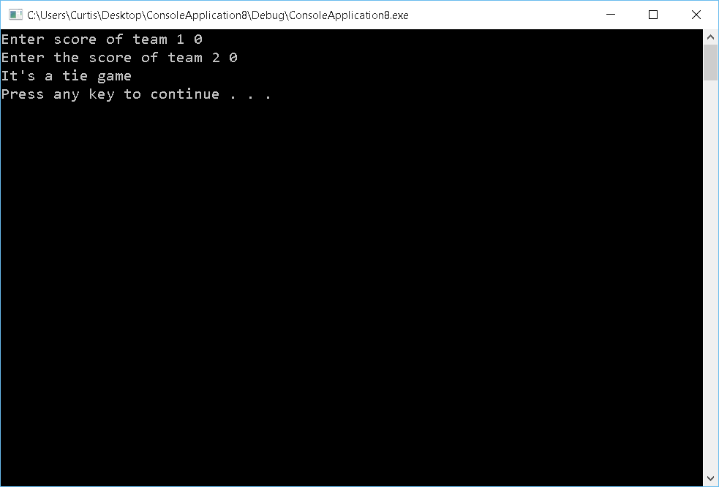

Question 2

#include <iostream>

#include <iostream>

#include <string>

using namespace std;

double HighestVal(double current, double highest)

{

if (current > highest)

{

return current;

}

return highest;

}

double LowestVal(double current, double lowest)

{

if (current < lowest)

{

return current;

}

return lowest;

}

int main()

{

int i = 0;

double lowest = 0;

double highest = 0;

int numInts = 0;

double current = 0;

cout << "How many numbers do you want to enter ";

cin >> numInts;

while (i < numInts)

{

if (i == 0)

{

cout << "Enter a number ";

cin >> current;

lowest = current;

highest = current;

i++;

}

else

{

cout << "Enter a number ";

cin >> current;

lowest = LowestVal(current, lowest);

highest = HighestVal(current, highest);

i++;

}

}

cout << "The higest value is " << highest << endl;

cout << "The lowest value is " << lowest << endl;

system("pause");

return 0;

}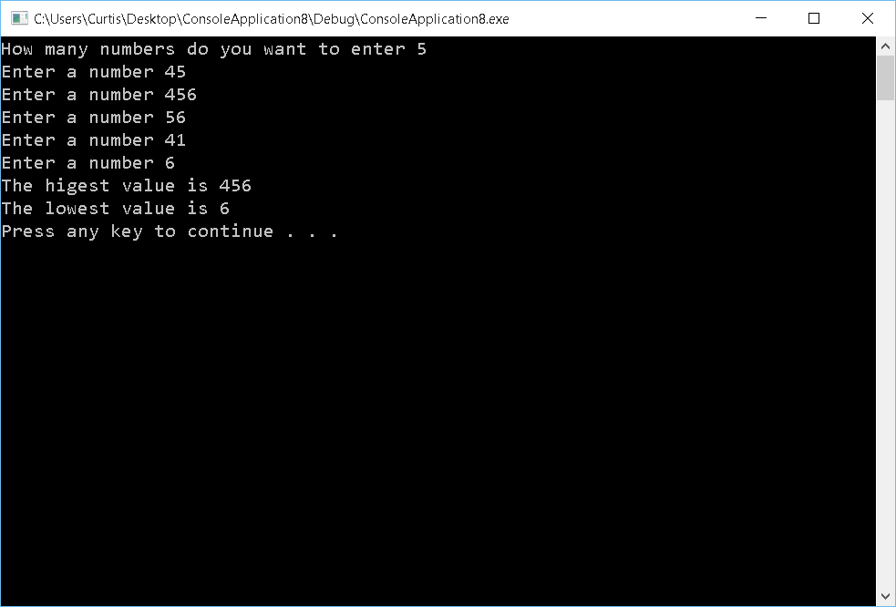

Question 3

#include <iostream>

#include <string>

#include <cmath>

using namespace std;

int reverse(int num)

{

int length = log10(num);

int reversedNum;

double remainder;

int i = 0;

while (i <= length)

{

if (i == 0)

{

remainder = num % 10;

num = floor(num / 10);

reversedNum = pow(10, length) \* remainder;

}

else

{

remainder = num % 10;

num = floor(num / 10);

reversedNum += pow (10, length - i) \* remainder;

}

i++;

}

return reversedNum;

}

int main()

{

int num = 0;

int reversedNum = 0;

cout << "Enter the number you would like reversed: ";

cin >> num;

reversedNum = reverse(num);

cout << reversedNum << endl;

system("pause");

return 0;

}

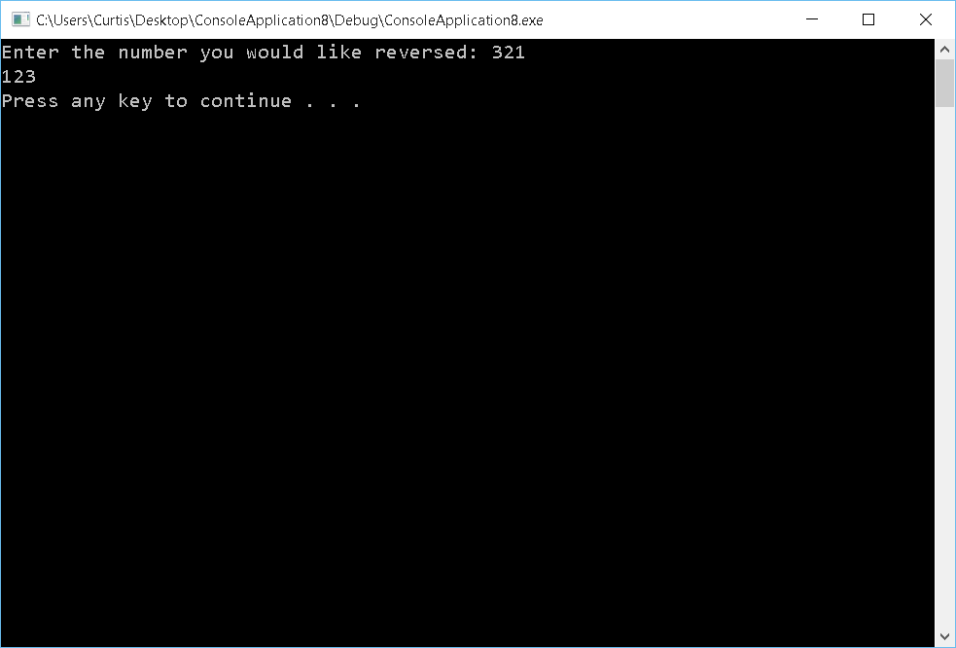

Question 4

#include <iostream>

#include <string>

#include <cmath>

using namespace std;

int reverse(int num)

{

int length = log10(num);

int reversedNum;

double remainder;

int i = 0;

while (i <= length)

{

if (i == 0)

{

remainder = num % 10;

num = floor(num / 10);

reversedNum = pow(10, length) \* remainder;

}

else

{

remainder = num % 10;

num = floor(num / 10);

reversedNum += pow(10, length - i) \* remainder;

}

i++;

}

return reversedNum;

}

void Palindrome(int num, int reversedNum)

{

if (reversedNum == num)

{

cout << "The number you entered is a palidrome" << endl;

}

else

{

cout << "The number you entered is not a palidrome" << endl;

}

}

int main()

{

int num = 0;

int reversedNum = 0;

cout << "Enter the number you would know if it's a palidrome: ";

cin >> num;

reversedNum = reverse(num);

cout << "The num ber reversed is " << reversedNum << endl;

Palindrome(num, reversedNum);

system("pause");

return 0;

}

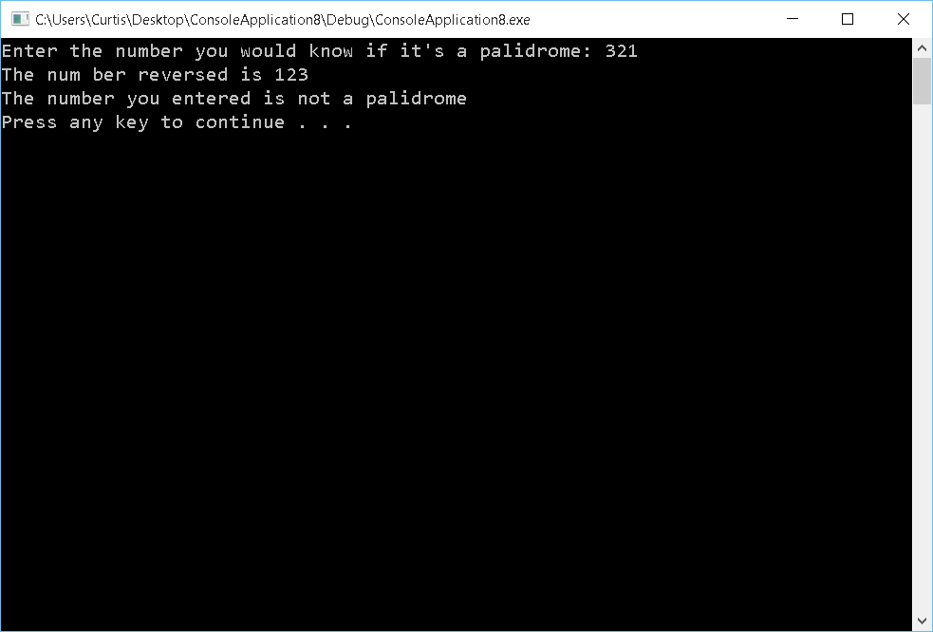

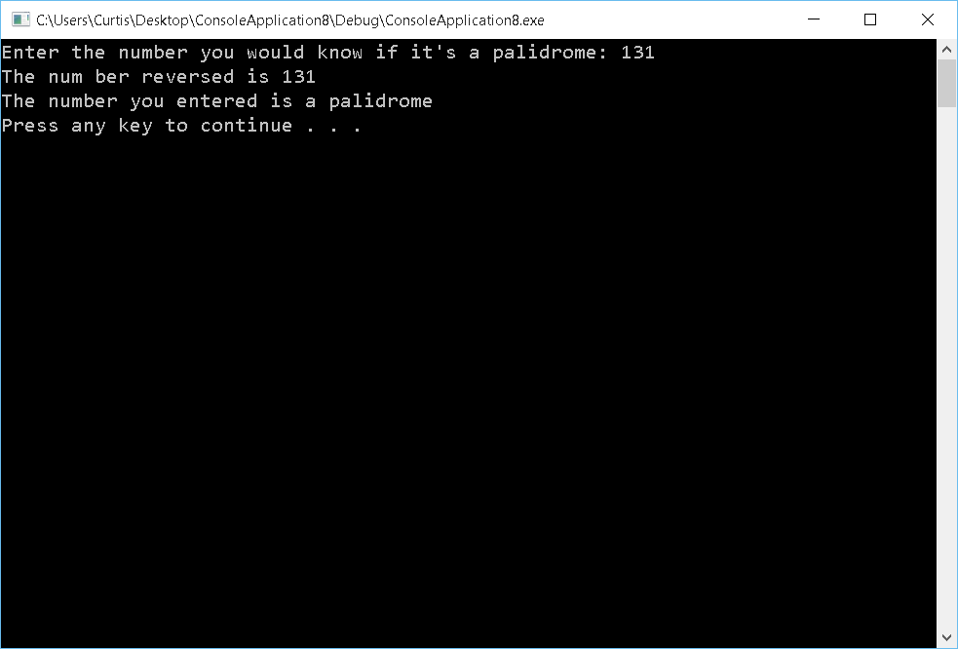

Question 5

#include <iostream>

#include <string>

#include <stdlib.h>

#include <time.h>

using namespace std;

int GuessNum()

{

int num = rand() % 100;

int userNum = -1;

int tries = 0;

while (userNum != num)

{

cout << "Enter a number from 0 to 99: ";

cin >> userNum;

if (userNum > num)

{

cout << "Need to go smaller" << endl;

}

else if (userNum < num)

{

cout << "Need to go larger" << endl;

}

tries++;

}

cout << "The number was " << userNum << endl;

return tries;

}

int main()

{

srand(time(0));

int tries = GuessNum();

cout << "It took you " << tries << " tries to guess the right number" << endl;

system("pause");

return 0;

}

