Question 1

#include <iostream>

#include <string>

using namespace std;

int calculateSum(int n)

{

int i = 0;

int sum = 0;

while (i <= n)

{

sum += i++;

}

return sum;

}

double Avg(int sum, int n)

{

double avg = static_cast<double> (sum) / n;

return avg;

}

int main()

{

int num;

int sum = 0;

double avg = 0;

cout << "Please enter a number for the sum and average of the range 0 to n ";

cin >> num;

sum = calculateSum(num);

cout << "The sum of the range equals " << sum << endl;

avg = Avg(sum, num);

cout << "The average of the range is " << avg << endl;

system("pause");

return 0;

}

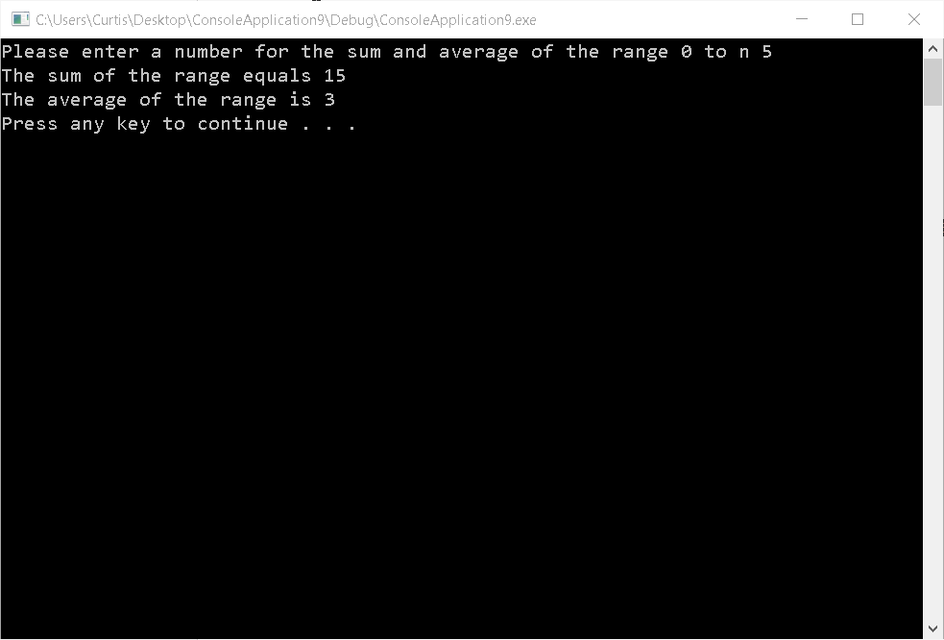

Question 2

A is passed as a pointer/reference so the value of a will actually change including outside the function but b is a copy of the value so the variable value won’t change outside of the function.

#include <iostream>

#include <string>

using namespace std;

void doIt(int& a, int b)

{

a = a * 2;

b = b * 2;

}

int main()

{

int num1;

int num2;

cout << "Please enter two numbers ";

cin >> num1;

cin >> num2;

doIt(num1, num2);

cout << "The new values are " << num1 << " " << num2 << endl;

system("pause");

return 0;

}

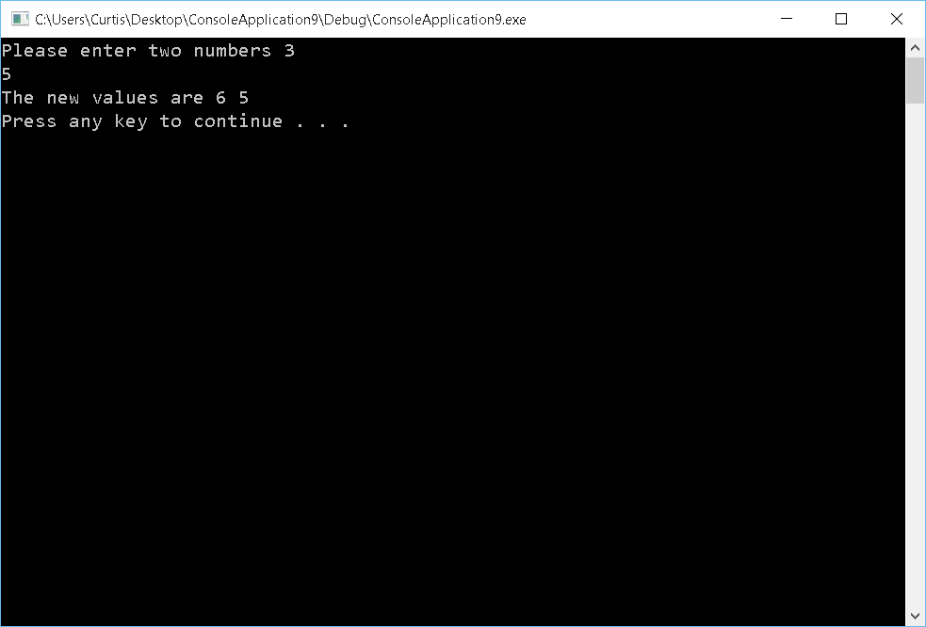

Question 3

#include <iostream>

#include <string>

using namespace std;

void drawWidth(char charcter, int width)

{

int i = 0;

while (i < width)

{

cout << charcter;

i++;

}

cout << endl;

}

void drawHeight(char charcter, int height)

{

int i = 0;

while (i < height - 2) // remove 2 becasue of the draw with on top and bottom

{

cout << charcter << endl;

i++;

}

}

int main()

{

char charcter;

int height;

int width;

cout << "Enter a charcter ";

cin >> charcter;

cout << "Enter the height and width ";

cin >> height;

cin >> width;

if (height >= 1)

{

drawWidth(charcter, width);

}

if (height > 2)

{

drawHeight(charcter, height);

}

if (height > 1)

{

drawWidth(charcter, width);

}

system("pause");

return 0;

}

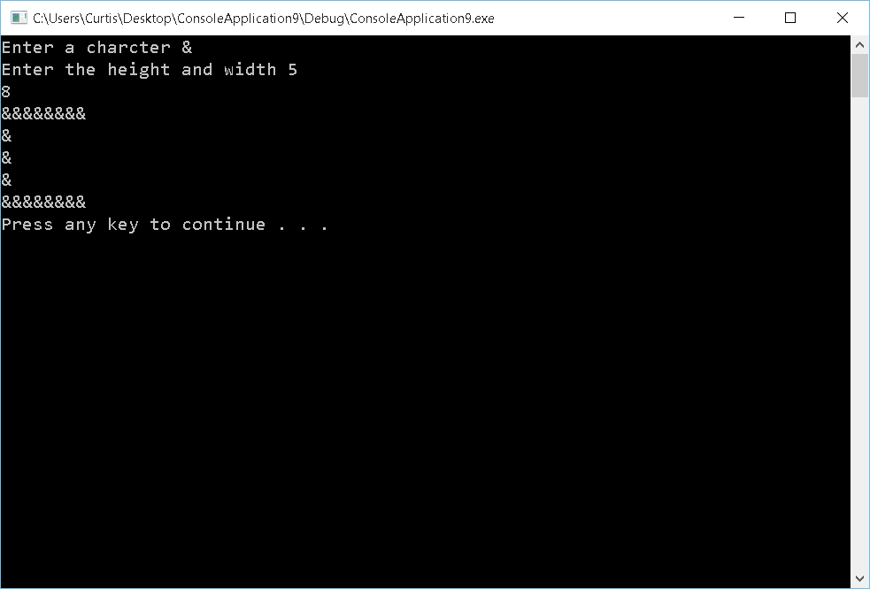

Question 4

#include <iostream>

#include <string>

#include <iomanip>

using namespace std;

double calulateCharges(double hours)

{

double charge = 2.00;

if (hours > 3.00 && hours < 19.00 && hours >= 0.00)

{

charge += (hours - 3) * 0.50;

}

else if (hours >= 19.00)

{

charge = 10;

}

return charge;

}

int main()

{

int numCars = 0;

double currentCarHours = 0;

double totalIncome = 0;

int i = 0;

cout << "Enter the number of cars that were in the garage";

cin >> numCars;

while (i < numCars)

{

cout << "Enter hours of car " << i + 1 << " ";

cin >> currentCarHours;

totalIncome += calulateCharges(currentCarHours);

i++;

}

cout << "Your total earnings for the day are " << fixed << setprecision(2) << totalIncome << endl;

system("pause");

return 0;

}

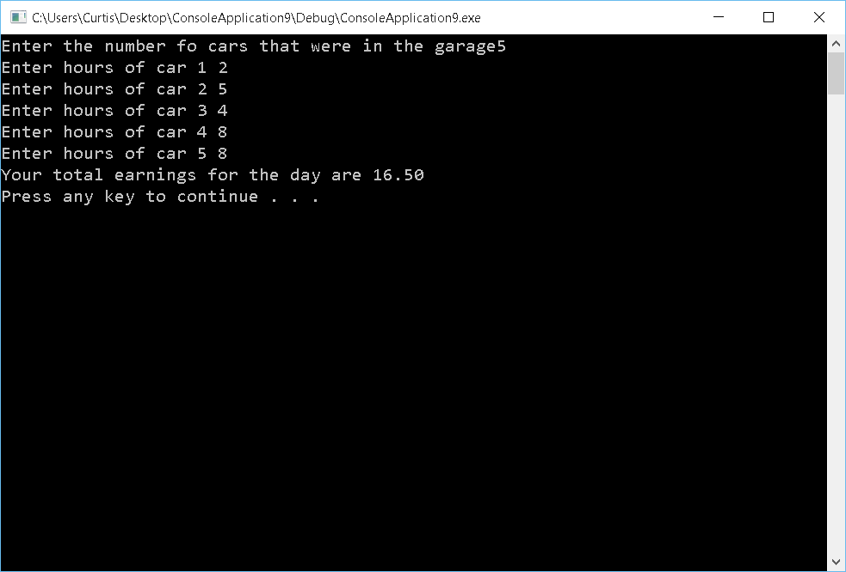

Question 5

#include <iostream>

#include <string>

#include <cmath>

using namespace std;

int Factorial(int num)

{

int result = num;

int i = 1;

while (i < num)

{

result *= num - i;

i++;

}

return result;

}

double Cosine()

{

double DEGREE_TO_RADIAN = (3.14159 / 180);

int percesion;

double cos = 1.0;

double userInput = 0.0;

int i = 2;

cout << "What angle in degrees would you like to find the Cosine for: ";

cin >> userInput;

userInput *= DEGREE_TO_RADIAN;

cout << "To what percesion would you like to find it to: ";

cin >> percesion;

if (percesion >= 34)

{

percesion = 33;

}

for (; i <= percesion; i += 2)

{

if (i % 4 == 0)

{

cos += pow(userInput, i) / Factorial(i);

}

else if (i % 2 == 0)

{

cos -= pow(userInput, i) / Factorial(i);

}

}

return cos;

}

double Sine()

{

double DEGREE_TO_RADIAN = (3.14159 / 180);

int percesion;

double sin = 0.0;

double userInput = 0.0;

int i = 3;

int addOrSubTracker = 2;

cout << "What angle in degrees would you like to find the Sine for: ";

cin >> userInput;

userInput *= DEGREE_TO_RADIAN;

cout << "To what percesion would you like to find it to: ";

cin >> percesion;

if (percesion >= 34)

{

percesion = 33;

}

sin = userInput;

for (; i <= percesion; i += 2)

{

if (addOrSubTracker % 2 == 0)

{

sin -= pow(userInput, i) / Factorial(i);

}

else

{

sin += pow(userInput, i) / Factorial(i);

}

addOrSubTracker++;

}

return sin;

}

int main()

{

double cos = Cosine();

cout << cos << endl;

double sin = Sine();

cout << sin << endl;

system("pause");

return 0;

}

