Question 1

#include <iostream>

#include <string>

#include <fstream>

using namespace std;

void ProcessFile(ofstream& push, ifstream& pull)

{

while (!pull.eof())

{

string fName;

string lName;

int hoursPerWeek;

int payRate;

int weeklySal;

pull >> fName;

pull >> lName;

pull >> hoursPerWeek;

pull >> payRate;

weeklySal = payRate * hoursPerWeek;

push << fName << " " << lName << " " << weeklySal << endl;

}

push.close();

pull.close();

}

int main()

{

ifstream pull;

ofstream push;

pull.open("employees.txt");

push.open("results.txt");

if (!pull.is_open())

{

cout << "Error please try again" << endl;

}

else

{

ProcessFile(push, pull);

}

return 0;

}

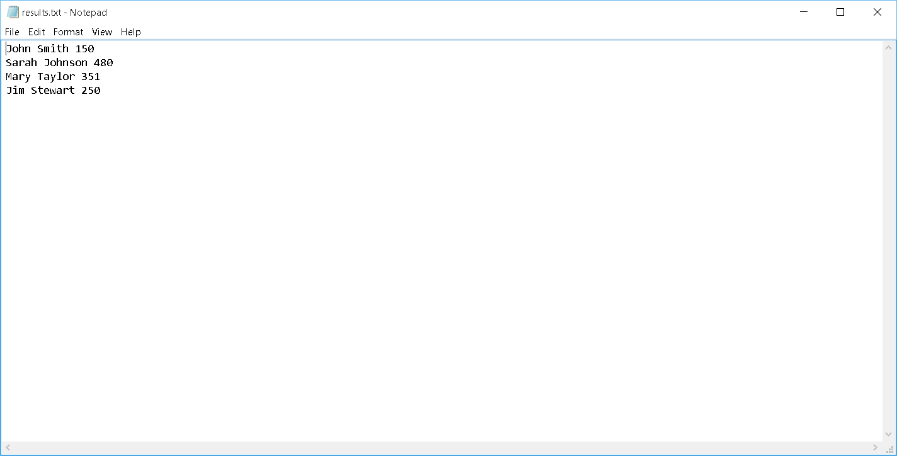

Question 2

#include <iostream>

#include <string>

#include <fstream>

using namespace std;

void ProcessFile(ifstream& file)

{

string temp;

double avgGrade = 0;

double currentGrade;

int numGrades = 0;

while (!file.eof())

{

file >> temp;

file >> temp;

file >> currentGrade;

avgGrade += currentGrade;

numGrades++;

}

avgGrade /= numGrades;

cout << "The class average is " << avgGrade << endl;

}

int main()

{

string filename;

ifstream file;

cout << "Please enter a file name: ";

cin >> filename;

file.open(filename);

if (!file.is_open())

{

cout << "Error" << endl;

}

else

{

ProcessFile(file);

}

system("pause");

return 0;

}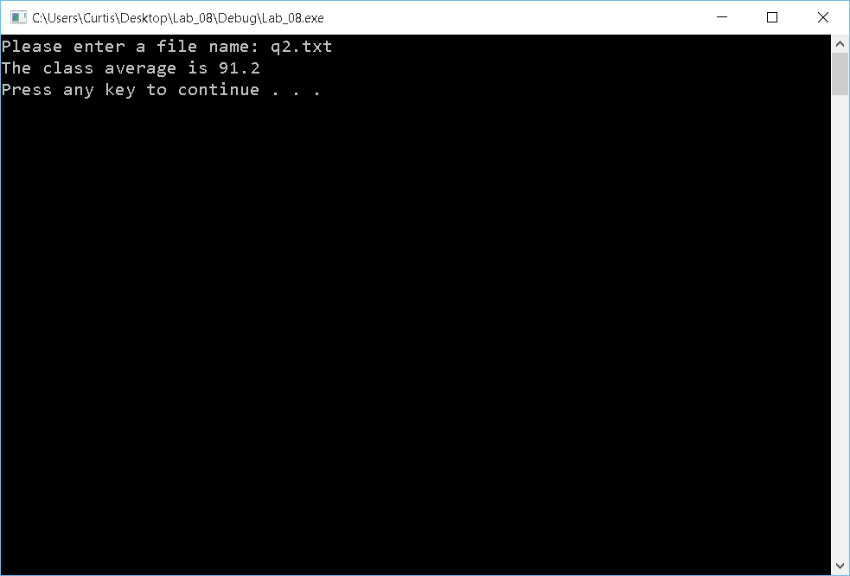

Question 3

#include <iostream>

#include <string>

#include <fstream>

#include <cctype>

using namespace std;

string StringToUpper(string sen)

{

for (int i = 0; i < sen.length(); i++)

{

sen[i] = toupper(sen[i]);

}

return sen;

}

int main()

{

int minVerse;

int maxVerse;

string currentVerse;

int numChar = 0;

int numLines = 0;

ifstream pull;

ofstream push;

pull.open("poem.txt");

if (!pull.is_open())

{

cout << "Error" << endl;

}

else

{

while (!pull.eof())

{

if (numLines == 0)

{

getline(pull, currentVerse);

minVerse = currentVerse.length();

maxVerse = currentVerse.length();

numChar += currentVerse.length();

numLines++;

push.open("poemcap.txt");

currentVerse = StringToUpper(currentVerse);

push << currentVerse << endl;

cout << currentVerse << endl;

}

else

{

getline(pull, currentVerse);

if (currentVerse.length() < minVerse)

{

minVerse = currentVerse.length();

}

else if (currentVerse.length() > maxVerse)

{

maxVerse = currentVerse.length();

}

numChar += currentVerse.length();

numLines++;

currentVerse = StringToUpper(currentVerse);

push << currentVerse << endl;

cout << currentVerse << endl;

}

}

push.close();

push.open("statpoem.txt");

push << "Max verse is: " << maxVerse << endl;

push << "Min verse is: " << minVerse << endl;

push << "Poem character length is: " << numChar << endl;

push << "Number of lines is: " << numLines << endl;

push.close();

cout << "Max verse is: " << maxVerse << endl;

cout << "Min verse is: " << minVerse << endl;

cout << "Poem character length is: " << numChar << endl;

cout << "Number of lines is: " << numLines << endl;

system("pause");

}

return 0;

}

