Question 1

#include <iostream>

#include <string>

#include <fstream>

using namespace std;

struct student

{

string lastName;

string firstName;

int id;

double grade;

};

double calculateAverageGrade(student students[], int numOfStudents)

{

double sum = 0;

for (int i = 0; i < numOfStudents; i++)

{

sum += students[i].grade;

}

return static_cast<double> (sum) / numOfStudents;

}

double calculateMinimumGrade(student students[], int numOfStudents)

{

double min = students[0].grade;

int position = 0;

for (int i = 0; i < numOfStudents; i++)

{

if (min > students[i].grade)

{

min = students[i].grade;

position = i;

}

}

return position;

}

double calculateMaximumGrade(student students[], int numberOfStudents)

{

double max = students[0].grade;

int position = 0;

for (int i = 0; i < numberOfStudents; i++)

{

if (students[i].grade > max)

{

max = students[i].grade;

position = i;

}

}

return position;

}

string getFileName()

{

string file;

cout << "Choose a file you would like to open: ";

cin >> file;

return file;

}

void fillArrayFromFile(ifstream& pull, student students[], int& numberOfStudents)

{

numberOfStudents = 0;

while (!pull.eof())

{

pull >> students[numberOfStudents].firstName;

pull >> students[numberOfStudents].lastName;

pull >> students[numberOfStudents].id;

pull >> students[numberOfStudents].grade;

numberOfStudents++;

}

return;

}

int main()

{

int numberOfStudents = 0;

int minPosition;

int maxPosition;

double avg;

string file;

student students[100];

ifstream pull;

ofstream push;

file = getFileName();

pull.open(file);

if (pull.is_open())

{

fillArrayFromFile(pull, students, numberOfStudents);

minPosition = calculateMinimumGrade(students, numberOfStudents);

maxPosition = calculateMaximumGrade(students, numberOfStudents);

avg = calculateAverageGrade(students, numberOfStudents);

cout << "Number of Students: " << numberOfStudents << endl;

cout << "Max grade was by: " << students[maxPosition].firstName << " " << students[maxPosition].lastName << " " << students[maxPosition].grade << endl;

cout << "Min grade was by: " << students[minPosition].firstName << " " << students[minPosition].lastName << " " << students[minPosition].grade << endl;

cout << "Class average: " << avg << endl;

push.open("gradestats.txt");

push << "Number of Students: " << numberOfStudents << endl;

push << "Max grade was by: " << students[maxPosition].firstName << " " << students[maxPosition].lastName << " " << students[maxPosition].grade << endl;

push << "Min grade was by: " << students[minPosition].firstName << " " << students[minPosition].lastName << " " << students[minPosition].grade << endl;

push << "Class average: " << avg << endl;

system("pause");

}

else

{

cout << "Error couldn't acesses that file." << endl;

}

return 0;

}

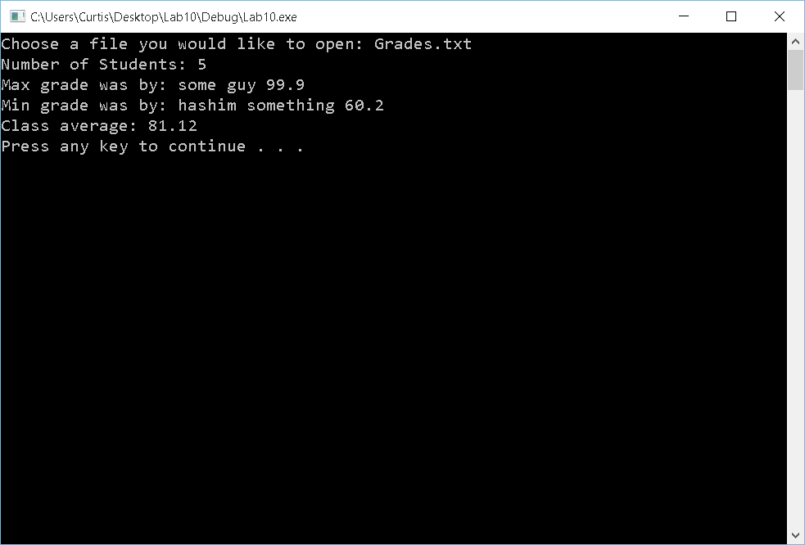

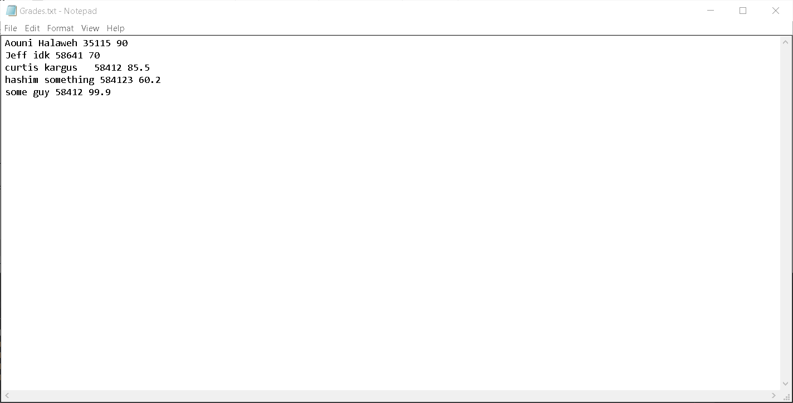

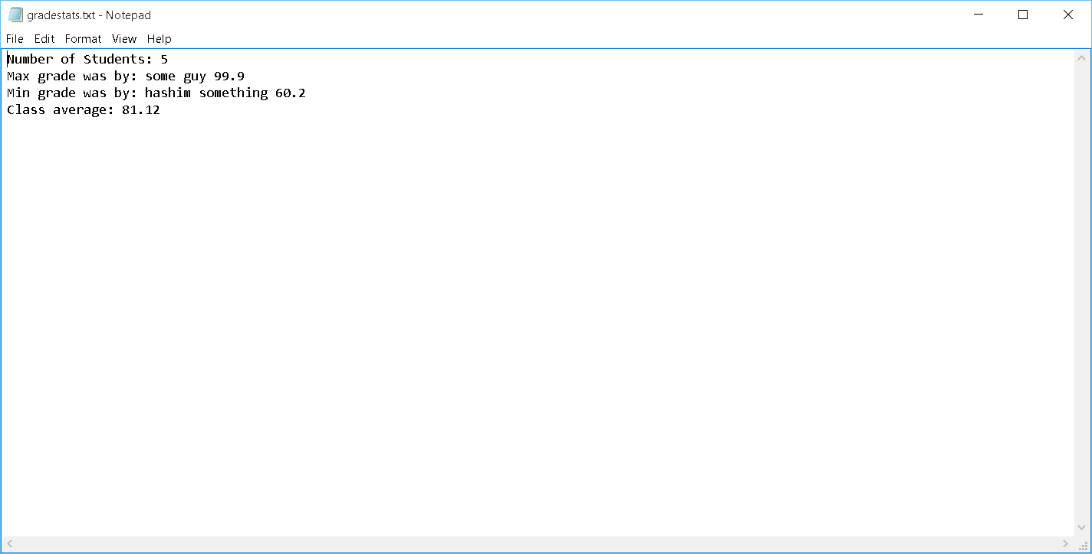

Question 2

#include <iostream>

#include <string>

using namespace std;

double SumOfArray(int length, int height, float box[][4])

{

double sum = 0.0;

for (int i = 0; i < length; i++)

{

for (int j = 0; j < height; j++)

{

sum += box[i][j];

}

}

return sum;

}

double AvgOfArray(int length, int height, float box[][4])

{

double sum = 0.0;

int divsor = length * height;

for (int i = 0; i < length; i++)

{

for (int j = 0; j < height; j++)

{

sum += box[i][j];

}

}

return sum / divsor;

}

int TargetOfArray(int length, int height, float box[][4], int target)

{

int found = -1;

for (int i = 0; i < length; i++)

{

for (int j = 0; j < height; j++)

{

if (target == box[i][j])

{

found = 0;

return found;

}

}

}

return found;

}

int main()

{

const int LENGTH = 4;

const int HEIGHT = 4;

double total;

double average;

double target;

int found;

float box[LENGTH][HEIGHT] = { { 11, 8, 0, -4 }, { 74, 5, 13, 42 }, { 29, -7, 45, 4 }, { 100, 23, -3, 61 } };

total = SumOfArray(LENGTH, HEIGHT, box);

average = AvgOfArray(LENGTH, HEIGHT, box);

cout << "What target number would you like to find: ";

cin >> target;

found = TargetOfArray(LENGTH, HEIGHT, box, target);

cout << "The sum of the array is: " << total << endl;

cout << "The average of the array is: " << average << endl;

if (found == 0)

{

cout << "Target " << target << " was found!" << endl;

}

else

{

cout << "Target " << target << " was not found" << endl;

}

system("pause");

return 0;

}

