Question 1

#include <iostream>

#include <string>

using namespace std;

void CountDown(int num)

{

if (num >= 1)

{

cout << num << endl;

CountDown(num - 1);

}

else

{

cout << "I've learned how to use recurison" << endl;

}

return;

}

int main()

{

int num;

cout << "Please enter a number: ";

cin >> num;

CountDown(num);

system("pause");

return 0;

}

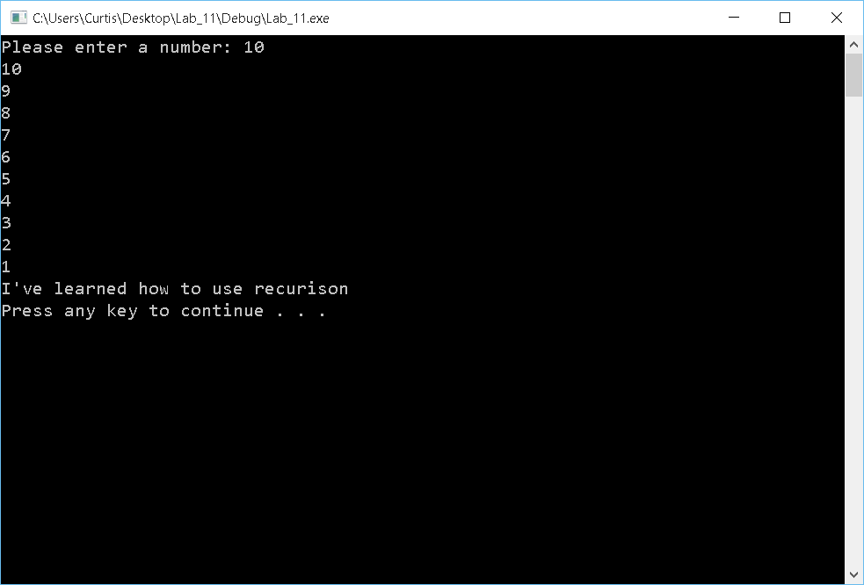

Question 2

#include <iostream>

#include <string>

#include "Triangle.h"

using namespace std;

int main()

{

Triangle tri1;

Triangle tri2;

float base;

float height;

cout << "Enter the height for the first triangle: ";

cin >> height;

tri1.SetHeight(height);

cout << "Enter the base for the first triangle: ";

cin >> base;

tri1.SetBase(base);

tri1.SetArea(tri1.GetBase(), tri1.GetHeight());

cout << "Enter the height for the second triangle: ";

cin >> height;

tri2.SetHeight(height);

cout << "Enter the base for the second triangle: ";

cin >> base;

tri2.SetBase(base);

tri2.SetArea(tri2.GetBase(), tri2.GetHeight());

if (tri1.GetArea() > tri2.GetArea())

{

cout << "Triangle one has a larger area of: " << tri1.GetArea() <<endl;

}

else

{

cout << "Triangle two has a larger area of: " << tri2.GetArea() << endl;

}

system("pause");

return 0;

}

#ifndef Triangle_h

#define Triangle_h

class Triangle

{

public:

float GetHeight() const;

float GetBase() const;

void SetBase(float);

void SetHeight(float);

void SetArea(float,float);

float GetArea() const;

private:

float height;

float base;

float area;

};

#endif

#include "Triangle.h"

#include <iostream>

using namespace std;

float Triangle::GetArea() const

{

return area;

}

float Triangle::GetBase() const

{

return base;

}

float Triangle::GetHeight() const

{

return height;

}

void Triangle::SetBase(float base)

{

while (base < 0.0)

{

cout << "No negative numbers" << endl;

cout << "Enter new number: ";

cin >> base;

}

this->base = base;

}

void Triangle::SetHeight(float height)

{

while (height < 0.0)

{

cout << "No negative numbers" << endl;

cout << "Enter new number: ";

cin >> height;

}

this->height = height;

}

void Triangle::SetArea(float base, float height)

{

area = .5 * base * height;

}

