Observation 1: select count(*) from project_c360.weather_data_partitioned –

Total record count - 6506

Observation 2:

sealevelpressure has all null/missing values

skyconditiontotalcoveragecode has all null/missing values

liquidprecipitation_sixhour has all null/missing values

Observation 3:

Maximum airtemperature and dewpointtemperature by year and month

select * from

(

select airtemperature,

dewpointtemperature,

winddirection,

windspeedrate,

observationyear,

observationmonth,

observationday,

observationhour,

row_number() over(partition BY observationyear, observationmonth order by airtemperature DESC, dewpointtemperature desc) AS rank

from project_c360.weather_data_partitioned)b

where rank = 1;

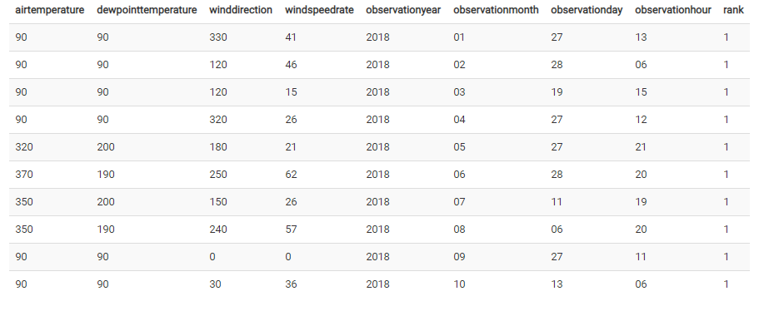

Minimum airtemperature and dewpointtemperature by year and month

select * from

(

select airtemperature,

dewpointtemperature,

winddirection,

windspeedrate,

observationyear,

observationmonth,

observationday,

observationhour,

row_number() over(partition BY observationyear, observationmonth order by airtemperature asc, dewpointtemperature asc) AS rank

from project_c360.weather_data_partitioned)b

where rank = 1;

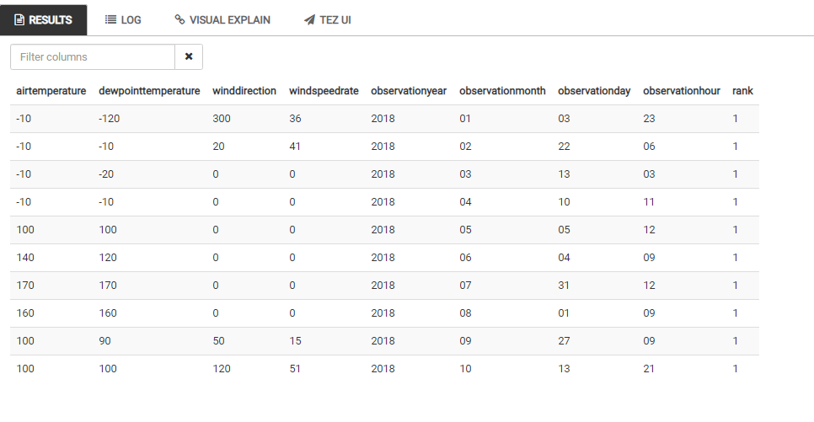

Observation 5:

Maximum wind direction and windspeedrate by year and month

select * from

(

select airtemperature,

dewpointtemperature,

winddirection,

windspeedrate,

observationyear,

observationmonth,

observationday,

observationhour,

row_number() over(partition BY observationyear, observationmonth order by winddirection DESC, windspeedrate desc) AS rank

from project_c360.weather_data_partitioned)b

where rank = 1;

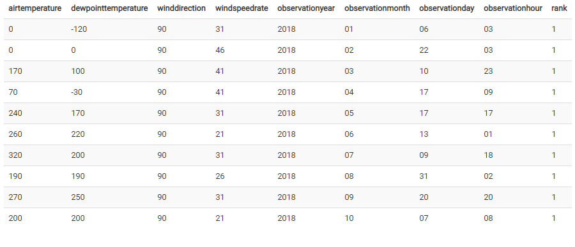

Observation 6:

Minimum wind direction and windspeedrate by year and month

select * from

(

select airtemperature,

dewpointtemperature,

winddirection,

windspeedrate,

observationyear,

observationmonth,

observationday,

observationhour,

row_number() over(partition BY observationyear, observationmonth order by winddirection asc, windspeedrate asc) AS rank

from project_c360.weather_data_partitioned where winddirection is not null and windspeedrate is not null)b

where rank = 1;

