**AI in Daily Life**

**Name:** [Karthik Chinnadurai]  
**Date:** [11-Dec-2024]

**1. Application 1**

* **Name:** Google Translate
* **Description:** It provides real time translation of text, speech, and images between different languages
* **AI Type:** Natural Language Processing and Computer Vision
* **AI Functionality:** It processes input text or images to identify and translate the content into the desired language
* **Visuals (Optional):**

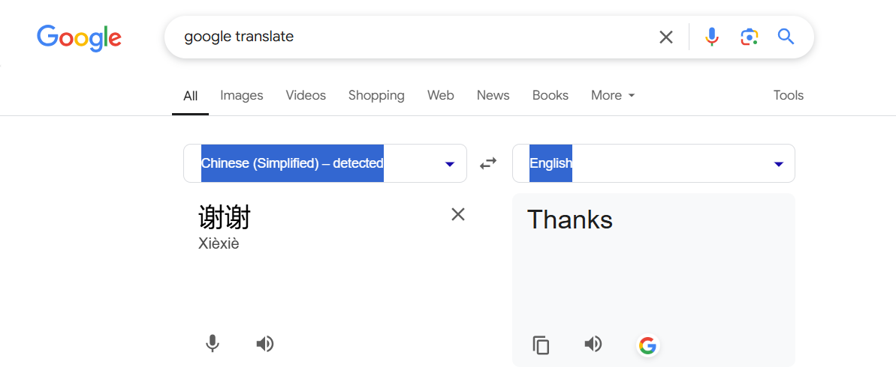

**2. Application 2**

* **Name:** Amazon Recommendations
* **Description:** Amazon’s AI recommends products based on browsing , purchase history, geo location, etc.
* **AI Type:** Machine Learning
* **AI Functionality:** Analyzes user behavior to suggest items that users might be interested in and enhances shopping experiences. Amazon uses its own AI powered recommender system - “Amazon personalize” to product recommendations
* **Visuals (Optional):**

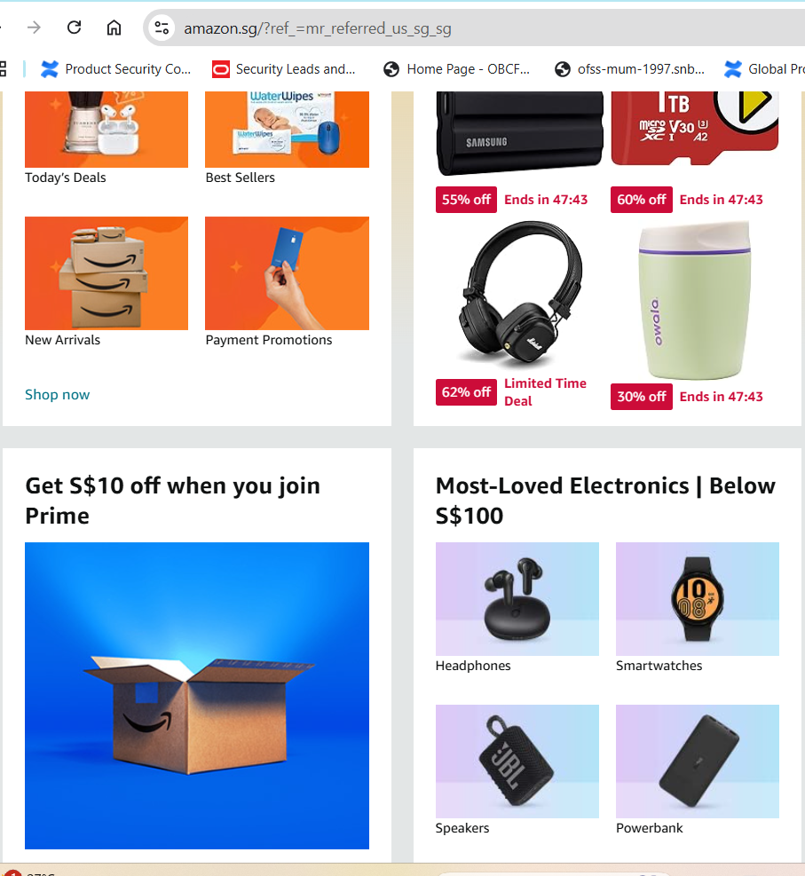

**3. Application 3**

* **Name:** Robotics cleaner
* **Description:** AI-powered robotic vacuum cleaner that cleans floors autonomously
* **AI Type:** Robotics and Computer Vision
* **AI Functionality:** It uses sensors and AI to map the area, avoid obstacles, and efficiently clean the floors without manual intervention
* **Visuals (Optional):** (We have one at office 😊 can’t take picture of it 😊)