Crocodilian Growth and Size Models
HCC AI Pilot Project – First Iteration of Proposed AI Levels
CSCI 130 Computer Science I · Charlie Karun · November 2026 · Step 3 report (AI Level 3: information gathered by the student, report drafted with AI)

1. Summary
- The Step 1 linear growth model is valid only inside its data range. For ages 0–5 it stays within about 15% of the chart averages, but at age 10 it predicts 519.5 cm against a chart range of 320–360 cm, a 52.8% overestimate.
- A growth curve fixes the problem. A von Bertalanffy curve fitted to the same ages 0–5 predicts 342.7 cm at age 10, inside the chart range, without ever being shown the age-10 value.
- Males are larger in every species. Male mean weight is 1.22–1.62 times the female mean, and male mean length is 1.15–1.54 times the female mean.
- Weight predicts length well across species but not within a group. The combined regression has R² = 0.727, but inside any one species-and-sex group R² is at most 0.14, and four of the eight group slopes are negative.
- The Java code is correct. All 13 regression lines from Step 2 matched an independent AI calculation to the 4 decimals the program prints.

2. Data and Method
Two datasets were used. Saltwater_croc_growth.csv gives average lengths of saltwater crocodiles at ages 0–5 (cleaned rows) plus a range for age 10, cited from crocodilian.com. Crocodilia_individual_160_sorted.csv gives the family, species, sex, weight (kg) and length (m) of 160 individuals: 20 of each sex for 4 species.
Every line was computed by the LinearRegressionModel class with the least squares formulas from the assignment:
m = [n Σxy − (Σx)(Σy)] / [n Σx² − (Σx)²], b = μ_{y} − m μ_{x}
R² values and the non-linear comparison models in Section 3 were calculated separately in Python for this report; they are not part of the Java program.

3. Part 1: Validity of the Age–Length Model

3.1 Predictions vs. the chart
The Step 1 model is y = 47.5x + 44.5 (x = age in years, y = length in cm), with R² = 0.966.
Age (yr) | Predicted (cm) | Chart range (cm) | Chart average (cm) | Percent error | In range?
1 | 92.0 | 70–100 | 85 | +8.2% | Yes
3 | 187.0 | 180–220 | 200 | −6.5% | Yes
5 | 282.0 | 250–280 | 265 | +6.4% | No (2 cm high)
10 | 519.5 | 320–360 | 340 (midpoint) | +52.8% | No (160 cm high)
Correction to the Step 1 table: the actual value used there for age 3 (165 cm) is the age-2 average. The file lists 200 cm for age 3, which changes that error from 13.3% to −6.5%. The conclusion does not change.

3.2 Why a high R² is not enough
R² = 0.966 suggests an excellent fit, but the residuals have a clear pattern: negative at both ends and positive in the middle. That shape means the data bends downward, so growth is slowing. The yearly gains in the file are 55.5, 80, 35, 35 and 30 cm, and the chart implies only about 15 cm per year between ages 5 and 10. The linear model assumes 47.5 cm every year forever.
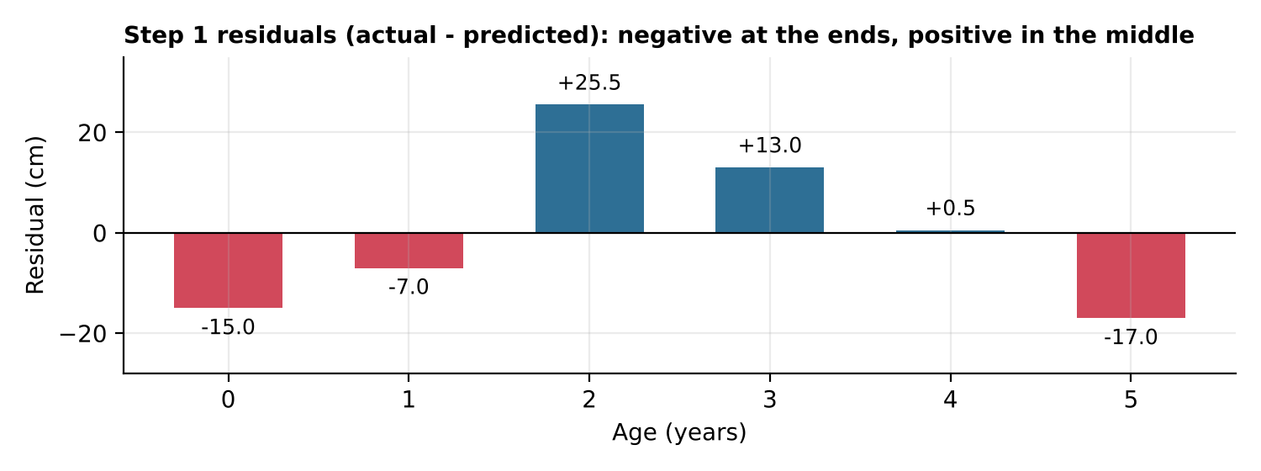
Figure 1. Step 1 residuals. A systematic arch like this means the model has the wrong shape, regardless of R².

3.3 Testing curved models
Three curved models were fitted to the same data and used to predict age 10, the same out-of-sample test the linear model failed.
Model | Fitted on | R² (fit data) | Age-10 prediction | Inside 320–360?
Linear (Step 1) | Ages 0–5 | 0.966 | 519.5 cm | No
Logarithmic, y = 109.4 ln x + 85.2 | Ages 1–5 | 0.997 | 337.2 cm | Yes
Logistic (S-curve) | Ages 0–5 | 0.989 | 262.9 cm | No (too low)
Von Bertalanffy, L∞ = 379 cm, k = 0.227/yr | Ages 0–5 | 0.993 | 342.7 cm | Yes
Von Bertalanffy is the best choice. It is the standard growth model for fish and reptiles: growth is fastest at hatching and slows toward a maximum length (L∞). It passes the age-10 test with no knowledge of that value.
Logistic fails here. An S-curve assumes slow early growth that speeds up and then levels off. Crocodiles grow fastest right after hatching, so the logistic curve levels off at 263 cm, right where the data stops, and underpredicts age 10. The Step 1 report suggested a logistic model; the right instinct (a curve with capped growth) points to von Bertalanffy instead.
Logarithmic works but has flaws. It also passes the test, but it is undefined at age 0 and never stops growing, so it would fail further out.
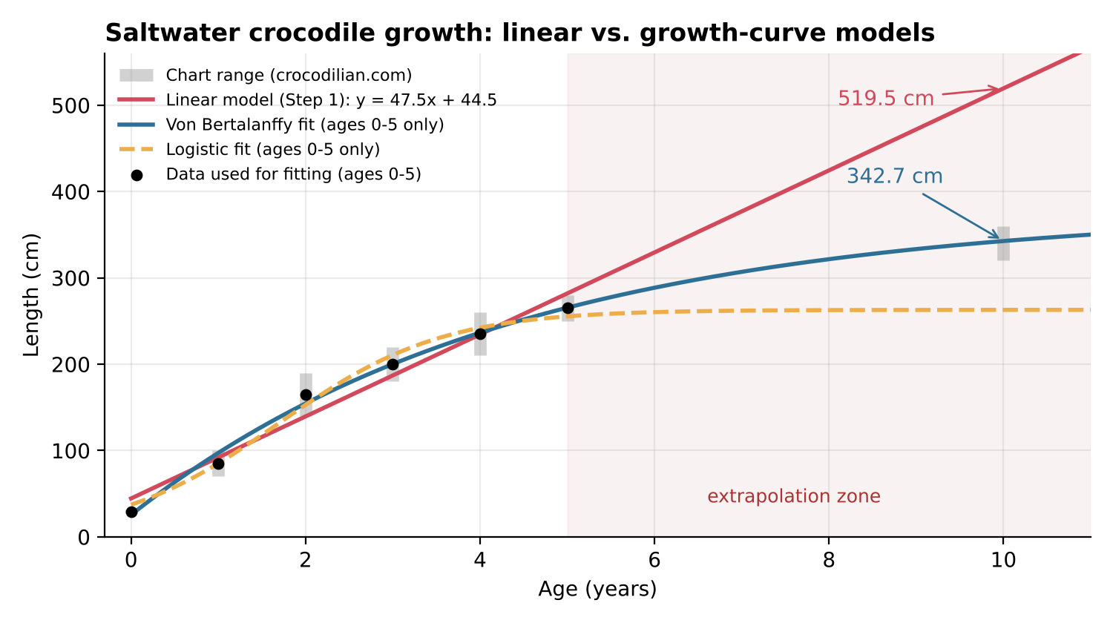
Figure 2. All models use only ages 0–5. The grey bars are the chart ranges; only the growth curves reach the age-10 range.
Verdict on the Step 1 model: use it only to interpolate within ages 0–5. For anything beyond that, use a von Bertalanffy curve. Note also that the chart describes well-fed captive males, so wild crocodiles and females would likely be smaller.

4. Part 2: Comparing Species and Sexes

4.1 Mean weight and length
Species | Sex | n | Mean weight (kg) | Mean length (m)
All crocodilians | All | 160 | 212.5 | 2.584
American alligator | Both | 40 | 262.4 | 2.862
 | Female | 20 | 201.4 | 2.256
 | Male | 20 | 323.5 | 3.468
Chinese alligator | Both | 40 | 27.8 | 1.536
 | Female | 20 | 25.0 | 1.308
 | Male | 20 | 30.6 | 1.764
Nile crocodile | Both | 40 | 273.6 | 2.993
 | Female | 20 | 215.5 | 2.611
 | Male | 20 | 331.8 | 3.374
Saltwater crocodile | Both | 40 | 286.2 | 2.946
 | Female | 20 | 218.3 | 2.746
 | Male | 20 | 354.1 | 3.145
The Chinese alligator is far smaller than the other three species: about one-tenth of their weight and about half their length. Saltwater crocodiles are the heaviest on average (286.2 kg). Males are larger than females in every species:
Species | Male/female weight | Male/female length
American alligator | 1.61× | 1.54×
Chinese alligator | 1.22× | 1.35×
Nile crocodile | 1.54× | 1.29×
Saltwater crocodile | 1.62× | 1.15×

4.2 Regression lines (x = weight in kg, y = length in m)
Species | Sex | Regression line | R²
All crocodilians | All | y = 0.005268x + 1.4644 | 0.727
American alligator | Both | y = 0.007560x + 0.8775 | 0.670
 | Female | y = -0.000281x + 2.3122 | 0.002
 | Male | y = -0.001393x + 3.9184 | 0.058
Chinese alligator | Both | y = 0.016693x + 1.0724 | 0.202
 | Female | y = 0.001263x + 1.2761 | 0.003
 | Male | y = 0.007301x + 1.5413 | 0.136
Nile crocodile | Both | y = 0.004741x + 1.6954 | 0.443
 | Female | y = 0.000406x + 2.5239 | 0.003
 | Male | y = 0.001318x + 2.9366 | 0.025
Saltwater crocodile | Both | y = 0.001402x + 2.5443 | 0.075
 | Female | y = -0.000870x + 2.9362 | 0.012
 | Male | y = -0.001946x + 3.8342 | 0.061
These lines match croc_data_results.txt to 4 decimals, confirming the Java program.

4.3 The main story: a strong trend made of flat clusters
The combined line says each extra kilogram adds about 5.3 mm of length, and weight explains 73% of the variation in length. But that relationship comes almost entirely from the differences between groups: small Chinese alligators sit at one end, large males at the other. Inside any one species-and-sex group, weight tells you almost nothing about length (R² ≤ 0.14), and the slope is negative for American alligators and saltwater crocodiles of both sexes. With each group centred on its own means, the pooled correlation between weight and length is −0.08.
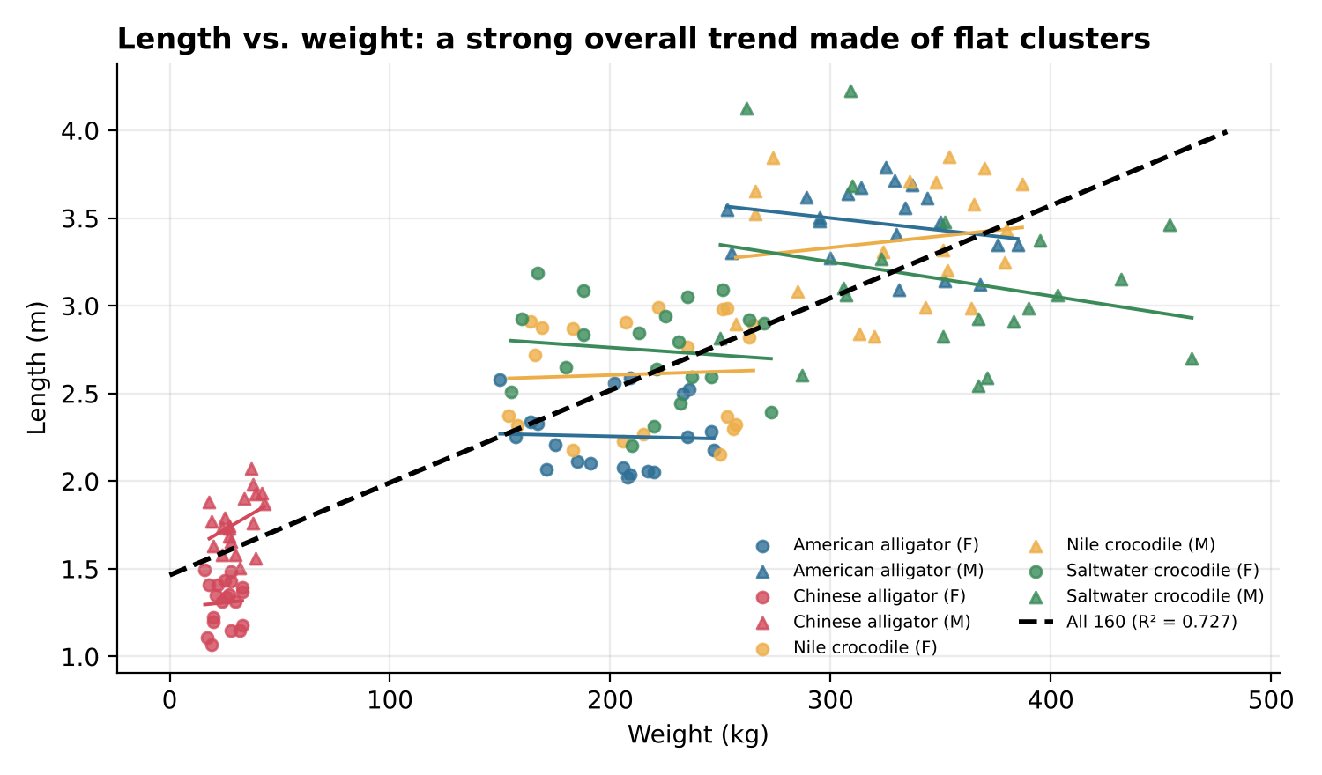
Figure 3. Each cluster is one species and sex, with its own short regression line. The dashed line connects the clusters rather than following any one of them.
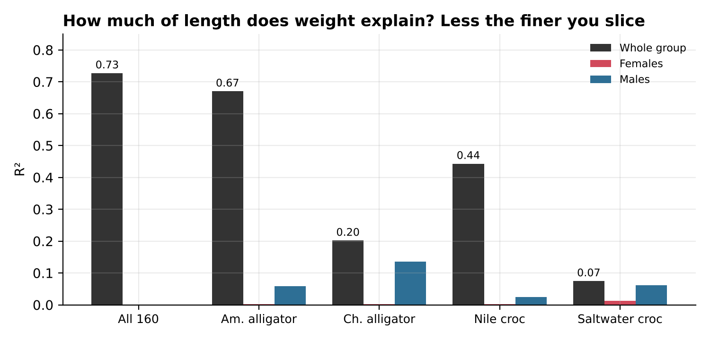
Figure 4. R² drops sharply when the data is split by species and sex.
What this means: the combined line is really a "which group is this animal in?" line, not a growth law. It should not be used to predict an individual's length from its weight within a species. This is an aggregation effect, closely related to Simpson's paradox: a trend in combined data can disappear or reverse inside the subgroups.
A caution about the data: in real animals, a longer individual of the same species and sex is almost always heavier, so near-zero and negative within-group slopes are biologically unlikely. This suggests the weights and lengths in this file may have been generated independently within each group. The source of the file is not stated, so this cannot be confirmed.
A better model form: mass scales roughly with length cubed, so a power law fits the combined data better than a line. Fitting log L against log W gives L ≈ 0.579 W^{0.289} with R² = 0.790, versus 0.727 for the linear model, and the exponent is close to the 1/3 that this scaling predicts.

5. Model Comparison
Model | Data | R² | Assessment
Age → length, linear | Growth chart, ages 0–5 | 0.966 | Good inside ages 0–5; 52.8% error at age 10
Age → length, von Bertalanffy | Growth chart, ages 0–5 | 0.993 | Best; predicts age 10 within the chart range
Weight → length, all 160 | Individual records | 0.727 | Strong, but driven by species and sex differences
Weight → length, power law | Individual records | 0.790 | Better shape than linear for the combined data
Weight → length, by species | Individual records | 0.07–0.67 | Varies widely; mostly sex differences inside each species
Weight → length, by species and sex | Individual records | 0.00–0.14 | No useful relationship

6. What the Data Is Telling Us
- Extrapolation is the biggest risk. A model can fit its data almost perfectly and still fail badly just outside it.
- Check the residuals, not just R². The residual pattern showed the Step 1 problem before the age-10 test did.
- Group structure matters. Combining species and sexes created a relationship that does not exist inside any group.
- Choose the model form from how the system works. Growth slows with age, and mass scales with volume; both point away from straight lines.
Suggested presentation: lead with Figure 2 (linear vs. growth curve at age 10) and Figure 3 (the clusters), since each shows one finding at a glance; keep the tables as backup.

