Step 1
Compare your regression predictions to the provided chart (search for the value that would be associated with 10 years, since this isn't in the chart). Create a report.docx file with your findings and your evaluation of the linear regression line:

After running the regression, the output was:
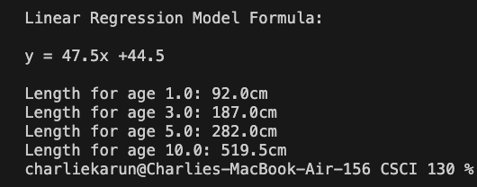

The predicted values are relatively close to the actual values for ages 1, 3, and 5 but deviate for 10:

Age | Predicted Values (cm) | Actual Values (cm) | Percent error
1 | 92 | 85 | 8.24%
3 | 187 | 200 | 6.50%
5 | 282 | 265 | 6.42%
10 | 519.5 | 340 | 52.8%

http://crocodilian.com/crocfaq/faq-1.html (Used to obtain actual value for age 10)

From these results, we can conclude that the linear regression line is not satisfactory. The model was given 6 data points, with lengths for ages (0-5). This causes the model to be relatively accurate for ages in that range, with percent errors ranging from 6.42% to 8.24%. However, at age 10, we are extrapolating from the data set. This leads to the high percent error of 52.8% as seen at age 10. In order to improve this model, more data needs to be given to the model, particularly from ages 5 and up. Also, it is important to consider that another regression model most likely fits better. More growth happens near birth, and it tapers off as individuals age. For this reason, a logistic growth model is most likely appropriate.

Feed your LinearRegressionModel class into AI and ask it to evaluate your code. In your report, indicate its findings and your thoughts in terms of how helpful it is and if it prompts you to make any changes:

Prompt: Please evaluate the code below. (All the code for Linear Regression Model)
Response:
AI Code Evaluation – LinearRegressionModel
Overall: The math is correct. The slope and intercept calculations match the least squares formulas, and every required member is present.
Design Issues
- The static counter is shared across all instances. Creating any new LinearRegressionModel resets count to 0 for every existing model, and the alternate constructor overwrites it too. If two models exist at the same time, the newer one corrupts the older one’s results.
- The capacity is fixed at 100. Once the arrays are full, addDataPair prints a message and drops every later pair. Any dataset with more than 100 points is silently cut off unless the caller uses the alternate constructor with larger arrays.
- Degenerate data divides by zero. With fewer than 2 points, or when all x-values are the same, the slope’s denominator is 0. Because these are doubles, the result is NaN or Infinity instead of an exception, and the bad values carry into every later result.
Correctness and Robustness
- Invalid selectors fail silently. If sumSingleValues gets anything other than ‘x’ or ‘y’, it prints a message and returns 0, and sumDualValues does the same for unrecognized strings. Everything calculated from that is wrong with no error. Throwing an IllegalArgumentException would catch it at the source.
- String matching on “x * x” is fragile. A missing space breaks it. A char parameter (‘x’ meaning x times x, ‘y’ meaning x times y) would also match the style of sumSingleValues.
- The alternate constructor doesn’t validate its inputs. It doesn’t check that the two arrays have equal lengths or that setCount fits within them. It also stores the caller’s arrays directly, so changes made outside the class change the model. The accessors expose the internal arrays the same way.
- calculateAverageValue returns NaN when count is 0.
Readability and Style
- The parameters in findXgivenY and findYgivenX shadow the fields. The y in findXgivenY and the x in findYgivenX share names with the instance arrays. Renaming them to yVal and xVal avoids confusion.
- toString produces messy output. There’s no space after “+”, a negative intercept prints as “x +-0.42”, and the doubles print with about 15 digits. Using String.format to round the values and handle the sign fixes all three. Adding @Override is also recommended.
- Minor details: Math.pow(xSum, 2) could just be xSum * xSum. The literal 100 could be a named constant. Java convention is lowercase package names (final_project).
Optional Numerical Note
The assigned slope formula can lose precision when x-values are large, because it subtracts two big, nearly equal numbers. A centered version of the formula, which subtracts the averages first, is more stable. For small datasets with moderate values, doubles are precise enough.
Recommended Changes: Fix #3, #4, and #9.
My thoughts: AI provided an honest and comprehensive evaluation of the code. I loved how it broke it down into sections; this allowed me to see where the largest issues are and what are minor tweaks. It caught the divide-by-zero error issue, a real problem that I did not consider. However, it made suggestions like changing the static variable. This goes against the assignment instructions. Giving the AI more context and being more specific with the prompt would lead to cleaner feedback. Based on its feedback, I responded with the following:

Issue 1: Did not change. The assignment specifically asks for a static variable, and multiple versions do not need to run at once for any part of the assignment.
Issue 2: Did not change. The alternative constructor can be used with sets larger than 100.

Issue 3: Changed. Updated the calculated slope method with a quick check. If there are fewer than 2 points, or all x values are the same, an error is thrown.
Issues 4-7: Did not change; changes deemed unnecessary for the scope of the assignment.

Issues 8 and 10: Did not change. Did not adopt minor suggestions.
Issue 9: Changed. Updated the to string method to be more robust.

Ask AI about the actual data for a 10-year-old croc, the data projected by the linear regression model, and its analysis of the numbers. Indicate its findings in your report.docx file and your thoughts on how helpful it was to your analysis.

Prompt: Now, actually look at the data for a 10-year-old croc, the data projected by the model, and make an analysis of the numbers.

Response:
AI Analysis – 10-Year-Old Saltwater Crocodile
Regression Model (ages 0–5)
y = 47.5x + 44.5, where x is age in years, and y is length in cm. R² = 0.966.
Model Predictions vs. Chart
Age 1: predicted 92.0 cm; chart range 70–100 cm. Within range.
Age 3: predicted 187.0 cm; chart range 180–220 cm. Within range.
Age 5: predicted 282.0 cm; chart range 250–280 cm. Slightly above range.
Age 10: predicted 519.5 cm; chart range 320–360 cm. Far above range.
Note on the 10-year value: the 320–360 cm figure is already in the raw Saltwater_croc_growth.csv file, cited from crocodilian.com. It was left out of the cleaned age/length rows the model uses, which stop at age 5.
The 10-Year Discrepancy
The model overpredicts by about 180 cm compared with the midpoint of 340 cm, roughly 53% too high. Even the top of the range (360 cm) is about 160 cm below the prediction. A 5.2 m prediction for a 10-year-old would put it at the size of a very large adult male, which is not realistic.
Why It Happens
- Growth slows down. Yearly gains from the data are 55.5, 80, 35, 35, and 30 cm, so growth is decelerating. From age 5 to 10, the chart implies only about 15 cm per year, but the model assumes a constant 47.5 cm per year forever.
- The residuals show curvature. The model underpredicts in the middle ages (+25.5 cm at age 2, +13.0 cm at age 3) and overpredicts at both ends (−15.0 cm at age 0, −17.0 cm at age 5). Positive errors in the middle and negative errors at the ends mean the real data curves downward, so a straight line is the wrong shape.
- Age 10 is an extrapolation. It is twice as far out as the oldest data point. A linear model can only be trusted near the range of the data it was built from, and here the growth pattern changes outside that range.
Conclusion
Within ages 0–5, the linear model is a reasonable approximation: R² is high, and its predictions for ages 1 and 3 fall inside the chart ranges. It should not be used to predict beyond age 5. The high R² hides the curvature, which shows that R² alone doesn’t prove a model is the right shape. A curve that levels off would fit animal growth better. For example, a logarithmic fit to ages 1–5 predicts about 337 cm at age 10, which falls inside the 320–360 cm range.
My thoughts: AI provided a great analysis of the data. It went through each value and verified whether it was in range, noted discrepancies, and clearly described them. It was helpful for my analysis as it supported my claims. It verified that for the lower values, the predicted results are mostly in range. But as the values grow, the results deviate. AI also calls for a non-linear model, a logarithmic one. I believe that a logistic model would be better, as it has capped growth, but nonetheless, we agree on a non-linear model. AI also added context by mentioning that this data is for optimally fed captive male crocodiles. This is not something that I had considered, and it is an important distinction.
Step 2
Feed the relevant information into your AI and ask it to calculate the linear regression models associated with steps 4, 5, and 6 above. Compare it to the models generated by the code, and if there are any discrepancies, ask AI for an explanation. Record all of this information in the report.docx file created in step 1.

Prompt: Calculate the linear regression for steps 4, 5, and 6. (sorted CSV uploaded).

Response:
I computed these with a Python script using the least-squares formulas from your directions, with x = weight in kg and y = length in m.
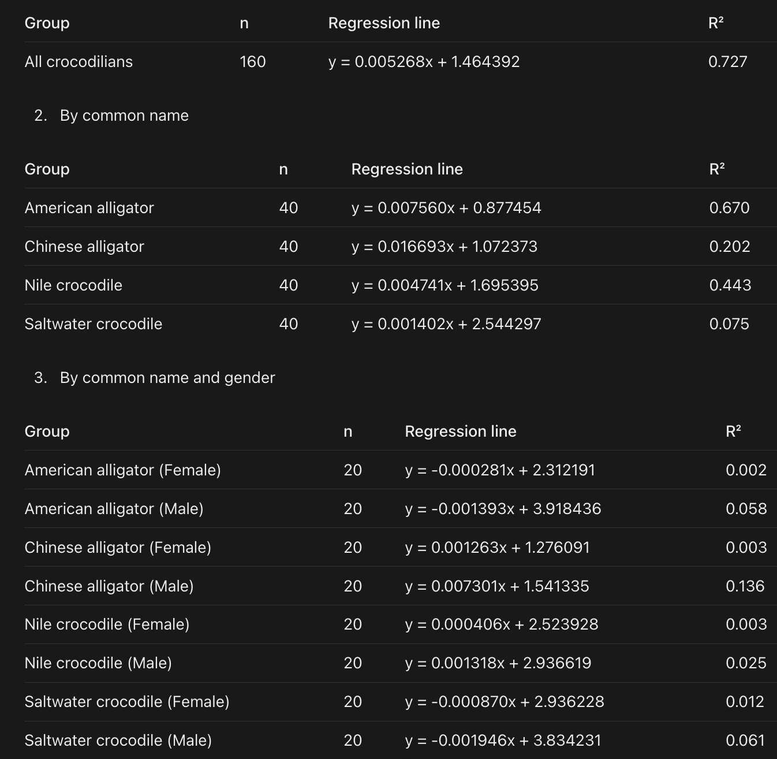

Comparison with your Java output
All 13 lines match croc_data_results.txt once rounded to the 4 decimals your toString uses, so there are no discrepancies. The only difference is precision: I show 6 decimals and your code shows 4.
How much did you need to change the CrocsStatsData class (if at all)?

Not at all. AI immediately delivered an accurate response that satisfied all the requirements of the assignment. Not a single additional prompt was needed after the initial prompt.
Would it have been easier to write the code yourself? Or perhaps provide the AI with some starter code?

No. The AI completed the task perfectly in a few minutes. It would not have been easier to give it an outline or starter code. However, if the prompt is more advanced, it may be necessary to provide AI with more context, pseudo code, or starter code.

Step 3
Finish your report with a paragraph summarizing your thoughts regarding this question: If you had to do a similar process again, how would you go about incorporating AI?

If I had to do a similar process again, I would mostly use AI on level 3 or 4. The more context AI has, the better it tends to do. I would gather a lot of information on the task/topic I wanted to achieve, and upload lots of files, data, and any other relevant information to the AI. Then, I would go back and forth with AI until we have landed on a complete result. I would work at this level because I have seen the capabilities of how AI can code, and the sheer efficiency of it cannot be beat. For example, Claude Code can work directly in VS Code and update the code in real time. There is not even a need for pasting. In the past, for an internship, I have coded in languages I do not know, just by feeding the AI significant context and using my understanding of programming logic. However, I think the appropriate AI level depends on the goal. For learning code, you need a level 0 or 1. You need to go out and write it, try and fail, and then see where you need to improve. When the objective is not learning, but straight completion, AI level 3 or 4 is most appropriate.

